Rotary District 7850
Alonzo Malouin Memorial
Scholarship for Teachers’ Education
For 2023/2024 Academic Year

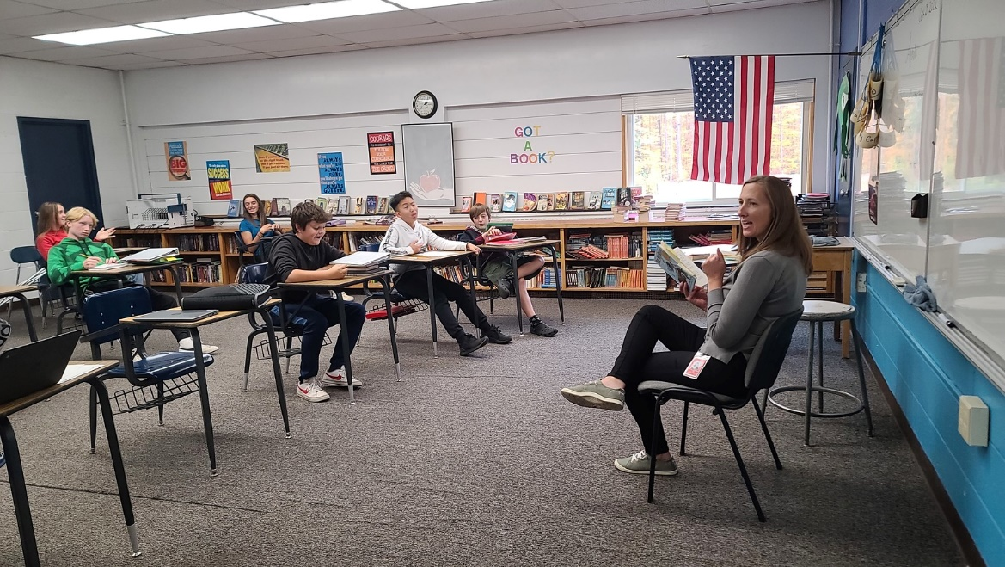
Summary
Rotary District 7850 is making available scholarship(s) to support educators furthering their education beyond a post-secondary degree. Scholarships of up to $5,000 will be awarded.
Goal/Purpose
The objective of this grant is to recognize and encourage excellence in education, to encourage and support advancement of teachers, and to promote the exchange of information and ideas among educators in the support of Rotary International’s six areas of focus. Rotary International and Rotary District 7850 have long supported peace through the promotion of education and better understanding. This grant further supports those principles.
In an effort to support the continuing education of teachers, scholarship monies may be used to cover a variety of expenses incurred by those continuing their education including but not limited to tuition, educational supplies (textbooks, computers, etc.), transportation costs, institutional room and board.

Eligibility
Eligible applicants
- must hold a full-time teaching appointment for 18 months or more,
- have previously completed bachelor’s degree,
- reside or work within Rotary District 7850,
- must be studying topic directly related to basic education and literacy for children from pre-school through high school.,
- must be sponsored by a Rotary Club in District 7850, and the completed application can only be submitted by the Rotary Club that is sponsoring your application,
- must submit their application by 28 April, 2023 to the address below.
Applicants must be non-Rotarians and may not be closely related to a Rotarian of District 7850. Awards are not restricted by nationality, gender, age or marital status.
The top 3 candidates will be interviewed on Saturday, May 13, 2023 and must be available for interviews on this date in person.
Scholarships will be awarded based on applicant’s stated goals and attending recommendations of fellow professionals.
All funds must be expended by May 15, 2024 with reports of expenditures including receipts filed by grantees every 4 months.
The final report including a statement about course work pursued with the funds, and any outstanding receipts and reimbursement of unexpended funds must be filed with Rotary District 7850 by May 20, 2024

Applications must be submitted by the sponsoring Rotary Club by 28 April, 2023 to:
Claude LaLiberte: - rotaryd7850foundation@gmail.com
or
Malouin Scholarship Report
C/O Claude LaLiberté
42 Silver Cir
Barre, VT 05641

In addition to this application form, applicants must submit all of the following:
- Current curriculum vitae including current teaching appointment
- A letter of recommendation from qualified academic persons, evaluating teaching ability and scholarly qualifications,
- A written statement no more than one (1) page in length, explaining specific educational plans,
- A letter from a college/university verifying admission for enrollment.

Applicant Name: _____________________________________________________
Home Address: _______________________________ Phone number: _________
______________________________ E-mail: ________________
______________________________
Highest Degree Completed: _______________ Date of Completion: _____
Granting Institution: ____________________________________

I will be pursuing education at __________________________________
From___________ to ___________ .(Specify the dates.)
□ I have been accepted at this institution.

This scholarship will be used to fund [INSERT ITEMS TO BE FUNDED]

I hereby apply for Rotary District 7850 Teacher Scholarship for the 2023-24 academic year to be funded by Rotary Foundation funds I certify that I am eligible to apply, understanding that persons in the following categories are ineligible: (a) a Rotarian or Honorary Rotarian; (b) an employee of a Rotary club or district, of Rotary International, or of another Rotary-affiliated entity; (c) a spouse, a lineal descendant (child or grandchild by blood or by legal adoption), a spouse of a lineal descendant, or an ancestor (parent or grandparent by blood) of any living person in categories (a) or (b); and that Rotarians and their relatives as described above remain ineligible for 36 months after resignation. I certify that the information on this form and the accompanying papers is accurate.
If awarded this scholarship, I agree to provide all supporting reports confirming my successful completion of proposed education. I understand that Rotary District 7850 reserves the right to discontinue payments at any time, and may require me to reimburse the District for any or all scholarship funds transmitted if, in the judgment of District 7850, I am not fulfilling or have not fulfilled the terms of the agreement.

I agree that all funds will be expended by May 15, 2024 with all reports, receipts and reimbursement of unexpended funds filed with Rotary District 7850 by May 20, 2024.

Applicant’s Signature_________________________________ Date _______
Applicant do not write below this line.

District 7850 Teacher Scholarship Application

DEADLINE FOR APPLICATION SUBMISSION IS 28 APRIL 2023

Application submitted by the Rotary Club of ___________________________

2022-23 Club President Name: ______________________________________
Club President E-mail Address: _____________________________________

□ This was our club’s only applicant.
□ We had ______applicants and this was the best application.

Why does your club think that this person is a worthy candidate?

Signature of Club Representative________________________________

District 7850 Review
Date of receipt of application: ____________
Date of interview: _______________ by: ___________________

District Teacher Scholarship Committee Chair name and signature:
(please print):________________________________
Signature: ___________________________________ Date: __________

Approved by Committee? ___________ Date: _____________

District 7850 Foundation Chair (print name):______________________________
Signature: ________________________ Date: ____________

District 7850 Governor (print name):______________________________
Signature: ________________________ Date: ____________

