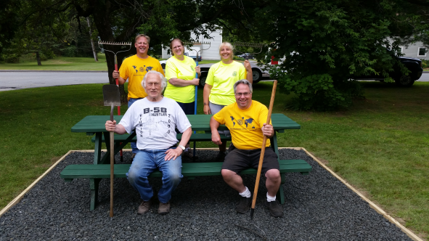  TOGETHER WE CAN  Many thanks to all who have donated to The Rotary Foundation allowing projects around our District and around the world to succeed.  Many thanks, too, to everyone who has donated their time in supporting the District Foundation review and allocation process.  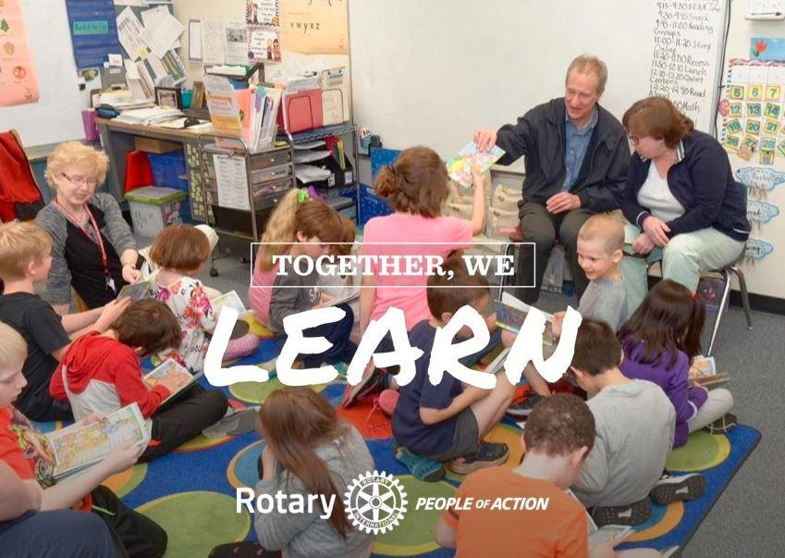 |  |  | CONTACT US  Interested in helping to with the District 7850 Foundation allocation and review process? Everyone is welcome!  42 Silver Cir, Barre, VT 05641  (802) 371-9819  rotary7850.org  rotaryd7850foundation@gmail.com | subhead | 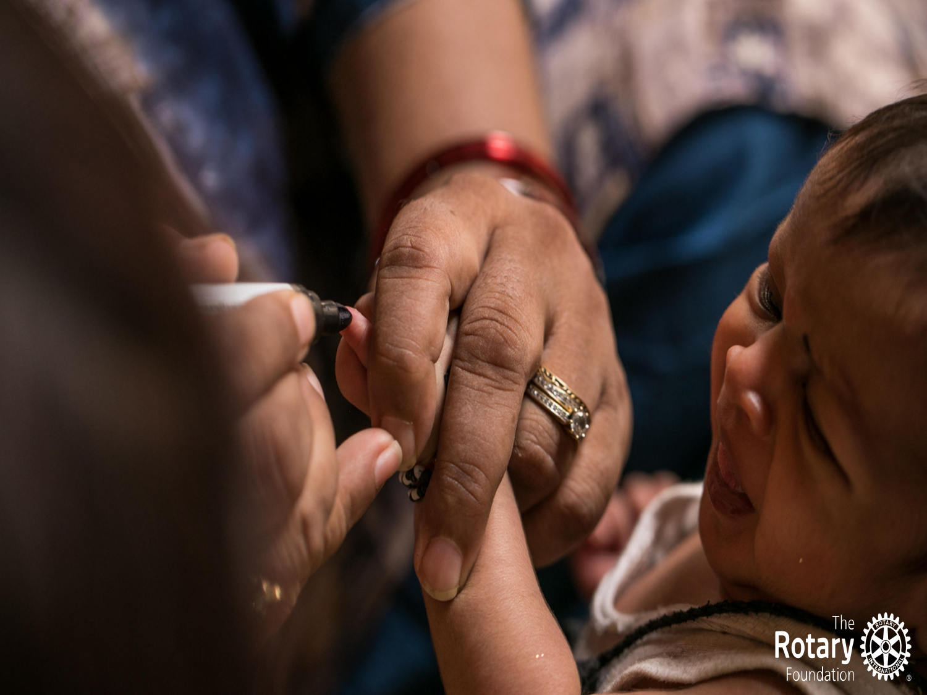 | 2023-24 District 7850 Foundation Report  April 20, 2024
THE ROTARY FOUNDATION’S MISSION
The mission of The Rotary Foundation is to enable Rotarians to advance world understanding, goodwill, and peace through the improvement of health, the support of education, and the alleviation of poverty.

 |  |  | 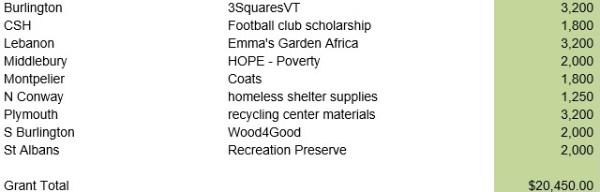 |  |  | FINAL REPORTS  Final reports for the the grants listed are due May 15, 2024. We expect to be able to successfully close the 2023-24 year without issue again this year to allow Rotary International to approve releasing the 2024-25 DDF funds by mid- to late June.  2024-25 District Grants  On October 7, 2023 the Distrct team met to review and allocate the 2024-25 available DDF of $29,870. The team allocated $5,000 to the teachers’ scholarship and $24,870 to District Grants.  Applications for the 2024-25 year are due April 26, 2024. The foundation review committee will meet on May 11, 2024 to review grant applications, interview teacher scholarship applicants and determine fund distribution.
2023-24 District Grants  Initial Allocation  On October 8, 2022 the District Governor track and Foundation Committee met to discuss allocation of the $27,856 available DDF. The decision was made to allocate $22,950 to district grants and $5,000 to teacher scholarships.  Actual Distribution  During the May 13, 2023 district grant review meeting the committee approved $7,500 in teacher scholarships and $20,450 in district grants(listed above) for the 2023-24 year. |  |  | “DDF” - District Designated Funds are monies available to District 7850 because of generous donations made by D7850 Rotarians. $30k available to us now in DDF means Rotarians in our district donated $120k three years ago!

