
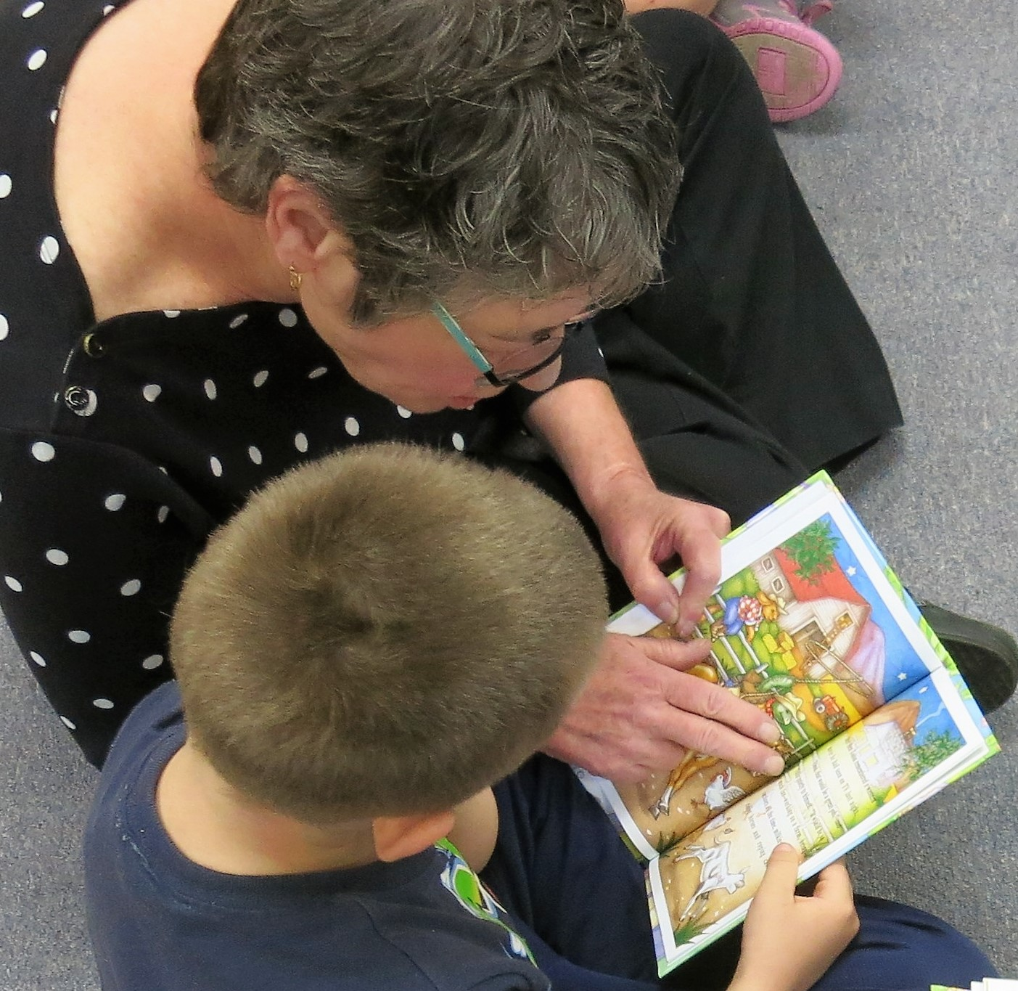

Rotary District 7850
Club Membership Development Handbook
October 10th 2021
District Governor, Mike Carrier
Membership Chair, Eric Denu

For all clubs in District 7850, you are encouraged to review the material in this handbook and take what you need to adapt it for your own club.
Good luck on your membership growth.

Michael Carrier
District Governor
2021-2022

Along with this handbook, Rotary International has some excellent Learning Courses for developing membership strategies. Learn about “Creating an Engaging Club Experience” and “Your Membership Plan.” Go to:
https://learn.rotary.org/members/learn/lp/8/Club%2520Membership%2520Committee%2520Basics
and then select: “Develop Membership Strategies”

Eric Denu
District Membership Chair

“A membership strategy based primarily on acquiring new members does not produce sustained membership growth.”

Service Projects are the Answer

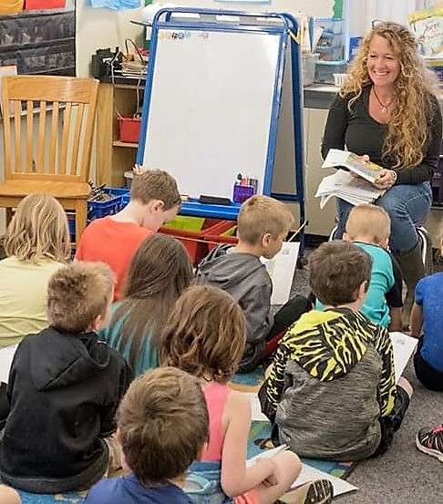

INTRODUCTION

When Rotary’s global membership strategy is focused only on increasing the number of new members, results have been inconsistent, with short-term membership spikes and a longer-term stagnation in membership totals. Worldwide we’ve been stuck at 1.2 Million members for over a decade. More alarming is the loss of members in North American clubs. Once with 500,000 members, today North America is bordering on only 300,000 Rotarians.

Building Membership in Rotary:
Recruitment is NOT the answer to building membership. There are better ways to build.

First: Retain the members you have. Keep them engaged, give them something of value.
Make meetings fun and inspirational . Show 2 min funny videos (there’s a ton of them on YouTube).
Do short opening and closing inspirations.
Use Classification talks to get to know your members.
Assign new members to committees.
Create many opportunities for service and fellowship.

Second: Make your club a magnet for new members.
Service projects are the answer.
Let the public see what you are doing
Invite them to participate

Lastly: Bring guests, friends and family members to meetings.
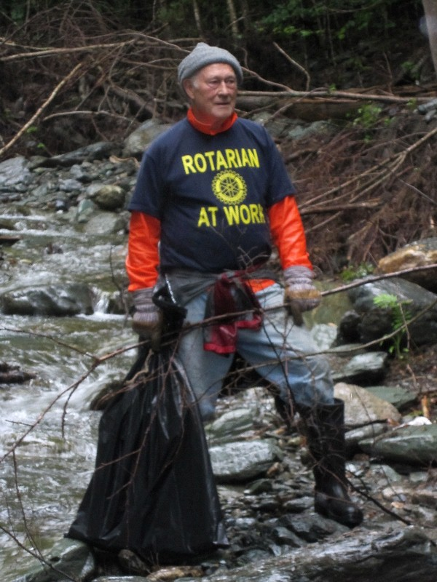
An interesting conversation:

“You’re telling me your club’s membership has been increasing every year – what’s your secret?”

“No secret. We just provide a lot of value for our members.”

“What does that mean?”

“It’s called the value proposition. When people decide to invest their time and money into something they hope to get the best value for their effort. If Rotarians receive value for the time, effort and cost they spend with Rotary, then that’s a good value proposition.”

“So how did you go about providing the best value to your members?”

“Well, we started thinking outside the box to see what changes we could make to better engage our members. We conducted a survey of our members to determine what we were doing right, what we were doing wrong and what we could do better as a club. We insisted on maximum participation because we especially needed input from members with low attendance to find out why they were not coming to meetings.”

“Then what?”

“Well, for one thing we made sure we got the best programs possible at each meeting, and not necessarily just speakers. We’ve had magicians, comedians, singers, fiddlers, and even our school band.”

“What are you doing about lowering costs? I understand that this is one of the reasons people leave Rotary”

“You’re right. Cost and time are given as the top reason why members leave Rotary and 52% leave within their first two years of membership. Worldwide, 18,000 left Rotary this past year before completing even one year of membership. Perhaps this 52% felt the “value proposition” offered to them wasn’t worth it.”
“Can you give me some examples of how to lower costs?”

“Well, in our club, we do not do fines. Above all, no one is obligated to donate money for any cause. It’s strictly voluntary and usually comes from the heart after the cause is fully explained and why it is beneficial. To further contain costs, and allow more opportunities for attendance, we don’t do meals. For our morning meetings, members are free to bring their own coffee. One club in our district meets in the evening and their members are free to leave after the meeting or stay and have dinner with other members.”

“What else?”

“We also reduce the cost of membership by allowing members under the age of 36 to pay reduced club dues. We also have a family plan where a spouse or family member may join and pay roughly half the normal club dues. Every six months our District provides monetary awards for the number of members we have in these plans.”

“Wow!! How can I find out more?”

“Read our Membership Development Plan”

THE PLAN:

Membership in Rotary should provide value for the time and energy freely donated by its members. Each club should strive to meet the needs of its members by providing opportunities to serve on worthwhile service activities, in an atmosphere of friendship, fellowship and camaraderie. Additional benefits accrue through business networking and the opportunity to develop leadership skills. We also take pride in our programs for youth, for they are the future of Rotary.

We need to start thinking ‘outside the box’ and focus on creating meaningful experiences for our members. We need to look at new practices that engage our members and attract new ‘customers’ to our cause.

Strong, vibrant clubs with excellent programs, opportunities for service and good public relations will become magnets for keeping current members and attracting potential members from the local community.

There are four parts to an effective membership development program. This plan will provide the best practices for each part.

- Member Retention: Means taking certain actions that will effectively engage, involve, and hold the interest of individual members.

- Member Recruitment: Involves attracting, identifying and contacting potential members and bringing them into the club.

- Club Extension: Encourages the formation of new clubs to meet the needs of large population areas or those areas without a Rotary club, or within a current Rotary community to meet, for example, the needs of younger professionals.

- Public Relations: Makes people aware of all the good things Rotary is doing and how it can provide an avenue for people who feel the need to serve both locally and internationally.

First Steps in Membership Development:
Clubs should first determine what possible impediments may exist in maintaining members or recruiting new members. Then they should fix the problems and begin improving club operations to the point where members and potential members will see a real need to belong. For club presidents; try to make your club strong, vibrant, and proactive, so it will serve as a magnet for attracting and keeping members. These first steps will make the recruitment steps easier, more productive, and longer lasting.

- Member Retention:

Action steps to engage and retain members:
Success in retaining members, current or new, should begin with an introspective look at your current club. Pass out the following questionnaire to your club members and ask them to answer each one. If they answer ‘No’ to any of the questions ask them to provide their recommendation to make things better. Survey Monkey is a useful tool for conducting this survey.

- Do we have a club where almost all of our members eagerly attend each meeting?
- Do we praise rather than criticize?
- Do we recognize rather than ignore?
- Do we discuss important, relevant issues?
- Do we have dynamic, interesting programs?
- Do we have a diverse and proactive Board of Directors with terms of office limited to not more than three years?
- Do we invite suggestions for improving our meeting format and substance?
- Are we a ‘community service oriented club?
- Do we seek out interesting community and international service projects?
- Do we have fun and fellowship at our meetings?
- Do we actively seek out new members to learn more about them and to inform them about Rotary and our club’s activities?
- Do we incorporate options to reach out to younger professionals and explore membership/attendance options consistent with the younger generation – like less emphasis on meetings and more on service project involvement.?
- Do we refrain from discussing politics at our meetings?

If you receive many “No” answers then you may wish to re-orient your club so that it acts as a magnet for keeping current members and attracting new members. One way to do this is to issue the club member survey found at Appendix 1. on a yearly basis. Try for a 100% return of the surveys. For those members with low attendance you might want to mail it to their home address and include a pre-addressed, stamped envelope for ease of return. That way you won’t miss important feedback from people who do not attend on a regular basis.

Who is your most important customer? Businesses succeed or fail in how well they treat their customers. Our most important customer is the Rotarians in our club. Therefor our planning process should be aimed at the single concept that … we will do everything possible to satisfy the needs of our “customers.” The following four steps should guide us to meet that objective.

1.Identify, define and promote Rotary’s “value proposition” to our members by increasing the focus on the significant benefits exclusive to membership in a Rotary club.

2.Complete an objective assessment of the current member satisfaction quotient and then implement specific, actionable plans to increase satisfaction.

3.Assess club practices and then develop and implement changes to encourage and maintain a strong and vibrant club.

4.Gain recognition that increased member satisfaction will create increased interest
to join from potential new members.

PREPARING YOUR ROTARY CLUB FOR NEW MEMBERS
Take a Look at Ourselves:

Like any project your Rotary Club prepares for, there is some planning needed to attract and keep new Rotarians. This is a “take a look” at ourselves project. It may even be good to have a Rotarian from a neighboring Club visit and critique your meeting and your meeting place and surroundings. What we are going to outline here are only basic things that should happen continually.

1. Does your Club really want to expand and attract new active members? If so, the barrier between old members and new members needs to be addressed. Some of the members that have been Rotarians for a number of years may have some reservations to a large population entering the Club and perhaps taking over at some point. This is certainly a topic for discussion.

2. Look at your meeting place. Is it a facility that is pleasant to visit? Is it appealing? Is it a place where “Professionals” enjoy coming to weekly?

3.What is your set up? Are your banners straight, does your Club banner look impressive, same for the “Four Way Test” banner? Are your banners neat? Are they soiled?

4. Speak positive in meetings. Any club problems and concerns should be held for discussion at Board meetings. A good image is very important. If prospective members see it and feel it as they enter the meeting place, it is a good impression.

5. Are programs interesting, diverse and informative. Remember that a good program does not always require a speaker … try performers like musicians, singers, comedians, etc.?

6. Do your members sit in the same place every week? Perhaps an occasional table rotation would be helpful.

7. Do you have a greeter?

8. Encourage members to take pride in their membership and wear the Rotary pin not only at meetings but within the community.

Have Fun. Mix it up. Paul Harris the founder of Rotary always thought of Rotary as being an opportunity for fun and friendship. Think about putting fun into your meetings. There are hundreds of two minute funny videos available on YouTube from a production outfit called “Just for Laughs Gags” Play one of these at each meeting. Here’s a sample of what’s available: https://www.youtube.com/watch?v=XTm4JKlPvX4
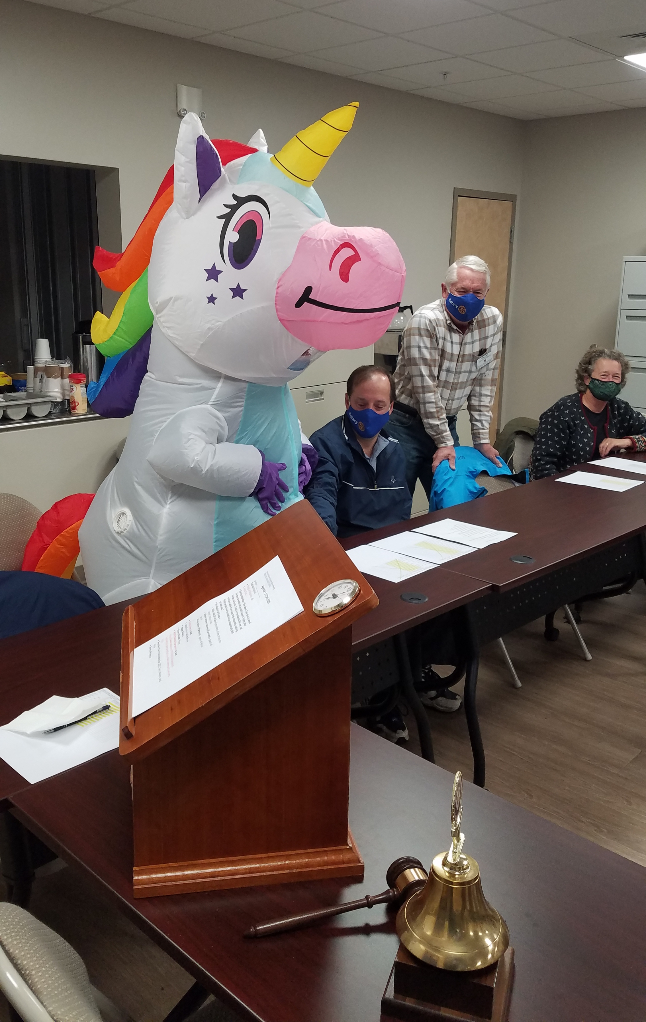
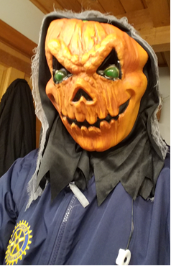
Have a monthly theme. This unicorn showed up during Halloween week, while the club president showed up wearing this grotesque mask.

Re-engaging Missing Members:

Do you find that only half of your membership shows up at meetings? Do you also notice that it’s always the same five or six members that work most service projects?

1. We should treat each club member as part of our family. We have to let them know how much we appreciate them as members. Show them that we value them for their past contributions. And like a valued family member, we become concerned about their welfare when they are missing.

2. We should contact those that miss meetings and get their thoughts. Just that personal contact alone might be enough to bring them back into the fold. And it's important that the contact be either in person or by phone - don't use Email. Someone with good people skills should be appointed to make these contacts.

3. One way to get missing members more engaged is to ask them to give a Rotary Minute at a meeting.

4. Classification talks are another way of getting missing members back into the fold - go through the list of missing members and schedule them to give their talk - if they had already given a talk, we should ask them to do it again for the benefit of new members.

5. It's important to keep our missing members aware of upcoming events like speakers, and service projects so they can mark their calendars well in advance of the events. If you do not publish a weekly club newsletter, then just a short notice from the Club President or Secretary should suffice.

6. Give time for members to become engaged with other members. In this regard, it's important to allow time for open discussion among members, so don’t allow your speakers to use up all of your meeting time. A good practice is to tell speakers they have only 15 minutes for their talk plus 5 minutes for Q&A., Rotary minutes should not last more than a minute and Classification talks should be only 10 minutes.

7. Consider doing a Fireside Chat some evening to build a new list of service projects and scope out a plan on where we want to be in the next 5 years. Encourage max attendance especially from our missing members. The District also has a Visioning Team to help plan your club’s future.

8. For more participation in Service Projects consider appointing someone to be a “Barker” with the responsibility of calling as many members as possible the day before to “hype” the project and to encourage them to attend? Remember that Service Projects can do wonders for building camaraderie among members.

Retaining New Members:

The largest loss of new members happens within the first three years of joining a Rotary Club. Surveys show they leave because Rotary didn’t meet their expectations or they did not feel involved or necessary. If a new member begins to be absent, it usually means lack of involvement, more than business pressure although the latter excuse frequently is given.

Once new Rotarians are immersed in Service, they will never leave –and if they do, it will not be because of neglect or disillusionment, but for another un-avoidable reason. Get them active and involved. An “Entry Interview” will uncover their spheres of interest and an “Exit Interview” will tell us about their true reason for leaving.

1. Do not become exclusively a “check writing” Rotary Club with no involvement of service within the community. This type of Club scares new members away.

2. Give the new member responsibilities: It is important that new members participate in meaningful Committee work during their first year. Assign them to committees of their choice or where they would be a good fit.

3. Ask a new member to give a brief “My Classification” talk, using the guide at Appendix 2.

If your club is going to go to all the work of recruiting new members then an equal amount of time and energy has to go into "mentoring" them. Their mentor or sponsor should call to find out what their interests are and see if there is a specific job opening that the member could fill.

How to mentor new members:
- Hold mentoring workshops to train selected club members on how to be a mentor
- Assign a mentor to each New Rotarian (not necessarily the sponsor)
- Create a satisfaction survey for new members to determine what is working and what is not meeting their expectations within the club.
- There is much to learn about Rotary on the rotary International Web Site: Here’s the link: www.Rotary.org
- You might also consider showing new members the introductory video This Is Rotary, a four-minute comprehensive overview of Rotary. Here’s the YouTube link: https://www.youtube.com/watch?v=oV38lAul8Xw

Involve
- Assign a new member to be a greeter or to introduce a guest speaker.

- Have a new member serve as a delegate to the district conference. A new Rotarian learns much about the world of Rotary and the vast
Projects beyond the borders of his or her own club by attending a district conference. Some clubs assist the new member by paying part or all of the registration fees and costs of the conference. After the conference, ask the new members to give a report to the club.

- Introduce a “commencement” program, where all club members who join in the same Rotary year work together on a project or meet on special occasions.

- Ask new members, especially younger ones, to find two or three other new members from among their peer group.

- Use a program called SPOKES to keep new members involved and active in club activities. See Appendix 3. for an explanation of the SPOKES program,

Educate
- There is a wealth of information to learn about Rotary contained in various on-line learning courses. The sponsor should show the new member how to enroll in “My Rotary” and then encourage the new member to investigate what is available at: https://learn.rotary.org/members/pages/36/course-catalogs
- This should help expand his or her vision about Rotary.

Expand Horizons: Explain to the new member how Rotarians can travel world wide to perform service in other countries: These Rotarians travelled to India to help build a stone and concrete dam to hold back water during the monsoon rains so sufficient water would be available for crop planting during the dry season.
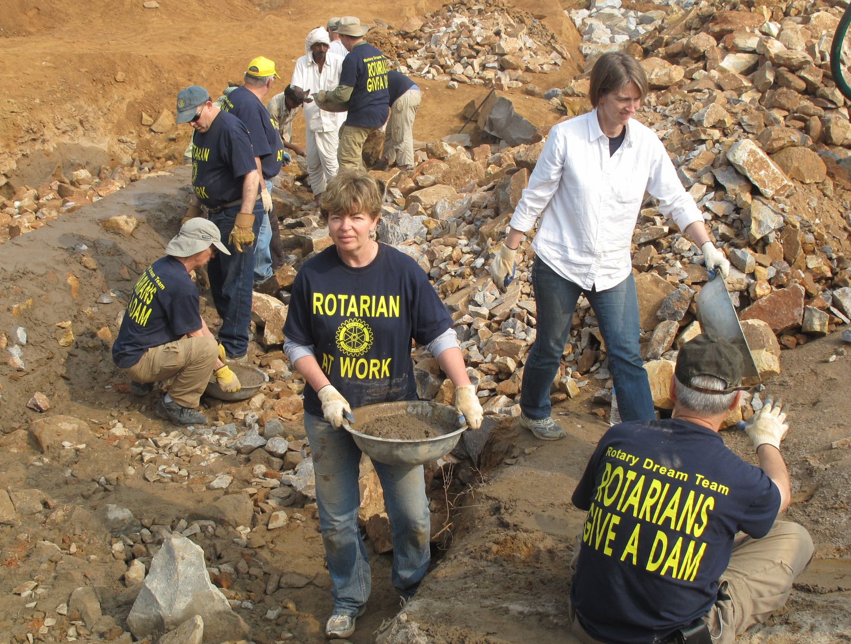

Continuing Education

These programs might include:

• Regular club assemblies to discuss which club activities club members
want to continue and which they want to change

• A leadership development program to enhance members’ professional
lives and nurture future club leaders. Consider sending all new members to the
Rotary Leadership Institute (RLI) as part of this program.

• A club program focused on Rotary, its history, object, scope, and activities

• A presentation from a District leader on the many Service Projects, both local and International, that other clubs are involved in.

Close the Back Door:

Exit Interviews: Always conduct one-on-one Exit Interviews with people who terminate or plan to terminate their membership. Find out their real reason for leaving and then act to keep them as a member. If they say their needs are not being met, then ask them what it is the club could do to better meet their needs. If they see no value in membership then perhaps the club should look at the “Value Proposition” it is offering to all of its members and change it as necessary.

Excused Absences: The club’s board may excuse a member’s absence for reasons which it considers to be good and sufficient. Such excused absences should not extend for longer than twelve months.

Rule of 85: Don’t lose long term members of Rotary because of adverse economic conditions or, if a member decides to leave because he/she feels they can no longer stay actively involved. You should avail to them the advantages of the ‘Rule of 85’ or what may be termed “Active Retired.” If a member’s age plus his/her years in Rotary add up to 85 and he/she applies for and becomes an “Active Retired”, he/she is no longer required to meet any attendance requirements. Some dues compensation may also be considered.

Honorary Memberships: Honorary members are exempt from the payment of admission fees, and dues and shall have no vote and shall not be eligible to hold any office in the club. Honorary membership is the highest distinction that a club may bestow and should be conferred only in exceptional cases. Rather than bestowing an honorary membership, if a club wants to “Honor” one of its truly outstanding members, a more appropriate alternative might be a special ceremony with the presentation of an award for meritorious service and if applicable, changing the members status to “Active Retired.” That way the club does not lose an active member.

- Member Recruitment:

It’s important to focus on benefits exclusive to Rotary club membership. These include, personal and professional leadership development, creating new friendships and relationships, opportunities for community service, networking, and opportunities for international travel such as Friendship Exchanges, and International Service Projects.

It’s also important to build and maintain attractive and inviting clubs. Clubs should assess themselves in terms of attracting prospective members by identifying the “value proposition” in being a member of the club.

But the key to successful membership development lies in the hands of each member who is willing to share his or her passion for Rotary with others in the community. We need to find those in our community who have a sincere desire to make life better for people.

Action steps to bring in New Members:

Identify and Attract: Identify well-qualified members within your community, especially younger people who may be looking for the opportunity to serve.

Qualifications: They must be an adult; of any age, of good character and of good business, professional or community reputation, or currently retired. Individuals should be of good ethical character and have a commitment to service.

Classifications: The classification principle limits the number of individuals in a club to either five per classification or 10 percent of the total membership if the club has more than 50 members. Conduct a classification survey to determine your club’s open classifications.

Diversity: Women accounted for 51.8 percent of all workers employed in management, professional, and related occupations in 2019. However in Rotary only 24% of members in North America are women. Filling open classifications will help in professional diversity. Concentrating on women and youth will build strength in these under-representative groups.

Where to look: Friends/ family members; business contacts; places of worship; and Rotary Alumni such as:
- Rotaractors or former Rotaractors
- Group Study Exchange members
- Former Youth Exchange participants
- Former Rotary Youth Leadership Award (RYLA) participants
- Ambassadorial Scholars
- Rotary Foundation Alumni

Ask each club member to provide a list of at least two potential candidates, their qualifications and why they would be a good Rotarian.

Check with new and existing businesses and professions.
- Ask the Chamber of Commerce in your community for a listing of businesses and contact persons.
- Use Manta.com to get business information and contacts in your community.
- Attend or sponsor Chamber “Business After Hours” events.
- Check newspaper ads for professional services
- Ask your city or town clerk for a copy of the grand list (a listing of all properties) to fill in what was missed from above.

Maintain a List: Once you’ve identified potential members, develop and maintain a list of potential new members. The list should be updated periodically and scrubbed by the membership committee to ensure that quality candidates always are available. Take action on that list by implementing the: “Bring a Guest to Meeting Program” as proposed in Appendix 4.

Advertise: Have your public relations chair and all club members inform the community about what Rotary is about and all the good things your club has been doing for the community. See Appendix 5. for an example of “Bragging About Your Club” for use on your web site, in radio spots, newspaper articles, bulletin boards, and flyers. Have your club members wear their Rotary pin all the time and not just at club meetings, and if asked, be prepared to explain what Rotary stands for, being brief and mentioning the highlights. This is known as an “Elevator Speech.” – a story you can tell in the time it takes to make a trip between floors on an elevator. Here is one example:
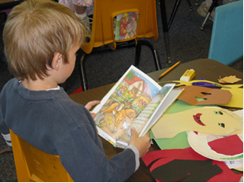
Elevator Speech: “Rotary is a worldwide organization of volunteers who strive to make our communities and the world a better place to live. We meet weekly to plan service projects, discuss community and international needs, and enjoy fellowship.
In our community, we’ve cleaned up our river, painted the gazebo, hosted dinners for seniors, placed flags along Main St, and provided personalized story books for first graders.
Personalized Story Books for 1st Graders

We also sponsor a high school student for a school year in a foreign country and host an inbound student from another country. In the past ten years we’ve awarded over $100,000 in scholarships to our high school seniors. Internationally we’ve provided hurricane and tsunami relief, subsidized a micro-credit program in Ecuador, supported a clean water project in Ghana, and travelled to India to give children the Polio vaccine. PolioPlus is Rotary’s flagship program. By the time polio is eradicated, Rotary club members will have contributed countless volunteer hours to immunize more than two billion children in 122 countries.
Rotary is the only charitable (service) organization, in the world, to have a seat at the United Nations. Our motto is “Service above Self .”

If your club has a Web site or Facebook page, make sure it is kept current.

Inform
Informing is more in-depth than advertising. Inform prospective members of your club's service efforts, especially ‘hands-on’ volunteer efforts in your community. Develop a list showing where your club has donated money over the past ten years and the money raising activities involved over this same ten year period and provide it to potential members.

Bring to Meeting
Invite a potential member to your club’s breakfast, lunch, or dinner meeting so that he/she may get a flavor of how your club operates. This initial invitation should be low-key with little, or no, mention about the possibility of joining. Subsequent meetings may be used for this purpose. And as mentioned in Appendix 4., it is important for the current member to go out of his/her way on these invitations. Don’t say “I’ll meet you at noon at the Moose Track Inn.” Say “I’ll pick you up at your house (or office) and bring you to the meeting.” Your club should pick up the tab for this person’s first and second meal.

Other Recruitment Options
A number of clubs in the district have used successful recruitment methods such as: 1) Writing letters to potential candidates; 2) A club president, the membership chair, or other dedicated Rotarian making weekly visits to local businesses to discuss advantages of joining Rotary.

District Programs for Increasing Membership

At Appendix 6, you’ll find three plans designed to help alleviate three problem areas within Rotary: 1.) Lack of diversity; 2.) Difficulty in recruiting younger professionals; and 3.) Cost of membership. It proposes three alternative membership plans to address these three problem areas.

The Family Membership plan encourages spouses/partners (or any family member) of Rotarians who otherwise would qualify for membership, to join Rotary by offering the incentive of reduced dues payments. Currently, there is a much higher ratio of males to females in Rotary, therefore by bringing in the spouses/partners of current members the female ratio should, of necessity, rise over time. The Rotary International Council on Legislation (2013) has created a new membership category which will admit to membership spouses who have not worked or who have stayed at home to care for children or assist their spouses in their work

The Young Leaders plan encourages professionals 35 years of age or younger to join Rotary by also offering the incentive of reduced dues payments. Professionals who qualify for this plan are encouraged to bring in another member to Rotary within 12 months to retain their status as Young Leaders.

The Corporate Plan allows Rotary clubs to involve a corporation — or any
business, nonprofit, or government entity — in Rotary by offering an alternative
membership package to some of its employees.
The club has wide latitude on how they want to set up the program. There has to be one primary member and the other members are designated as alternates. Depending on the model used, clubs may charge corporate members the same club dues as their traditional members.
See Appendix 6. For details. .

Other Options:
- Ask members to consider recruiting their spouses, and offer an incentive for joining (such two free coffee mugs with your club’s name.)
- Hold a lunch for community leaders. Ask each member to invite a specific number of leaders. Show the brief Welcome to Rotary video or a segment from RVM (The Rotarian Video Magazine), and bring in a dynamic Rotary leader as a speaker.
- Print wallet-size cards with your name and the Rotary emblem, along with the words “Be My Guest” and the day, time, and location of your club’s meetings.
- Obtain space in a prominent shop window to display information about the club’s activities in the community.
- Give gift subscriptions of The Rotarian to potential members.
- Give a gift subscription of The Rotarian to your local school and public libraries.
- Send a welcome letter to the owners of new businesses in your community.
- At each meeting, collect business cards from guests and speakers, and follow up with a note or postcard thanking them and inviting them back for a free meal.

See Appendix 7. For 100 other ideas to recruit new members.
Rotarians Building a Dam in Chahalka, India

Induction of new members:
Your club should induct new members in a dignified and meaningful manner. Use the induction ceremony as an opportunity to underscore the benefits and responsibilities of being a Rotarian. A new member should be provided with the following items:
- Rotary lapel pin
- Copy of the club bulletin/newsletter
- Latest District Governor’s monthly letter
- List of local clubs for make-up meetings
- Name badge
- A history of the club
Optional
- A club banner
- Membership identification card
- Copy of THE ROTARIAN or your regional Rotary magazine
- District directory

Examples of possible induction ceremonies are listed in Appendix 8.

Invite family members to attend if possible. During the ceremony, allow new members to give a five-minute talk about themselves, their businesses and/or interests and their families. You should make the induction ceremony special. It should imprint on the new member an enthusiasm for membership.

Welcome to Rotary by the District Governor: Once a month, clubs may submit the names and home address’ of new members to the District Governor. The District Governor will then mail a personal welcome letter to each new Rotarian telling them about the advantages of being a Rotarian and encouraging them to become involved in their club and district activities.

The Paul Harris One And Done
Grow your Club’s membership and have fun doing it.
Similar to the beginning of Rotary, when Paul Harris and three other Rotarians had the great insight to grow the world's most successful service organization, introducing the Paul Harris One and Done. Led by the Club Presidents, Clubs form teams of 4 Rotarians with their goal to develop 1 new Rotarian during the year. As soon as the team inducts their new Rotarian, they can disband. If all teams perform, the growth potential for the year is 25%. This is an opportunity for Presidents and Clubs to have a fun, simple, measurable, achievable, and controllable way to insure that membership will grow under their leadership.
“WHY JOIN ROTARY?”

1. Friendship: In an increasingly complex world, Rotary provides one of the most basic human needs: The need for friendship and fellowship. It is one of two reasons why Rotary began in 1905.

2. Business Development: The second original reason for Rotary’s beginning is business development. Everyone needs to network. Rotary consists of a cross section of every business community and profession. Its members come from all walks of life. Rotarians help each other and collectively help others.

3. Personal Growth and Development: Membership in Rotary continues one’s growth and education in human relations and personal development.

4. Leadership Development: Rotary is an organization of leaders and successful people. Serving in Rotary positions is like college education. Leadership: Learning how to motivate, influence, and lead people.

5. Citizenship in the Community: Membership in a Rotary Club makes one a better community citizen. The average Rotary Club consists of the most active citizens of any community.

6. Continuing Education: Rotary has programs designed to keep one informed about what is going on in the community, nation, and world. Each meeting provides an opportunity to listen to different speakers or enjoy other programs.

7. Fun: Rotary is fun, a lot of fun. Each meeting is fun. The Club projects are fun. Social activities are fun. The service is fun.

8. Public Speaking Skills: Many individuals who joined Rotary were afraid to speak in public. Rotary develops confidence and skill in public communication and the opportunity to practice and perfect these skills.

9. Citizenship in the World: Every Rotarian wears a pin that says “Rotary International.” There are few places on the globe that do not have a Rotary Club. Every Rotarian is welcome – even encouraged – to attend any of the 35,000 Clubs in 200 nations and geographical regions. This means instant friends in both one’s own community and in the world community.

10. Assistance when Traveling: Because there are Rotary Clubs everywhere, many a Rotarian in need of a doctor, lawyer, hotel, dentist, advice, etc., while traveling has found assistance through Rotary.

11. Entertainment: Every Rotary Club and District has parties and activities that provide diversion in one’s business life. Rotary holds Conferences, Conventions, and Assemblies that provide entertainment in addition to Rotary information, education, and service.

12. The Development of Social Skills: Every week and at various events and functions, Rotary develops one’s personality, social skills, and people skills. Rotary is for people who like people.

13. Family Programs: Rotary provides one of the world’s largest youth exchange programs; high school and college clubs for future Rotarians; opportunities for spouse involvement; and a host of activities designed to help family members in growth and the development of family values.

14. Vocational Skills: Every Rotarian is expected to take part in the growth and development of his or her own profession or vocation; to serve on Committees and to teach youth about one’s job or vocation. Rotary helps to make one a better doctor, lawyer, teacher, etc.

15. The Development of Ethics: Rotarians practice a 4-Way Test that governs one’s ethical standards. Rotarians are expected to be ethical in business and personal relationships.

16. Cultural Awareness: Around the world, practically every religion, country, culture, race, creed, political persuasion, language, color, and ethnic identity is found in Rotary. It is a cross section of the world’s most prominent citizens from every background. Rotarians become aware of their cultures and learn to love and work with people everywhere. They become better citizens of their countries in the process.

17. Prestige: Rotary members are prominent people: Leaders of business, the professions, art, government, sports, military, religion, and all disciplines. Rotary is the oldest and most prestigious service club in the world. Its ranks include executives, managers, professionals – people who make decisions and influence policy.

18. Nice People: Rotarians above all are nice people – the nicest people on the face of the earth. They are important people who follow the policy of it is nice to be important but it is important to be nice.

19. The Absence of an “Official Creed”: Rotary has no secret handshake, no secret policy, no official creed, no secret meeting or rituals. It is an open society of men and women who simply believe in helping others.

20. The Opportunity to Serve: Rotary is a service club. Its business is mankind. Its product is service. Rotarians provide community service to both local and international communities. This is perhaps the best reason for becoming a Rotarian: The chance to do something for somebody else and to sense the self-fulfillment that it brings.

OTHER TIPS FROM SUCCESSFUL CLUBS:

1. Community Projects …A successful project attracts new members. Encourage Club members to invite their friends to participate in a worthwhile community project.

2. Classifications …The Rotary Club of Trenton, Ontario, Canada, reads a list of unfilled classifications at each meeting. This regular reminder helps Club members consider potential members during their daily interaction with a wide variety of people. The Rotary Club of Trenton gained 20 new members through this strategy.

3. Randolph Sunrise Rotary: This club in our District was recently notified by Rotary international that they were among the top 5% of all clubs in North America for membership growth. Here’s how they achieved their success.

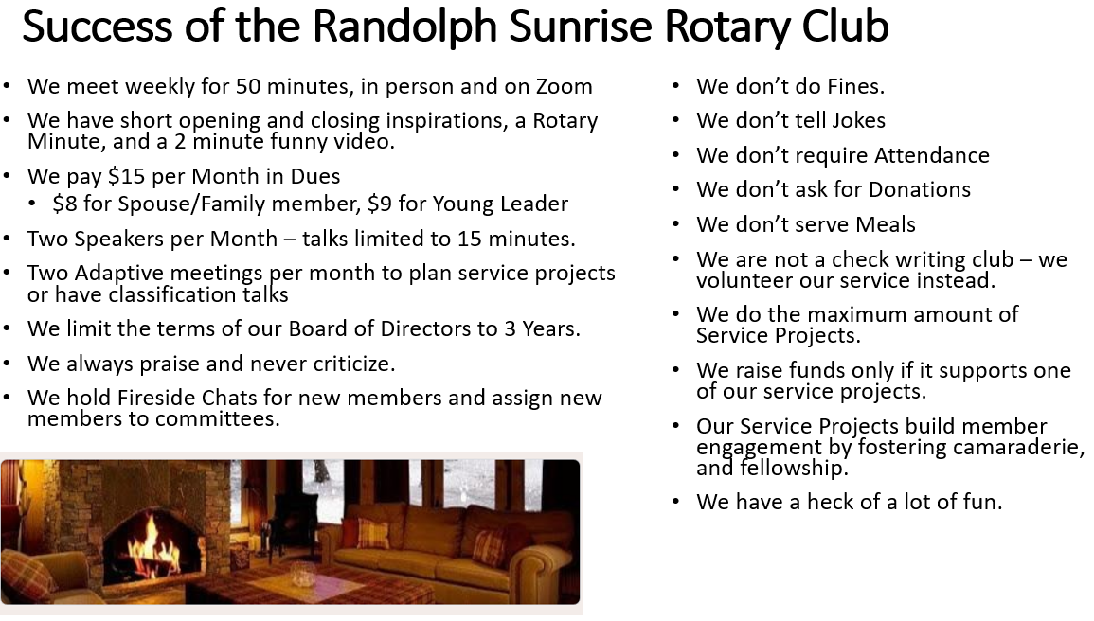

3. Club Extension:

New Club Development:

New club development can be an effective and critical tool in achieving increased diversity, as new clubs can be developed to be relevant to a specific target audience, and they are not challenged with the historical cultures current clubs maintain.

The District’s Club Extension committee’s responsibility is to identify areas within the district that are appropriate for the development of new clubs as well as assisting in the development of these clubs.

Potential new club opportunities:

1. Alternative meeting times and formats, such as no mandatory meal and associated costs. This has already been initiated with “New Generation” clubs, to great success.

2. Weekend Clubs: These clubs can meet on weekends, at times that provide fewer conflicts with other commitments these members have developed in areas where many potential Rotarians commute to larger cities for their work. A weekend club allows these potential members to make an impact in their own communities.

3. Clubs targeted at younger members.

4. E-Clubs: Rotary e-clubs are Rotary clubs that meet electronically. Rotary e-clubs follow the same policies as all Rotary clubs. The key difference is that an e-club conducts
its weekly meeting on the club’s website. Rather than being physically present at an appointed day and time, members may attend meetings at any time and any day of the week.

5. Hybrid-Clubs: Hybrid clubs came into fashion during the Covid-19 pandemic, when members met either in-person or electronically through social media applications such as Zoom. The advantages of Hybrid clubs are that they allow members to attend when they are on travel or when work conditions prevent in-person attendance. They can also bring in the District Governor or other District Leaders for short talks or discussions. And if you are looking for outstanding speakers, one club in our District brought in the Rotary International President, a Rotary International Vice President, and the soon-to-be first woman president of Rotary International.

6. EarlyAct, Interact and Rotaract Clubs. Call on your New Generations District Officer for help in forming these clubs. EarlyAct is for Elementary School Children, Interact is for High School students and Rotaract clubs are either Community based or College based for members up to the age of 35.

7. Provisional Clubs: This requires an “Organization of New Club Survey” signed by the district governor and submitted to Rotary International. Potential charter members are recruited for the new Rotary club and the district governor appoints a special representative to work with the charter group in organizing the club. The new club may or may not have a sponsor club, but a sponsor club is highly recommended. Once the club has 20 or more members they can apply for a charter from Rotary International.
For complete detailed instructions refer to Rotary International publication 808en “Organizing New Clubs”

8. Satellite Clubs: You can start a satellite club with just eight people with the sponsorship of an established club. Satellite clubs meet at different times, have their own bylaws and club culture, and their own club leaders. They function as a short-term transitional step on the way to becoming a fully, independent Rotary club.
4. Public Relations for Membership Development
It has been shown that an aggressive and pro-active Public Relations program can be one of the most important tools for recruiting new members. Here are some Public Relations action items:

Develop a Rotary Web site and/or Facebook Page and encourage community organizations to link to it, The Internet is a powerful tool for sharing your club and district activities. Your club should develop your own Web/Facebook page to help attract and retain members, improve communications with clubs across the globe, and make club project information available to your members and local media.

Solicit third-party endorsements of club or district projects. It’s important for Rotarians to share the good work of Rotary. But having others talk about your good deeds is even more credible and more impressive. Organizations that your club or district has worked with are excellent sources for a third-party endorsement. You should endeavor to ask executive directors of organizations and community leaders to speak favorably of Rotary at events, in organizational publications, and through the media.

Ask the beneficiaries of Rotary service to speak on behalf of your club or district.
No testimony is more powerful than that of an organization, family or a person who has benefited from Rotary’s work. For example, at a press conference talk about your donations to the Boys & Girls Club and what this has meant to that organization. Have the director or one of the children speak instead of a Rotary official. Most television viewers and newspaper readers will be more moved by such personal testimony.

Publicize member participation in club and district activities in business and trade periodicals. Rotary members spend a lot of time volunteering. Have their work recognized among their professional peers by sending a press release to various professional publications. For example, for a member who is a hospital professional, you might publicize the member’s volunteer work after a hurricane or the fight against Covid-19.

Produce a video of club and district activity. A compelling video depicting hands-on activities is a good way to tell the Rotary story. Many of your club members may have the necessary equipment and knowledge to produce a video, and editing can often be donated. The video could be used as part of a display or sent to organizations and interested members of the media. A shorter version could be submitted for consideration as a public service announcement. The video could also be used for district conferences and other Rotary events or as a short clip on your Web site.

Promote Rotary’s work with and for young people. The media is often interested in programs relating to young people and have a particular interest in projects carried out by young people. Promoting their activities to the media is a good way of updating Rotary’s image.

Seek opportunities for Rotarians to speak at community events and in schools
Visibility is an important prerequisite to membership recruitment. Be aggressive in identifying opportunities for Rotarians to speak at community events. Your club members are capable of providing valuable commentary on any number of community issues. Be proactive! Don’t wait to be invited. Organizers will be glad that you called.

Cite Rotary’s International Presence: Rotary's aims are to promote world peace, end

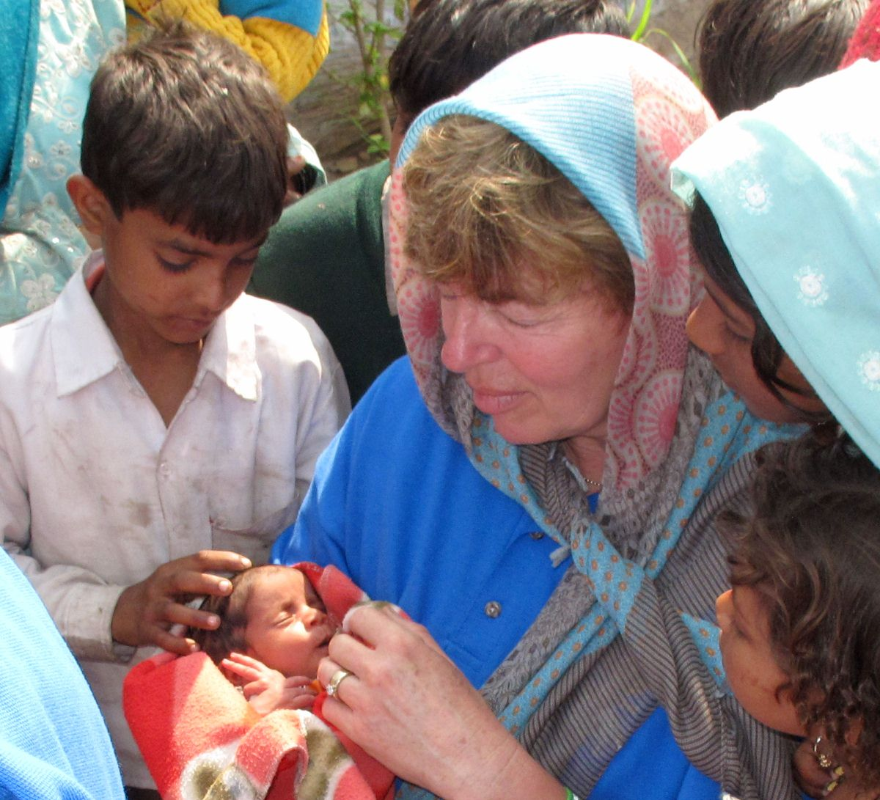

Polio, provide clean water, alleviate hunger, reduce poverty and child mortality, and to help sustain higher living standards. Grand aims you may say, but with 1.2 million members, a seat at the United Nations and a truly apolitical and non-religious approach to all that we do, we can talk to the world's governments and be trusted, respected and encouraged.

Rotary is the only charitable (service) organization, in the world, to have a seat at the United Nations.

Rotary International PR Assets

1. RI provides a host of resources to help districts and their clubs promote Rotary in their communities through the PR section of the RI website . It also offers support to newcomers to the world of public relations with tips on PR writing and how to best work with the media. Districts should also encourage members to subscribe to RI’s e-newsletter Rotary PR Tips , which contains free content for Rotary leaders on best practices to promote Rotary in their communities. Here’s a very comprehensive manual on how to implement your Public Relations program: https://clubrunner.blob.core.windows.net/00000050042/en-ca/files/homepage/rotary-pr-manual/226c_en.pdf

2. Visit Rotary’s Media Center to view and download multimedia content including broadcast quality video, high resolution print images, radio-ready announcements, and a link to Rotary’s social media accounts. Share the link to the media center www.rotary.org/mediacenter with other district leaders, PR committee members, and the local media.

3. Public relations grants - Public relations grants help districts promote Rotary to the general public and enhance Rotary’s public image, part of the RI Strategic Plan. RI has awarded $Millions in PR grants. Grants are awarded to districts on a competitive basis. Our District was awarded its second PR grant in 2012-2013 in the amount of $9000 for only a $2000 District contribution.


Rotaractors helping to build a dam in India

Appendix 1: Club Member Survey

Member Survey
This is a survey to be completed by all members. By completing this survey we hope to find out what changes may be made in our club operations to improve the value and satisfaction of being a Rotarian. You may choose to remain anonymous if you so desire. Please return the questionnaire within 7 days.
Thank you for your support.

- Do you enjoy fun and fellowship during our club meetings? Yes or No ________
If No, please explain.

- What ideas do you have to increase social activities and friendship among members in the club?

- Does our club have good programs (speakers or performers)? Yes or No ______
If No, please explain.

- Name something you would like to see more of in our club.

- What would you change in our club to make it better?

- What is the main reason you sometimes do not attend our meetings?

- Do you enjoy working on service projects? Yes or No ________
If No, please explain.

- What suggestions do you have for improving the club’s community projects?

- Do you feel welcome when you attend meetings? Yes or No ________
If No, please explain.

- Is the benefit of your membership in this club worth the time and money you have invested in the club? Yes or No ________
If No, please explain.

- Have you ever gone to a district event? Yes or No ________ If No, please explain.

- Additional comments:
Appendix 2. Format for Classification Talk

Talk from podium (10 Minutes max)
Introduce yourself and give your classification e.g., Banker, Homemaker, etc.
Place of birth, where you grew up and meaningful memories about growing up

Education,

Current or former Employment/Profession

Work history, how did you get to where you are today?
Parts of your job you find most rewarding and most difficult.
Advice you would give persons entering your career field.
What have you learned about work relationships and life
in general, during the course of your employment history?

What has been your real passion in life?

What life changing experience(s) brought you to where you are today?

What attracted you to Rotary service?

What would you like to accomplish in Rotary?

Hobbies / Travel to other countries

Ask for questions

Appendix 3: The Spokes Program



Representing the six spokes of the Rotary wheel, new Rotarians are asked to accomplish the following six goals during their first six months of membership.

1. Give your classification talk within the first 8 weeks of joining the club.
- Gives members an opportunity to learn about your career, about your business or organization, and whatever you’d like to share about yourself.

2. Be the greeter - checking in members at meetings for at least six meetings in your first six months of membership.
- Gives you a chance to become acquainted with members, learning their names and bringing a smile to their day.

3. Collect the fines/happy dollars for at least 6 meetings in your first 4 months.
- The goal is participation; to stand up, join in the fun…… and somebody has to do it. You can volunteer for this at any meeting.

4. Attend a fireside chat in the first 4 weeks of becoming a member.
- This is an important first step in becoming a Rotarian. Learn the ABCs of Rotary, discover the opportunities our club provides you with, and ask questions, becoming knowledgeable and comfortable about our meetings, events, structure, and traditions.

5. Work on at least one major Rotary event.
- Being a Rotarian is all about being an individual who brings his/her talents and energy to a team, where you can make a difference in our community and around the world.

6. Sponsor a new member.
- You are in a unique position to bring in a new member through your circle of connections. Building membership is vital to a strong and vibrant club, striving for a diversity that unites our community and expands our horizons.
Appendix 4: Bring a Guest to Meeting Program

Potential New Members and Assignments for Current Members

Develop a spreadsheet to list all of your potential new members. Then each month the membership committee chair should send out an Email to two of their members, two months in advance, with the following request:

Dear David
As part of our membership drive, we ask you to bring a guest to meeting sometime during the month of _____________. You may choose anyone you would consider to be a good potential Rotarian. If you have difficulty finding someone you may choose anyone from the list of potential new members from the spreadsheet attached to this Email. Please make contact by phone and if they accept your invitation, offer to pick them up and bring them to our meeting. If you call someone and they either accept or decline your invitation, please call me so we may keep the list of potential members updated.

Let me know the date you will be bringing your guest to our meeting and I will prepare a package of information about Rotary that you may hand out to them.

Thanks for all you do for Rotary

Jack Smith
Membership Committee Chair
802-728-4665

Continue sending out Emails like these to your club members two months in advance. Depending on club size, you may choose to appoint more than two members per month.

Appendix 5: Bragging About Your Club.

Rotary Club of Pigeon Cove
(an example for your web site or Facebook home page. Put photos in to draw attention.)

What IS Rotary? “Rotary is a worldwide organization of volunteers who strive to make our communities and the world a better place to live. We meet weekly to plan service projects, discuss community and international issues, and enjoy fellowship.
The Rotary Club of Pigeon Cove has been active since 1924 and still going strong! The odds are that it will move forward with the times, changing and growing to reflect the needs of the local community it represents and supports.
In our community, we’ve cleaned up our river, painted the gazebo and the food shelf building, hosted dinners for seniors, placed flags along Main St, and provided personalized story books for first graders. We also address today’s challenges — including illiteracy, disease, hunger, poverty, and lack of clean water. Internationally we’ve provided hurricane and tsunami relief, subsidized a micro-credit program in Ecuador, supported a clean water project in Ghana, and travelled to India to give children the Polio vaccine. PolioPlus is Rotary’s flagship program. By the time polio is eradicated, Rotary club members all over the world will have contributed Millions of dollars and countless volunteer hours to immunize more than two billion children in 122 countries.
Rotary helps more than 1,000 students annually to study abroad and serve as cultural ambassadors. Rotary also partners with seven prestigious universities around the world, providing opportunities to earn a master’s degree in peace and conflict resolution. Rotary is the only charitable (service) organization, in the world, to have a seat at the United Nations. Our motto is Service above Self .”
Youth activities have always been at the forefront of Pigeon Cove’s initiatives, both local and international. The International Youth Exchange Program sponsors a High School student for a school year in a foreign country and hosts an inbound student from another country. In addition to the 2-year and 4-year Scholarships awarded to High School Seniors, Pigeon Cove Rotarians also sponsor the High School Speech Contest, and sends students to attend the Rotary Youth Leadership Awards (RYLA) program.
We welcome new members and look forward to continue our "Service above Self" support of the Pigeon Cove community as well as the larger community around us by sending aid and materials to support, for example; New Orleans and Gulf Coast Hurricane relief; Tsunami aid for Japan; the Zienzele Foundation in Africa to support child headed households; helping to subsidize a new micro credit program in San Cristobal, Ecuador; shipping books to San Juan, Argentina for a new Children's English Library; and contributing to District 7850’s International Water Project in Ghana.
Money has been raised through sponsorships of our website as well as tried and true events such as the Scholarship Dinner, Golf Tournament, Memorial Day Downtown Chicken BBQ, Annual Fruit sale, and an exciting Pigeon Cove Rotary Fine Arts Auction co-sponsored by Pigeon Cove’s High School, Interact club.
At the heart of each Rotary club's yearlong work is the support it offers its local community. In Pigeon Cove this has included sponsoring new Welcome Signs and otherwise beautifying our town by providing and placing flags in the downtown area, and helping to put up flower baskets along Main Street. For many years we’ve provided gave personalized story books to 1^{std} graders. Last but not least is Merry Mulch, a fun and productive community service project where we grind up old Christmas trees to produce mulch.
But for all these efforts, sometimes nothing helps like cash - and Pigeon Cove Rotary has in the past year donated significant funding to more than twenty local service providers. The areas they cover include; sports, safety, education, youth, seniors, gardens, cultural arts, mental health, and robotics - to name just a few!
Appendix 6: Family Membership, Young Leaders and Corporate Plans

General

These plans are designed to help alleviate three problem areas within Rotary: 1.) Lack of diversity; 2.) Difficulty in recruiting younger professionals; and 3.) Cost of membership.

The Family Membership plan encourages spouses/partners (or any family member) of Rotarians who otherwise would qualify for membership, to join Rotary by offering the incentive of reduced dues payments. Currently, there is a much higher ratio of males to females in Rotary, therefore by bringing in the spouses/partners of current members the female ratio should, of necessity, rise over time. The Rotary International Council on Legislation (2013) created a new membership category which will admit to membership spouses who have not worked or who have stayed at home to care for children or assist their spouses in their work.

The Young Leaders plan encourages professionals 35 years of age or younger to join Rotary by also offering the incentive of reduced dues payments. Professionals who qualify for this plan will be encouraged to bring in another member to Rotary within 12 months after receiving their status as Young Leader.

Every six months our District will provide monetary awards to those clubs who have Young Family Members and Young Leaders enrolled as Rotarians. For a club to qualify for one or both of these plans, the club must publish a document describing their plan(s) and include the following program details, as illustrated in the following examples from one of our District Clubs already engaged in both programs. The reduction in dues should be approximately 50% of the standard dues for regular members.

Section I – Family Plan Membership

- Definitions:

Primary member: A Primary Member is a fully qualified Rotarian. Each Family Plan household must have one Rotarian designated as the primary member

Family member: A Family Member is a fully qualified Rotarian who meets, or will meet, all membership requirements for his/her club, and resides in the same household of at least one Primary Member. In District 7850 a Family Member may belong to a different club from that of the Primary Member.

B. Program details: If ALL the following apply, the potential Family Member will qualify for the program:

  - The Primary Member will pay the standard member dues of $15.00 per month.
  - The Family Member will pay $8.00/month (a savings of 46%)
  - Because the Family Member plan is a tool to increase membership once a Family Plan unit is established, that unit is strongly encouraged to bring in one new member within 12 months after attaining Family Member status.
  - Family Members will be reported to Rotary International as active members.
  - Each year, in January and July, the club President will report to the District Secretary and Treasurer BOTH the total number of active members in their clubs and also the number of qualifying Family Members (not Primary Members) within that total.
C.Awards: Each year, in February and August, the District will award each club $20 for all Family Members reported.

Section II – Young Leader Plan Membership
- Definition:
A Young Leader is a fully qualified potential Rotarian who will meet, all Club and Rotary International membership requirements, and is 35 years of age or younger.
B. Program details: If ALL the following apply, the potential Young Leader will qualify for the program:
- The Young Leader will pay dues of $9.00/month (a savings of 40%)
2. If two Young Leader members reside in the same household, both may qualify for the program
3. Because the Young Leader membership plan is a tool to both increase membership and increase leadership potential, once a Rotarian qualifies for Young Leader status, to retain that status, he/she shall be encouraged to bring in at least one new member within 12 months after attaining Young Leader status.
4. Young Leader members will be reported to Rotary International as active members.
5. Each year, in January and July, the club President will report to the District Secretary and Treasurer BOTH the total number of active members in their clubs and also the number of qualifying Young Leaders within that total.
C.Awards: Each year, in February and August, the District will award each club $20 for all Young Leaders reported.

Section III – Corporate Plan Membership
WHAT IS A CORPORATE MEMBERSHIP?
A corporate membership allows Rotary clubs to involve a corporation — or any
business, nonprofit, or government entity — in Rotary by offering an alternative
membership package to some of its employees. Having corporate members
increases the club’s membership while expanding its network and visibility in the
community. Members gain access to the fellowship and service opportunities of
Rotary.
The club has wide latitude on how they want to set up the program. There has to be one primary member and the other members are designated as alternates. Depending on the model used, clubs may charge corporate members the same club dues as their traditional members.

However you structure your club dues and fees, make sure you document it
in the club’s bylaws and that all members understand the dues structure. The club gets credit for all corporate members being active members, however attendance requirements can be lessened.

Although the club has wide latitude on how they want to set up the program it would probably be prudent to require attendance from at least one designee at each meeting.
Appendix 7: 100 IDEAS TO RECRUIT NEW MEMBERS

1. Simply ask

2. Bring a guest to meetings
3. Advertise in newspapers, radio, public access/cable TV
4. Have a membership strategic plan
5. Define membership committee members’ roles & responsibilities
6. Send letters to local businesses or visit in person
7. Give the membership chair one minute at every club meeting
8. Hold a club assembly only on membership
9. Print club business cards with meeting location and time
10. Put together guest information packets and distribute to any non-Rotarian visiting your club
11. Send letters to people featured in your local news with a formal invitation to visit the club
12. Invite family members to join
13. Ask Rotary Alumni to join/ e.g. former Youth Exchange, Group Study Exchange members.
14. Participate in service projects that serve a need in the community
15 Form a relationship with your local Chamber of Commerce
16. Wear your Rotary pin every day.
17. Place pamphlets promoting Rotary in doctors’ offices, hospitals, cafeterias, libraries, etc
18. Have your club go “On the Road” and hold meetings at other locations
19. Have a Rotary booth at malls, fairs, festivals etc.
20. Host an ‘Open House’
21. Distribute extra copies of the Rotary magazine in waiting rooms, etc
22. Hold high-profile meetings
23. Hold wine and cheese receptions for prospective members
24. Ask for help from Rotary Coordinators at Zone and International level.
25. Have a special guest day
26. Send club members to the district membership seminar/ to the Rotary Leadership Institute
27. Make guests feel welcome
28. Honor outstanding community members with Paul Harris Fellow awards.
29. Don’t wait for Rotaractors to reach age 30 before they are invited to join Rotary
30. Make some meetings social events
31. Keep your club website up to date
32. Use group email to promote Rotary
33. Put posters in public areas
34. Ask corporations and employers to sponsor or subsidize membership
35. Have a reward program for those who bring in new members
36. Create more fun and fellowship
37. Give a money back guarantee—if after 3 months a new member does not want to be a
Rotarian return their fees
38. Invite the media to cover recognized speakers
39. Use word of mouth
40. Network with co-workers, friends, and family
41. Follow up with guests
42. Place a colored dot on the watch of every member to remind them to bring a guest
43. Lead by example—how many members have you recruited?
44. Have members give talks at other organizations
45. Provide guests with free meals
46. Update your club’s classification survey – post missing classifications at club meetings
47. Look for members in ethnic groups not represented in your club
48. Provide brochures for new employee packets in members companies
49. Advertise at sports events
50. Ask the district for help
51. Hold joint meetings with non-Rotary groups
52. Share your Rotary experience with others
53. Participate in community events
54. Write letters to the newspaper about the polio campaign
55. If a prospect can’t attend your meeting due to time, suggest another club
56. Publicize club successes, elections, events, etc. in local newspapers
57. Circulate the club newsletter widely
58. Design a club brochure
59. Hold recruiting events with two or more clubs
60. Form/join a speakers’ bureau
61. Wear Rotary attire
62. Mention Rotary at meetings of other organizations during announcements
63. Send newsletter to guests
64. When asked about your leadership skills & career success, tell them about Rotary
65. Ask the AG/ District Chair to attend a board meeting to talk about membership
66. Ask every member to submit 3 prospects to the membership chair
67. Make it FUN
68. Give every member a Rotary decal or bumper stickers for their car
69. Give testimonials about Rotary while guests are at the meeting
70. Repeatedly invite prospective members
71. Practice selling Rotary at Club meetings—have a one minute elevator speech about Rotary
72. Conduct a Membership Satisfaction Survey (RI Publication #417)
73. The club president asks three club members as a personal favor to each recruit a new member
74. Bring your boss to a club meeting
75. Make direct contact with women’s business associations
76. Bring your co-workers to a club meeting
77. Bring your subordinates to a club meeting
78. Display a thermometer showing progress towards club’s membership goal
79. Use books, brochures, videos and posters from RI
80. Hand out Be My Guest cards for a “Free” lunch (breakfast, dinner)
81. Members should be constantly promoting and raving about Rotary
82. Meet at a good location
83. Assign every member to a 5 person recruitment team—each team brings in a new member every six months
84. Feature a Polio information night & contact community polio survivors & media
85. Have incentives for recruitment
86. Have a poster that lists all the members who have sponsored a new member in the past year
87. Select a missing classification and work on filling it
88. Have new member social once or twice a year
89. Feature a member’s “benefit of the month” in the club newsletter
90. Induct new members with pizazz and invite their spouse/partner
91. Develop a welcome letter from the president for all new members
92. Contact all members who have resigned in the past 3 years

93. Use billboards at bus stops and road signs
94. Ask Rotarians to put Rotary ads on their commercial trucks
95. Recognize new members in newsletters
96. Regularly check the RI web site for ideas
97. Subscribe to the Rotary Membership Minute on the RI web site
98. Invite spouses to social functions
99. Ask recipients of Rotary donations or sevice to promote Rotary
100. Pass out M & M candy to remind members that “Membership Matters” and that we need “More Members”
Appendix 8: New Member Induction Ceremonies

Although there is no prescribed ceremony for inducting new members, it is very important that becoming a Rotarian be marked with some formality. It is suggested that the family attends, as it is important for a Rotarian to have family support.

In addition to selecting the ceremony you wish to use you can mix parts of each to produce the ceremony that best represents your club’s culture or a particular situation.
.

I
Rotary is an international organization with 1.2 Million members in over 35,000 Rotary clubs located in more than 220 countries and geographical areas around the world. When one joins Rotary, he/she becomes a part of a worldwide fraternity. You can travel throughout most of the world and find a Rotary club within easy distance. Rotarians will welcome you warmly.

This is the Induction Ceremony for ______________________.
It is my privilege and honor to induct you as a member of the ________________ Club.
You are here this morning because you have shown your willingness to become a Rotarian. No one is eligible to become a Rotarian unless they endeavor to practice the principles of goodwill and service. You have been invited to join Rotary because we believe you are already endowed by these motives.

Through the Rotary community, you can exchange ideas and build lifelong friendships with like-minded people. You will be joining a global community of more than 1.2 million men and women, in more than 35,000 Rotary clubs worldwide. And no matter where you go in the world, you will always be welcome at any Rotary meeting, including any of our district’s 41 Rotary clubs in VT, NH, and Quebec.

We are proud to welcome you to our global community dedicated to building a better world. We all endeavor to make life better for people in our communities and hopefully step by step to someday create real peace in the world.

Feel free to take advantage of the resources and activities available through our club, our district, and Rotary International to make your experience with Rotary both rewarding and fun.

Lastly, but by no means least, is our ideal of friendship. As you expect to receive, so you should give. May you be stimulated by the friendship you find here, and may we in turn know you to be an added source of strength to our club.

Fellow Rotarians and friends, I present to you Rotarian ______________ I charge you not to fail in your duty by giving our new member your friendship and help to make his/her membership useful and meaningful.
_________________________ will give you your membership certificate and your pin with the Rotary Wheel - the emblem of our worldwide association. Wear it always with pride.

II (Short Version)
Fellow Rotarians, it is my privilege and pleasure today to welcome into membership in our club ____________, whose name was proposed by __________. The proposal has been reviewed in accordance with the constitution and bylaws of the club. I now ask __(sponsor)__ to come up here with __(proposed new member).

__________, we now proceed to admit you into membership in the Rotary Club of __________ and so to the fellowship of Rotary throughout the world. It has already been explained to you that the ideal of Rotary is service. Our principal motto is “Service Above Self” and the object of this club and all Rotary clubs is to encourage and foster this ideal as a basis of worthy enterprise. You are to share in this effort.

You have been approved for membership in this club because we believe you to be a worthy representative of your vocation, interested in the ideals of Rotary, and willing to do your share in translating these ideals into tangible realities.

Now I have the pleasure of asking your proposer to pin on the Rotary emblem, which we expect you to wear daily and with pride.

Welcome to the Rotary Club of ____________.

Fellow Rotarians, I am happy to present to you Rotarian ____________, our newest member.

