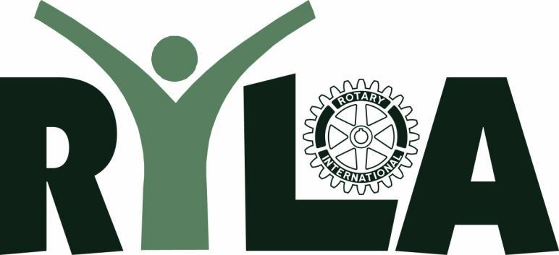

2024 Rotary Youth

Leadership Academy Conference
Rotary District 7850 - Northern NH, VT, & Quebec
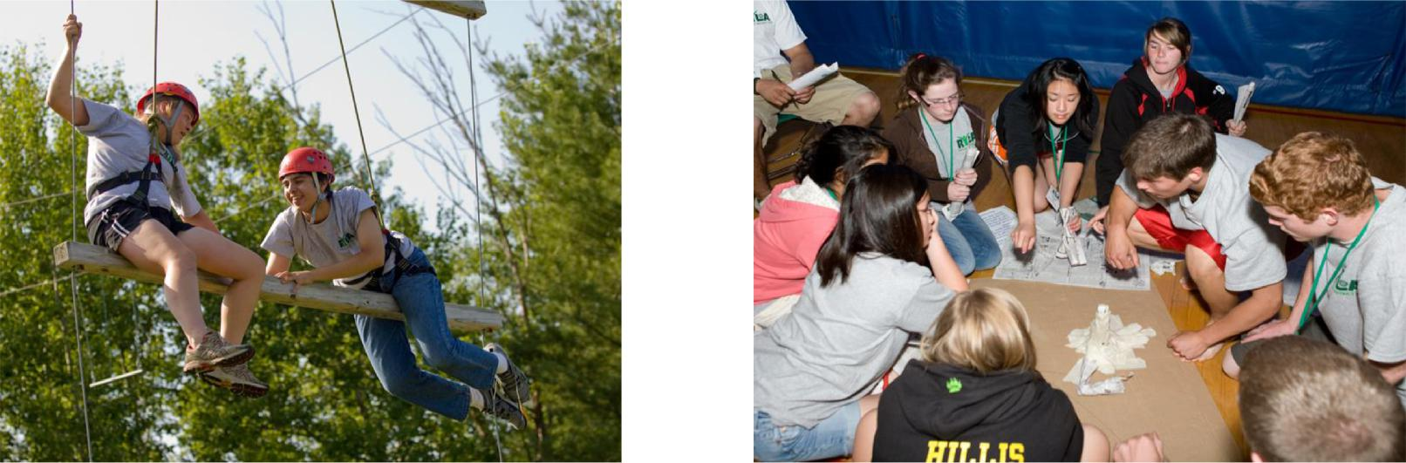

 | Challenge Yourself!
WHO: | Students completing sophomore year
WHEN: | 8:00 a.m. Friday morning, June 21, 2024 to
 | 1:00 p.m. Sunday afternoon, June 23, 2024
WHERE: | Northern Vermont University
 | Lyndonville, Vermont
TO APPLY: | Applications are accepted through your
 | local Rotary Club. To find the nearest club,
 | go to http://rotary7850.org/SitePage/ryla.
 | To learn more, click on the RYLA link under
 | the Youth Services tab!
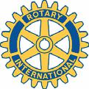
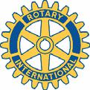

Contact:

