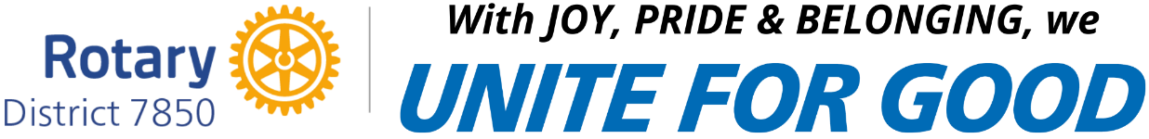

Recognition of Participation in
Club Round 1 Speech Contest

-Contestant’s Name here-

January 7, 2025______________________ ____________________
Rotary Club President Rotary Club Contest Chair

