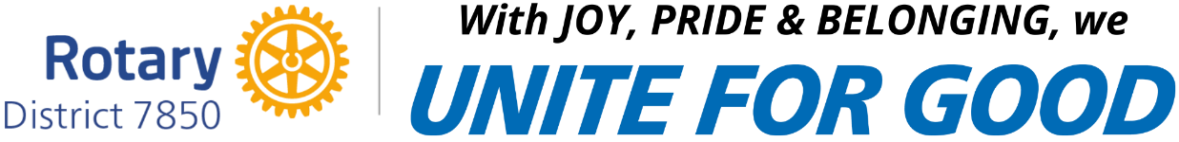

Club Round 1 Speech Contest
1st Place Winner - $200 Prize

-Contestant’s Name here-

January 7, 2025______________________ ____________________
Rotary Club President Rotary Club Contest Chair

