**The 2016 Rotary Mission Trips and Projects – By Chris Parkinson (Trip Leader)**

Over the last fifteen years, Rotary District 7870 (60 Rotary Clubs in Southern NH and Southern VT) have had 27 mission trips and provided aid to Honduras which is the second poorest country in the western hemisphere. Twenty (21) trips to Danli and Six (6) to San Pedro Sula.

Amigos De Honduras is a program of the Rotary District 7870 Foundation which is a non-profit corporation and two of the trustees of the foundation are Dr. Rich Berryman and Chris Parkinson.

Since 2001, Amigos De Honduras has concentrated its efforts in four areas:

* Medical Care - We have seen approximately 26,000 medical and dental patients.
* Medical Equipment and Supplies
  + Over 12 Tons of Medical Supplies Transported by Team Members
  + 7 – 40’ Containers of Medical Equip. & Supplies
  + 3 Ambulances shipped
* School Construction & Education – We have constructed 7 schools, expanded 3 schools, and converted 2 other buildings into schools. We have repaired and painted 18 schools, and have also worked on a youth center and a drug rehabilitation facility.  We have also provided school uniforms to over 300 students – which are required for children to attend school.

* Pure Water - Working with another 501c3 Rotary partner,

*Pure Water for the World*, we have installed or funded over 11,000 water filters which provide clean water to more than 55,000 people. We have also provided wells and latrines to several villages.

One of the founders and the soul of this effort was Mary Crooker, from Nashua, who had been on 23 of the mission trips. IN 2015, Mary unfortunately died of ALS and the Rotarians in Danli named a school in her honor. Mary’s spirit lives on in everything we do.

This year’s Mission team traveled to Danli, Honduras on January 30, 2016, and returned on February 7, 2016. The team of 18 people was led by Chris Parkinson; Dave Lawrence led the construction project which was the addition to the school that was built in 2015 in San Marcos Abajo; Jim Magennis led the Pure Water and Sanitation team to Trojes; Dr. Rory Richardson led the Medical Team; and, Dr. Jim Wright led the Dental team. As team leader, Chris Parkinson coordinated all activity of the team travel, the project scope, and coordinated with the Foundation Treasurer with respect to all financial activity.

**A full report of the 2016 Amigos De Honduras Projects follows:**

**San Marcos Abajo School**

A great deal was accomplished during the 8 days of the trip. Working with local Hondurans from the village of San Marcos Abajo which was about 8 kilometers outside of Danli. In 2014 we built a school for the village’s kindergarten which was to become “The Mary Crooker Escuela”. In 2015, we returned to San Marcos Abajo to build a second school for first and second grade. In 2016, we returned again to San Marcos Abajo to build an addition to the school that was built in 2015. As noted above, the project leader for the school was Dave Lawrence.

Because the overall team was only eighteen people, the construction team usually consisted of about five of our team. The Honduran “El Maestro” was Nelson and his assistant was Fernando. Together the “Magnificent Seven” did a remarkable job and nearly completed most of the block work during the 8 days of our trip. This was particularly remarkable in that five of us took two days and went to Trojes to help form the Water and Sanitation Team.

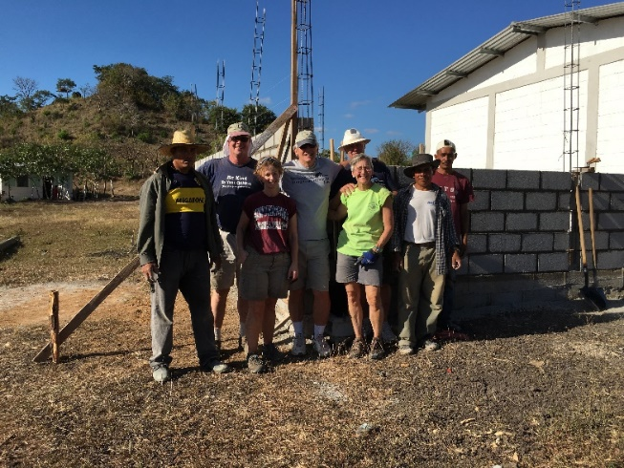 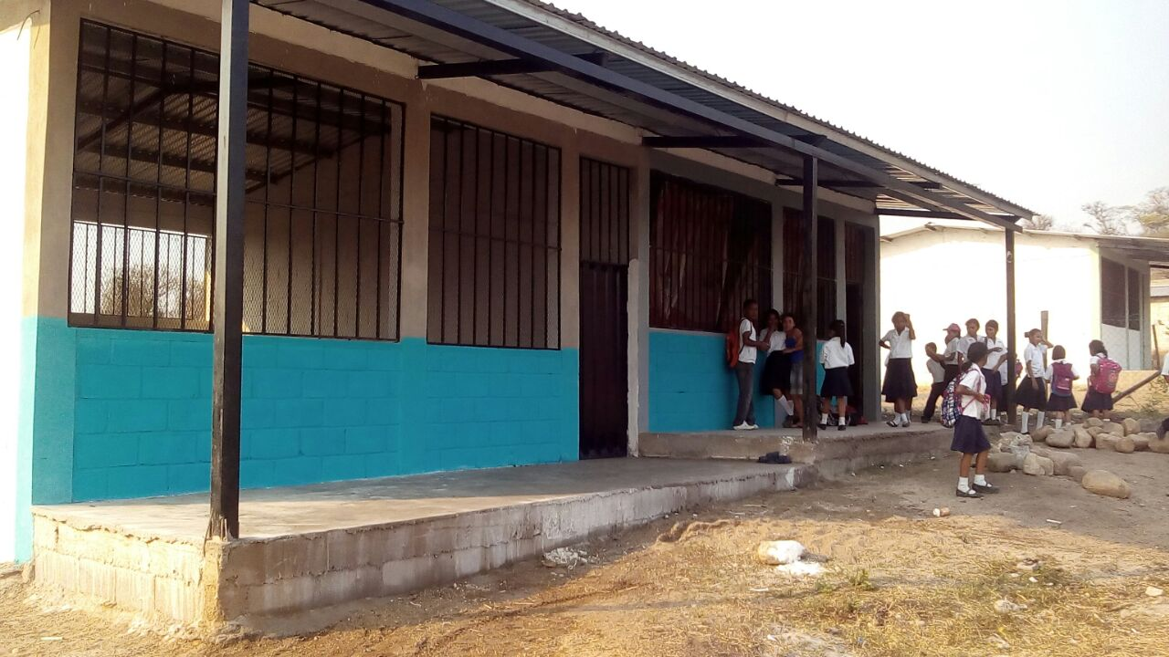

**A report from Dave Lawrence – Construct Team Leader:**

**The 2016 Amigos Construction project involved adding a third classroom onto the elementary school which is adjacent to the Mary Crooker School in San Marcos Abajo.  Although our crew was smaller this year, the neighborhood children and our local crew did a fabulous job.  Our work team was small and we also took a couple days off to travel to Trojes for a water project.**

**Overall, this trip was another great adventure and a worthwhile endeavor. We only had one close call when I almost fell off the scaffolding, but I was saved from my "dangling" position by several of the crew. Thank you and I am already looking forward to next year.**

**San Marcos Abajo School (Continued):**

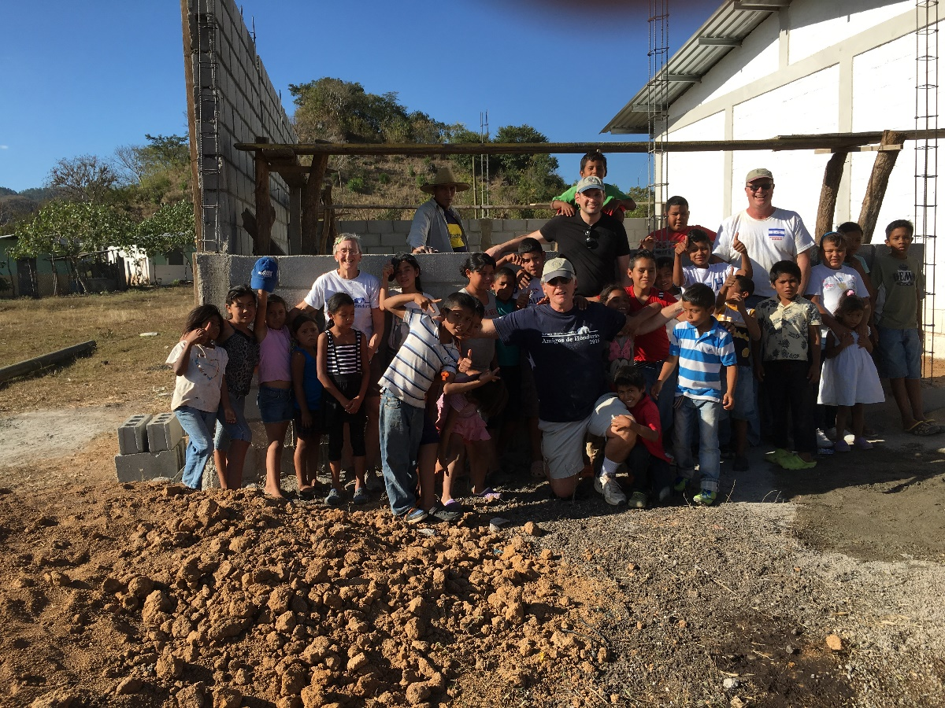

The 2016 School Addition in San Marcos Abajo at the end of our week’s efforts

**San Marcos Abajo - School Uniforms**

Once again Tosh Stickney of the team and her elementary school class were able to raise money for uniforms. The Danli Rotary Club identified a number of children that were not attending school due to not having a uniform and we were able to fund 25 children’s uniforms at $35 each (this also included shoes). These uniforms were presented to the students at a special ceremony at the school that was built in 2015 (And which we were building an addition to in 2016) at San Marcos Abajo.

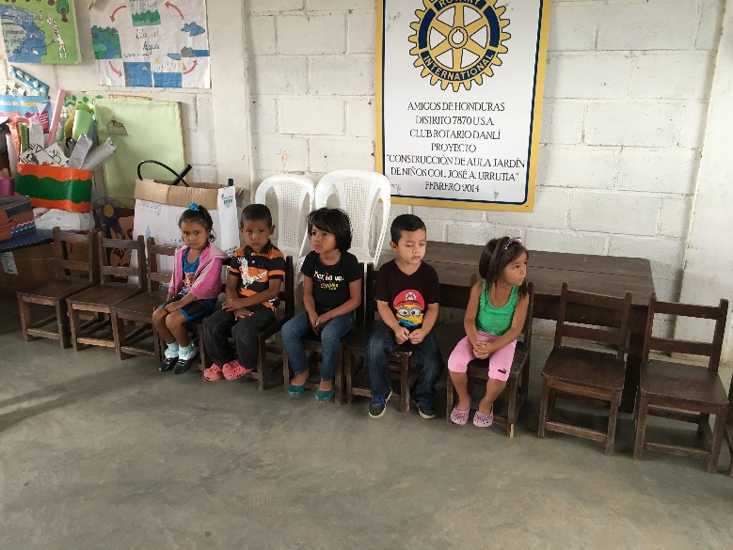 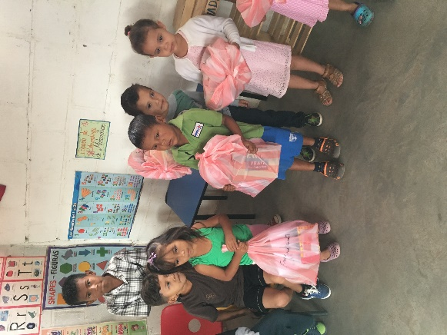

**The Medical and Dental Team**

Dr. Rory Richardson led the Medical Team; and, Dr. Jim Wright led the Dental team.

The teams had another great year.   Over 7 days, the team held clinics in El Pozo Bendito (354 patients and 48 dental patients), in El Paraiso  (155 patients and 37 dental patients), in San Diego (550 patients and 51 dental patients) in San Marcos Abajo (141 patients and 47 dental patients), in Camelias, (233 patients and 35 dental patients), in the Carbonera section of Danli (229 patients and 37 dental patients). Overall, the Medical Providers saw over 1660 patients and the Dentists saw over 250 patients (and pulled over 400 teeth).

Local Danli Rotarians, Danli Rotaractors including two physicians, and local physicians also were present every day to assist the team and help with the translations. Filled hundreds of prescriptions (not including handouts of vitamins, tylenol, and other OTC medications.

This year’s medical team included one Doctor, Rory Richardson from Hopkinton, NH, one Resident, Meagan Kingman of Pembroke, NH, two RNs, Judy Miller who is a Rotarian from Henniker, and Jenn Poland of Concord, one Medical Assistant, Brian Stimpson of Concord, and during the week Phil Currier of Boston, Shelly Proulx a Rotarian from Gilford NH, and Jim Magennis of Mashpee, MA, a former Rotarian of the Hollis-Brookline Club assisted the Medical team.

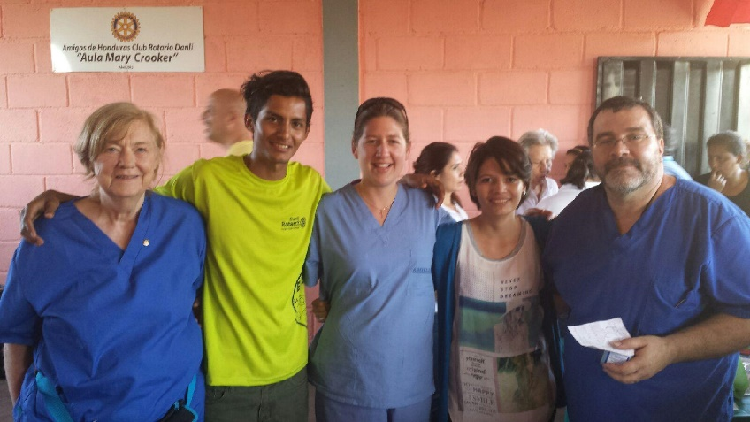 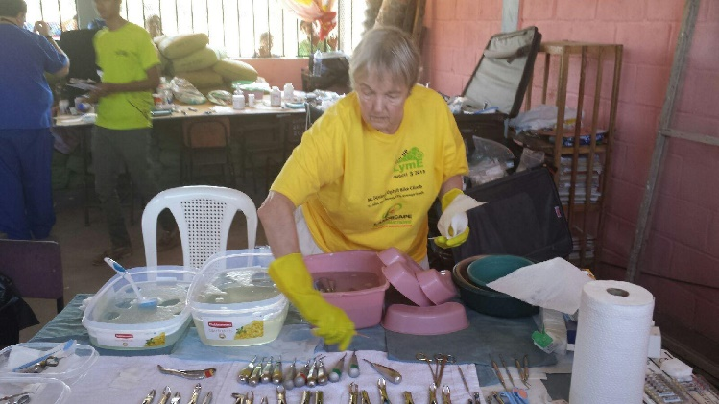

*Henniker’s Judy Miller, Jenn Poland, and Brian Stimpson Kathie Stone of the Manchester VT Rotary Club with 2 members of the Rotaract Team*

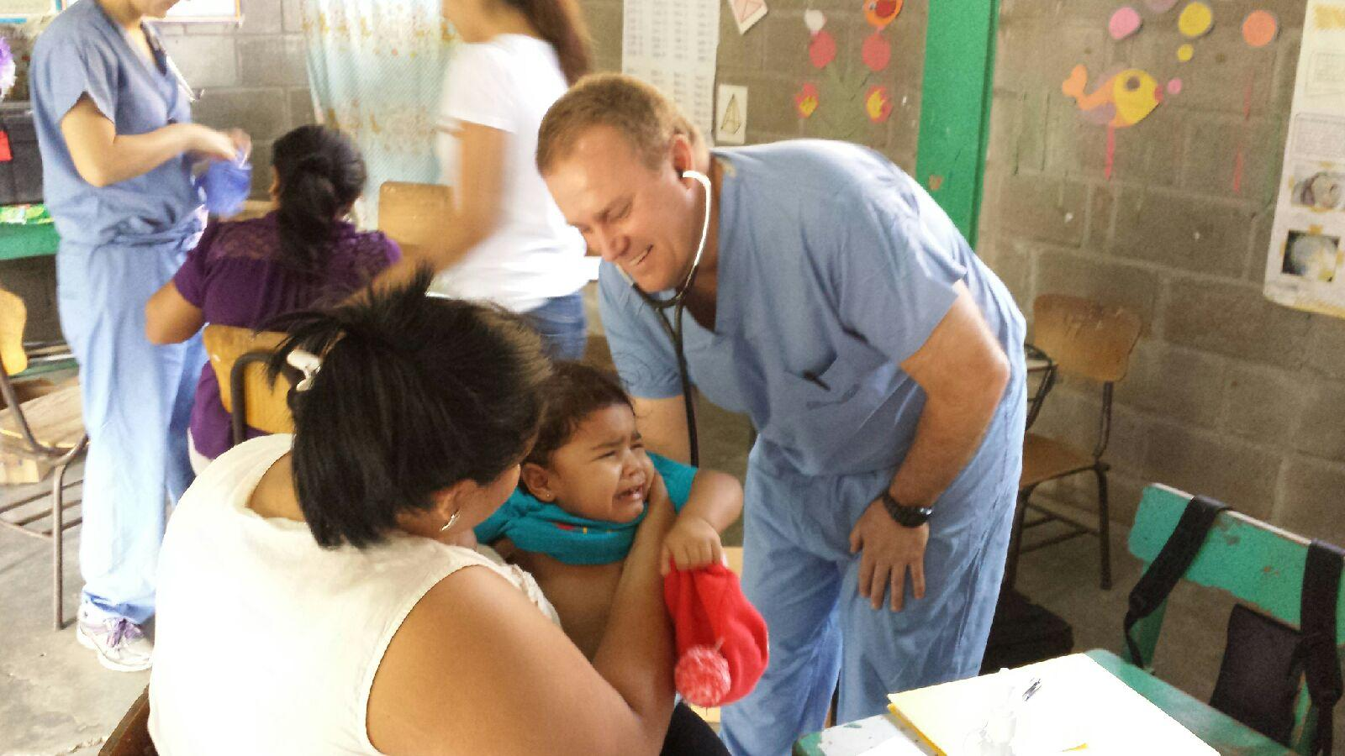 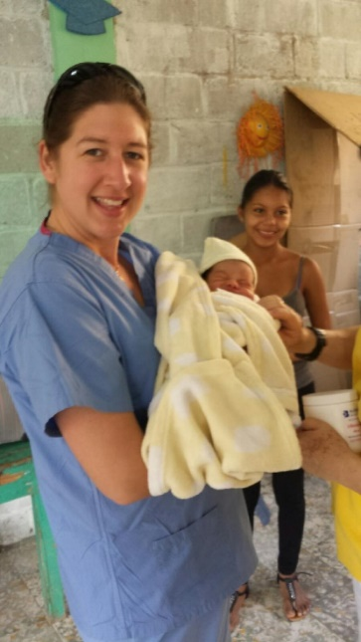

*Dr. Rory Richardson and Jenn Poland*

**The Medical and Dental Team (Continued)**

This year’s team included two dentists, Jim Wright from Fairhaven, VT, and Carl Feirrara from Bristol, Rhode Island, and they traveled to the same locations as the medical team. We also had two trained dental assistants, Esdras Almeida, from Fall River, and Deb Bergschneider, from Concord, NH. In addition, Kathie Stone of the Manchester, VT Rotary Club assisted. Over the 7 days, approximately 250 patients were seen and over 400 teeth were extracted.

The team also gave out over 200 tooth brushes and toothpaste that NE Delta Dental and others had provided.

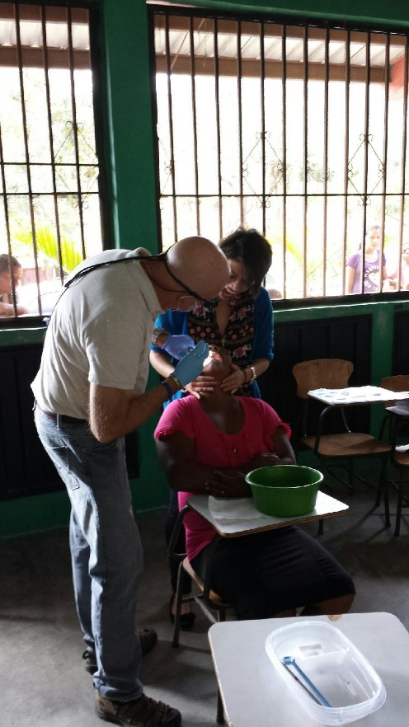 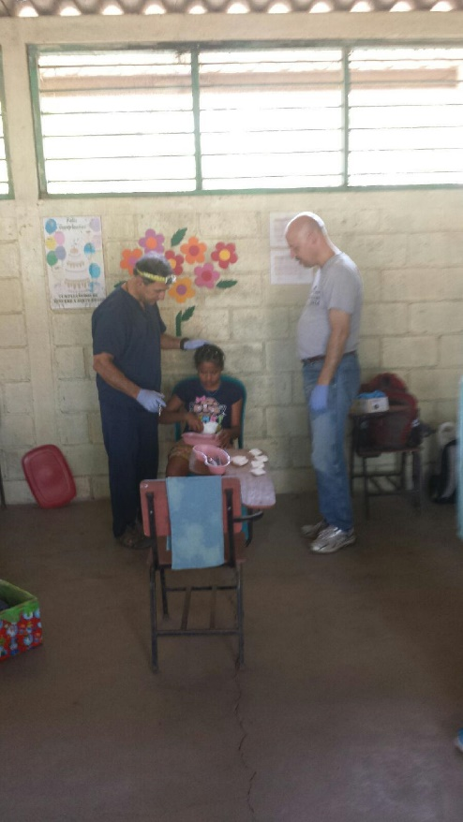

*Dentist Jim Wright From Fairhaven VT Dentist Carl Feirrara and Assistant Esdras Almeida*

**Water and Sanitation Team**

**Jim Magennis led the water team (which included the entire construction team) and on the first day they split up and installed 20 bio-mass water filters in remote homes around Trojes. On the second day of the Trojes trip the team helped construct a septic system for a school in the area.  We were fortunate that the locals had already dug the two 5 foot diameter holes about 12 feet into the earth.  We built forms for the tops, mixed and poured the concrete for the caps.  This involved a bucket brigade of concrete down over a 30 foot bank. We were very glad that we were handing the buckets downhill when full!  We also helped finish the exterior of the bano (bathroom) for the school with stucco.**

**Water and Sanitation Team (Continued)**

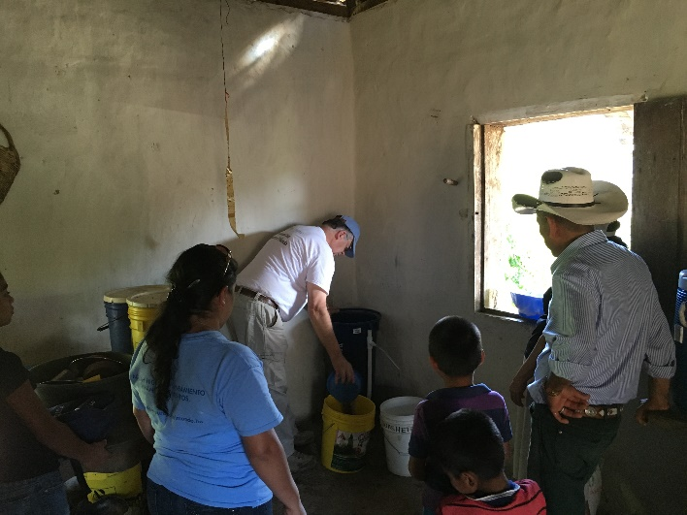 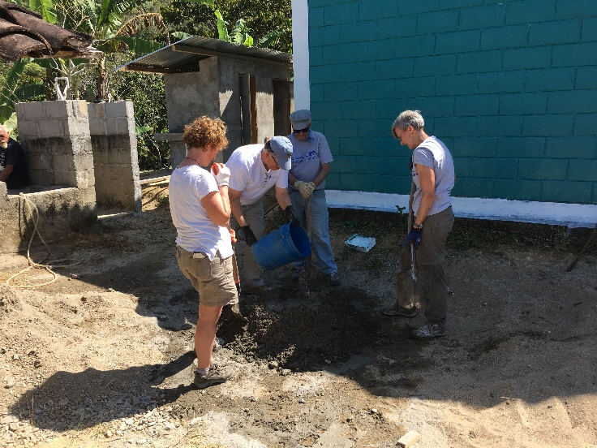

***PDG Tony Gilmore Installing Water Filter Jim Magennis and the Water& Sanitation Team***

**Summary**

The Mission trips are funded by Rotary Clubs, individual Rotarians, friends of Rotarians, and businesses in the NH and VT region. This trip was an excellent one and our team was filled with wonderful people. As always, seeing the smiles on the children’s faces and seeing the classrooms filled with those children, made the trip a memorable and worthwhile experience. The following are some comments from several of the team members:

*I had a great experience overall. Going to Trojes for the wáter project was probably the highlight for me. I'm also looking forward to seeing final pictures of the school project! – Phil Currier*

*I enjoyed the trip to Honduras even though it was very hard work.  I worked in the Pharmacy with the medical team.  We worked at the sites and then came back and prepared dosages of common meds during the evening so we worked day and night.  I was especially impressed by the Honduran doctors that worked with us.  They weren't always easy to decipher (handwriting) but it is so important that locals be involved and our work is not just outsiders doing to and for others.  In that vein the Interact and Rotaract and Rotary wives were incredibly helpful to us as translators and crowd control.  We had one tough day in crowd control but most days were pretty good.  The day our primary helper was 16 was the tough day.  Other days with older persons things went very smoothly. Most of the college students were incredible.  Their enthusiasm and energy were palpable. – Judy Miller*

***The 2016 Team***

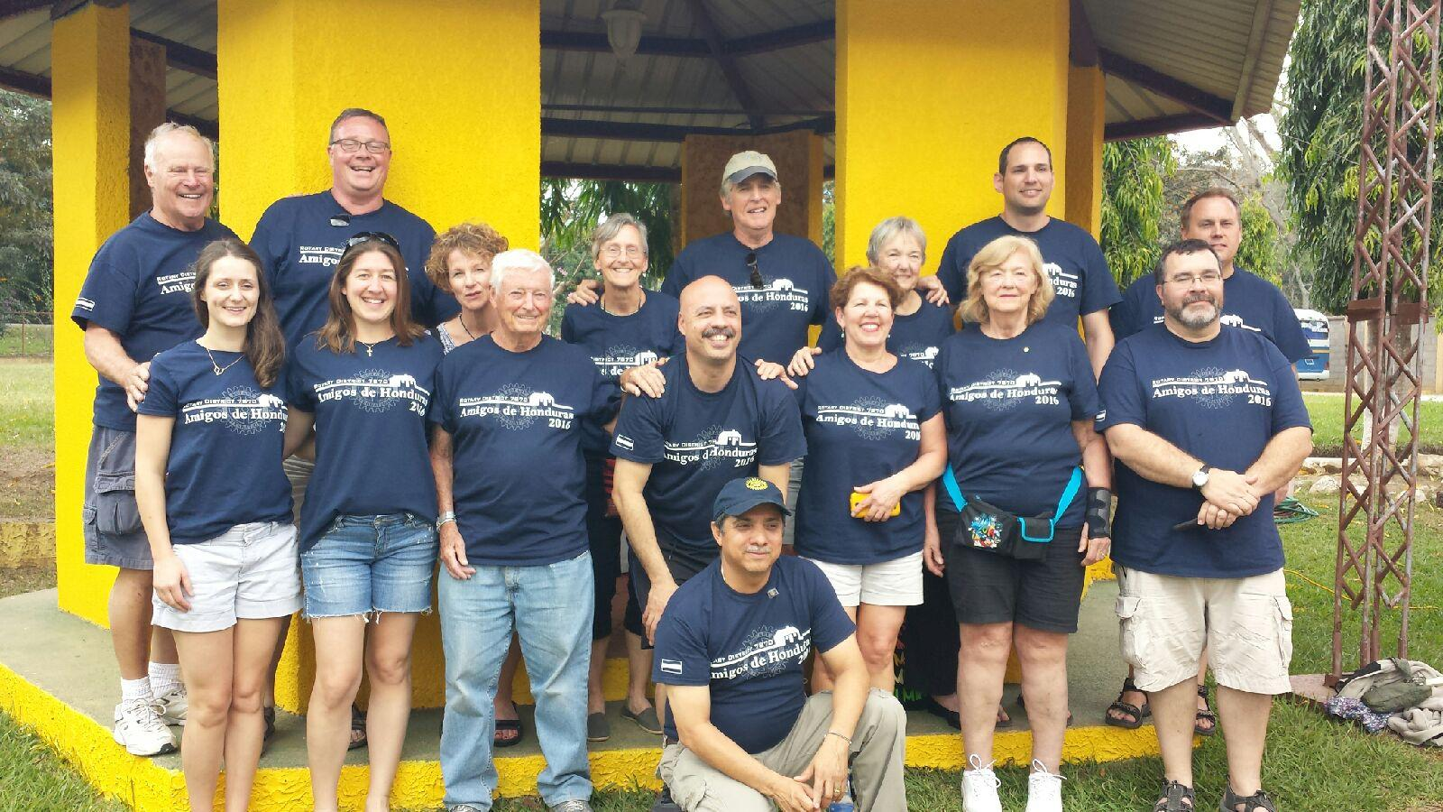

***Back Row: Don Crooker, Dave Lawerence, Shelley Proulx, Tosh Stickney, Chris Parkinson,***

***Kathie Stone, Phil Currier, and Rory Richardson***

***Front Row: Meagan Kingman, Jenn Poland, Jim Magennis, Esdras Almeida, Deb Bergschneider,***

***Judy Miller, Brian Stimpson***

***Kneeling: Danli Rotary Club President, Alexis Montes***

***Not Shown: Carl Feirrara, Tony Gilmore, Jim Wright***

**Additional Photos of the 2016 Team**

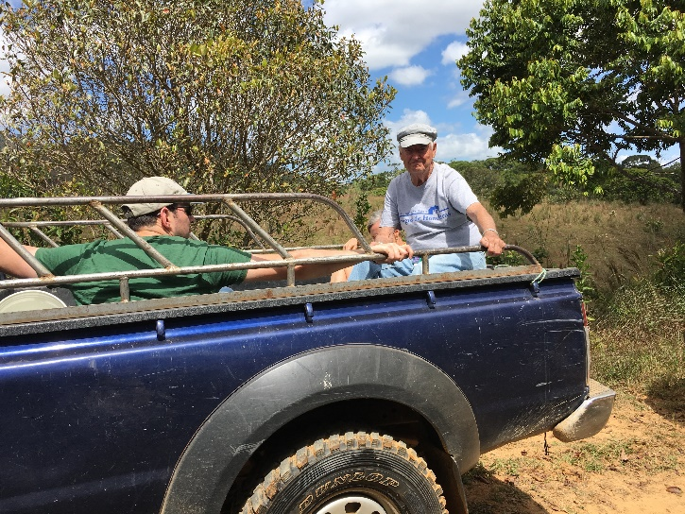 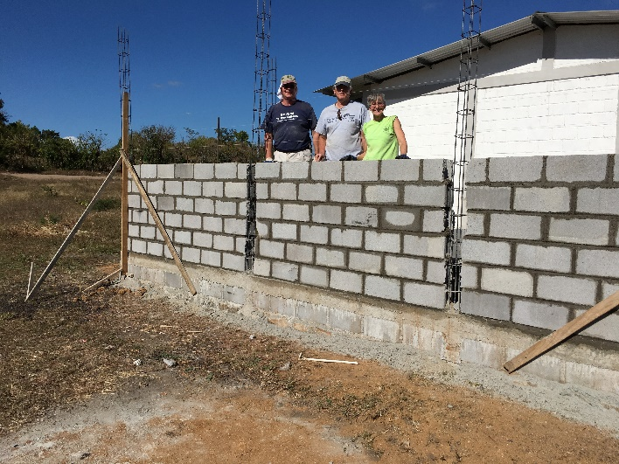

*Jim Magennis Leader of the Water and Sanitation Team Dave Lawrence, Chris Parkinson, and Tosh Stickney*

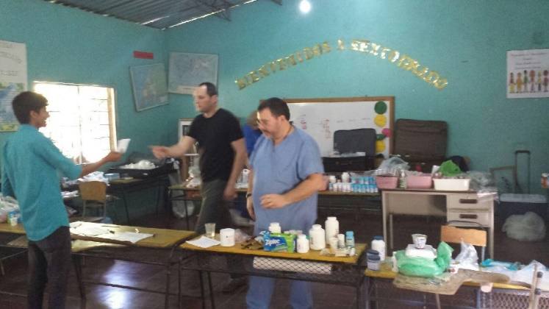 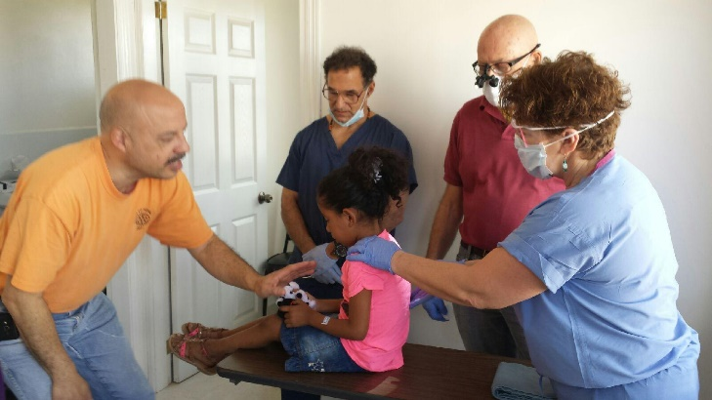

*Brian Stimpson and Phil Currier in the Pharmacy Esdras, Carl, Jim and Deb with Dental Patient*

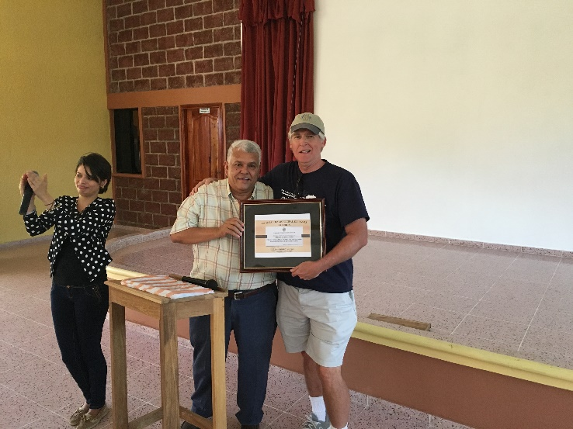 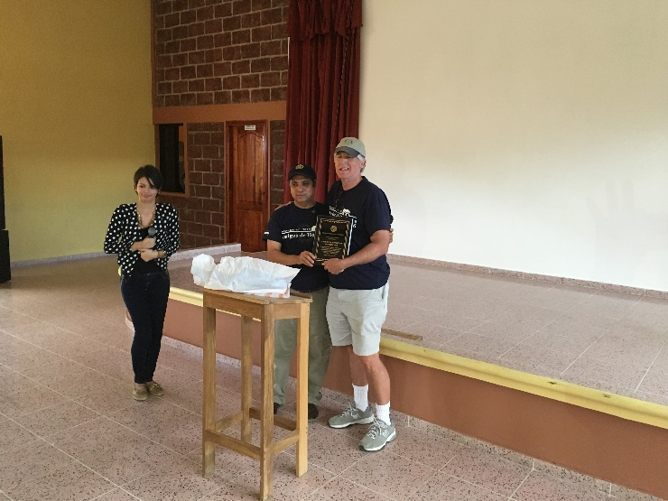

*The Mayor of Danli and Club President Alexis presented District 7870 Awards for 15 years of dedicated service to the Danli Community*

**The following was engraved on a plaque which was presented to the Danli Rotary Club and now hangs in their Rotary Hall.**

**Rotary District 7870 Foundation – 2016 Amigos De Honduras**

**Recognition of 2016 Contributors**

**Concord Rotary Club Lancaster PA Rotary Club**

**Nashua West Rotary Club Hollis-Brookline Rotary Club**

**Gilford Rotary Club** **Henniker Rotary Club Bow Rotary Club**

**Adrian Levesque Bill Pockl John Tulley**

**NE Delta Dental Chris Parkinson David Lawerence**

**The Hampton Inn**

**2016 Team Members**

**Esdras Almeida Deb Bergschneider Don Crooker**

**Phil Currier Carl Feirrara Tony Gilmore**

**Meagan Kingman David Lawrence Jim Magennis**

**Judy Miller Chris Parkinson Jenn Poland**

**Shelley Proulx Rory Richardson Tosh Stickney**

**Brian Stimpson Kathie Stone Jim Wright**

**2016 – Cost Summary**

**Summary of Danli Rotary Club Expenditures (Funded by Amigos De Honduras):**

**BEGINNING BALANCE AT JULY 2015– IN DANLI U$. 4,800.77**

**Misc. Expenses U$ (85.94)**

**Balance in Danli in November U$ 4,714.83**

**Wire from Dist. 7870 Foundation in December U$ 7,500.00**

**Danli Bank Fees U$ (15.00)**

**BEGINNING BALANCE AT JULY 2015– IN DANLI U$. 12,199.83**

|  |  |  |  |
| --- | --- | --- | --- |
|  | | **LEMPIRAS** | **DOLLARS** |
| **1. MARY CROOKER SCHOOL CONSTRUCTION (CLASSROOM):** | |  | |
| HAND LABOR: ROOF, WINDOWS AND DOOR | | 29,000.00 |  |
| 1,285.60 |
| TOOLS | | 867.95 | 38.48 |
| MATERIALS: WALLS, ROOF, DOOR, WINDOWS AND FLOOR. | | 96,960.03 | 4,298.35 |
| FENCE CONSTRUCTION | | 28, 145.60 | 1,247.72 |
|  | | **154,973.58** | **6,870.16** |
|  |  |
|  |
| **2. BRIGADES TRANSPORT** : | |  |
| OLIVERTO CHAVEZ (BUS) | | 20,000.00 | 886.62 |
| RICARDO HERNANDEZ (VAN) | | 9,700.00 | 430.01 |
| COMBUSTIBLE (FUEL) | | 1,936.00 | 85.83 |
|  | | **31,636.00** | **1,402.46** |
|  |  |
| **3. MEDICAL BRIGADES SUPPLIES:** | |
| **ANAESTHESIA (04 BOXES)** ' | | **1,580.00** | **70.04** |
|  | | **12,000.00**  **33,246.38** | **531.97**  **1,458.50** |
| **4. SCHOOL CHAIRS (24)** | |
|  | |
| **5. PURE WATER BRIGADE** | |
| **TOTAL EXPENSES** | | **233,435.96** | **10,333.13** |
|  |  |
| **MISC. EXPENSES** | |  | **92.75** |
| **CARLOS SALINAS UNIVERSITY SCHOLARSHIP** | |  | **300.00** |
| **LUISA SILVA FLORES UNIVERSITY SCHOLARSHIP** | |  | **300.00** |
|  | |  |  |
| **TOTAL EXPENDED IN PROJECTS** | |  | **11,025.78** |
|  | **2016 ENDING BALANCE** |  | **1,174.05** |

**ENDING BALANCE AT MAY 2016 – IN DANLI U$. 1,174.05**

**Summary of Revenue and Expenditures - 2016:**

**Ending Fund Balance – May 2015: $ 1,207.17**

**Unrestricted Revenue:**

Donations* $ 3120.00

Club Donations* 5290.97

Team Member Fees 2,250.00

Interest .19

**Total UnrestrictedRevenue $ 10,661.16**

**Unrestricted Expenditures:**

Transfer to Danli $ 7,500.00

Filing Fee 75.00

Wire Fee 42.00

In-Country Expenses 649.00

Medical Supplies 410.68

**Total Unrestricted Expenditures*** $ 8,676.68**

**Ending Fund Balance – May 2016: $ 3,191.65**

Restricted – Medical Team Revenue & Expenses

Donations* $ 3611.93

Medical Team Expenses 3592.84

**Total Unrestricted Revenue Balance $ 19.09**

*\*Donations: Adrian Levesque; John Tulley; Dave Lawrence; Chris Parkinson;*

*David Killory; Francis Boucher; and, NE Delta Dental*

*Medical Team Donations: Monarch’s Hockey; UNOs; Medications from Copley Health Systems; and Proceeds from Spaghetti Dinner and Silent Auction*

*Other Contributions: the Hampton Inn in Bow donated 5 hotel rooms for VT team members to stay in on both the outgoing and incoming trips.*

*\*\*Club Donations: Concord, Nashua West; Gilford; Hollis-Brookline; Bow; Henniker; and, the Lancaster PA Sunrise Rotary Club*

*\*\*\*See Above Detail for Danli Rotary Expenditures and Remaining Balance*