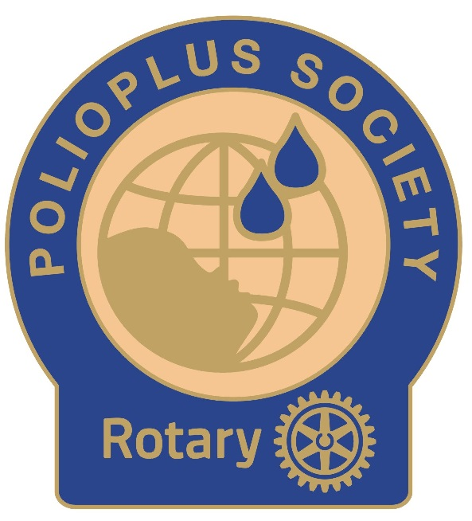
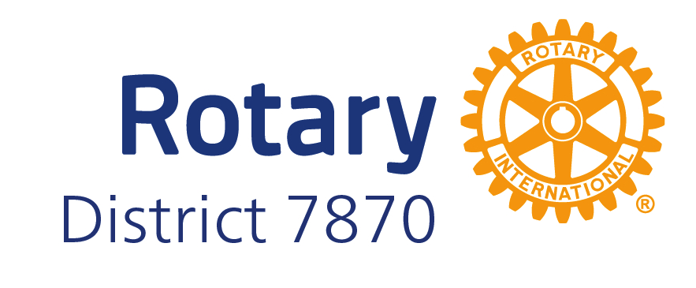
THE POLIOPLUS SOCIETY

The PolioPlus Society is a program currently being offered by Districts around the world.

What is the PolioPlus Society? Polio is still endemic in two countries Afghanistan and Pakistan. We have seen a combined 33 cases this year. That is both wild polio and Vaccine Derived Polio Virus. In an effort to increase sustainable giving, the PolioPlus Society (PPS) was formed to encourage Rotarians to commit to a minimum of $100 per year to the PolioPlus Fund until polio is eradicated from the face of the earth. Society members, who commit to at least $100/year donation to PolioPlus, will receive a special PPS pin, and a certificate.

How to donate to PolioPlus thru the PPS:

- Rotarians and guests can go to myrotary.org/donate, and click on Polio Fund where they can make a one time or recurring donation.
- We encourage Rotarians to join PolioPlus Direct (the recurring option), signing up for automatic giving with a credit card. $10 (or more) per month will qualify them for the society.
- Of course, they can also donate by giving their club Foundation Chair a check, payable to The Rotary Foundation, with “Polio Fund” in the memo section.
- Bill Gates and the Gates Foundation have renewed their commitment to match 2:1 any Rotarian gift to PolioPlus.

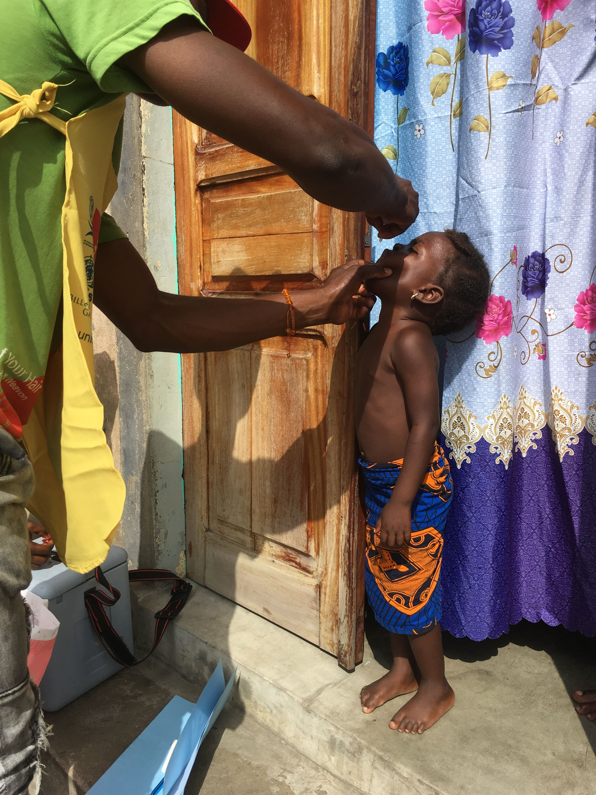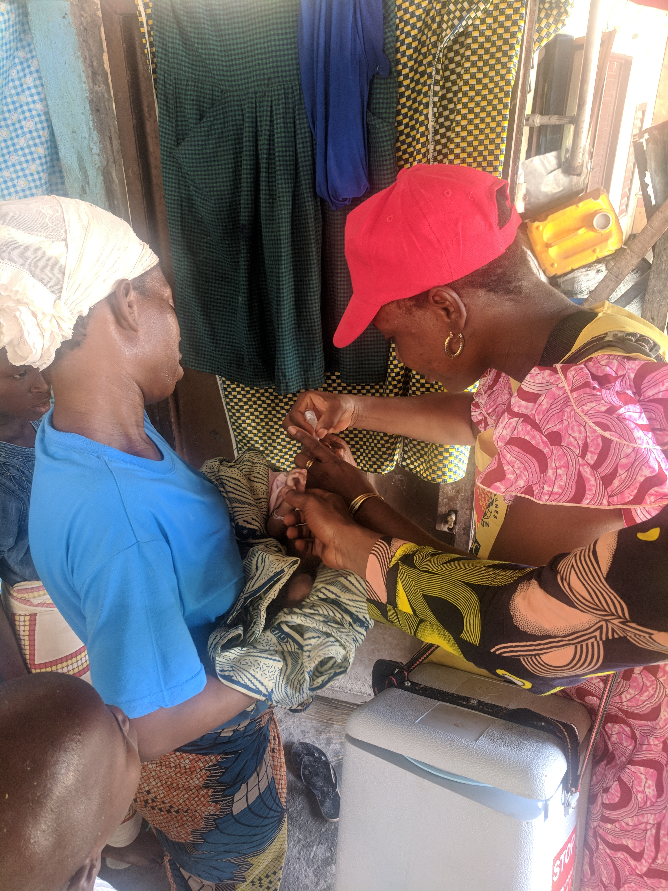

Where can I sign up? – Please use the link below for the online registration form to make your commitment.

https://tinyurl.com/2a8rfckd

