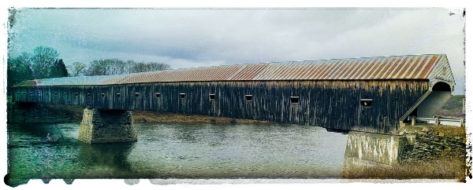

Cornish-Windsor Bridge
ROTARY DISTRICT 7870

January 30, 2021
Early
Session 1 – Rotary International
9AM until 10AM

30 minute break

Session 2 – The District
10:30AM until 11:30AM

Late
Session 3 – Being President
6:30PM until 7:30PM

15 minute break

Session 4 – Membership
7:45PM until 8:45PM

15 minutes to chat and wrap up

Done at 9:00PM

February 27, 2021
Early
Session 3 – Being President
9AM until 10AM

30 minute break

Session 4 – Membership
10:30AM until 11:30AM

Late
Session 1 – Rotary International
6:30PM until 7:30PM

15 minute break

Session 2 – The District
7:45PM until 8:45PM

15 minutes to chat and wrap up

Done at 9:00PM

