PROJECT NUMBER ________________
ASSIGNED BY D7870 DG COMMITTEE
District 7870 Grant Application
2021-22 ROTARY YEAR
(Please Type or Print Legibly)

1) PROJECT DESCRIPTION:

- Describe the project and how it meets the needs of the community

- Define how Rotarians will actively participate in this project

C) Club Size _____ Number of Members expected to participate ______

2) COOPERATING ORGANIZATION:

- Name of Organization or Community Government

- Describe contribution of this organization

3) PROJECT BUDGET:

Items(s) to be purchased Cost
1. ___________
2. ___________
3. ___________
4. ___________
5. ___________

Budget Total: ___________

4) PROPOSED FINANCING
Amount
Source of Funds

Sponsoring Rotary Club ____________
Supporting Rotary Club ____________
Cooperating Organization (if any) ____________
District Grant Request ____________
Other (define) ____________

Financing Total: ____________
(must equal proposed financing)

5) PROJECT COMMITTEE CONTACTS:

Sponsoring Club President:
Name
Phone(s)
Email

Primary Grant Contact:
Name
Phone
Email
Mailing Address

Secondary Grant Contact:
Name
Phone
Email
Mailing Address

6) AGREEMENTS:

Sponsoring Rotary Club

This agreement is entered into between the Sponsoring Club and District 7870. In applying and accepting project funding from District 7870, the Sponsoring Club agrees:

- Funding requested and received from District 7870 will be used exclusively for the project described in Section 1 of this agreement.
- This project and its implementation meets all guidelines and restrictions of the District 7870 District Grants.
- Every effort will be made to complete this project within the 2021-22 Rotary Year. If it becomes evident that this not be possible, the Sponsoring Club will promptly contact the District Grants Committee and request an extension not to exceed an additional six months.
- The Sponsoring Club and any Supporting Rotary Clubs, cooperating organizations and/or other contributing parties shall defend, indemnify and hold harmless District 7870, Rotary International, their respective Directors, Trustees, Officers, employees and committee members from any and all damages, losses, judgments, cost, fines, awards, liabilities and/or expenses, including without limitation reasonable attorney’s fees and cost of litigation, asserted or recovered from RI/D7870, that may result or arise directly or indirectly from the implementation of this project. It is the responsibility of the Sponsoring Club to ensure that all participating parties have been advised and have accepted the terms and conditions contained herein.
- This agreement may be cancelled without notice upon the failure of the participants to abide by the terms and conditions set forth herein, including any reporting to District 7870 and TRF. If this agreement is cancelled prior to the District having made payment of any or all of the approved funding, the District shall have no further obligation of any kind including payment of any amounts thereafter. If a portion or all of the District funding has been made, such amount plus any interest accrued shall be promptly returned to the District.
- The Sponsoring Club accepts the responsibility for submission of the Final Report to District 7870 within 3 months of the completion of the project or the 30th of June 2022 which ever comes first.

Acknowledged and accepted by:
- President, Rotary Club of

_____________________________________________________________ Date _________________
President’s signature

Cooperating Organization

By signing below, the Cooperating Organization confirms:

- They have been fully advised of any and all terms and conditions of this agreement that extends beyond the Sponsoring Club to such organization and acknowledge their acceptance of said terms and conditions.
- They are in possession of and can supply upon request verification of reputable standing in the community and any appropriate registration or licensing necessary to work within the community.
- They are willing and able to work with Rotarians in the implementation of this project in accordance with the extend of participation agreed upon with the Sponsoring Club.
- They will cooperate as necessary to a fair and reasonable extent with any financial review of activities associated with this project.

Acknowledged and accepted by:

Name:
Title:
Organization:

_____________________________________ Date __________________
Authorized Signature

Please Return this completed application to :

PDG Richard A. Berryman
Co-Chair District Grants Committee
18 Foxcross Circle
Concord, NH 03301

Email applications will be accepted for consideration by the D7870 District Grant Committee but a signed original agreement must be provided before a grant can be awarded. Email to rberrymandds@gmail.com

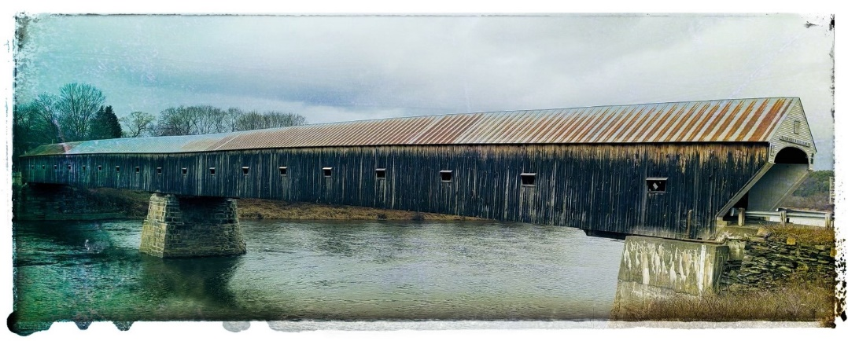

District 7870 Connecting Southern Vermont and Southern New Hampshire

