Dear $NICK_NAME$,

It is our pleasure to share with you the April 4 issue of Rotary District 7910 Newsletter, which now comes out on Tuesday at 10:00 a.m. The weekly submission deadline remains the same: Friday.

For the complete issue, click here.

To explore past issues, click here.

Highlights of the April 4 issue:

Governor’s Message: Try hard to attend 'our' Multi-District Conference - By Pat and Skip Doyle

Million Dollar Journey: District 7910 to celebrate Centennial of Rotary Foundation with Million Dollar Journey Dinner on May 25 at Mechanics Hall - By Satya Mitra and Sanjay Deshpande

Interact Actions: Please make it possible for your Interactors to attend April 29 Youth Conference in Providence - By Bob Anthony

Polio Plus Update:The Rotary Foundation makes it much easier - By Carl Good III

Thai And Stop Me: Flag ceremony - By Cassidy in Thailand

PR Tips: Promote your service projects - By Laura Spear

Foundation Note: Foundation-giving scorecard as of March 3 - By Sanjay Deshpande

A Rotarian’s Blog: Is Rotary a port in a world of storms and loneliness? – By Ron Goodenow

Plus: Lots more district and club news, information, events and activities

Our next newsletter will come out next Tuesday, April 11. The submission deadline is this Friday, April 7.

Text content must be submitted in Word format. Image content must be submitted in either JPEG or PDF format.

Send your content submissions to Immediate Past District Governor/Newsletter Editor Jim Fusco at jim.fusco2@gmail.com.

Governors Pat & Skip

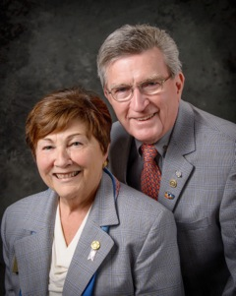Pat and Skip Doyle
2016-2017 Governors
Rotary District 7910

pwdoyle2@verizon.net
skipdoyle2@verizon.net

