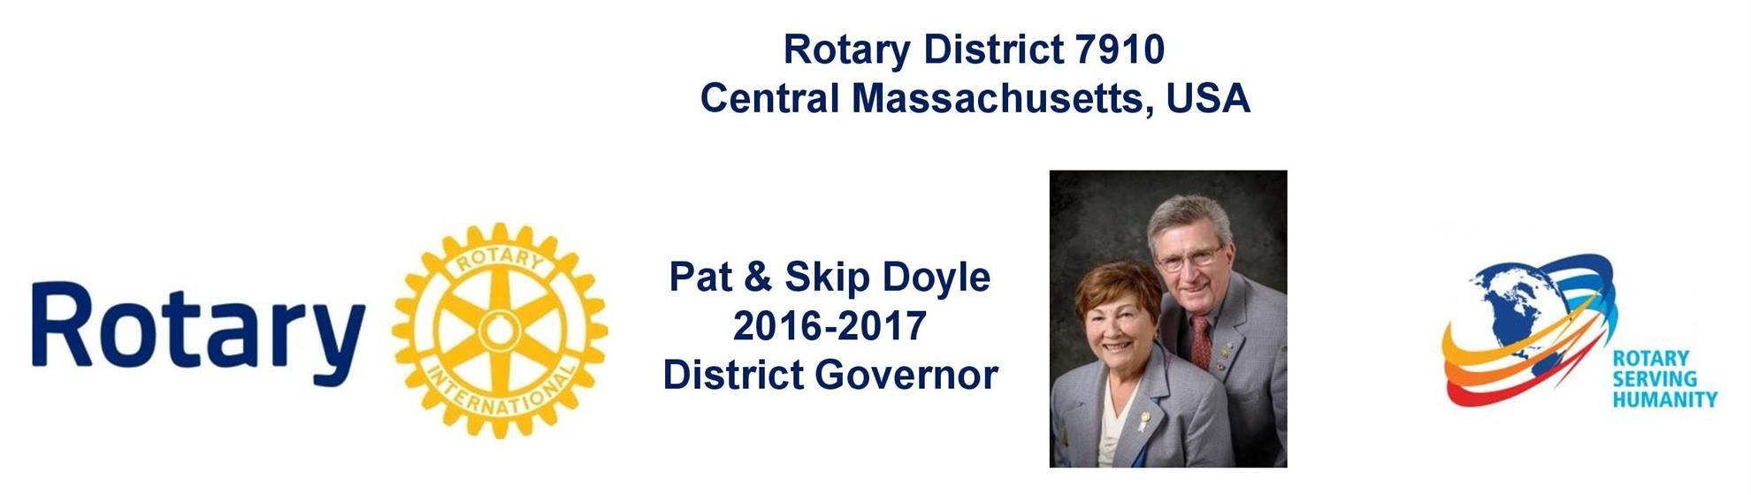

REGISTER NOW: DISTRICT 7910'S MILLION DOLLAR JOURNEY DINNER TO RECOGNIZE CENTENNIAL OF THE ROTARY FOUNDATION - MAY 25, MECHANICS HALL, WORCESTER
To register and pay, click here

To download the event flyer in PDF format, click here

To download the event flyer in JPEG format, click here

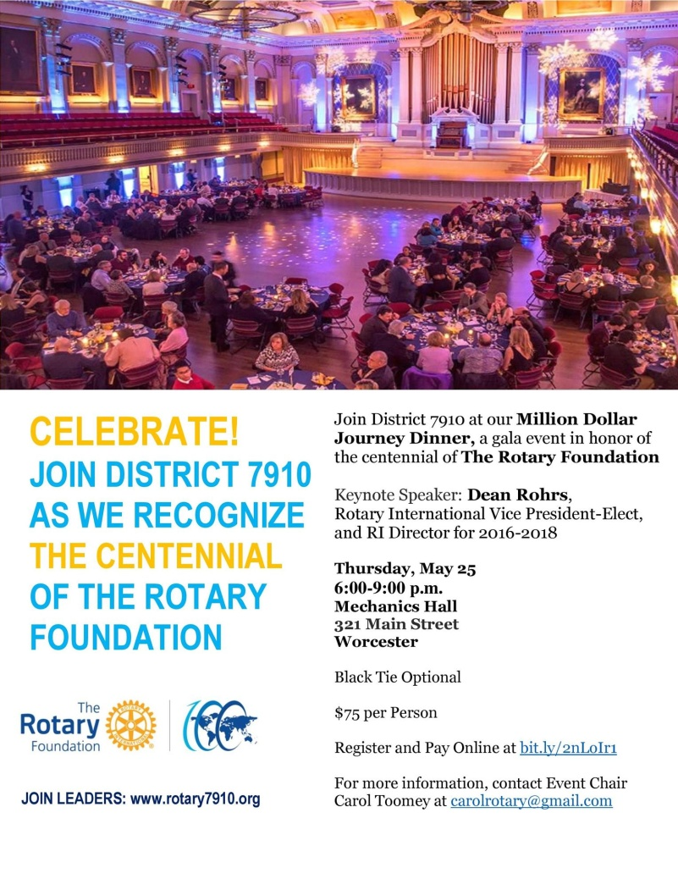

REGISTER NOW: 2017 MULTI-DISTRICT CONFERENCE, APRIL 28-30, PROVIDENCE

TO REGISTER, CLICK HERE.
To download the Conference Highlights flyer (shown, below) in:
- PDF format, click here
- JPEG format, click here
To download the Conference Sponsorship Donation form in PDF format, click here
To download the Rotary Waterfire Fundraiser brochure in PDF format, click here

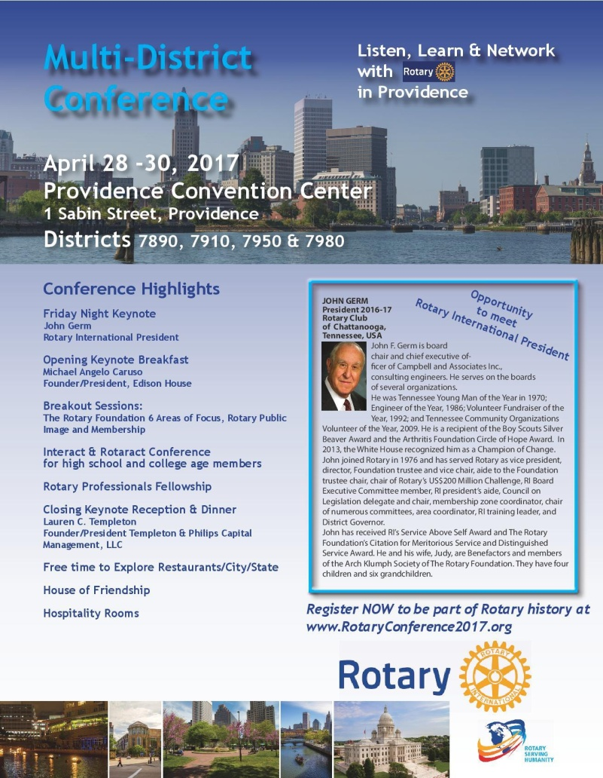

Multi-District Conference Sponsors

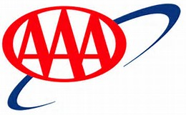

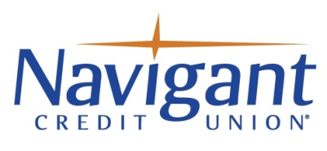

AAA Northeast
Coventry Credit Union
Navigant Credit Union
Stadium Theatre Performing Arts Center

YOUTH CONFERENCE: SATURDAY, APRIL 29, PROVIDENCE
To register, click here.

To download 2016-2017 Presidential Citation for Interact Clubs, in PDF format, click here

To download event flyer, in PDF format, click here
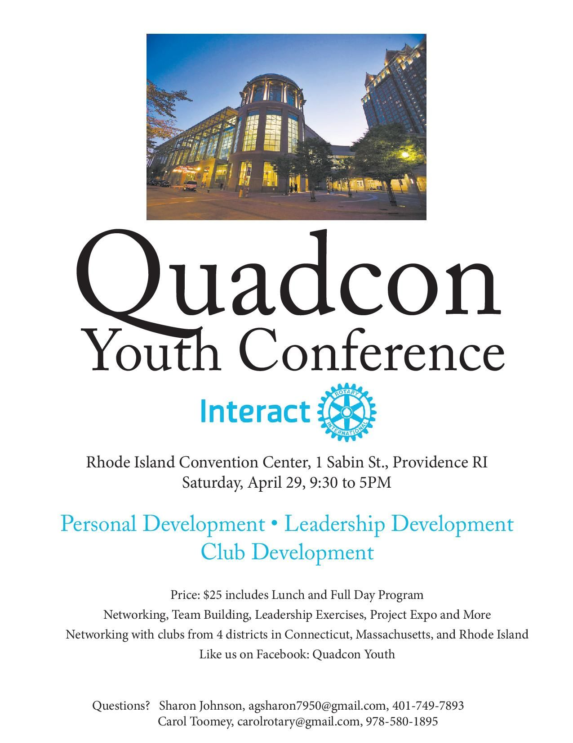

APRIL 15 APPLICATION DEADLINE: DAVID & ELEANOR MORLEY ENDOWED GLOBAL GRANT SCHOLARSHIP
To learn more about the Morley Scholarship, click here.
To download the application in Word format, click here.
To download the application in PDF format, click here.
To download the flyer in PDF format, click here.

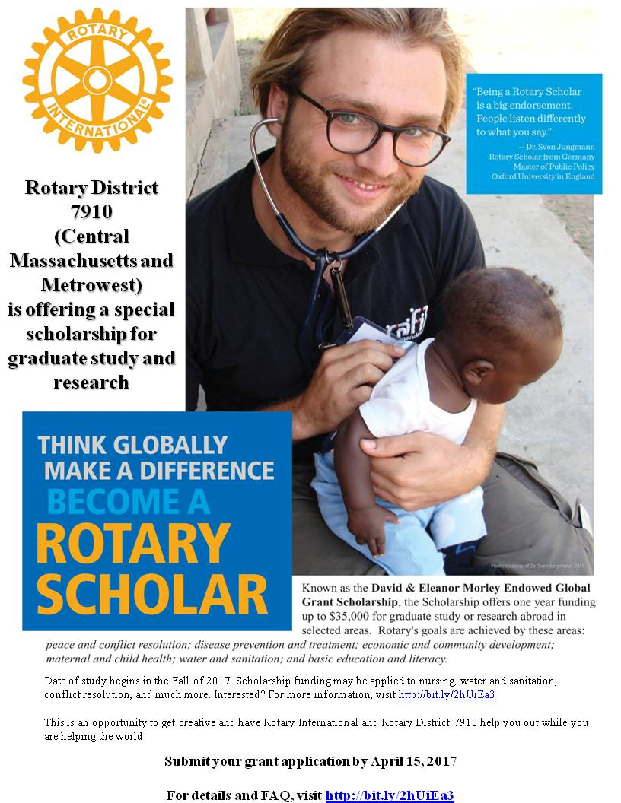

HOT OFF THE PRESS!

2016-2017 ROTARY DISTRICT 7910 DIRECTORY
Print copies of our 332-page, information-packed 2016-2017 RotaryDistrict 7910 Directory have been delivered to your club.
The Directory includes:
- District 7910 and Rotary International general information
- District club information
- Yellow Pages of Rotarian-run businesses
- District Resolutions
- Complete membership directory
A digital version of the Directory is now available for automatic download, in PDF format. Please note: Member login is required.
Click here, to download
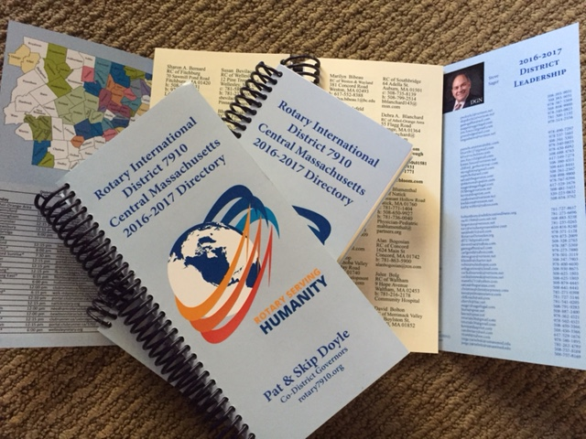

DISTRICT AT A GLANCE
Click on each one

DISTRICT SOCIAL MEDIA, PHOTOS & VIDEOS
Facebook

Twitter

Photos (May 2015 and after)

Photos (May 2015 and before)

Videos

VIEW LIVE: OUR FACEBOOK PAGE!
​

CLICK HERE FOR THE COMPLETE ISSUE
Or, click on each of these issue highlights:
Governor’s Message: Try hard to attend 'our' Multi-District Conference - By Pat and Skip Doyle

Million Dollar Journey: District 7910 to celebrate Centennial of Rotary Foundation with Million Dollar Journey Dinner on May 25 at Mechanics Hall - By Satya Mitra and Sanjay Deshpande

Interact Actions: Please make it possible for your Interactors to attend April 29 Youth Conference in Providence - By Bob Anthony

Polio Plus Update:The Rotary Foundation makes it much easier - By Carl Good III

Thai And Stop Me: Flag ceremony - By Cassidy in Thailand

PR Tips: Promote your service projects - By Laura Spear

Foundation Note: Foundation-giving scorecard as of March 3 - By Sanjay Deshpande

A Rotarian’s Blog: Is Rotary a port in a world of storms and loneliness? – By Ron Goodenow

Plus: Lots more district and club news, information, events and activities

CLICK HERE FOR OUR ARCHIVE OF PAST ISSUES

