please make it possible for your interactors to attend april 29 youth conference in providence
By Bob Anthony

While all teens are welcome to attend the Interact Youth Conference on Saturday, April 29 in Providence, at least the presidents of active or forming Interact clubs should attend. To all Rotary clubs sponsoring Interact clubs: Please make it possible for them to attend.

The full-day with lunch is $25 per person. To register, click here

This training will ensure our Interact clubs finish this school year strong and prepared to expand in the coming school year. An afternoon session will brainstorm on how to ramp up the collaboration among Interact and Rotary members, which helps with membership goals.

Here is the schedule for the day: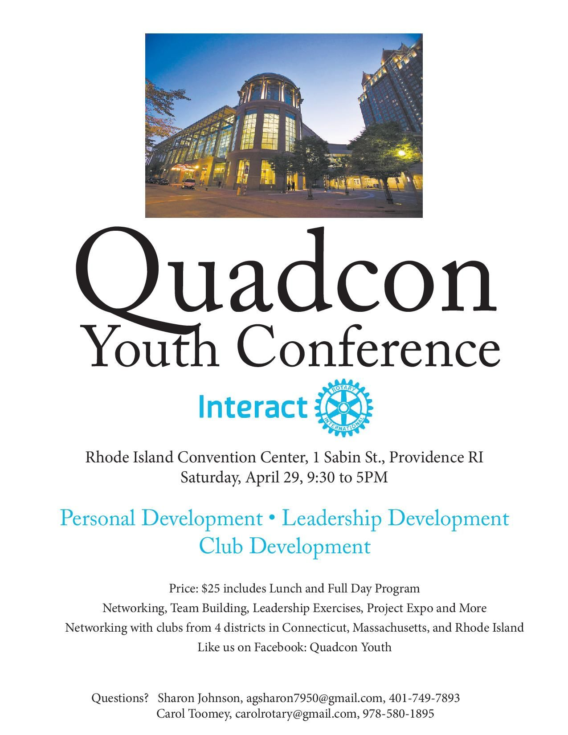
- 9:00-9:30 a.m.: Sign In
- 9:30-10:30 a.m.: Shout it Out! - Introductions
- 10:30 a.m.-12:00 noon: Peer Leadership and Depression Prevention
- 12:00 noon-1:00 p.m.: Networking Lunch
- 1:00-2:00 p.m.: Boss Status - Effective Interact Clubs
- 2:00-3:00 p.m.: Projects! Projects! Projects!
- 3:00-3:30 p.m.: Rotary Is There for You
- 3:30- 4:50 p.m.: Proposal Competitions
To download the conference-overview document in PDF format,click here.

I am happy to answer any questions you may have.

Bob Anthony, chair of the District Interact Committee, may be reached at rwa1645@gmail.com.

Return to April 4 Newsletter

Visit our website
'Like' our Facebook page
'Follow' us on Twitter
Watch our videos
View our photo albums

