DISTRICT & CLUB EVENTS

Submit Your Events
You may submit event information per the District 7910 Promotional Guidelines. If your club does not use ClubRunner, please send your event information to Immediate Past Governor/Newsletter Editor Jim Fusco, jim.fusco2@gmail.com. And, please make sure to add Jim to your club's distribution list.

Submit Your Newsletter Content

To submit content for consideration for the Tuesday, April 11 issue of Rotary District 7910 Newsletter, please e-mail it to Immediate Past District Governor and Newsletter Editor Jim Fusco at jim.fusco2@gmail.com.
The submission deadline for that issue is Friday, April 7. All text must be in Word format. All images must be in either JPEG or PDF format.
Please, please please... identify the people, left to right, who are shown in your photos, including their first and last names, and their club or other title/position.

DISTRICT SOCIAL MEDIA
'Like' and share us on Facebook

'Follow' us on Twitter

View us on Google Photos

Watch us on YouTube

UPCOMING DISTRICT EVENTS
For April 4-May 4

RYLA Group Facilitator Training Session #2

Sunday, April 9
1:00–5:00 p.m.

DoubleTree Hotel, Leominster

Interact Committee meeting

Tuesday, April 11
1:00-2:30 p.m.

Spaulding Management LLC, Concord

RYLA Committee Meeting

Wednesday, April 12
6:30– 9:00 p.m.

Action Unlimited, Concord

RYLA Signed Student Forms Are Due

Saturday, April 15

Trustee Meeting

Monday, April 17

6:30-8:30 p.m.

Hilton Garden Inn Marlborough

District Governor-Elect Karin Cabinet Meeting

Thursday, April 20

6:00– 7:30 p.m.

Courtyard Littleton

Multi-District Conference

Friday, April 28-Sunday, April 30

Providence Convention Center, Providence

Interact Youth Day

Saturday, April 29

Omni Hotel, Providence

Rotary Means Business Networking Event

Saturday, April 29
4:00 6:00 p.m.

Omni Hotel Providence

PR Committee Meeting

Wednesday, May 3
6:30-8:30 p.m.

Location to be announced

District Council Meeting

Thursday, May 4
6:30-8:30 p.m.

DoubleTree Hotel, Leominster

VIEW THESE PLUS MORE UPCOMING DISTRICT EVENTS - INCLUDING ALL GOVERNOR'S VISITS

RI SPOTLIGHT

'17-'19 UNESCO-IHE Scholarship Applications Available

By Abby McNear

READ MORE

Zone Coordinators Are Standing By

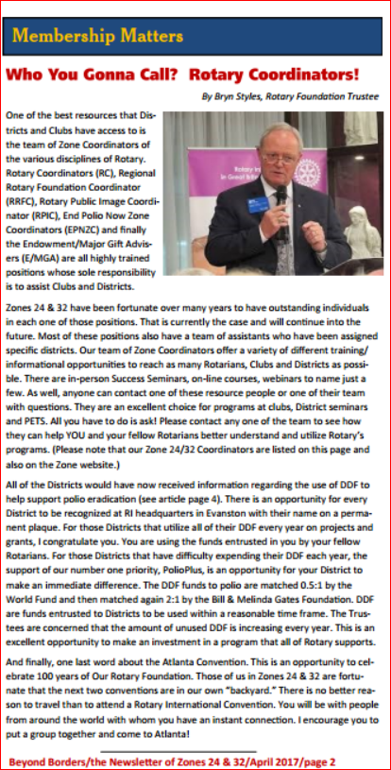

Rotary Weekly: March 31 edition

READ ISSUE

Rotary Peace Centers: 2019 Rotary Peace Fellowship applications now available

READ MORE

Club & District Support Newsletter: February edition

READ ISSUE

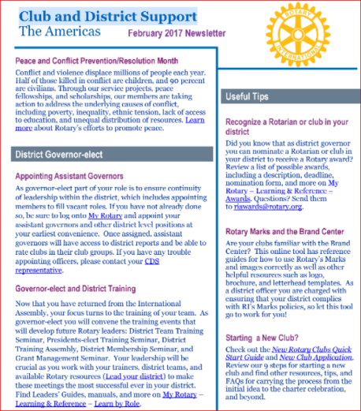

Young Leaders in Action: March 17 edition

READ ISSUE

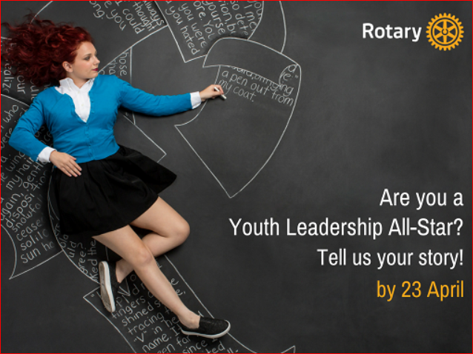

Rotary Releases $35 Million to Combat Polio

READ MORE

To read the February 2017 issue of End Polio Now Newsletter, click here.

RI Website Has Been Updated

For a sneak peak at the new Rotary International website, click here.
Read more about the web-refresh project
Learn more about the online tools available to you and your club

Club & District Report from RI

By Katlin Bautz

READ REPORT

In 2017: Spend Less. Give More.
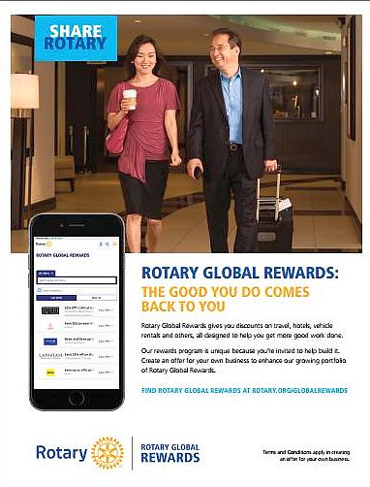

To learn more about Rotary Global Reward, click here

To download the Rotary Global Reward flyer,click here

Contact Judy Merriman, chair of the District Rotary Global Rewards Committee at judymerriman@townisp.com.

The Rotary Foundation Named 'World’s Outstanding Foundation'

READ MORE
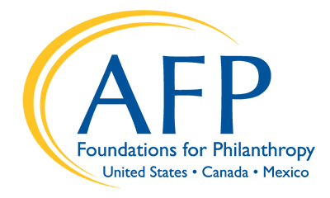

Rotary Leader Newsletter: March edition

READ ISSUE

Meet Ian Riseley: '17-'18 RI President

READ MORE
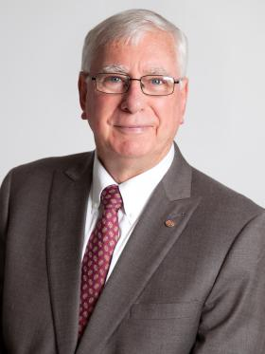

Ian Riseley will address the 2017 World Affairs Seminar, "Education & Social Justice: Shaping the World You Will Inherit," on June 26 in Wisconsin

READ MORE

Beyond Borders

By Dean Rohrs, RI Vice President and RI Director for Zones 24 & 32
To read the April issue of Beyond Borders, click here.
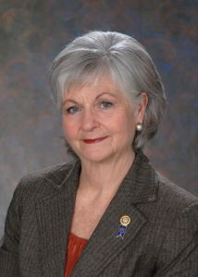

In the April issue:
- Director Dean and Trustee Bryn start off the issue with their thoughts on PETS, youth in Rotary, and the strength of our Coordinator team
- Director-elect Jeffry talks about the importance of coordination, particularly as the "old" Rotary year gives way to the new
- International PolioPlus Committee Chair Mike defines success in ending polio
- We learn specifically how each of our districts can do our part to End Polio Now
- We hear about a long-term relationship between a club in Nova Scotia and one in Uganda that continues to result in tangible benefits
- We learn how three clubs in Connecticut are marking The Rotary Foundation's centennial with a commitment to save 100 lives
- We get a first-hand report from Rotary's newest nation: Myanmar
- And, planning continues for Zone Institute 2017 in Hartford, while the Beyond Borders Dinner in Atlanta is sold out!
To read Dean Rohr's highlights of the January RI Board of Directors meeting, click here.

Meet Jeff Cadorette: Our New RI Director

READ MORE

Meet Sam Owori: Our '18-'19 RI President

Sam is a Ugandan businessman and a member of the Rotary Club of Kampala.

READ MORE

A Letter from '16-'17 RI President John Germ
READ MORE
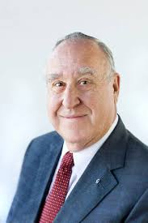

To download the World Polio Day toolkit, click here

For information on the April 2017 Rotary International Convention, click here.

To read a profile of John Germ, click here

To visit the President’s page, click here

To watch the Meet Your President video, click here

2017 Rotary Zone 24 & 32 Institute

READ MORE & REGISTER NOW

Campaign to End Polio: What you don't know
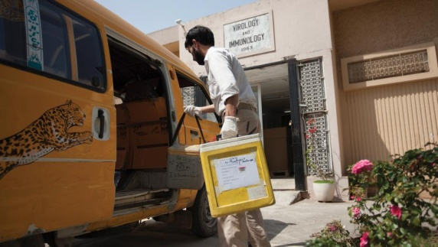

When was the last time there was polio in Europe?

READ MORE

What Millennials Love About Rotary

Millennials, an ethnically diverse, fiercely independent generation of digital natives, are doing more than just snapping selfies—they’re looking for a way to make a difference in their communities.

READ MORE

Get Ready For Your District's Rotary Foundation Seminar
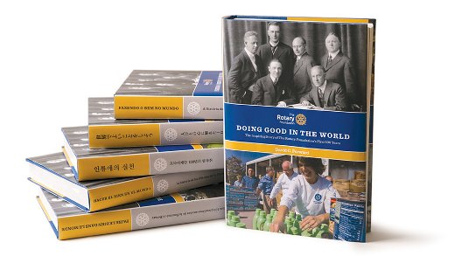
The Rotary Foundation is celebrating its 100th year of Doing Good in the World. Take the opportunity to strengthen your district and clubs during your district's Rotary Foundation Seminar by using resources from centennial.rotary.org.
Go to the Promotional resources tab to download the following Centennial Promotional Kit materials:
- Ideas and activities for clubs
- Doing Good in the World promotional flier
- Doing Good in the World bookmark
- Sample press release
- Centennial letterhead
- Centennial PowerPoint template
- History of the Rotary Foundation PowerPoint
- Centennial postcard
Let others know about these materials they can use to promote the Foundation in their clubs and communities.

Membership Minute: Impact Begins with You

A positive member experience begins long before someone joins a Rotary club. Start by introducing prospective members to Rotary with the Impact Begins With You brochure.

READ MORE

New Tools for 'Membership Tool Belt'

Looking to enhance your club-membership experience?

READ MORE

A How-To Membership-Leads Video
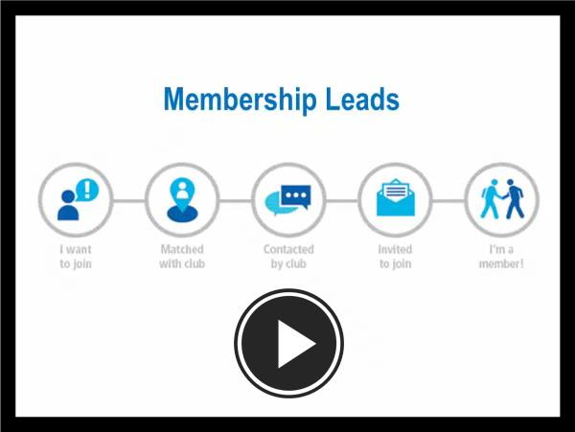
WATCH VIDEO

RI Membership Resource Guide
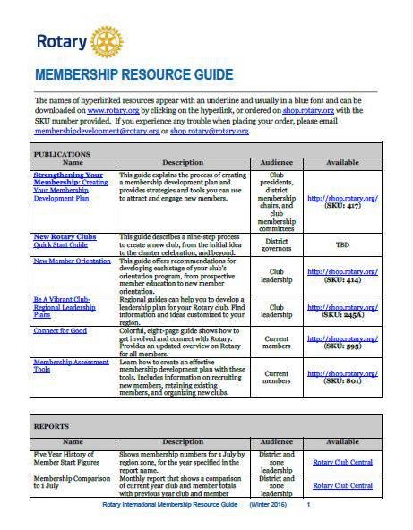

To download the Guide in PDF format, click here

RI Makes Changes in 'Brand Center' Online Tool

We hope that you've found Rotary International’s Brand Center a useful tool to create customized logos and brochures - and to tell Rotary's story in a consistent and engaging way. To gain access, you will need to login with your Rotary Membership ID.

'16-'17 Rotary Theme: 'Rotary Serving Humanity'

To download the image in JPEG format, click here.

Check Out 'Rotary Voices' Blog

Check out Rotary Voices, the official blog of Rotary International. This blog features stories by and about Rotary members, Rotary program alumni, and the people we partner and work with.

