GOVERNOR'S MESSAGE
Try Hard To Attend 'Our' Multi-District Conference
By Pat and Skip Doyle

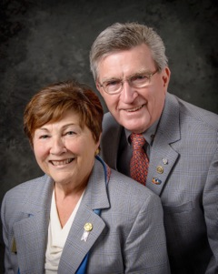
Finally, it is April. We don't want to count the mornings that we sat and watched the snow come down as we wrote our weekly message. This last storm had better be the final one until next winter.
Thank you to all the Rotarians who attended the four District Membership Workshops held around the district in the past two weeks. We wish to give a special thank-you to Tom Sturiale, vice chair of the District Membership Committee, who put the workshop material together, and is now reviewing the results in order to share them with all the clubs in the district. We wish only that more members had availed themselves of this format, which was brought right into their own local community.

Our atte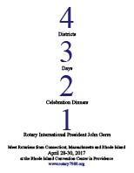ntion now goes to our Multi-District Conference on April 28 through 30 in Providence, which is less than a month away. Remember, when we say "our" conference, we are referring to all of us. This conference is a celebration of the 2016-2017 Rotary year for all clubs in our district. Please try hard to find a way to a part of the celebration.

Ideally, we would love to see you all at the full conference. But we also understand that many of you have weekend demands on your time.

How about bringing your family down to Providence to see Waterfire (shown, right) on Friday 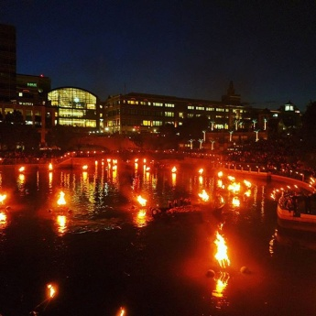evening? No charge, and you will be joining with Rotarians from around Southern New England.

Only av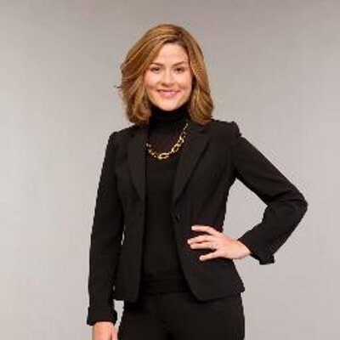ailable for Saturday? For $145, you can enjoy a fun-filled breakfast, numerous interesting breakout sessions, the yearly District Business meeting, an afternoon to enjoy our House of Friendship, or shop at Russell Hampton and/or the Providence Mall. Late afternoon, you can enjoy a free Rotary Means Business networking event. You can end the day with an evening dinner and a chance to hear Lauren Templeton (shown, left), one of the top 5 women financiers in the world. If you head back home before then, you would miss some evening fun.
To check out these no-cost and low-cost Multi-District Conference opportunities, click here.
Donor Needed

Tom Sturiale, one of our long-time and well-known members, a past president of the Rotary Club of Framingham, vice chair of the District Membership Committee, and chair of the District Visioning Committee Tom Sturiale, is in need of a kidney transplant. Before Tom he became ill a few years ago, was in line to become district governor.

We are sharing with you a letter written by his daughter, Lauren Sturiale Dymek. This letter expresses in words far more eloquent than we could ever write what it is we are asking.

"Fo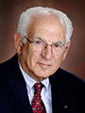r those of you who may not know, three years ago this March Tom, my dad, fell ill. He had started to have some abdominal pain over the weekend, and by Monday he was in the ER in total renal failure, and had become septic. It's been a long road to recovery, but as anyone who knows Tom will attest to, he is a fighter.

"Tom has lived his life with a fighting spirit and integrity that all who have had the honor of knowing him are inspired by. It's that same fighting spirit that brought him back from the brink of death. Tom battled his way out of a wheelchair, determined to walk his youngest daughter down the aisle, and share a father-daughter dance at her wedding.

"Since falling il,l he has been on dialysis. It has been increasingly difficult, and is taking a toll on his health. Even Tom can't will a broken organ to work again - although if anyone could, I think we can all agree it would be him.

"For this reason, his family is reaching out to those who know and love him for help. We are asking that willing donors click here for information on confidential testing."

Please consider today being tested as a possible donor for Tom!

Pointing in the right direction

Our message this week will also serve, we hope, to point you in the right direction by providing the information you need to make these last three months of the 2016-2017 Rotary year productive for all of us.
- Register now for our Multi-District Conference, on April 29 through 30 in Providence. To register now, see the banner ad at the top of this newsletter.
- Save the date for our Million Dollar Journey Foundation Dinner: Thursday, May 25, Mechanics Hall, Worcester. To learn more, click here.
It’s time to celebrate!

The quote, "Be careful what you wish for," comes to mind - along with the ending, “Because you might get it.” We wished for one million new dollars for The Rotary Foundation in 2016-2017, and we got it thanks to the work of our Major Donor Gift Committee under the extraordinary leadership of Chair Satya Mitra.

Join us at our Million Dollar Journey Dinner gala on Thursday, May 25 at Mechanics Hall in Worcester. Let's celebrate Rotary doing good in the world.

Thank you, Satya, and all who made this happen!

What is the Multi-District Conference?

One question we have been asked frequently is, "What is the Saturday, April 29 schedule for the Multi-District Conference in Providence?" We are posting it here, in detail. Our own district's Business Meeting will follow these sessions. Don’t miss these amazing presentations.

To sign up today for the Multi-District Conference, to be held April 28 through 30, click here.

To view the Conference video produced by Steve Kirk (see image, left), president of the Rotary Club of Concord, click here.

9:30-10:15 a.m.: Breakout Sessions 1

Living a Rotary Lifestyle – Rene Pothetes
- Getting more from Rotary: Balancing Rotary, your work and your personal life; and, maintaining a healthy Rotary lifestyle: Finding your Rotary passion and tips for being a Rotary spouse or partner.
Peer Leadership and Depression Prevention – Bob Anthony and Nadja Reilly
- This Train-the-Trainer workshop on the Peer Leadership and Depression Prevention program teaches Interact teens how to co-facilitate locally theemotional-wellness project, teaching youth group audiences how to help either one's elf or a friend through tough times. This program has been implemented by clubs in Massachusetts, Puerto Rico and India.
How to Attract the 30-Somethings to Your Club – Tarah Warner, Zack Whittenberger and Jason Camuti
- This panel discussion will focus of the Three Rs of Rotary Membership by exploring how Rotary club leaders and members can recruit, retain and recognize people.This session will give you specific ideas and techniques that your club can immediately implement to help get more publicity and help you reach all Rotarians - including a younger demographic.
National Immunization Days 101: Up Close and Personal – Past District Governor Sue Klock and Greyson Schwing
- What you always wanted to know but were afraid to ask. We will be describing our experiences in two very different areas of the Rotary world: the Indian subcontinent (India and Bangladesh) and west Africa (Nigeria).
10:30-11:15 a.m.: Breakout Sessions 2

Putting Your Best Face Forward: Public image and marketing – Judith Green, Christine Looby, Laura Spear and Betty Galligan
- How can you get beyond the “no one knows Rotary” dilemma? It starts with you and your club, and not just your Public Relations Chair. Every Rotarian is a brand ambassador. Applicable to all Rotarians, learn PR tips and tricks and best practices from our panel of experts who represent our four districts.
Are we serious about youth? - Jason Phillips
- Are we prepared to walk the path that it will take youth into Rotary? Prove it. Hear three youth voices that will describe the authentic Rotary progression and journey. What can we as Rotarians do to properly Inspire, engage, empower and deliver our youth leaders into becoming Rotarian leaders of today. This will be an in-depth focused group discussion with solid action items for districts, clubs and individual Rotarians to act immediately upon.
Understanding Personalities: Gaining Effective Teamwork and Leadership – Bill Domings
- This session is an interactive exercise to identify personality styles and how style influences behavior, teamwork and leadership. Participants plot their personality styles and then compare them with research data. The session will include the discussion of the challenges of matching personalities.
Rotary Relates to Alzheimer's/Dementia: the present and the future – Past District Governors Barry Clayman and David Clifton
- Rotary Community Corps of Adult Day Health Programs: families living with the reality of dementia/Alzheimer's; taking action against dementia/Alzheimer's - the challenge is real; focus on research, a cure, patients, and caregivers.
QuadCon Call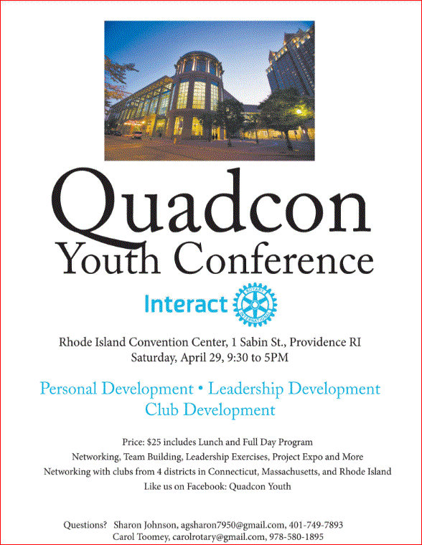

Interactors from all over the District 7910 are getting excited about theYouth Conference to be held as part of the Multi District Conference - QuadCon, for short - this April 28 through 30 in Providence. Check Quadcon web page for updates.

Four important things to know:

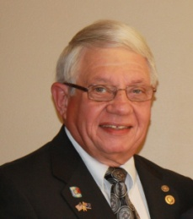
1. The weekly submission deadline for the Newsletter is Friday. As usual, text content must be submitted in Word format, and image content, in either JPEG or PDF format. Continue to submit your content to Immediate Past District Governor/Newsletter Editor Jim Fusco at jim.fusco2@gmail.com.

2. Rotary Youth Leadership Awards: The RYLA Club Pack has been updated and posted on RYLA7910.org. When you download it, you will notice changes from last year. Please read the material carefully and direct your questions to Christine Pinney, chair of the RYLA Committee,who may be reachedat christine@christinepinney.com. The RYLA season has begun and the RYLA Committee is working to make RYLA 2017 the "best RYLA ever." (See RYLA article, right-hand column.)

3. Club Planning Worksheet: To download the Club Planning Worksheet, click here.This worksheet is made available to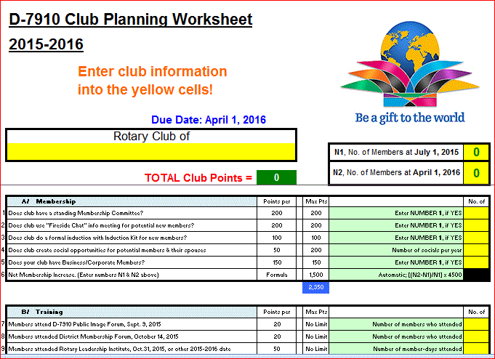 clubs so they can gauge their progress in achieving the goals they set last July. This month is a good time to review the worksheet and see how far you have come and how much farther you need to go as a club. You may surprise yourselves and realize that you are well on the way to earning district recognition. We recommend the club president appoint the president-elect to be the "champion" of the Worksheet, and to use it as a guide for the club, and to report monthly to the club's membership and board on the club's progress.

4. As your district governors, we have resolved to: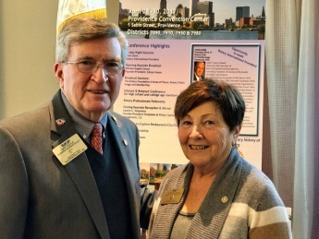
- Revisit as many clubs as possible in the next few months.
- Help our clubs achieve the goals they set in July
- Do all we can to build membership in the district
- Plan a grand event to celebrate our Million Dollar Foundation Journey
- "Move the ball forward," in harmony, with District Governor-ElectKarin Gaffney, District Governor-Nominee Steve Sager and District Governor-Nominee-Designate Pamela Anastasi
- Celebrate all of this at our Multi-District Conference this April in in Providence
'GOVERNOR'S MESSAGE' PAGE (in case you want to share a link to this article)

District Governors Pat and Skip Doyle (shown, right) may be reached
at pwdoyle2@verizon.net and skipdoyle2@verizon.net, respectively.

Click here to submit content for the Tuesday, April 11 issue. The submission deadline for this issue is Friday, April 7.

Click here for past issues.

WELCOME, NEW ROTARIANS
Alphabetical, by last name

- Sarlah Bernard, Nashoba Valley
- Glen Bunnell, Nashoba Valley
Remember to ask ... ask ... ask!

DISTRICT SCHOLARSHIP DEADLINE: EXTENDED TO APRIL 15

Applications Sought for David and Eleanor Morley Endowed Global Grant Scholarship

- To learn more about the Morley Scholarship, click here.
- To download the application in Word format, click here.
- To download the application in PDF format, click here.
- To download the flyer in PDF format, click here.
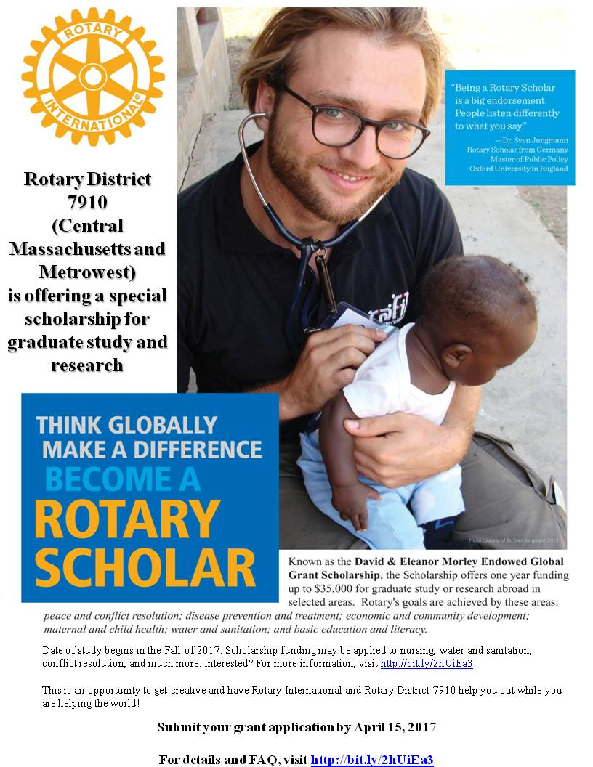

ESSEX BLOG
Thai And Stop Me: Flag ceremony

By Cassidy in Thailand

READ MORE

Cassidy is an Eastern States Exchange Student sponsored by the Rotary Club of Uxbridge. To visit their website, click here. To learn more on ESSEX, click here.

DISTRICT & CLUB ROUNDS
Acton-Boxborough, Littleton Presidents Tie The Knot

Congratulations to Joe Badenhoff and Corrine Braciska, who joined hands in marriage last Saturday. Joe is president of Acton-Boxborough Rotary, and Corrine is president of Littleton Rotary.

To learn more on Acton-Boxborough Rotary, click here.

To learn more on Littleton Rotary, click here

Fitchburg Holds Foundation Night

During Fitchburg Rotary's recent Foundation Night, six of the club's members received Paul Harris Recognition awards for their giving to The Rotary Foundation.

Left to right: Member Gerry Martel; club Foundation Chair Mary Whitney; District Governor-Nominee Steve Sager; Immediate Past District Governor Jim Fusco
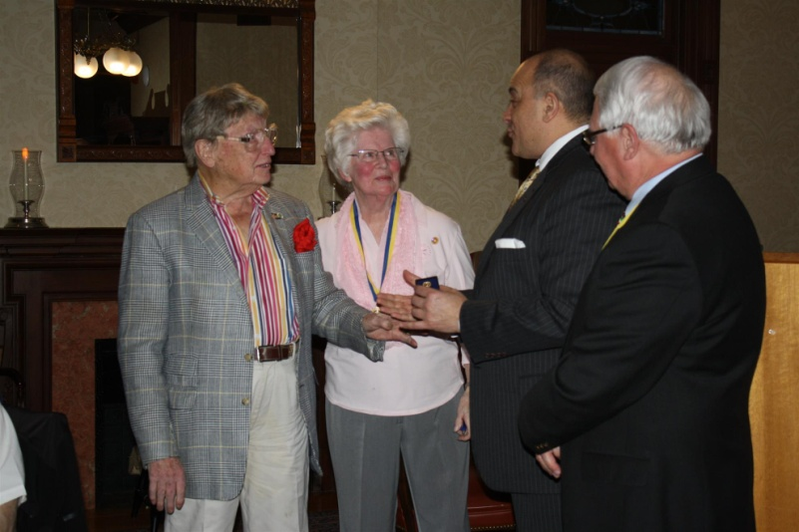

To learn more on Fitchburg Rotary, click here.

Nashoba Valley's Sandy Mahoney Presented Paul Harris +4 Recognition

Left to right: Past President Carol Toomey; Past President Sandy Mahoney; and District Foundation Chair Sanjay Deshpande
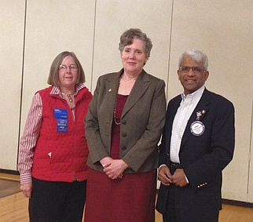

To learn more on Nashoba Valley Rotary, click here

Framingham Co-Sponsors Training for Service Dog 'Harris'

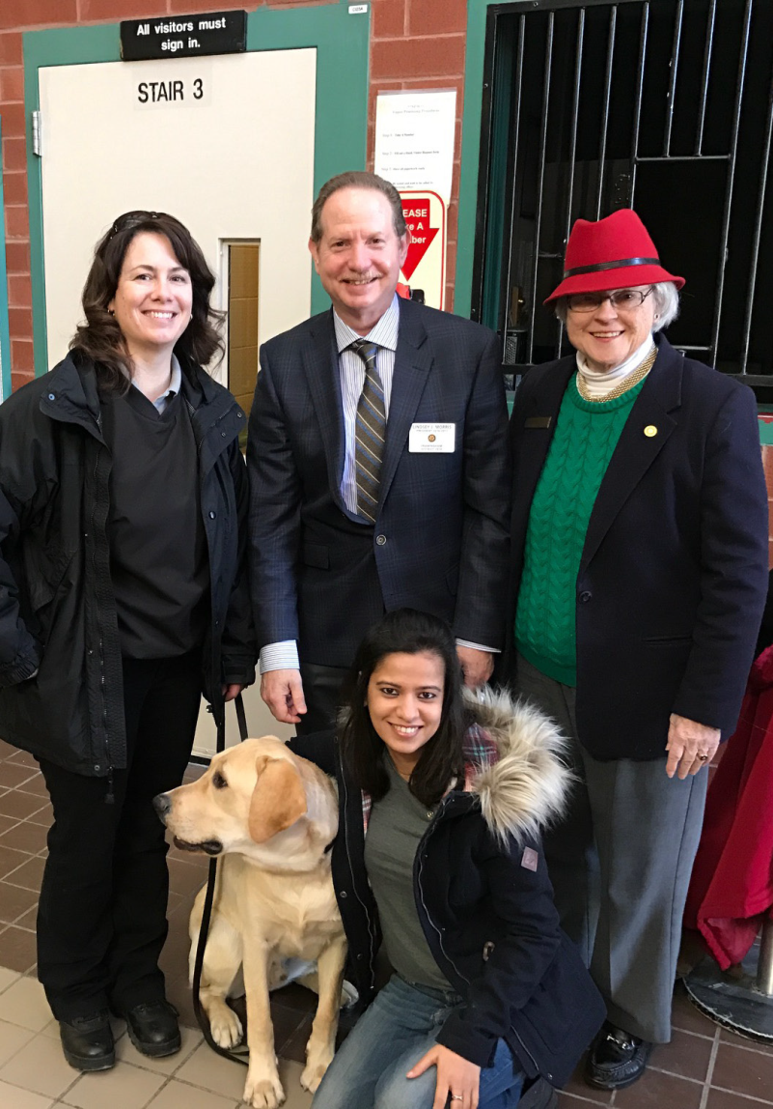Framingham Rotary is co-sponsoring the training of a service dog that club members have named“Harris”—in honor of Paul Harris, the founder of Rotary International.

Kneeling: MCI Framingham trainer Laura Galvani, withHarris. Standing, left to right: Framingham club PresidentLindsey Morris, and Framingham RotariansShikha Dhiyani and Sherrie Whitemore.

READ MORE

Framingham has teamed up with Wachusett Area Rotary on a District Grant project to support NEADS –National Education for Assistance Dog Services. As part of the various activities around that grant, Wachusett Area held a club meeting on March 3 at the NEADS campus in Princeton, arranging a tour of the various buildings as part of the visit.

WATCH VIDEO OF MARCH 3 EVENT

- To learn more on NEADS, click here.
- To learn more on Framingham Rotary, click here.
- To learn more on Wachusett Rotary, click here.

Franklin Inducts Crissy Beard As Newest Member

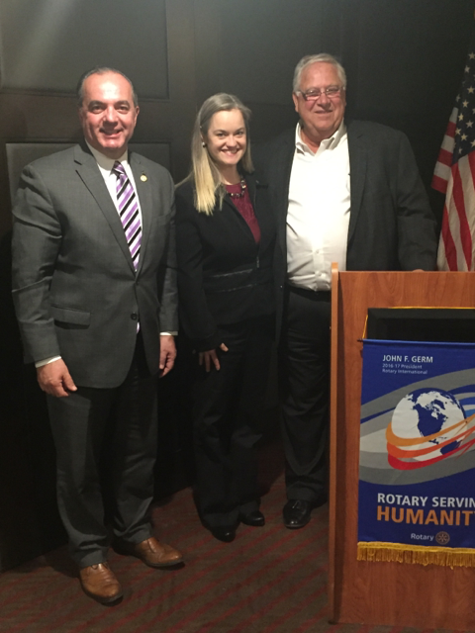

Left to right: President Terry Katsaros, Dr.Crissy Beard, and club Member Dan Gentil, who conducted the installation.

To learn more on Franklin Rotary, click here.

Montachusett Area Inducts Stephanie Hyles As Newest Member

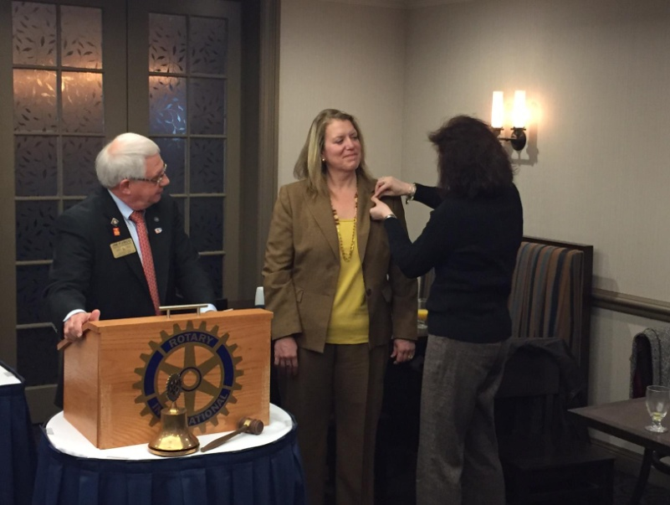
Left to right: Club Member and Immediate Past District Governor Jim Fusco, club Member Stephanie Hyles, Leominster Credit Union, and club member Maila Berry, who sponsored Stephanie.

To learn more on Montachusett Area Rotary, click here.

Needham Delivers Daffodils To Area Nursing Home

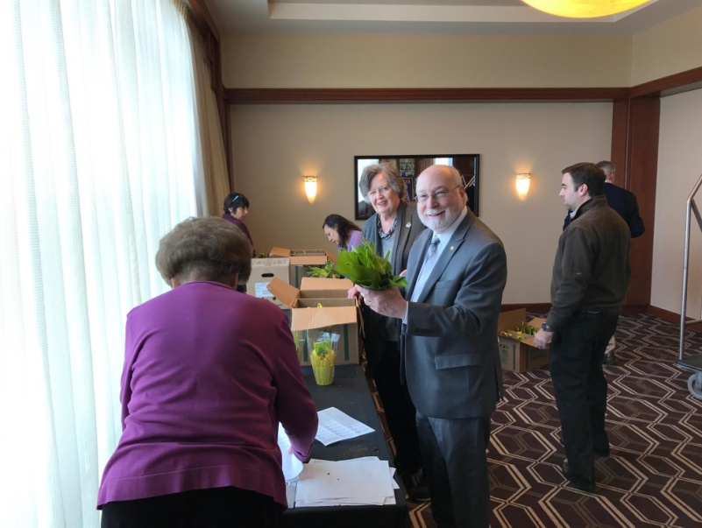
President Ted Shaughnessy (center) helps label 400 daffodils, which were delivered to all the area nursing homes.

To learn more on Needham Rotary, click here

Multi-Club Effort Does Fourth Year In Row Of Food Packaging

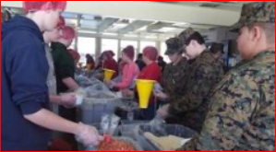The event was sponsored for the fourth consecutive year by the seven Rotary Clubs of Acton-Boxborough, Clinton, Hudson, Littleton, Nashoba Valley, Wachusett Area and Westborough. The Interact Clubs of Nashoba and West Boylston, along with the Littleton High School Humanitarian Club, also sponsored this year's event.

READ MORE

To learn more on:
- Acton-Boxborough Rotary, click here
- Clinton Rotary, click here
- Hudson Rotary, click here
- Littleton Rotary, click here
- Nashoba Valley Rotary, click here
- Wachusett Area Rotary, click here
- Westborough Rotary, click here

Auburn, FAME's Education Fundraiser Nets $2,000 for Music-Education Scholarships, Other Charitable Endeavors

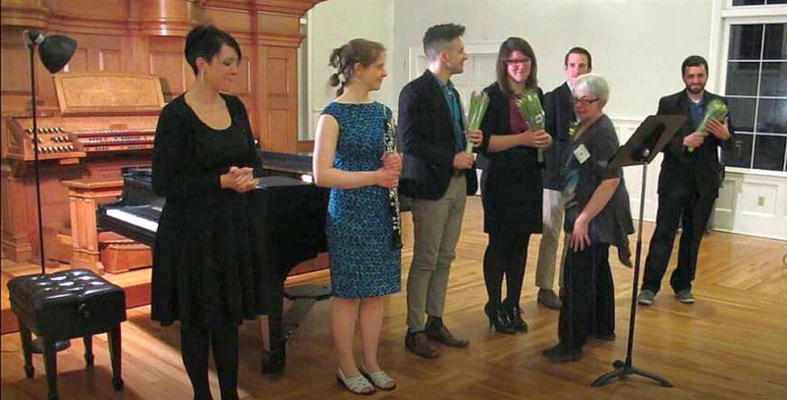Auburn Rotary thanks everyone who attended and/or volunteered for the March 17 Auburn Rotary and Friends of Auburn Music Education's 2017 St. Patrick's Day Music & Wine Fundraiser for Education at Auburn's Pakachoag Church. The festive event raised about $2,000 for music-education scholarships and other charitable endeavors

READ MORE & VIEW EVENT PHOTO AND PERFORMANCE VIDEOS

To learn more on:
- Auburn Rotary, click here
- Friends of Auburn Music, click here
- Professional Oboist Lydia Consilvio, click here
- Auburn Public Schools' Fine Arts Department, click here

Needham Looks for the Sky

READ MORE

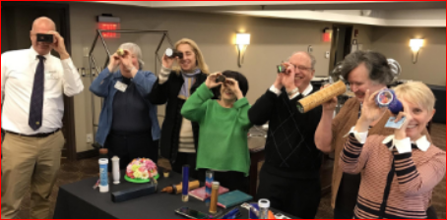

To learn more on Needham Rotary, click here.

Uxbridge Wine & Chocolate Fundraiser A Huge Success

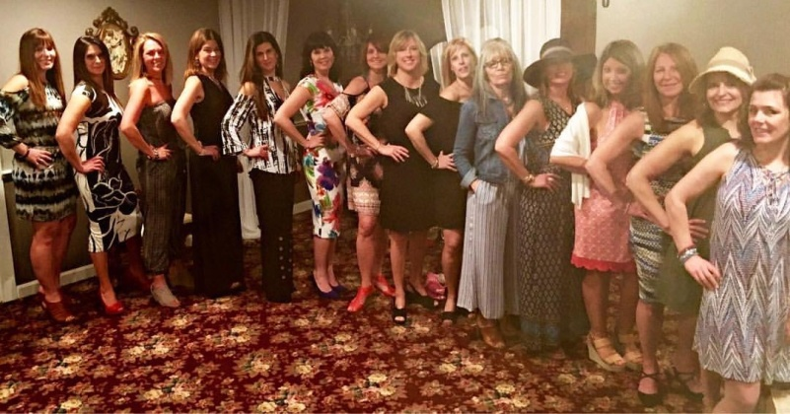

To learn more on Uxbridge Rotary, click here.

RI PE Ian Riseley Attends, Addresses NorthEast PETS in Framingham
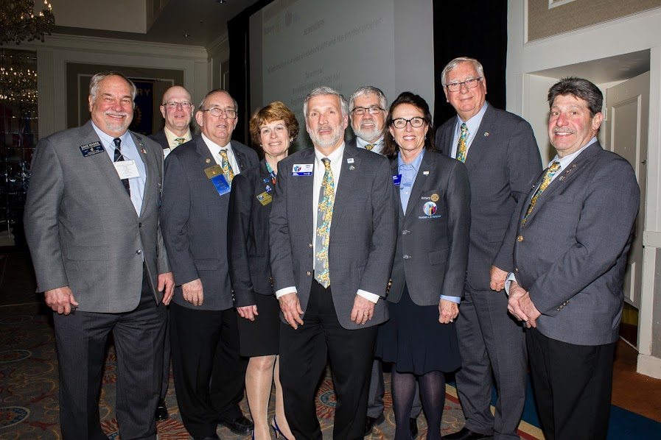
Shown at the 2017 Northeast Presidents Elect Seminar last Thursday in Framingham, are the eight governors-elect in the Northeast posing with Rotary International President-Elect Ian Riseley (second from right). Among the DGEs is our own Karin Gaffney (third from right).

To view event photos by District 7910 Photographer Cheryl Rosen, a member of the Rotary Club of Hudson, click here.

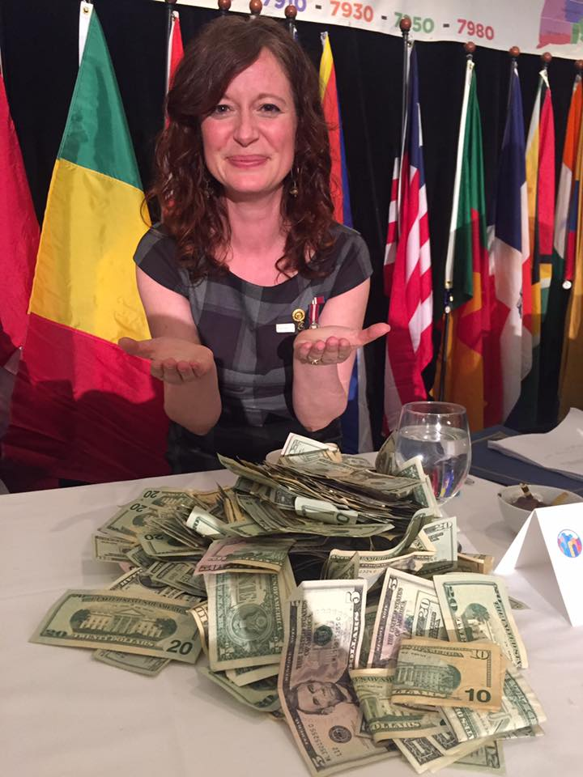Spontaneous donations at NEPETS totaled $5,500 for a Right to Read literacy project run by Shirley-Pat Chamberlain (shown, left) of the Rotary Club of Williams Lake, British Columbia. All eight districts decided to match the contribution, bringing the total up to$11,000. That is enough to fund half the$22,000 cost to get the library up and running.

Auburn, Horses and Heroes Foundation Saddle Up for Tarentino Strong

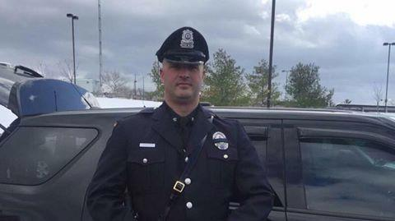Auburn Rotary and the charitable, non-profit Horses and Heroes Foundation just got a nice write-up in Worcester Magazine for their collaborative effort to dedicate a police-patrol horse, Tarentino Strong, in honor of Auburn Police Officer Ronald Tarantino Jr. (shown, left) who was shot and killed in the line of duty last year during a routine traffic stop. The Dedication Ceremony will be held in early May in Auburn. The horse is being purchased by the Revere-based Horses and Heroes Foundation, led by Skyllar Mullvaney, a member of the Rotary Club of Malden. The Foundation has bought and donated more than a dozen police-patrol horses in recent years in honor of police officers who were "involved in a selfless and heroic act while on duty."

READ WOMAG ARTICLE

To learn more on Auburn Rotary, click here.
To learn more the Ronald Tarentino Jr. Memorial Scholarship Fund, click here.

Chelmsford Honors Student of the Month

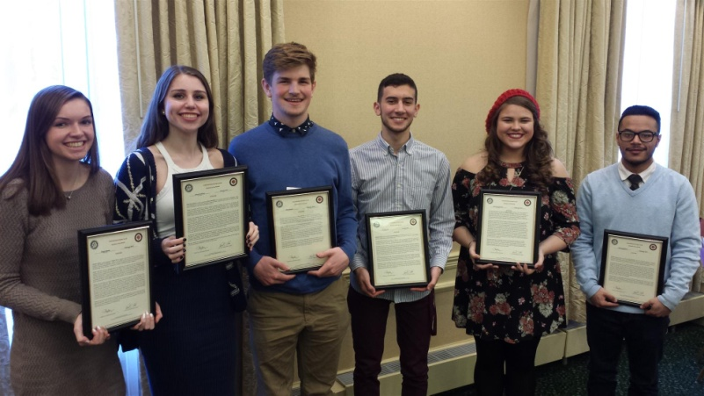

To learn more on Chelmsford Rotary, click here.

In Support of Polish-Ukrainian Rotary Project

By Roy Balfour
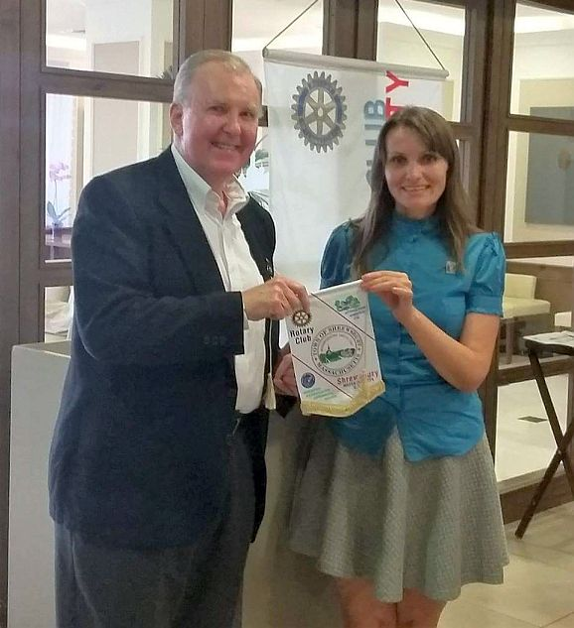
The Polish-Ukrainian Rotary project deals with rehabilitation in Poland of a group of 25 Ukrainian children who are 10 to 12 years old, plus three accompanying adults. The children belong to families who lost their parents in the war unleashed in the East of Ukraine. This project has been successfully going on for the last three Rotary years successfully, and its main financial burden was carried by Polish Rotary clubs.
READ MORE

Montachusett Area Hears from AG Kevin Fry on Hero's Cup Hockey, April 21-23

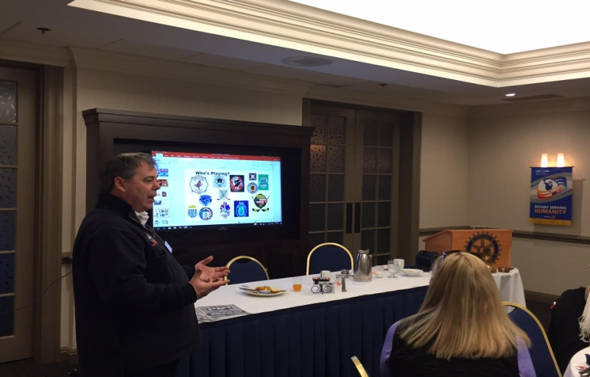
Assistant Governor Kevin Fry is shown addressing the membership at a recent meeting of the Rotary Club of Montachusett Area at the DoubleTree Hotel in Leominster. He spoke about Hero's Cup Hockey on April 21 to 23.

The weekend-long event designed to bring firefighters, police officers, EMS, and military members together in a fun weekend to raise money and awareness for multiple charities. Each team will be playing for the charity of their choice, with a cash prize going to the winning teams charity of each division.

LEARN MORE

To learn more on Montachusett Area Rotary, click here.

Multi-Club Power Play: Needham Teams Up with Framingham, Newton, Waltham and Watertown on India Solar-Power Project

Needham, Framingham, Newton, Waltham and Watertown Rotary have partnered to fund a $6,000 solar-power project (shown, left) for Film Nagar High School in Hyerabad, India. The host club there is the Jubilee Hills Rotary, in District 3150.

Needham paid $3,000 of the $6,000 - $1,500 of which should come back as District Grant match. Watertown, Waltham, Newton and Framingham paid $500 each.

READ MORE

To learn more about:
- Framingham Rotary, click here
- Jubilee Hills Rotary, click here
- Needham Rotary, click here
- Newton Rotary, click here
- Waltham Rotary, click here
- Watertown Rotary, click here

Great Club Fundraising Tool: Westborough uses PayPal to raise nearly $2,000 for Polio Plus

READ MORE

To research charities that have a registered 501(c)3 account with PayPal, click here.

To learn more about Westborough Rotary, click here.

District Highlights Fundraising Goals in Video

We are all well aware that The Rotary Foundation is celebrating its 100th anniversary in 2017. Steve Kirk, president of Concord Rotary, has produced a five-minute video that outlines our own district’s fundraising goals for the current Rotary year, which ends this June 30.

WATCH VIDEO

To learn more about The Rotary Foundation, click here.

Watch Video: Governor Baker Addresses District 7910 Rotarians

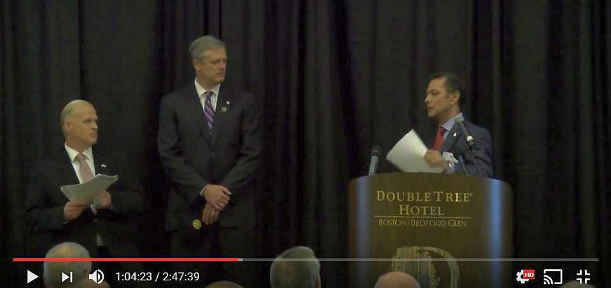
The Rotary Club ofBillerica has provided a video of Governor Charlie Baker's address to District 7910 Rotarians last September 27 at the DoubleTree Hotel in Bedford.
To watch the two-hour-47-minute video, click here.

The Rotary Clubs of Bedford, Billerica, Lowell, Newtonand Shrewsbury sponsored the event, which was a unique opportunity for Rotarians and friends to discuss partnering on humanitarian projects affecting our local communities. To view event photos, click here.

To learn more on:
- Bedford Rotary, click here
- Billerica Rotary, click here
- Lowell Rotary, click here
- Newton Rotary, click here
- Shrewsbury Rotary, click here
- Wachusett Area Rotary, click here

See You at RI Convention This June in Atlanta: Register now!

For more information on the RI Convention, click here & click here

Planning to attend? Contact District RI Convention Chair Steve Glines.

To learn more, click here.

To register for the 2017 RI Convention in Atlanta, click here.

Pat and Skip Doyle Installed as '16-'17 DGs

To watch a video of the installation, click here.

MAJOR DISTRICT & CLUB HAPPENINGS: SPRING 2017

Friday, April 7: Concord - 'Pops for a Playground'

To download event flyer, click here

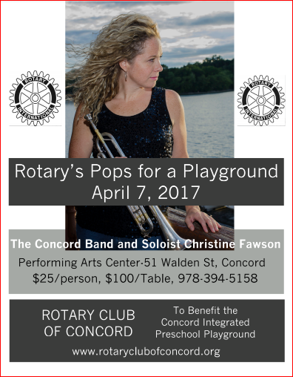

Saturday, April 15: District 7910 - 'Extended application Deadline for David and Eleanor Morley Endowed Global Grant Scholarship'

- To learn more about the Morley Scholarship, click here.
- To download the application in Word format, click here.
- To download the application in PDF format, click here.
- To download the flyer in PDF format, click here.

Friday April 21: Wachusett Area - 'Cruisin' Sock Hop'

To download donation & registration form in PDF format, click here

Friday, April 21: District - "Submission Deadline for Spring 2017 Interact Video Contest'

To download flyer in PDF format, click here

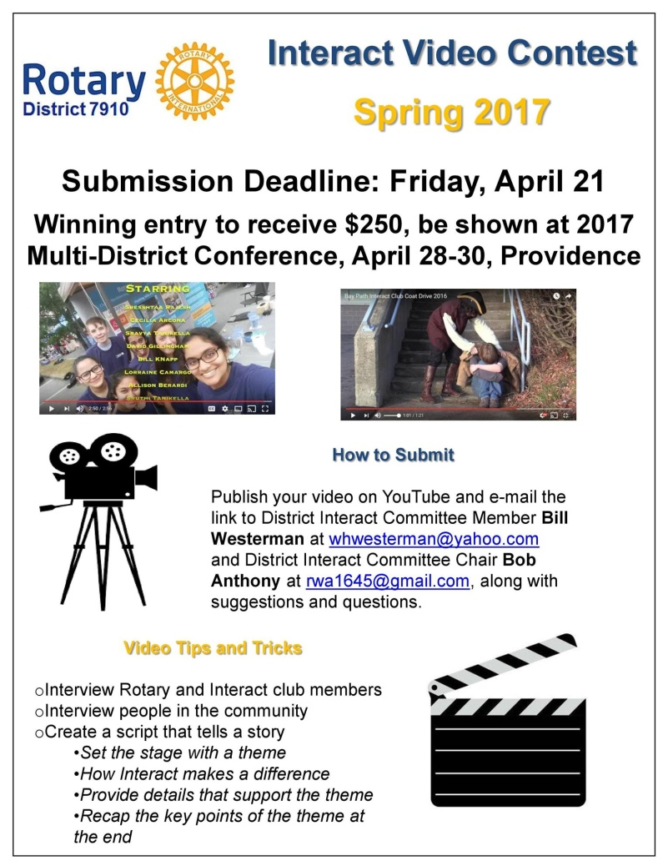

Saturday, April 29: Multi-District - 'Youth Conference'
To register, click here.

To download 2016-2017 Presidential Citation for Interact Clubs, in PDF format, click here

To download event flyer, in PDF format, click here
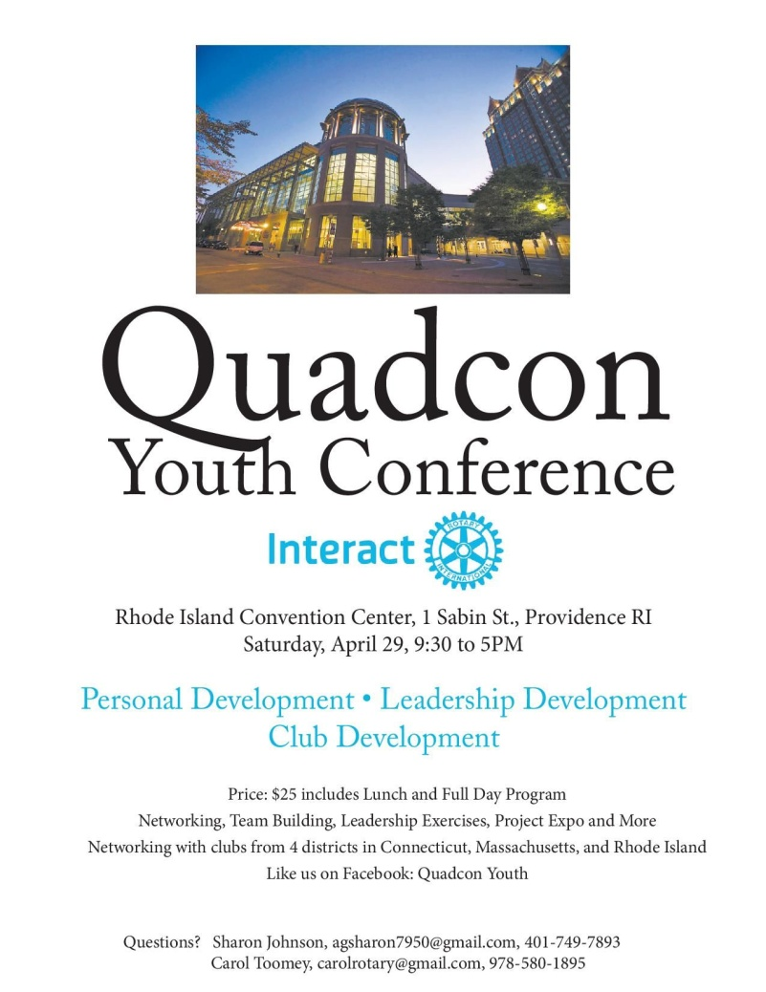

Saturday, May 6: Worcester - 'Casino Night To Build a Playground for Inner-City Kids'

To download Sponsorship Opportunities form in PDF format,click here

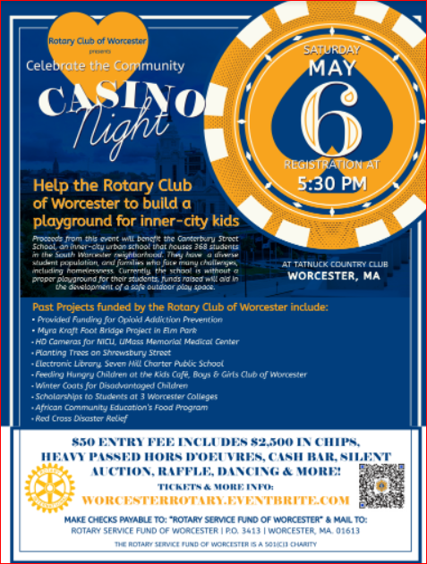

Sunday, May 7: Auburn - "Auburn Cub Scouts Pack 53 Needs Your Treasures'

To download flyer in PDF format, click here

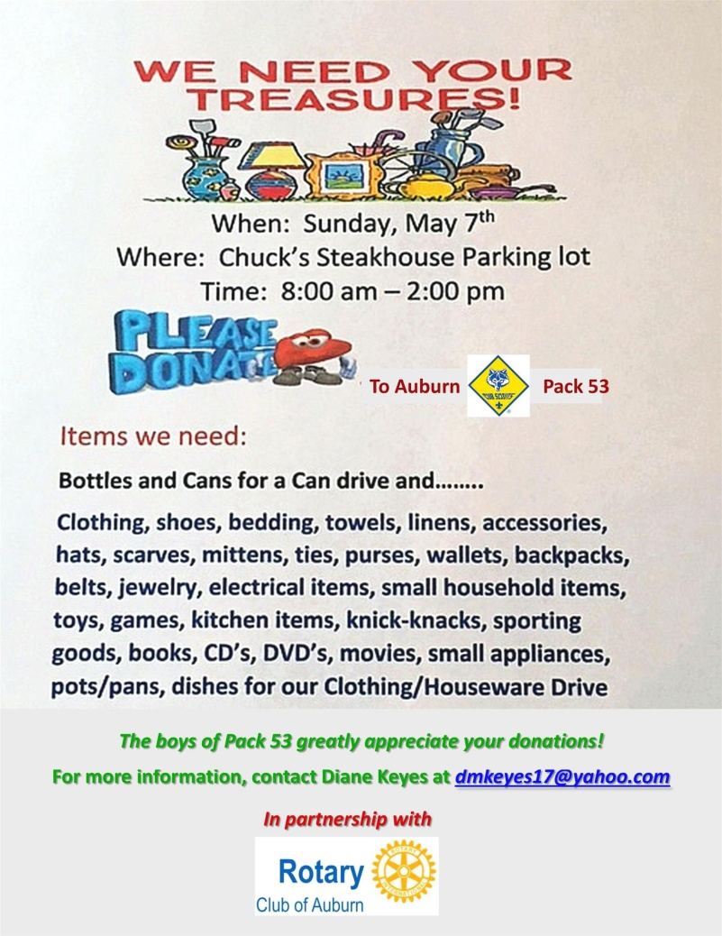

Saturday May 13: Newton - 'Newton Has Talent!'

To download event flyer in PDF Format, click here

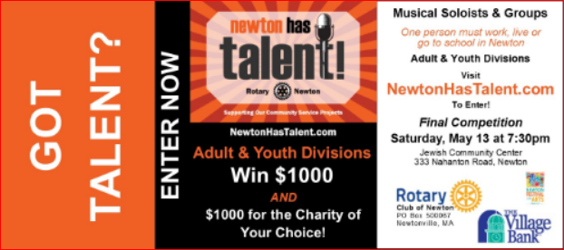

Saturday, May 13: Multi-District - 'Interact Summit'

To download event flyer in PDF format, click here
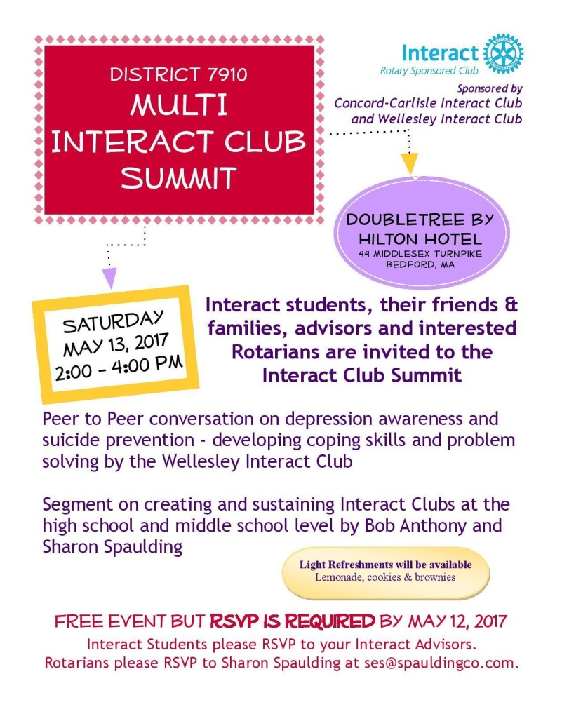

Thursday, May 25: District 7910 - 'Million Dollar Journey Dinner'

To register and pay, click here

To download the event flyer in PDF format, click here

To download the event flyer in JPEG format, click here

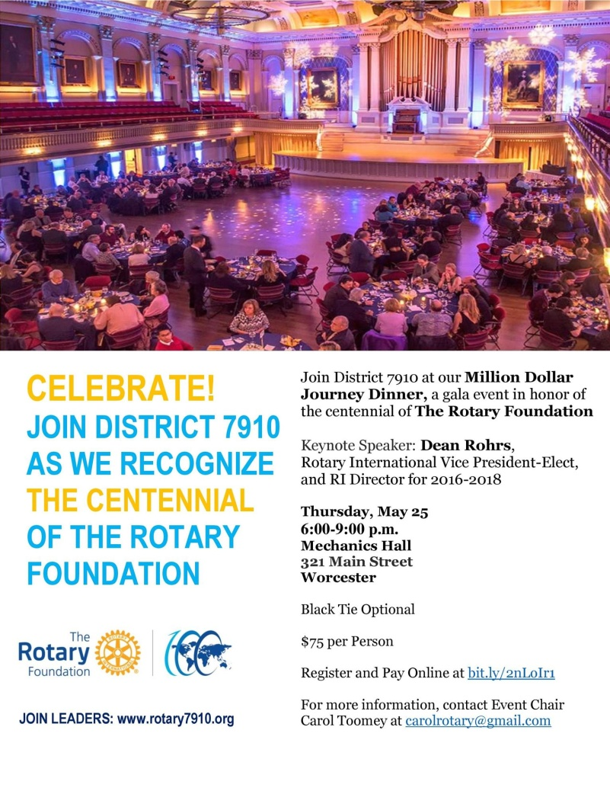

SUBMIT MAJOR CLUB HAPPENINGS
Send flyers of your club's major events and activities, in either JPEG or PDF format, to Immediate Past District
Governor/Newsletter Editor Jim Fusco at jim.fusco2@gmail.com.

