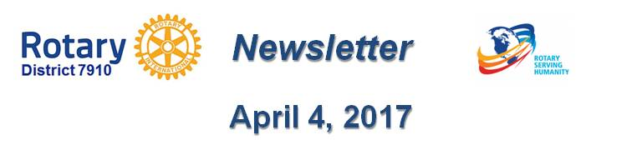

District 7910 To Celebrate Centennial Of Rotary Foundation With Million Dollar Journey Dinner On May 25 At Mechanics Hall
By Satya Mitra and Sanjay Deshpande
Join District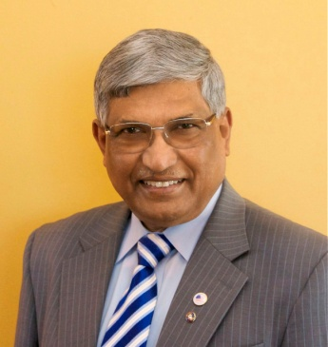 7910 at its Million Dollar Journey Dinner, a gala event in honor of the centennial of The Rotary 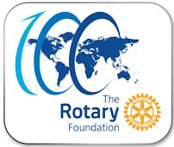Foundation, on Thursday, May 25 from 6:00 to 9:00 p.m. at Mechanics Hall in Worcester. The cost of the Million Dollar Journey Dinner, which is open to both Rotarians and non-Rotarians, is $75 per person, and includes dinner. To register and pay, click here.
To download the event flyer in PDF format, click here
To download the event flyer in JPEG format, click here

The keyn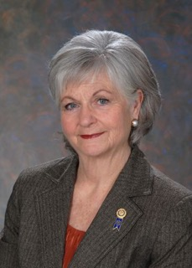ote speaker will be Dean Rohrs (shown, left), vice president-elect of Rotary International, and an RI director for the 2016-2018 Rotary years. The purpose of the charitable, non-profit Foundation, which was founded in 1917, is “doing good in the world.”
Under the leadership of District 7910 Assistant Governor Satya Mitra (shown, above, left) chair of the district’s Million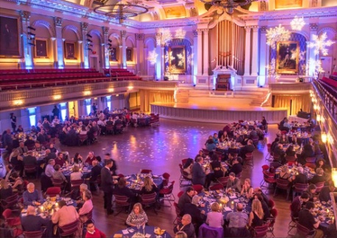 Dollar Journey Subcommittee, and a past president of the Rotary Club of Worcester, the Million Dollar Journey drive was launched seven months ago. In only six months, the campaign raised a total of $1.05 million.

"While I loved the challenge, Mitra states, “it is historically known that to raise this amount of money and receive major commitments usually takes two to three years. Traditionally, a project, to raise $1 million - comprised of direct giving and bequests – requires training by a Rotary Zone expert. The adviser and expert on Million Dollar Dinners in our Rotary Zone 32 was Past District Governor Mac Leask, who lives in Fairfield, Connecticut.

“Training is meant for 10 table captains, who are given the responsibility to do their best and together raise $1 million,” Mitra continues. “We had seven table captains. Mac was very graceful, coming all the way from Fairfield last November 17 to give us the training and all needed information, to help us accomplish the mission to raise at least $1 million. We are thankful to Mac for sharing his knowledge and ideas with us.”

The mission of Rotary’s Million Dollar Journey was to create an opportunity for Rotarians members and friends to give or pledge to the Rotary Foundation’s Endowment Fund a cumulative total of $1 million in the form of one or more of the following:

- An outright contribution - major gift - of at least $10,000 in cash or appreciated stock
- A bequest of at least $10,000 established through one’s will
- The designation of the Foundation as a beneficiary for at least $10,000 in a life-insurance policy, including a term policy or a retirement account such as a 401(k), 403(b) or IRA
- A commitment to donate only $277.78 per month for 36 months - totaling $10,000
Sanjay De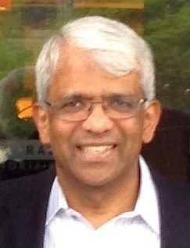shpande (shown, left), chair of District 7910’s Foundation Committee, has congratulated the district’s Million Dollar Journey team, adding, “Although we have reached the million-dollar target, we are not stopping here. We will continue to bring in more donations and bequest pledges, to add more to the endowment funds of the Rotary Foundation, and continue this journey. Please be generous and support our mission. While 2016-’17 - being the 100th year of the Rotary Foundation and the very first year our district has launched a Million Dollar journey - is the best year to contribute, the District Foundation Committee will strive to raise pledges of another $1 million during 2017-‘18.

“Let’s all contribute to the best of our ability and, thus, do more good in the world,” Deshpande continues. “When these pledges do get realized, each $1 million in the Rotary Foundation’s Endowment Fund will generate at least $20,000 in district-designated funds for our District and Global Grants programs.”

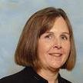For more information on District 7910’s Million Dollar Journey Dinner, and to make a donation to our Million Dollar Journey Fundraiser, contact either Satya Mitra at 508-641-8441 or satya@thegurutax.com, or Carol Toomey (shown, left) at 978-580-1895 or carolrotary@gmail.com.

About The Rotary Foundation

In 1917, Rotary International President Arch C. Klumph (shown, left) proposed an endowment "for the purpose of doing good in the world." His vision became The Rotary Foundation.

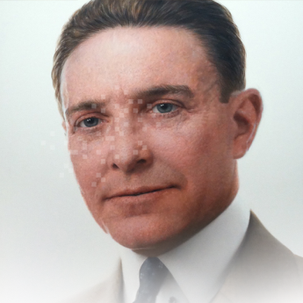The Foundation transforms gifts into projects that change lives both close to home and around the world. As the charitable arm of Rotary International, the Foundation taps into a global network of Rotarians who invest their time, money, and expertise into Foundation priorities, such as eradicating polio and promoting peace. Foundation grants empower Rotarians to approach challenges such as poverty, illiteracy, and malnutrition with sustainable solutions that leave a lasting impact.

Strong financial oversight, a stellar charity rating, and a unique funding model mean that the Rotary Foundation makes the very most of every dollar of each contribution. Give, and become a part of Rotary’s life, thus leaving behind your own legacy of doing good in the world!

Sanjay Deshpande, chair of the District Foundation Committee, may be reached at sanjdesh51@aol.com.

Satya Mitra, chair of the District Million Dollar Journey Subcommittee, may be reached at satya@thegurutax.com

For the Foundation Notes archive, click here

Learn more about District 7910 Foundation Grants:
- Timeline for District 7910 Foundation Grants (Web Page)
- District 7910 Monthly Club Contribution Report - Total Per Capita as of December 30, 2016 (PDF Format)
- District 7910 Monthly Club Contribution Report - Alphabetical as of December 30, 2016 (PDF Format)
- Rotary Areas of Focus Policy Statements (PDF Format)
- District 7910 Eligible and Ineligible Activities in a District Grant (Word Format)
- District 7910 Grant Qualification Table (PDF Format)
- District 7910 Grant Proposals and Qualifications Status (Web Page)
- District 7910 2015-2016 Foundation Contributions Report - (Excel Format)
- Foundation Grants in 2016-'17 and Beyond (PDF Format)
- District 7910 2016-2017 District Grant Proposal Template (PDF Format)
- District Grant Proposal Form (Word Format)
- Global Grant Proposal Form (Word Format)
- District 7910 District Grants Scoring Rubric (PDF format)
- District 7910 Club Memorandum of Understanding (PDF Format)
Return to April 4 Newsletter

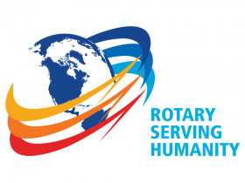Visit our website
'Like' our Facebook page
'Follow' us on Twitter
Watch our videos
View our photo albums

