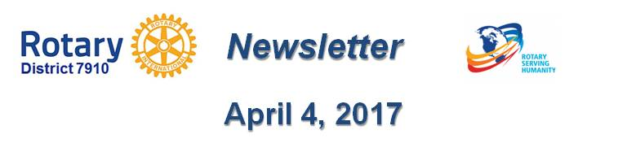

Promote Your Service Projects
By Laura Spear

Promote your service projects! Watch this Rotary webinar on demand, to learn tips and tricks for
promoting your service projects.

In this fifth webinar in a series, you will learn about the importance of comparing project outcomes to original goals and how to capitalize on lessons learned, how to evaluate your project and maximize its sustainability, and available Rotary resources to help you
share your service-project story with the world.

To view the webinar on Service Projects, click here.

New Rotary logo

You may have noticed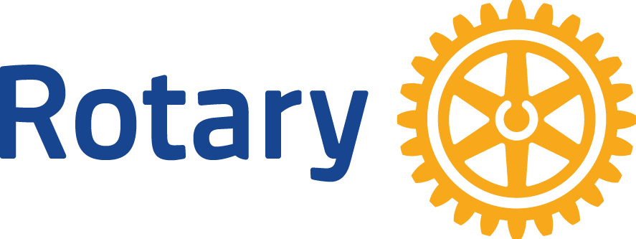 that as of last July 1, we have not distributed any flyers, notices, or announcements that use the old Rotary logo. We want to avoid confusion, build awareness and trust in our Rotary brand, and through consistency, attract new members, donors, and community support.You have pr
You should be doing the same. Use only this "new" Rotary logo and branding.

To learn more, click here and click here.

To learn more in Rotary Voice and Visual Identity Guidelines, click here.

To learn more about PR for your club, click on the Public Relations section of the navigation bar of the District 7910 website.

Laura Spear, chair of District 7910's Public Relations Committee, may be reached at laura@spear.net.

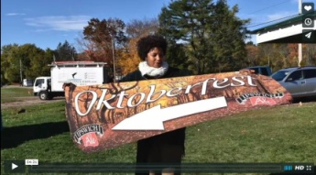Click here for an excellent example of a club-event promotional video by Concord President Steve Kirk.

Return to April 4 Newsletter

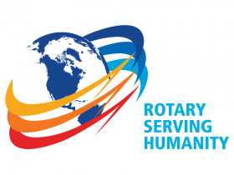Visit our website
'Like' our Facebook page
'Follow' us on Twitter
Watch our videos
View our photo albums

