COMMITTEE REPORTS
District 7910 To Celebrate Centennial Of Rotary Foundation With Million Dollar Journey Dinner On May 25 At Mechanics Hall

By Satya Mirta and Sanjay Deshpande

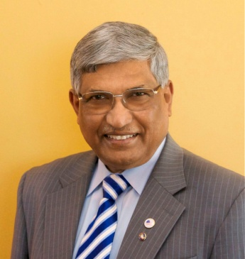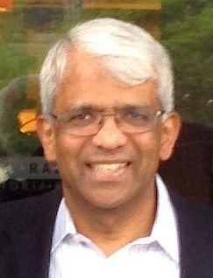

READ MORE

RI President Ian Riseley Announces '17-'18 Rotary Theme ...
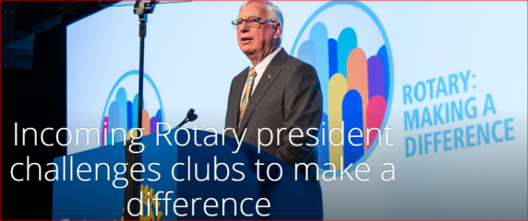
... And Here It Is
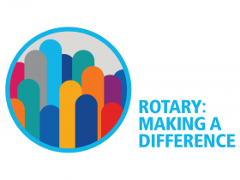

RYLA Right Now: Collect applications, interview, choose your students

By Christine Pinney

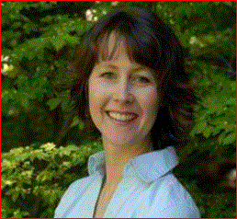

READ MORE

To download the RYLA information flyer, click here.

Interact Actions: Please make it possible for your Interactors to attend April 29 Youth Conference in Providence

By Bob Anthony
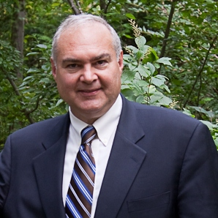

READ MORE
Spring 2017 District Interact Video Contest: April 21 Submission Deadline
LEARN MORE
2017 Multi-District Conference: Youth Conference
- To register, click here.
- To download 2016-2017 Presidential Citation for Interact Clubs, in PDF format, click here
- To download event flyer, in PDF format, click here
How to launch an Interact club

WATCH VIDEO

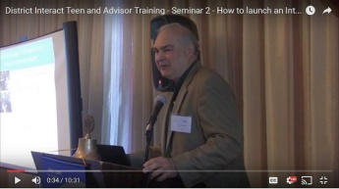

Our Interact family is growing

The Interact Club of Montachusett Vocational Technical High School was chartered by the Rotary Club of Montachusett Area on February 15.

Polio Plus Update: The Rotary Foundation makes it much easier

By Carl Good III

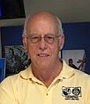

READ MORE

Foundation Note: Foundation-Giving Scorecard as of March 3

By Sanjay Deshpande

READ MORE

Sixteen humanitarian trips have now been completed

By Dick Manelis

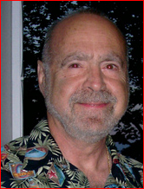

Sixteen humanitarian trips have now been completed on behalf of District 7910. We have been able to extend the hand of friendship and provide hope to hundreds of people in third-world countries in Centraland South America. These efforts are a partnership between those who volunteer their time and resources and the clubs that offer financial support for the various projects. Without both, we could not accomplish what we do. I would like to extend a special "thank you" to those clubs that have supported these efforts over the years: Dedham, Framingham, Marlborough, Montachusett Area, Nashoba Valley, Needham, Uxbridge, Westborough, and Uxbridge.

Past District Governor Richard Manelis, a member of Framingham Rotary, may be reached at manelis711@yahoo.com.

Rotary Blog: Is Rotary A Port In A World of Storms and Loneliness?

By Ron Goodenow

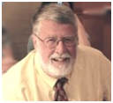

READ MORE

ESSEX Examples: Who's behind making us best

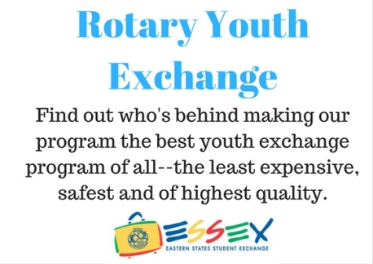

READ MORE

PR Tips: Promote Your Service Projects

By Laura Spear
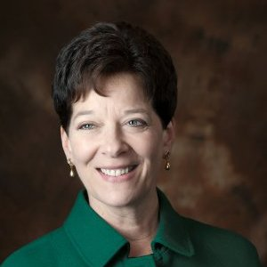

READ MORE

To view Service Projects Webinar, click here

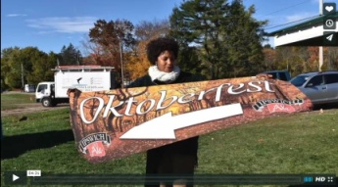

Click here for an excellent example of a club-event promotional video by Concord President Steve Kirk.
District Banners Available

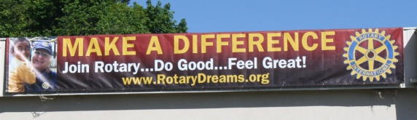

Our district banners are available for your use when you have an upcoming event or fundraiser.

If you want to reserve one of the banners, please contact PR Chair Laura Spear at laura@spear.net.

RLI Leads: Upcoming events

By David Kaiser

FAQs about RLI: Click here

What are the courses? Click here
To download the brochure with all of the RLI Northeast America classes for 2016-2017, click here.

For the complete RLI Northeast America schedule, click here.

Join Us at the RLI Breakfast at June's RI Convention in Atlanta

REGISTER AND PAY

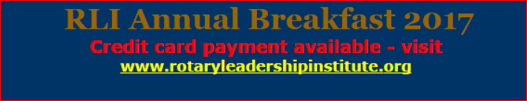

'17 RI Convention this June in Atlanta: Register now!

By Steve Glines

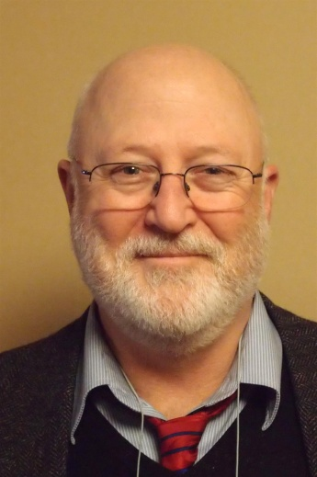

For more information on the RI Convention, click here.

To register now for the Beyond Borders Dinner on June 11, click here.

Bill Gates to be keynote speaker

READ MORE

More than 100 breakout sessions

There will be more than 100 breakout sessions at the RI Convention in Atlanta. Help us plan the sessions by taking a survey: TAKE SURVEY
To read a letter from Steve Glines (shown, above), chair of the District International Convention Promotion Committee, click here

To register and find hotel options, click here.

For more information on the 2017 RI Convention in Atlanta, click here

Club Central: Short video on how to post your club goals

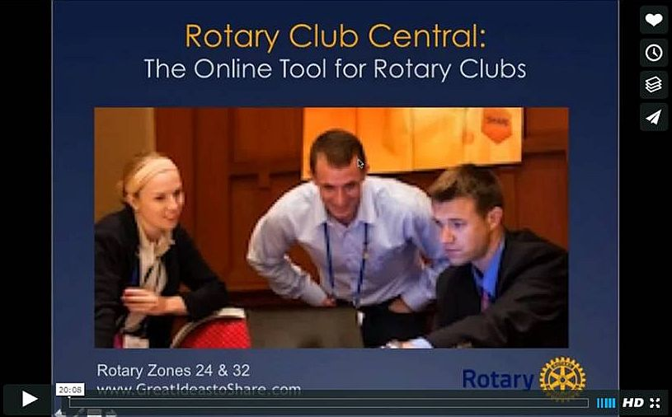

This 20-minute webinar recording is designed for club leaders to assist in posting goals on Rotary Club Central. Bob Wallace and Ian Lancaster, facilitators from Rotary Zone 24 East, provide practical start-up information. CLICK HERE

RAAGNE Newsletter: February 17 Edition

By Klaus Hachfeld

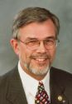

READ MORE

Speaker's Bureau: Looking for good speaker for your club?

By Steve Levitsky

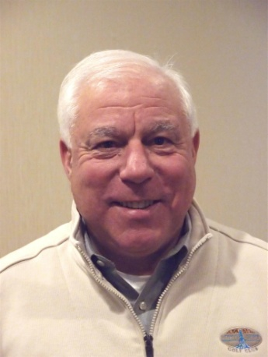

It's not always easy to come up with ideas week after week. We have many suggestions for you. Here are just a few:

- Power of the mind: Bob Martel - Newest topic addition to our list
- Rwandan genocide: Carine Boggis
- Elevator-pitch tips: Andy Winig
- Differentiation and game-changing simplicity: Stephen Melanson
VIEW MORE

District Charity Fund: How does DCF operate?

By Karin Gaffney
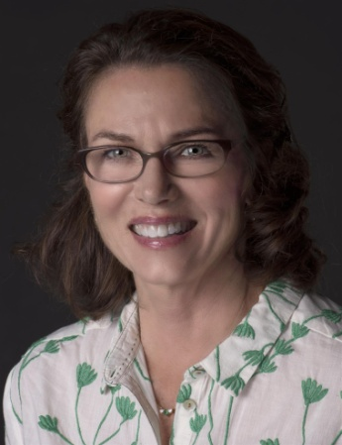

READ MORE

Communications Link: Seeking club photo, video albums
By Steve Jones-D'Agostino
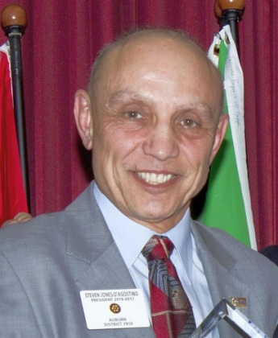

READ MORE

SUBMIT CONTENT
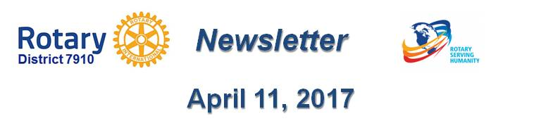

To submit content for consideration for the Tuesday, April 11 issue of Rotary District 7910 Newsletter, please e-mail it to Immediate Past District Governor and Newsletter Editor Jim Fusco at jim.fusco2@gmail.com.
The submission deadline for that issue is Friday, April 7. All text must be in Word format. All images must be in either JPEG or PDF format.
Please, please please... identify the people, left to right, who are shown in your photos, including their first and last names, and their club or other title/position.

PAST ISSUES
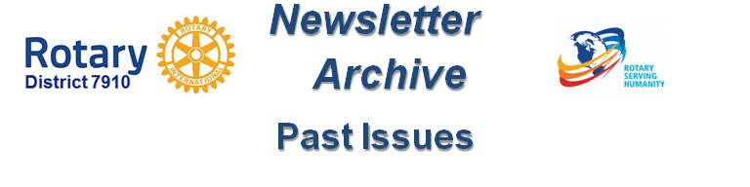

To view past issues of the weekly Rotary District 7910 Newsletter, click here

D7910 ONLINE
Visit Our Website

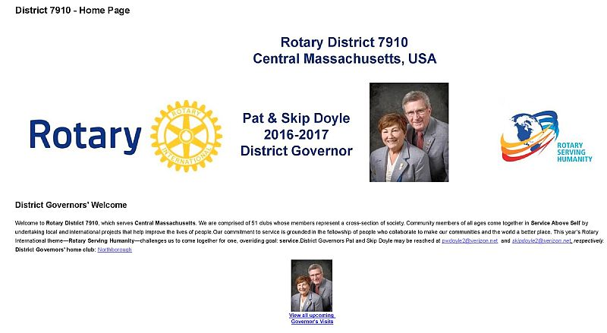
Click on each one

'Like' And Share Us On Facebook

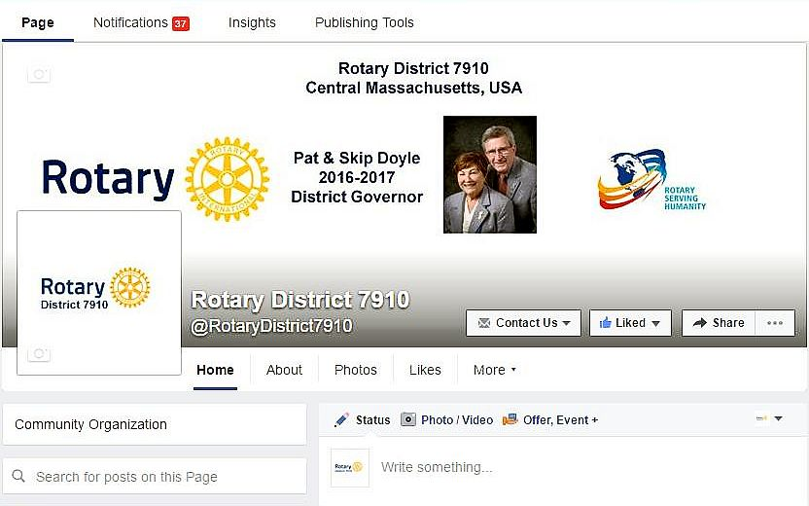

'Follow' Us On Twitter

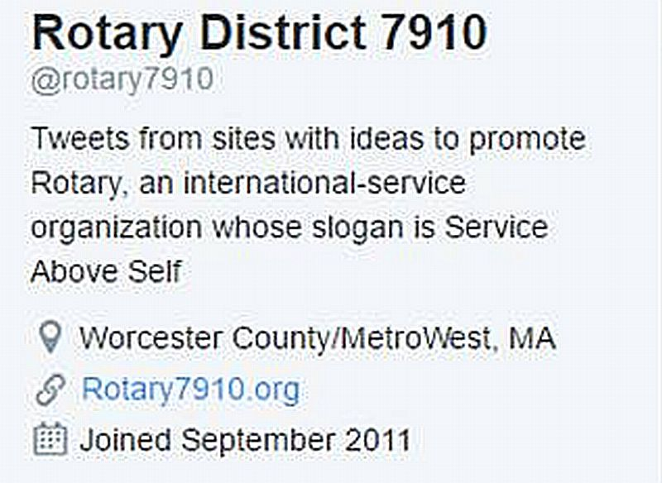

Watch Our Videos
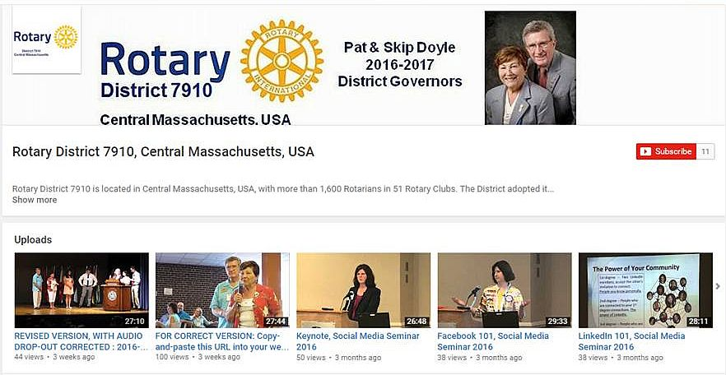

View Our Photos
Archived on Google Photos, since May 2015; and on ClubRunner, before May 2015
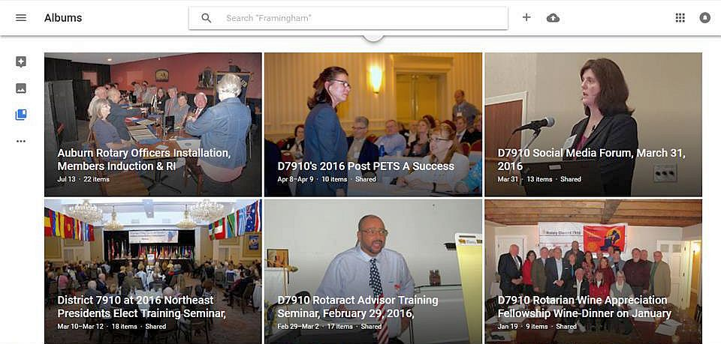

CONTACT US
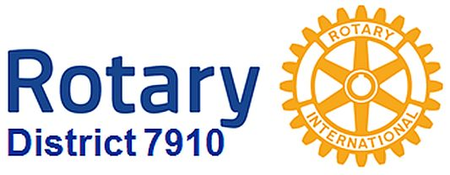

Jim Fusco, Immediate Past District Governor and Newsletter Editor
​jim.fusco2@gmail.com
Steve Jones-D'Agostino, District Webmaster and Newsletter Copyeditor
​srdagostino@icloud.com
© Copyright 2017-2018 - Rotary District 7910, Central Massachusetts and MetroWest, USA

