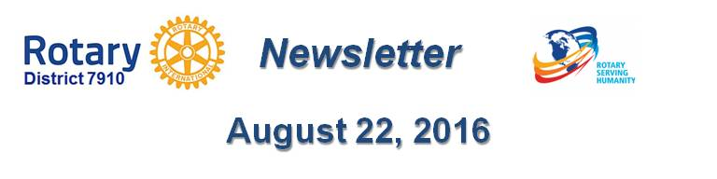

How Does DCF Operate?
By Karin Gaffney

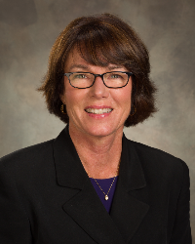The District Charity Fund is a 501(c)3 charitable, non-profit that can be used by the Rotary clubs in District 7910. To better explain how the DCF can be used, I have sent this letter to the club Presidents:

"The Fund is a 501(c)3 entity with a sales-tax exemption.

The purpose of the Fund is to provide a resource to clubs that do not have a 501(c)3 fund and need to provide donors with a charitable deduction for their contribution to your project.

If you would like to avail yourself of the Fund, be aware of the following provisions and requirements:

- The Fund can accept donations from any person or corporation at any time. The Treasurer will send out a “Thank you” for donations that are $100 or more.
- The release of funds from the Fund (for your project) requires two votes from the Trustees of the Charity Fund. If you have any questions regarding the appropriateness of using the Fund for your project, it is better to request that the Trustees vote prior to any solicitation. The Trustees must vote as follows:
a) That the purpose of the project is appropriate for a 501(c)3 entity to support - e.g. scholarships, medical project, food pantry.
b) That Charity Fund monies collected on behalf of a club may be distributed (to the extent of the funds received) as directed by the club for: (here would be the specific payees of the funds with an invoice or other documentation). The exact wording of the vote must be drafted to ensure that we comply with the requirements for a 501(c)3 expenditure.
- If the charity fund raiser requires an advanced deposit, appropriate documentation must be provided before any funds are reimbursed to the club. The Charity Trustees must vote before the disbursement to the club may be made.
- For any use of the Fund, there must be one and only one club member authorized to deal with the Charity Fund.
- All communications to and with the Fund must be directed to the Chair, Alan Bowers (alatbowers2@verizon.net) and not to the District Treasurer.
- Any collected funds specifically allocated shall be encumbered for a period of no longer than three years from receipt by the Fund. After three years, the encumbrance will be lifted and the Trustees may choose to use the then unrestricted funds for any other 501(c)3 charitable purposes as voted by the Trustees."
To read and download the Bylaws of the District Charity Fund, click here

Karin Gaffney, chair of the District Charity Fund, may be reached at karin.gaffney@rocklandtrust.com.

Return to November 28 Newsletter
Return to November 21 Newsletter
Return to November 14 Newsletter
Return to November 7 Newsletter
Return to October 31 Newsletter
Return to October 24 Newsletter
Return to October 17 Newsletter
Return to October 10 Newsletter
Return to October 3 Newsletter
Return to September 26 Newsletter
Return to September 19 Newsletter
Return to September 12 Newsletter
Return to September 5 Newsletter
Return to August 29 Newsletter
Return to August 22 Newsletter

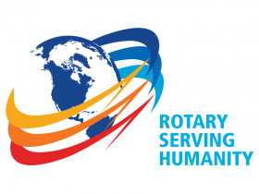
View past issues
Visit our website
'Like' our Facebook page
'Follow' our Twitter page

