OUR District's Bandey Hefler travelers are back
By Victor Tom
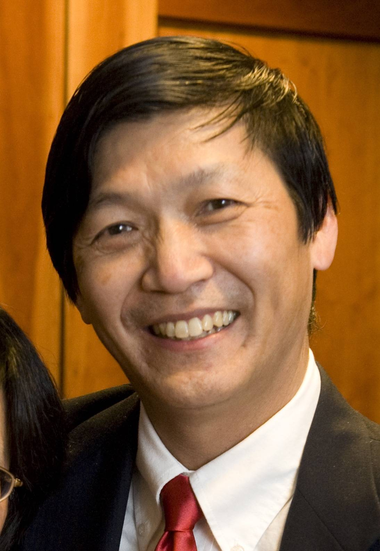On Sunday night, October 2, we gathered one last time as a group to say goodbye to our hosts and newfound Bandey Hefler family.

At the Farewell Dinner (see photo, right), I emphasized that the meaning of our Bandey Hefler Fellowship. Fellowship is defined as a friendly 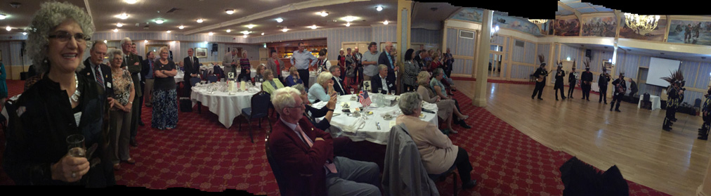association - especially, with people who share one’s interests. And so we did; we shared stories of our families (how we came to our countries, our children, our grandchildren) and our Rotary clubs (fundraising, membership, service projects).

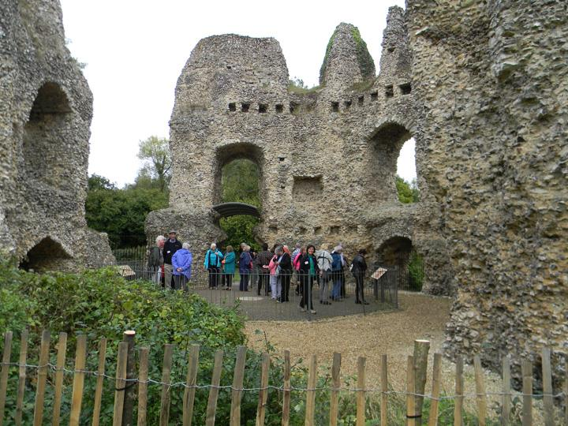Our travelers ranged all over the English countryside, from Bath in the East, Isle of Wight in the South to London in the Northeast. We visited the 809-year-old Oliham Castle (shown. left) in Hamsphire, one of only three fortresses built by King John during his reign.

Bedford Rotarian Christine Pinney presented the American summary of our experiences, stating that we are two countries divided by a common language. She shared one very touching story of how one of our Rotarians, who happened to enter an English antiques store with her hosts, discovered a decorative antique plate commemorating the Apollo moon landing. It turns out that this Rotarian had lost her first husband, who had worked for NASA on the moon landing, and had nothing to remember him by - until now. The event was capped off by a rousing performance of Old English folk dancing with participation of many in the audience.

The 2016 edition of our Bandey Hefler Fellowship exchange (see photo, below) was widely praised and generated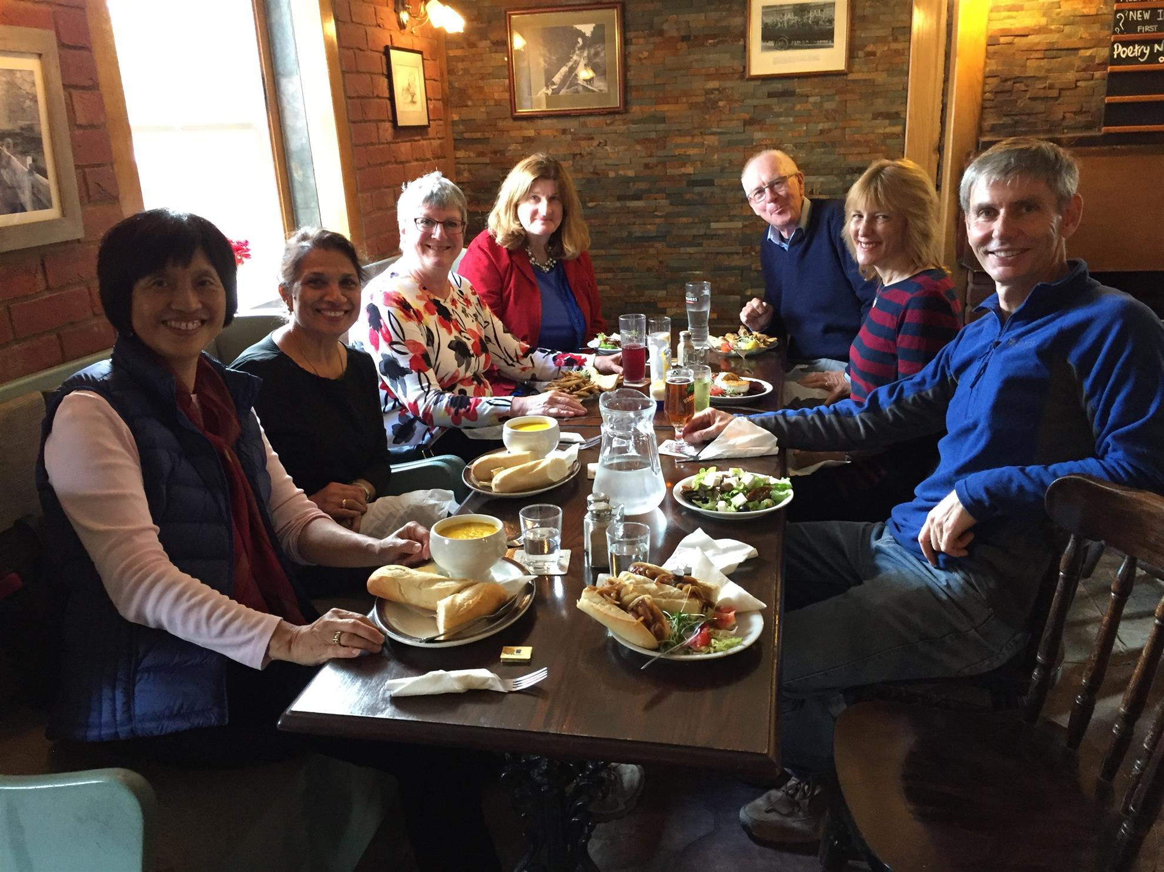 a new group of participants who were eager to volunteer for 2018 planning. If you are interested in joining our special Rotary fellowship, click here.

Victor Tom, co-chair of District 7910's Bandey Hefler Fellowship Exchange, may be reached at vtom0@yahoo.com.

Return to October 24 Newsletter

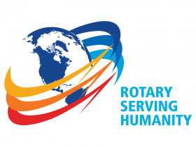
View past issues
Visit our website
'Like' our Facebook page
'Follow' our Twitter page

