Rotary District 7910 Club promotion Guidelines
January 13, 2015

Rotary District 7910 desires to support communications across the district for club activities, projects, and fundraisers. To that end, these guidelines provide a consistent framework for promoting club events and activities, with an objective of being informative without overwhelming Rotarians with information that does not get read.

Clubs wanting to promote your events must do the following:

- Include the event or activity on your club’s ClubRunner calendar as a calendar event.
- ClubRunner calendar events support uploading flyers, images, and other documents.
- You must check the Yes button for “Show Event in District Calendar.”

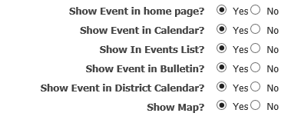

- If your club does not have ClubRunner, please contact Jim Fusco (jim.fusco2@gmail.com) with the information requested in the Appendix.

- Once your club’s event is listed in ClubRunner with “Show Event in District Calendar,” it will appear on the District 7910 website in the event calendar. (Click on “Find an Event” in the left column.)

- Based on calendar listings, the weekly District 7910 bulletin will promote club activities in the “Upcoming Events” section. Due to space limitations, events will be prioritized as follows:
  - District events
  - Multi-club events open to the public and Rotarians
  - Single-club events open to the public and Rotarians

- If your club has ClubRunner for your club, your club President can login and send email about events and activities to all other club Presidents, Presidents-Elect, Secretaries, and Treasurers.
  - Sign in by clicking on the Login link at the top of the page.
  - Enter your login information. (If you don’t know what it is, you can click on the link for “New and existing users: retrieve login and/or reset password.”)
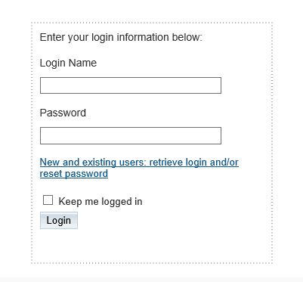

  - Click on the Communication tab.
  - Click on Email Service.
  - Click on Compose New Message.
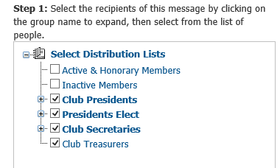
  - From the left column, select the Distribution list of the Rotarian officers whom you want to contact.

  - Compose your email message in the right column, then click on Send.

- If you do not have ClubRunner for your club, please contact Jim Fusco (jim.fusco2@gmail.com) to login to the District 7910 website.

- You can also post information about your event, including photos, on the District Facebook page, https://www.facebook.com/RotaryDistrict7910. To have it display in the main part of the Facebook page, contact Ron Goodenow (ron.goodenow@gmail.com).

Branding Rotary When Promoting Your Event

When promoting your event, please keep in mind that Rotary International recently embarked on a multiyear initiative of unprecedented scale to strengthen our image. All clubs need to do your part in protecting and promoting the Rotary "brand," which includes proper and consistent use of the Rotary logo, fonts, colors, and imagery.
An entire manual is devoted to the subject. Every PR Chair should download a copy of this manual (you need to login with your Rotary International account) and follow Rotary's guidelines for proper use of colors, fonts, and logos on all promotional materials that you produce. (Here's a quick-start summary of the basics.)

Learn more from the Public Relations section of the District 7910 website, or visit www.rotary.org/brandcenter.

FAQs

Q. How can I get my club’s event to show up in the left rail (column) of the district website?
A. By checking the box for “Show event in District Calendar?,” you automatically add the event to the district calendar. However, ClubRunner does not automatically post it in the left rail. We are working with ClubRunner to resolve this. For now, to have an event appear in the left rail of the district home page, contact Jim Fusco (jim.fusco2@gmail.com).

Q. How can I get my club’s event to be featured in the center column of the district website?
A. Contact Jim Fusco (jim.fusco2@gmail.com). Per these guidelines, district events and then multi-club events have priority.

Q. How can I include my event in the district bulletin and newsletter?
A. Contact Steve Jones-D'Agostino (srdagostino@icloud.com), editor of the District 7910 Newsletter. You must meet the following requirements:
- All articles must be submitted in Word format and must be unlocked so they can be edited, or they will be held until they are.
- At least one image must accompany each article, or the article will be held until at least one image is submitted.
- All images must be submitted in either JPEG or PNG format and in focus, or they will be held until they are.

Questions About These Guidelines?

Contact Jim Fusco (jim.fusco2@gmail.com).

Summary of Promotional Activities on the District 7910 Website

Section | Heading | Content | Web Contact/Editor
Left rail | District Alerts | Event title,  Date(s),  Contact person with email | Jim Fusco
Center column | District News | 5-7 brief “paperclip” articles:  - Informational, descriptive stories  - Submitters must provide:  - Brief description: 250 characters max (with spaces)  - Image (thumbnail)  - Full story, which will be made available through a Read more link  • Prioritized topics:  1. District activities  2. RI activities that apply to the district  3. Multi-club activities  4. Single club activities | Jim Fusco with consultation from District web team, Steve D’Agostino as copy editor
Club events | rotary7910.org/events/calendar | • Use Events 2.0 from your club’s ClubRunner site.  • Enter the requested information.  • Click “Yes” to show the event on your club’s home page.  • Click “Yes” to show the event in the district calendar. | Contact Jim Fusco if not using ClubRunner
Club flyers | rotary7910.org/events/calendar | Include as an attachment to your calendar event listing.

Appendix: Event Information

Please send this information to Jim Fusco (jim.fusco2@gmail.com) if your club does not have ClubRunner.

Club name:
Event name:
Start date and time:
End date and time:
Description (100 words max):

Event chair:
Email:
Phone:

Location:
Address:
City:
Zip:

Image (if available)
Flyer (if available)

