CRIBBAGE TOURNAMENT
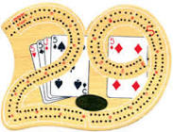
Saturday November 14, 2015
Doors Open at 12:15pm - Play begins 1:00pm Sharp Billerica Lodge of Elks
14 Webb Brook Road, Billerica, MA 01821

Grab a Partner and Your Cribbage Board
(Single Players Are Welcome - We'll Partner You Up!)

$25 Entry Fee Per Person (Limited to 100 Players)
Pre-Register at www.billericarotary.org
or Call Brian Goguen at 978-667-4595

Cash Prizes for the Top Three Teams!
24 Pool and 50/50 Raffle
Cash Bar Available
Sponsored by the Billerica Rotary Club
Proceeds to Benefit Local Charities and Scholarships

