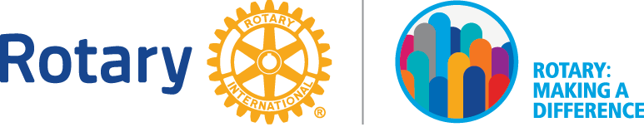
Rotary Recognition 2017 - 2018

Introduction

Rotary is a worldwide service organization whose mission is to do good in the world. Its 1.2 million members are volunteers, working to make this world a better place and not for awards. Recognizing their efforts is what the District 7910 Recognition program is all about. This document lists three types of recognition: Rotary International, The Rotary Foundation, and District 7910.

Deadline for submission
Where indicated, District 7910 award applications must be RECEIVED by the Awards Committee on or before June 30, 2018, in order to allow the committee sufficient time to evaluate the submissions and make the certificates. Please send your nominations electronically to:
Bob Cassidy PDG - rac011846@comcast.net or to Klaus Hachfeld PDG - laserklaus@gmail.com
Or by mail to:
Robert A. Cassidy PDG  District 7910 Awards Committee  9 Glenridge Dr.  Bedford, MA 01730 | Klaus Hachfeld PDG  District 7910 Awards Committee  50 Mc Gregory Rd.  Sturbridge, MA 01566

We wish we could control the US Postal Service, but alas, we cannot! So, send your submissions early! Submissions postmarked after June 30, 2018 will not be considered!
--------------------------------------------------------------------------------------------------------------------

Rotary International

Service Above Self Award

Rotary’s highest honor, the Service Above Self award, recognizes Rotarians who have demonstrated Rotary’s motto over many years by volunteering their time and talents to help others. It is internationally competitive and is granted to no more than 150 Rotarians worldwide and to no more than one Rotarian from each district each year. The District Governor submits the nomination to Rotary International by October 1, 2017. Please contact the District Governor if you have a candidate for this award.

You can find the nomination form at:

https://my.rotary.org/en/document/ri-service-above-self-award-nomination-form

Avenues of Service Citation for Individual Rotarians

Recognizing that the strength of the Rotary ideal is founded on the service carried out by club members worldwide, this citation allows Rotary clubs to recognize a club member for outstanding performance in the Five Avenues of Service. The citation reinforces the importance that Rotary places on the personal involvement of each club member in all Rotary service activities.

The club President determines the method of selecting a candidate. Club Presidents can appoint a special committee to select a nominee or ask their board of directors to carry out this responsibility. The club President must submit the nomination directly to Rotary International and send a copy to the District Governor. There is no deadline for this award.

You can find the nomination form at:

https://my.rotary.org/en/document/avenues-service-citation-nomination-form

Presidential Citation for Rotary Clubs 2017-2018

Clubs that are strong and make a positive difference in our communities achieve goals related to Rotary’s three strategic priorities: to support and strengthen clubs, focus and increase humanitarian service, and enhance Rotary’s public image and awareness. The 2017-2018 Presidential Citation will recognize clubs that complete activities that support these priorities. Clubs will have the entire Rotary year — 1 July 2017 to 30 June 2018 — to achieve the citation’s goals.

You can find the nomination form at:

https://my.rotary.org/en/document/presidential-theme-and-rotary-citation-brochure-2017-18

Clubs should circle the tasks they have completed and submit the brochure to the District Awards Committee.

Presidential Citation for Interact Clubs 2017-2018

Interact members should have fun while making a positive difference in their school and community. Interact clubs have the entire Rotary year — 1 July 2017 to 30 June 2018 — to work with their sponsoring Rotary clubs to achieve the Presidential Citation. To earn the citation, Interact clubs must achieve one required goal and at least four other goals.

The Interact club’s President or adviser should report the club’s achievements to the sponsoring Rotary club President. Rotary International will contact the Rotary club President with instructions for reporting the achievements, which are due by 15 August 2018.

You can find a link to the nomination form below. Interact club Presidents should complete the form and review it with their sponsoring clubs. The Rotary club President should submit the completed nomination form to the District Awards Committee:

https://my.rotary.org/en/document/rotary-citation-interact-clubs-2017-18

Presidential Citation for Rotaract Clubs 2017-2018

Rotaract members should have fun while making the world a better place. Rotaract clubs have the entire Rotary year — 1 July 2017 to 30 June 2018 — to work with their sponsoring Rotary clubs to achieve the Presidential Citation. To earn the citation, Rotaract clubs must achieve two required goals and at least five other goals.

Your accomplishments will be verified automatically through the data you provide using My Rotary. You don’t need to submit any forms or reports. Rotaract club presidents can track progress toward each goal on My Rotary. You should contact the District Awards Committee to confirm that you achieved the requirements. Rotaract club presidents can track progress toward each goal on My Rotary. To earn the citation, clubs must achieve two required goals and at least five other goals.

You can find a link to the nomination form below.

https://my.rotary.org/en/document/rotary-citation-rotaract-clubs-2017-18

---------------------------------------------------------------------------------------------------------------------

The Rotary Foundation

Distinguished Service Award
The Distinguished Service Award is The Rotary Foundation’s highest service recognition. The Distinguished Service Award recognizes a Rotarian’s sustained commitment, over a number of years, to The Rotary Foundation and its programs, both within the Rotarian’s district and around the world. The Trustees of The Rotary Foundation awards a total of 50 certificates annually. A Rotarian becomes eligible for the Distinguished Service Award four years after receiving the Citation for Meritorious Service.
The District Awards Committee will complete the nomination form, and the District Governor will sign and forward it to The Rotary Foundation.
The nomination form for the 2017-2018 Distinguished Service Award is not yet available.

Citation for Meritorious Service

The Citation for Meritorious Service is the second highest level of recognition awarded by The Rotary Foundation. It recognizes the outstanding efforts of a Rotarian to The Rotary Foundation, its programs, and committees for at least one year. Financial contributions to The Rotary Foundation, no matter how substantial, are not a consideration for this recognition. The District Governor may nominate one Rotarian for this recognition by June 30, 2018. Please contact the District Governor if you have a candidate for this award.
You can find a link to the nomination form below. The District Awards Committee will complete the nomination form, and the District Governor will sign and forward it to The Rotary Foundation.
https://my.rotary.org/en/document/citation-meritorious-service-rotary-foundation

Foundation District Service Award
The Foundation District Service Award recognizes individuals who have made meaningful contributions at the club and/or district level to the success of The Rotary Foundation grants, fundraising, awareness, and administration during the current Rotary year.
The District Governor can select up to 20 candidates from the district each year. Honorees will receive The Rotary Foundation certificates.

-----------------------------------------------------------------------------------------------------------------

District 7910

Rotarian of the Year Award
The Rotarian of the Year Award recognizes the outstanding efforts of Rotarians in service to their club and to District 7910. The District Governor determines the recipients for this recognition and awards it at the end of the Rotary year. The recognition may be given to a single Rotarian or a small group of Rotarians.

Club of the Year Award
The Club of the Year award recognizes the activities of a Rotary club in all Five Avenues of Service and more during the Rotary year. Achievement is based on the numerical total of all line items on the District 7910 Club Planning Worksheet. The worksheet is designed to highlight the broad base of activity and opportunities for Rotary clubs and their members. It also provides Rotary clubs a way to track their activities during the Rotary year. Point values for specific line items may vary from Rotary year to year based on the emphasis from that year’s Rotary International President and District Governor. Three Club-of-the-Year awards will be presented at the end of each Rotary year (Bronze, Silver, and Gold). The clubs with the three highest number of points will receive recognition.
We recommend downloading the form at the beginning of the Rotary year and using it as a guide for possible projects, programs, and activities through the current Rotary year. Submit the completed worksheet to the District Awards Committee by June 30, 2018.
Submitting the completed worksheet makes your club eligible for all of the district patch awards, recognizing the Five Avenues of Service as well as the Best Club award.
To access the District 7910 Club Planning Worksheet:
- Go to the District 7910 website at www.rotary7910.org.
- From the main menu at the top of the page, select “About District 7910.”
- Select “Resources.”
- You will find Excel and PDF versions of the worksheet in the drop-own menu that displays.
- Click on the version that you want to download. By default, you will find it in your Downloads folder.
You will also find the “2017-2018 Awards List” spreadsheet in PDF and Excel formats. Use the “Awards List” to identify line items on the “D-7910 Club Planning Worksheet” pertaining to a particular award.
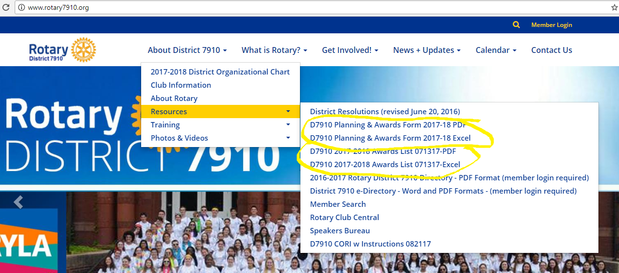
Club Service/Engagement Award
One of Rotary’s Five Avenues of Service, Club Service, requires Rotary clubs to have a strong base in organization, membership, fellowship, and financial stability. Club Service and engagement are the keys to achieving the Object of Rotary. Examples of Club Service activities include establishing goals, obtaining new members, getting good speakers, publicizing projects and fundraisers, communicating with club members (such as creating a bulletin), submitting attendance reports, and training club officers and new members. Three Club Service awards are given each year (Bronze, Silver, and Gold). The clubs with the three highest point totals of line items that relate to Club Service in the District 7910 Club Planning Worksheet will receive recognition.
For more information about how to access the Club Planning worksheet, see the Club of the Year award.

Community Service Award
Another of Rotary’s Five Avenues of Service, Community Service, focuses on planning and undertaking projects to improve the lives of others in the club’s local community. When Rotary clubs implement effective community service projects, they improve their community, which in turn reflects well on Rotary. When Rotary is viewed as a positive force in the community, its membership strengthens and grows, improving the organization’s ability to broaden its efforts in the community and worldwide. The Community Service award recognizes clubs that conduct community service using the following principles:
- Review regularly service opportunities within the community and involve each club member in an assessment of community needs
- Capitalize on the unique vocational and avocational talents of club members in implementing Community Service projects
- Initiate projects in accordance with the needs of the community recognizing that every Community Service activity, however small, is important
- Work closely with the Interact clubs, Rotaract clubs, and other civic groups to coordinate the club’s Community Service activities
- Use club resources to gain public recognition for Community Service projects
- Incorporate as part of Community Service project planning a methodology to transfer responsibility for the continuation of the project so the Rotary club can become involved in new projects
Three Community Service awards are given each year (Bronze, Silver, and Gold). The clubs with the highest point totals of line items that relate to Community Service in the District 7910 Club Planning Worksheet will receive recognition.
For more information about how to access the Club Planning worksheet, see the Club of the Year award.

International Service Award
Another of Rotary’s Five Avenues of Service, International Service, emphasizes what Rotarians can do to advance international understanding, goodwill, and peace. Activities include getting acquainted with people of other countries and learning about their cultures, customs, accomplishments, aspirations, and problems through personal contact, attending international conventions, and joint projects. Many international programs and projects are centered and partially funded through The Rotary Foundation and are designed to meet the humanitarian needs of people in many lands with emphasis on the most underprivileged children and families in developing countries.
One International Service award is given each year. The club with the highest point totals of line items that relate to International Service in the District 7910 Club Planning Worksheet receives recognition.
For more information about how to access the Club Planning worksheet, see the Club of the Year award.

Vocational Service Award
Another of Rotary’s Five Avenues of Service, Vocational Service, emphasizes service in the pursuit of all vocations. Activities include:
- Adherence to, and promotion of, the highest ethical standards in all occupations, including faithfulness and fidelity to employers, employees, and associates, fair treatment of them and competitors, the public, and all those with whom one has business or professional relationships
- The recognition of the worthiness to society of all useful occupations, not just your own or those pursued by Rotarians
- The contribution of vocational talents to the problems and needs of society
- Assisting young people in the pursuit of a career
Vocational Service is both the responsibility of Rotary clubs and its members. Rotary clubs can develop projects and activities that leverage the vocational talents of its members. Members should conduct themselves, their businesses, and their professions in accordance with Rotary principles and support projects developed by their club, using their professional skills and talents.
One Vocational Service award is given each year. The club with the highest point totals of line items that relate to Vocational Service in the District 7910 Club Planning Worksheet receives recognition.
For more information about how to access the Club Planning worksheet, see the Club of the Year award.
Youth Service Award
Another one of the Five Avenues of Service, Youth Service, serves as the cornerstone of Rotary’s future. This award recognized the time, patience, and effort put into working with youth in your community, both within and outside Rotary.
Opportunities for Rotary clubs to impact the lives of the youth are boundless and may include:
- Participation in Rotary Youth Leadership Awards (RYLA), including sending students and volunteers to help with this annual event
- Participation in Rotary’s youth exchange through the Eastern States Student Exchange program (ESSEX), including recruiting students to go abroad, sponsoring a student in your local high school, and volunteering to be a counselor to an exchange student
- Awarding local scholarships
- Sponsoring candidates for district and/or global scholarships
- Acting as a host counselor to a foreign scholar and inviting visiting scholars, who are studying locally, to speak to your club
- Sponsoring an Interact, Rotaract, or Earlyact club
- Engaging with the Interact, Rotaract, or Earlyact clubs you sponsor on a continuing basis, helping them with their projects, having joint meetings, and becoming an effective resource for them
One Youth Service award is given each year. The club with the highest point totals of line items that relate to Youth Service in the District 7910 Club Planning Worksheet receives recognition.

For more information about how to access the Club Planning worksheet, see the Club of the Year award.
Local Image Award
Visibility and reputation in the community are critical to the success and growth of a Rotary club. Communicating your projects, programs, and fundraisers to the general public plays an important role in the public’s participation in your events and increases their understanding of what your Rotary club is doing. Effective public communications means developing a plan with a specific goal, identifying your target audiences, and implementing public relations activities that address your target audiences to accomplish your goals.
One Local Image award is given each year. The club with the highest point totals of line items that relate to Public Relations in the District 7910 Club Planning Worksheet receives recognition.
For more information about how to access the Club Planning worksheet, see the Club of the Year award.
Assistant Governor Award
A key to a successful Rotary year is timely and effective communications between Rotary clubs and district leadership, and Assistant Governors serve as the district’s primary communication channel. Assistant Governors must know and understand the pulse of each Rotary club assigned to them, take the initiative to contact their clubs on a regular basis, answer questions, lend guidance, and on a regular basis communicate the strengths and weaknesses of their clubs to the District Governor. The Assistant Governor Award recognizes an Assistant Governor who performs these duties and more:
- Initiates contact with club Presidents and builds trust with them through the Rotary year
- Quickly and effectively passes information to and from the clubs and the district
- Visits each club at least quarterly, attends each club’s annual visit by the District Governor, including the District Governor’s business meeting, and attends each club’s events, programs, and fundraisers
- Acts as a resource for their clubs and is familiar with district and Rotary International resources and shares with the clubs as appropriate
- Rates the clubs in Rotary Club Central
- Keeps the District Governor informed of any issues related to a club
- Attends the Assistant Governor training at PETS
- Frequently attends district events and training
- Is viewed as a leader among all of the district’s Assistant Governors, promoting positive energy and momentum and lending assistance to other Assistant Governors and the District Governor when needed
- Serves with a smile, always willing to go the extra mile and assist the clubs and district as needed
The District Governor will select one candidate each year.

Edward C. Hall Foundation Achievement Award
This award recognizes the efforts of a District 7910 Rotarian who, over a period of years, has made a significant impact on the lives of people in the local and/or international community and who has advanced the goal of world understanding and peace, one person at a time, through support of The Rotary Foundation with time, talent, and treasure.
The District Governor One determines the recipient and makes one award for the Rotary year.
District 7910 Champions of Peace Award
For more than a century, Rotary has been committed to building bridges between people and promoting peace in communities the world over. In keeping with our commitment to peace and understanding, the District 7910 Champions of Peace award will honor one individual or organization for its commitment to using time and talents to create peace, either locally or internationally.

Recognition criteria:
- Nominee must be actively involved in peace initiatives or conflict resolution.
- Nominee should have an exemplary record around service and peace building initiatives/projects.
- Nominee is contributing to cultures of peace or is actively transforming conflict locally or internationally.
- Nominee should be involved with Rotary projects that are currently active or concluded within the past three Rotary years.

One District 7910 Champions of Peace award will be awarded each year. The nomination form is on the district website: www.rotary7910.org under the About District 7910>Resources tab. Please submit the nomination form to the District Governor by November 3, 2017 if you have a candidate for this award.
The District Governor One determines the recipient and makes one award for the Rotary year.
Club Growth Award
This award recognizes the club that has the greatest percentage in membership growth. It is calculated using “Net membership increase relative to club size.”
The formula uses the number of members at the end of March (N2) and the number of members at the beginning of the next Rotary year on July 1 (N1). The percentage (%) of club growth is the increase in membership (N2 minus N1), divided by N1, and then multiplied by 100.

