It's Winter Accessibility and Safety Time
By Ron Goodenow

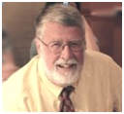According to the national Centers for Disease Control and Prevention, every year roughly 32,000 Americans die from falls. In 2012 and 2013, 55 percent of all unintentional-injury deaths among adults aged 65 and over were due to falls. Other studies reveal that falls are the leading cause of death due to injury among the elderly and that 87 percent of all fractures in the elderly are due to falls.

Though there are many reasons for falls, about one-third of those taken by seniors are 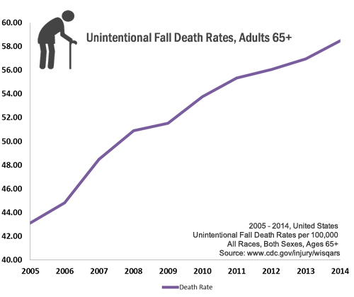environment-related, with data suggesting that more than one-third of adults in the U.S. suffer serious injuries due to falling on snow or ice. Almost 20,000 will die each year as the result of these injuries, and approximately 600,000 are hospitalized. Some of these are doubtless Rotarians.

So first things first. Are our clubs doing enough to protect seniors or people with mobility issues (and other members) from falling on the way in and out of meetings? Are regulations of the Americans With Disability Act and state agencies regarding safe access honored, meaning are handicap parking spaces available and is access to our restaurants or venues clean and safe? Beyond this, are parking lots themselves clean and safe? Do members know their rights?

Obviously, Rotarians who are "chronologically advantaged" or otherwise impaired should not be responsible for safety. This is the job of club presidents and those who negotiate with venues. Make it clear. When handicap spaces and the walk to and from the site are not clean, laws are being violated and owners should be warned that municipal compliance officers (each town and city in Massachusetts has one) will be notified.

As a very senior member with serious mobility issues (many of us, due to medications or other issues, are in extreme danger and share my boat), I have taken this up with my club president when conditions are bad. I also include my experiences in restaurant reviews, contact local chambers of commerce when I find widespread lack of compliance, and have persuaded at least two national restaurant-review companies to include accessibility information in all reviews. On several occasions, Rotarians have come out of nowhere to help me get to my car and my club members have been great. We should not, as I now do, hesitate to go to evening events and meetings in the winter - strong flashlight and walking stick, notwithstanding. Our clubs and events should have backup plans to help in the event of non-compliance or unexpected storms.

That is the Rotary way.

Finally, as Rotarians we should pay as much attention as possible to the needs of community members in winter. In my town (not Westborough) we are often blocked in or out by what many of us consider excessive plowing during and after storms. Nothing is done to help those with mobility issues, who are generally left to commercial plowers that many cannot afford. Many other communities in Massachusetts and around the country have set up volunteer organizations to pitch in. What a great opportunity for Rotary to improve community life! But let's also start at home and make this a membership issue. It's hard to think of a better fellowship - or even recruitment and retention - tool.

Let us know what you are doing and think. I would be happy to write up best practices or answer questions. I end with special thanks to District Governors Pat and Skip Doyle for letting me make my own winter blast! Happy and Safe Holidays to All!

To visit the Centers for Disease Control and Prevention web page, Important Facts about Falls, click here.

Ron Goodenow, a member of the Rotary Club of Westborugh, may be reached at ron.goodenow@gmail.com.

Return to December 12 Newsletter

View pa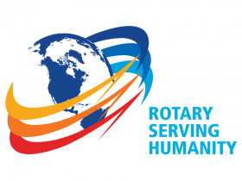st issues
Visit our website
'Like' our Facebook page
'Follow' our Twitter page

