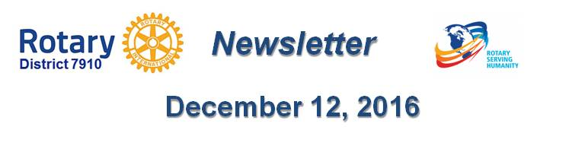

Dear $NICK_NAME$,

It is our pleasure to share with you the December 12 issue of Rotary District 7910 Newsletter.

For the complete issue, click here.

To explore past issues, click here.

Highlights of December 12 issue:

Governor's Message: - By Pat and Skip Doyle

District Alert: Winter accessibility and safety time - By Ron Goodenow

Club Central: Short video on how to post your club goals - By Bob Wallace and Ian Lancaster

Did You Know?: District 7640 has more Interactors than Rotarians - By Zone 24 & 32

Interact Actions: Interact teens needed to help next June in Atlanta - By Bob Anthony

Interact Video Contest: Bay Path High Rotaract is District’s First Winner

'17 RI Convention in Atlanta: Discount ends December 15 - By Steve Glines

Million Dollar Dinner: RI Past President Kalyan Banerjee to be keynote speaker - By Satya Mitra

Polio Plus Update: Portion of Papa’s Boots Proceeds to Benefit Polio Plus - By Carl Good III

Foundation Note: Foundation-Giving Scorecard for ‘16-‘17 - By Sanjay Deshpande

Rotary Means Business: First event was held December 7 - By Ron Bott

Membership Corner: Corporate memberships in Rotary - By Tom Sturiale

PR Tips: Pictures - Show something awesome! - By Laura Spear

RAAGNE Newsletter: Update on visioning process - By Klaus Hachfeld

Speakers Bureau: Do you need a speaker for your club? By Steve Levitsky
Treasurer's Report: Message about your dues - By Jack Hoell

District Charity Fund: How does DCF operate? - By Karin Gaffney

Communications Link: Seeking club photo, video albums - By Steve Jones-D'Agostino

Our next newsletter will come out on Monday, December 19. The submission deadline is this Friday, December 16. Text content must be submitted in Word format. Image content must be submitted in either JPEG or PDF format. Send your content submissions to Immediate Past District Governor/Newsletter Editor Jim Fusco at jim.fusco2@gmail.com.

Governors Pat & Skip

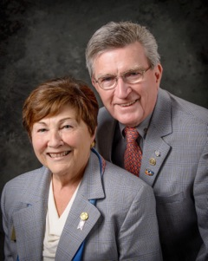Pat and Skip Doyle
2016-2017 Governors
Rotary District 7910
pwdoyle2@verizon.net
skipdoyle2@verizon.net

