'16-'17 District Directory being delivered TO CLUBS
By Pat and Skip Doyle

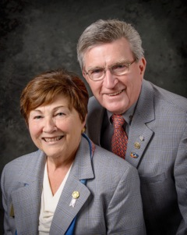
Our assistant district governors are busy during these days before the holidays delivering copies of the District 7910 2016-2017 Directory to club officers (see below). The Directory is full of Rotary information, club officers and meeting times and locations, a complete membership directory, and contact information for Rotary International officers and committee chairs. There are ads for member businesses, pieces of Rotary trivia, and tidbits about the upcoming Quadcon - the Multi-District Conference next April in Providence. We can all thank Immediate Past District Governor Jim Fusco for putting this comprehensive Directory together and shepherding it through the printing process. It was truly a labor of love. Thank you, Jim!

Last week, we attended our district's first meeting of Rotary Means Business, and it was a dynamic event. The more than 30 attendees were engaged from the moment they arrived. We heard so many positive comments from everyone there. Thank you to Ron Bott, chair of the District Rotary Means Business Committee, and his fellow committee members as well as District Governor-Nominee Steve Sager, District Governor-Nominee-Designate Pam Anastasi for a job well done. In case you missed this first meeting, there will be another one on January 25 in the Newton/Waltham area. To learn more, click here.

Please send us photos of your club's events during this season of giving. We hear so many wonderful stories of the good deeds you are all doing. We would love to fill the newsletter in the next couple of weeks with pictures of all you do. E-mail your club's event photos to newsletter Editor Jim Fusco at jim.fusco2@gmail.com.

Happy Holidays!

Left to right: District Governor-Elect Karin Gaffney, Immediate Past District Governor Jim Fusco, District Governor-Nominee-Designate Pam Anastasi, District Governor Skip Doyle, District Governor-Nominee Steve Sager and District Governor Pat Doyle, during the District Holiday Party on December 4 in Sturbridge.

VIEW ALL PHOTOS

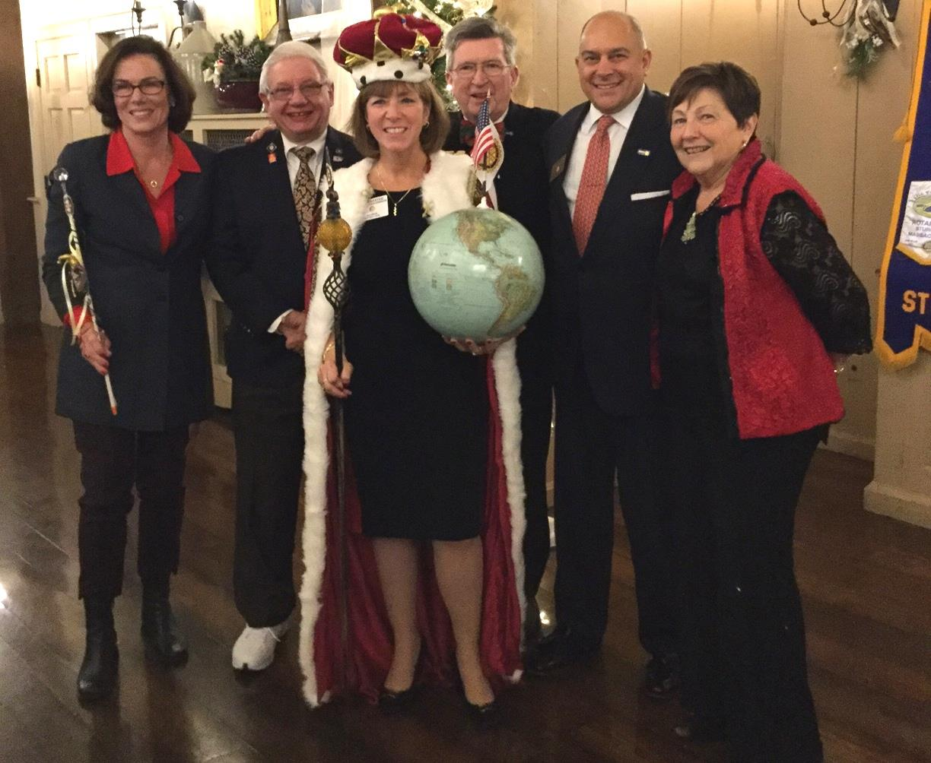

Hot Off the Press!: 2016-2017 District Directory
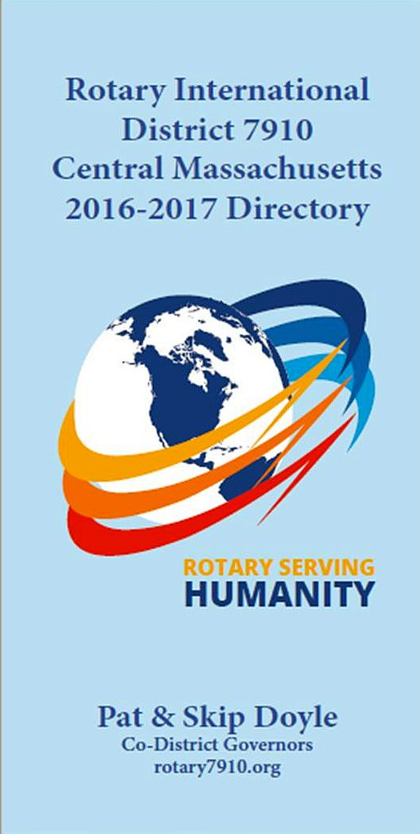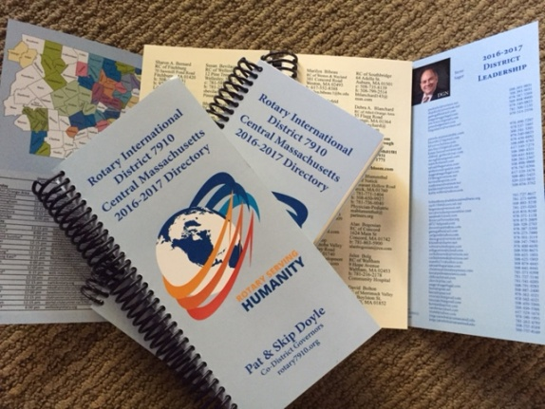
Print copies of our information-packed, 332-page Directory for this Rotary year will soon be delivered to your club.

The Directory includes: district and Rotary International general information; district club information; Yellow Pages of Rotarian-run businesses; District Resolutions; and a complete membership directory.

A digital copy is now available for automatic download, in PDF format.

Please note: Member login is required.

Click here, to download

Thank You! Thank You!! Thank You!!!

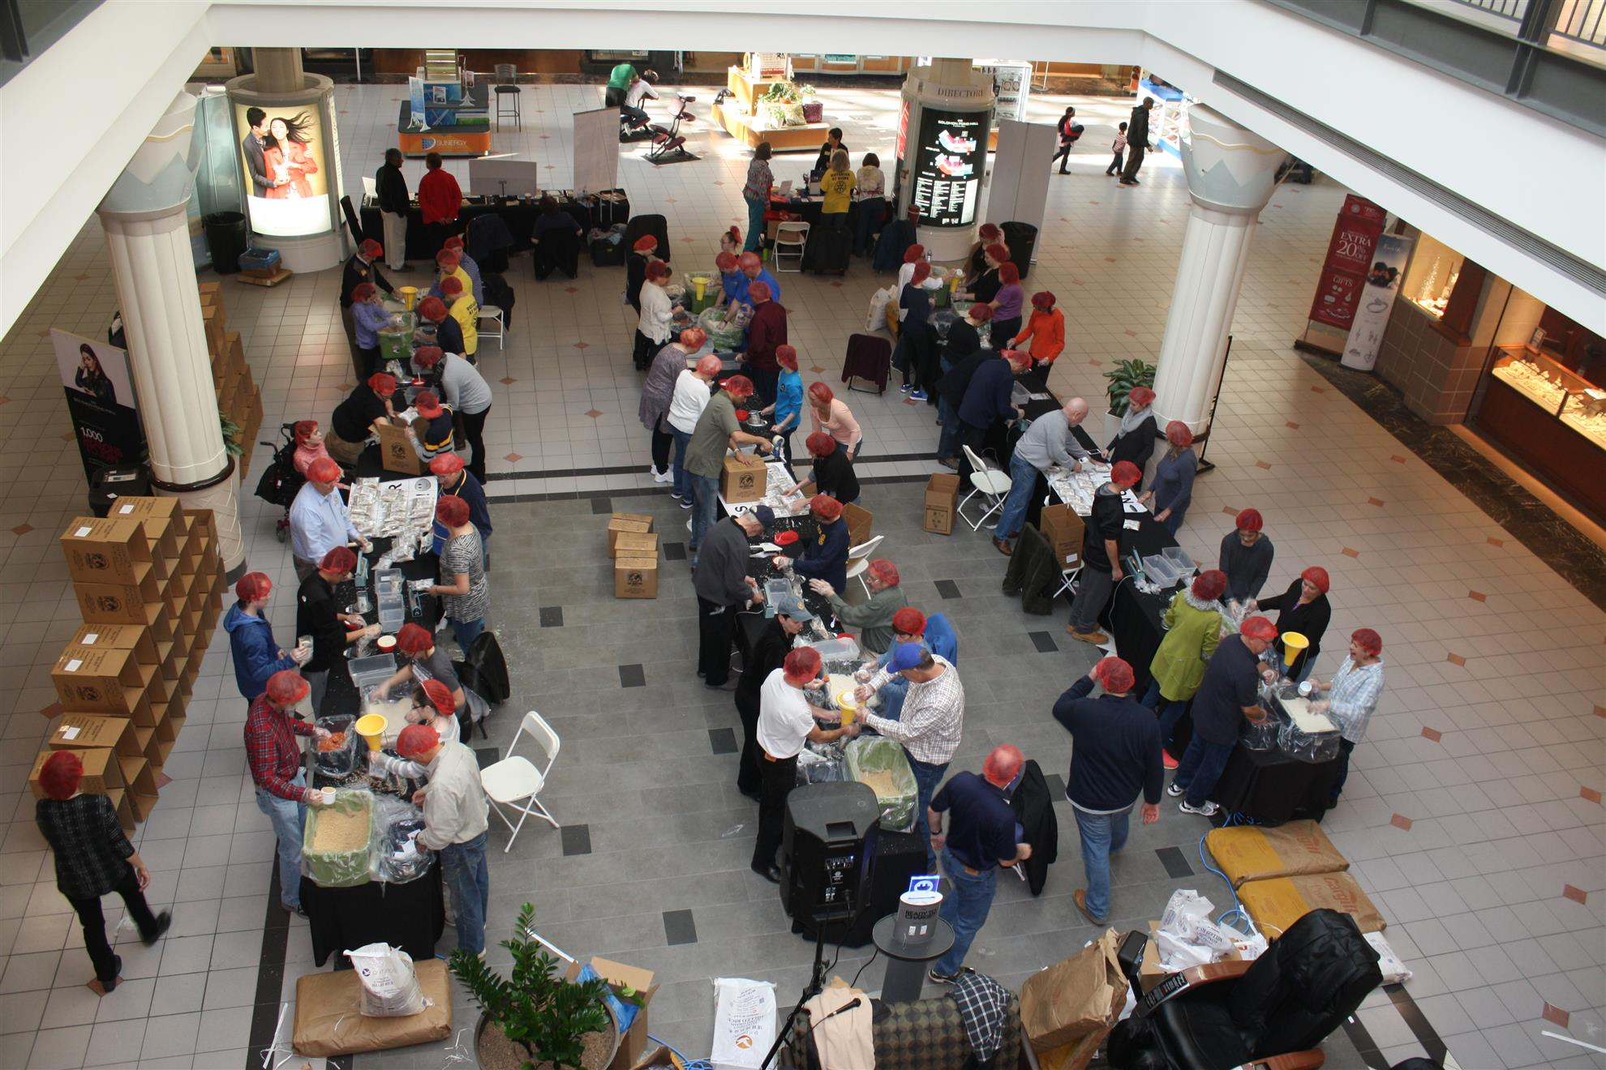Our District Food Packaging Event on November 12 at the Solomon Pond Mall in Marlborough was a solid success.

More than 100 volunteers from around the district packaged 20,000 meals, which will be sent to Haiti to help feed the children left homeless by the hurricane. These volunteers were Rotarians and their friends and families, young and old There were Interactors from local clubs, passersby who wanted to help and past and present participants of Rotary Youth Leadership Awards. We raised more than $4,000 toward our goal of $5,000 - so we are still actively seeking donations.

VIEW ALL PHOTOS

Always remember, you can call us with questions at 508-393-9031.

District Governors Pat and Skip Doyle may be reached at pwdoyle2@verizon.net and skipdoyle2@verizon.net,
respectively.

Click here to submit content for the December 19 issue.
The submission deadline for this issue is Friday, December 16.

Click here for past issues.

Return to December 12 Newsletter
Visit our website
'Like' our Facebook page
'Follow us on Twitter

