Interact teens invited to conferences in Providence and Atlanta
By Bob Anthony

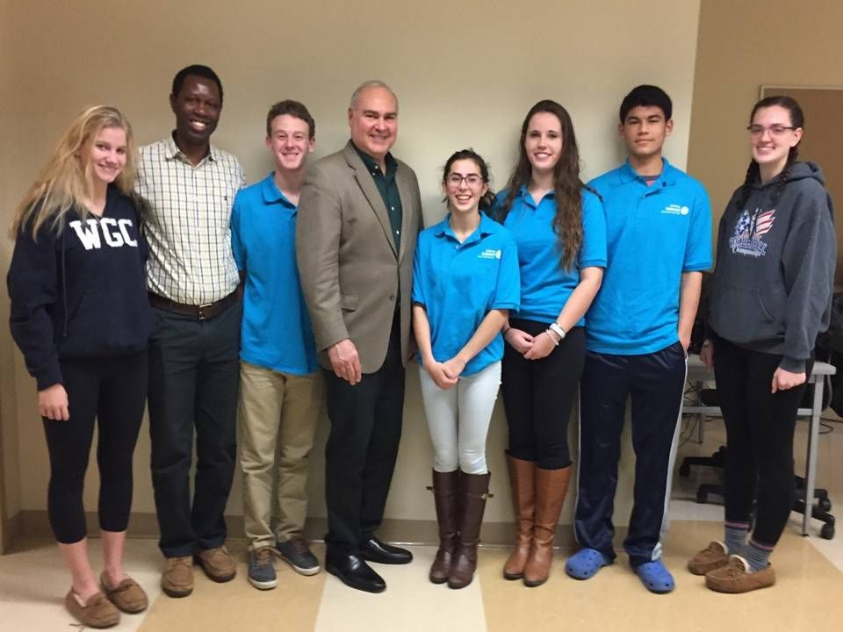
All Interact teens are invited to help staff the House of Friendship booths next April 29 during the Multi-District Conference in Providence and next June 10 to 14 during Rotary International Conference in Atlanta. We strongly encourage clubs that win a District Interact Video Contest to attend both events, to communicate their achievements!

To register for April's Multi-District Conference, click here.

For more information on June's Rotary International Conference, click here.

Left to right: Interact teen Susanna Buckley, a visitor from the project in India; Interact teens Ramnath Subba Siddi and Cole Harris; District Interact Chair Bob Anthony; and Interact teens Ana Natalia Epstein, Hannah Lee, Alex Kung and Lindsay Canaday.

Photo: Phyllis Gimbel

To learn more about Interact, click here.

Bob Anthony, chair of the District Interact Committee, may be reached at bobanthony@adolescentwellness.org.

How to launch an Interact club
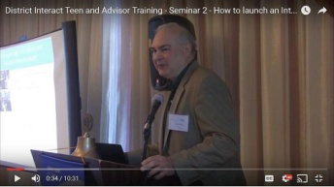In Seminar 2 of the District Interact Teen and Advisor Training Seminar, held on September 17 in Needham, Bob Anthony, chair of the District Interact Committee, discusses “How to launch an Interact club,” including the certification letter, roles and responsibilities of the president, the Rotary advisor and, in the case of school-based clubs, the faculty advisor.

WATCH VIDEO

Return to December 12 Newsletter

View past issues
Visit our website
'Like' our Facebook page
'Follow' our Twitter page

