GOVERNOR'S MESSAGE

'16-'17 District Directory Being Delivered to Clubs

By Pat and Skip Doyle
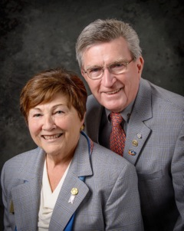
Our assistant district governors are busy during these days before the holidays delivering copies of the District 7910 2016-2017 Directory to club officers (see below). The Directory is full of Rotary information, club officers and meeting times and locations, a complete membership directory, and contact information for Rotary International officers and committee chairs. There are ads for member businesses, pieces of Rotary trivia, and tidbits about the upcoming Quadcon - the Multi-District Conference next April in Providence. We can all thank Immediate Past District Governor Jim Fusco for putting this comprehensive Directory together and shepherding it through the printing process. It was truly a labor of love. Thank you, Jim!

READ COMPLETE MESSAGE

Always remember, you can call us with questions at 508-393-9031.

District Governors Pat and Skip Doyle may be reached at pwdoyle2@verizon.net and skipdoyle2@verizon.net,
respectively.

Click here to submit content for the December 19 & 26 issue. The submission deadline for this issue is Friday, December 16. There will be no newsletter on Monday, December 26 because of the holiday weekend. Merry Christmas and Happy New Year!

Click here for past issues.

DISTRICT ALERT
It's Winter Accessibility and Safety Time

By Ron Goodenow

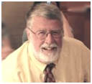
According to the national Centers for Disease Control and Prevention, roughly 32,000 Americans die every year fromfalls. In 2012 and 2013, 55 percent of all unintentional-injury deaths among adults aged 65 and over were due to falls. Other studies reveal that falls are the leading cause of death due to injury among the elderly and that 87 percent of all fractures in the elderly are due to falls.

Though there are many reasons for falls, about one-third of those taken by seniors are environment-related, with data suggesting that more than one-third of adults in the U.S. suffer serious injuries due to falling on snow or ice. Almost 20,000 will die each year as the result of these injuries, and approximately 600,000 are hospitalized. Some of these are doubtless Rotarians.

READ MORE

WELCOME, NEW ROTARIANS

- Mattie Merchant, Montachusett Area

Remember to ask ... ask ... ask!

HOT OFF THE PRESS!

2016-2017 DISTRICT DIRECTORY
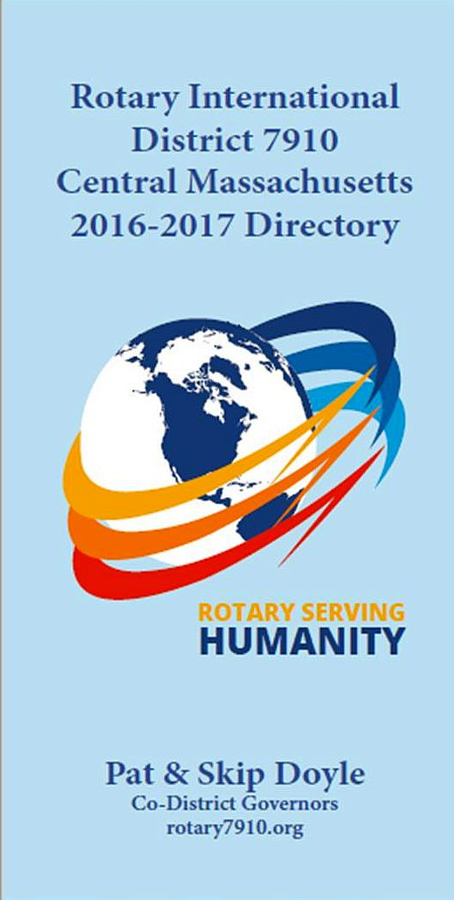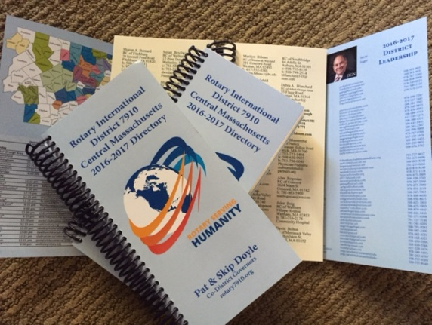
Print copies of our information-packed, 332-page Directory for this Rotary year will soon be delivered to your club.

The Directory includes: district and Rotary International general information; district club information; Yellow Pages of Rotarian-run businesses; District Resolutions; and a complete membership directory.

A digital copy is now available for automatic download, in PDF format.

Please note: Member login is required.

Click here, to download

CLUB MEMBERSHIP GROWTH, ’16-‘17
We share with you the results of club-membership growth in our district during Rotary year 2016-2017, which began July 1.

This is a unique opportunity for Rotarians and friends to discuss partnering on humanitarian projects affecting our local communities.

READ MORE

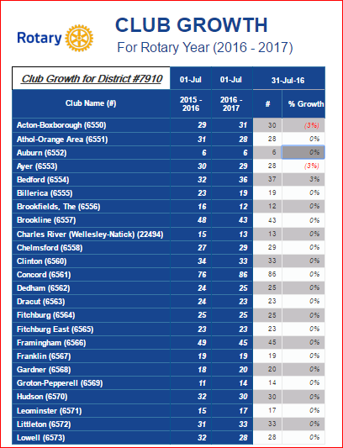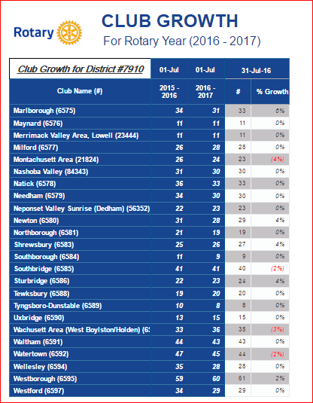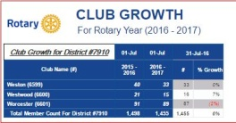

CLUB PLANNING WORKSHEET '16-'17
In both Excel and PDF formats, we share with you the Club Planning Worksheet for Rotary year 2016-2017, which began on July 1.
Please enter your club information in the indicated cells.

Excel Format

PDF Format

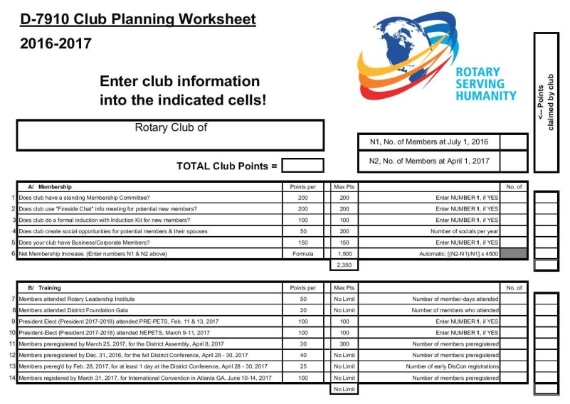

DISTRICT & CLUB ROUNDS
Rotary Means Business Holds First Event in Our District

On December 7, our district's new business-networking fellowship, Rotary Means Business, was launched. More than 30 Rotarians and guests met.

READ MORE

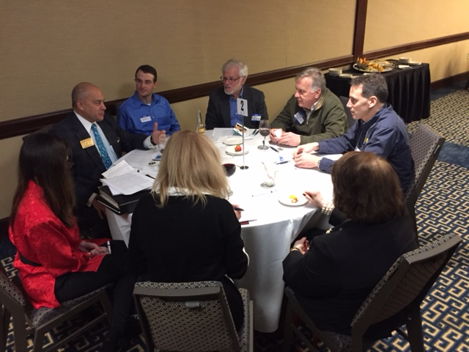
Clockwise, starting at top, are: an unidentified guest; Ron Facenda of Newton Rotary; Gerry Gross of Westborough Rotary; Tony Gallo of Milford Rotary; Peggy Thorsen of Marlborough Rotary; Nancy Gilroy of Bedford Rotary; Cheryl Rosen of Hudson Rotary; and District Governor-Nominee Steve Sager of Westborough Rotary.

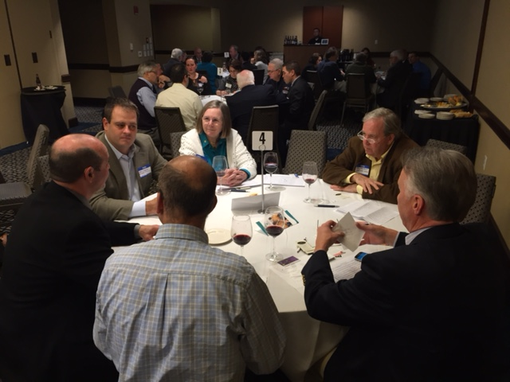Clockwise, starting at top:Carol Toomey of Nashoba Valley Rotary; Larry Perrault, a guest; Ron Fraser of Worcester Rotary; Vinny Tingley of Natick Rotary; Paul Gauvinof Fitchburg Rotary; andEric Lazzari of Natick Rotary.

Video of Governor Baker's Address to District Rotarians Now Available

The Rotary Club 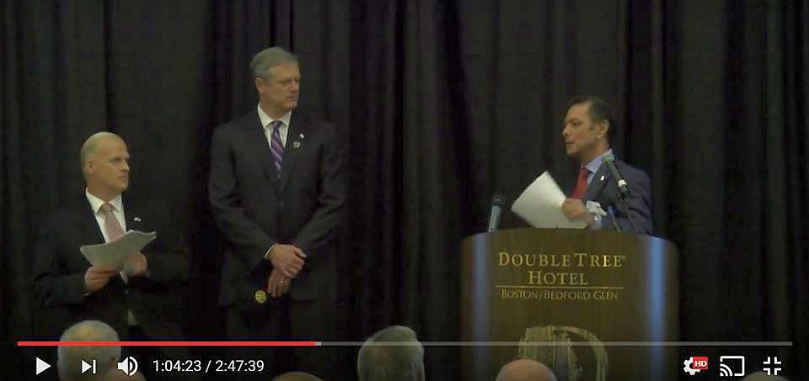of Billerica has provided avideo of Governor Charlie Baker's address to District 7910 Rotarians onSeptember 27 in Bedford. To watch the two-hour-47-minute video, click here.

The Rotary Clubs of Bedford, Billerica, Lowell, Newton and Shrewsbury sponsored the event, which was a unique opportunity for Rotarians and friends to discuss partnering on humanitarian projects affecting our local communities. To view eventphotos, click here.

Meet Tatsuya Hayase, Our Rotary Scholar

Thank You, Newton Rotary and Indira Desai

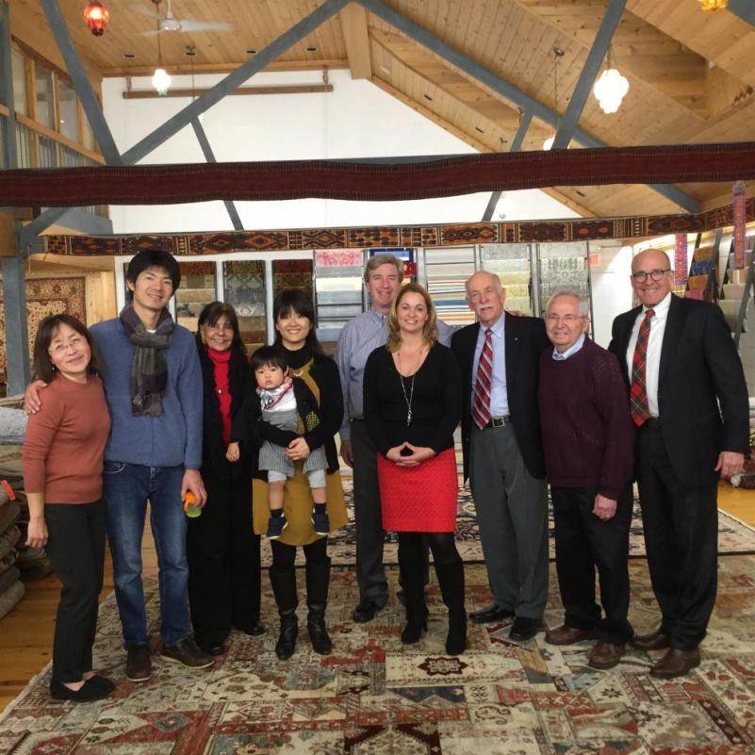
Meet Tatsuya Hayase(second from left), a Rotary Scholar from District 2760(Aichi Prefecture in Japan) who is visiting our district. He is spending the year at theHeller School for Social Policy and Management at Brandeis University in Waltham studying Peace and Conflict Prevention and Resolution.
READ MORE
Left to right: Newton Rotarian Chris Chu; Rotary Scholar Tatsuya Hayase, his wife, Marie Hayase, and their son, Yuto Hayase; Host Counselor Indira Desai, immediate past president of Newton Rotary; Newton Rotary President Paul Sullivan and his wife, Monica Sullivan; District Scholarship Chair Tory DeFazio, a Wellesley Rotarian; and Newton Rotarians Tony Bibbo and Tom Keery.

Athol-Orange's Al Bowers Makes Foundation Presentation

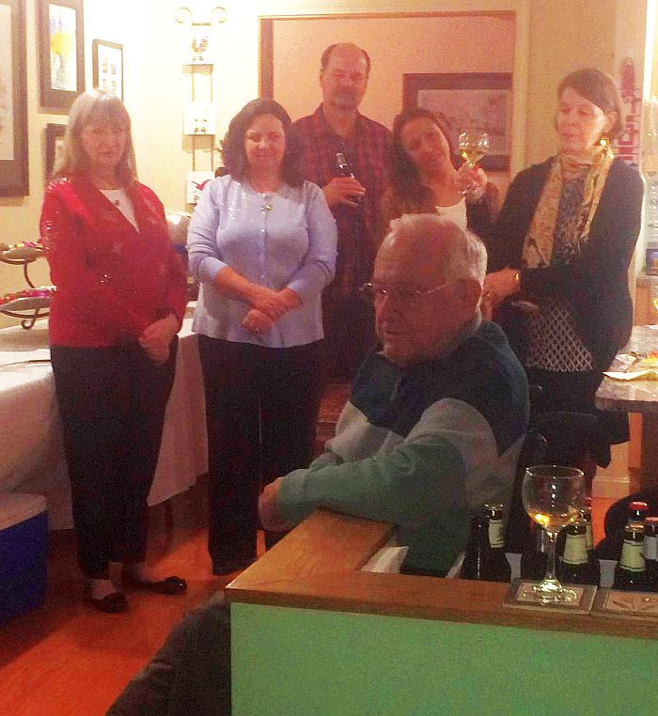The Rotary Club of Athol-Orange held its annual Christmas Party at the home of Member Bill Howland. Club Foundatioin Chair Al Bowers, immediate past District Charitable Fund chair, attended and made a wonderful presentation on The Rotary Foundation. A surprise Paul Harris recognition was bestowed on club Secretary Carol Courville by Assistant Governor Karen Fusco.

Posing during the Athol-Orange Christmas Party with club Foundation Chair Al Bowers, seated, are, left to right, Assistant Governor Karen Fusco, club Secretary Carol Courville, club MemberTed Ledgard, club President-Elect Tanya Quinn, and club Member Barbara Robichaud.

Bay Path Interactors Perform at Their School's Santa Claus Pancake Breakfast

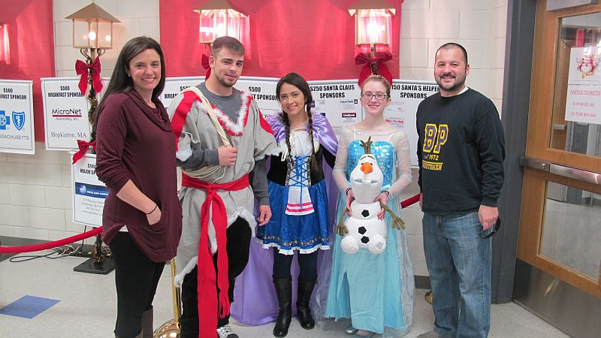
The Bay Path Educational Foundation, which supports Bay Path Regional Vocational Technical High School in Charlton, held its annualSanta Claus Pancake Breakfast on December 10at the school. Members of the Interact Club of Bay Path (shown) participated, playing characters from Disney's 2013 hit movie "Frozen," inspired by Hans Christian Andersen's fairy tale "The Snow Queen." The Bay Path club is co-sponsored by the Rotary Club of Auburn and the Rotary Club of Southbridge.

Shown: Bay Path Interact President Veronica Martinez (middle),Treasurer Kayleigh Blanchard (second from right) and Member Matthew Pecore (second from left) are shown posing with Auburn Rotarian and Bay Path Teacher Jen Reil (far left) and Bay Path Teacher Rick Carrero (far right), both of whom advise the Bay Path club.

Photos: Steve Jones-D'Agostino, Auburn Rotary

VIEW ALL PHOTOS

Learn more about:
- Bay Path
- Auburn Rotary
- Southbridge Rotary

Chelmsford Donates $1,000 to The Wish Project

The Rotary Club of Chelmsford made a $1,000 donation to The Wish Project at a recent meeting. The project's mission is to "help end homelessness by providing otherwise-expensive home and baby items for free so that families moving out of shelters succeed the first time."

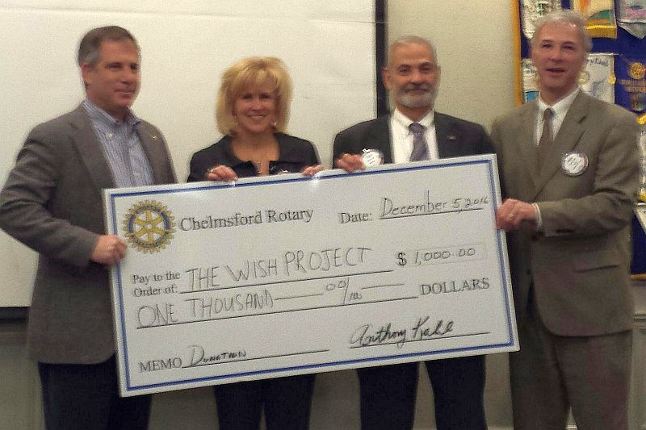Left to right: David Fitzgerald, executive director of The Wish Project, Chelmsford Past PresidentDawn Ferrari; Chelmsford Treasurer Tony Kalil; and Chelmsford President Paul Cohen.

Fitchburg Throws Holiday Party for Its Past Presidents

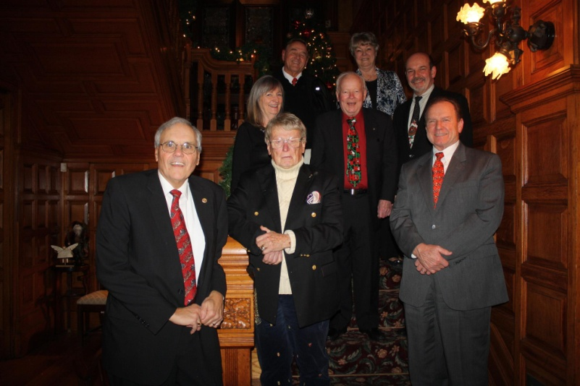
Left to right, bottom: David Moquin, Gerry Martel, andBernie.

Left to right, middle: Karen Fusco, Bill Lakso, andPaul Gauvin.

Left to right, top: Gill, andLinda Largey

Maynard Marches in Christmas Parade

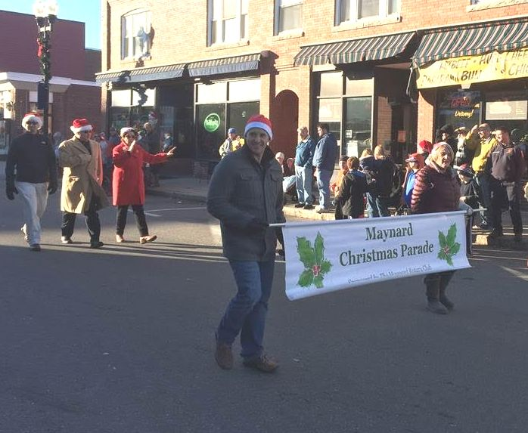
Left to right: Maynard President Matthew Farrow, and Maynard Secretary Ann Heinonen.

Littleton Tree-Lighting Kicks Off Holiday Season

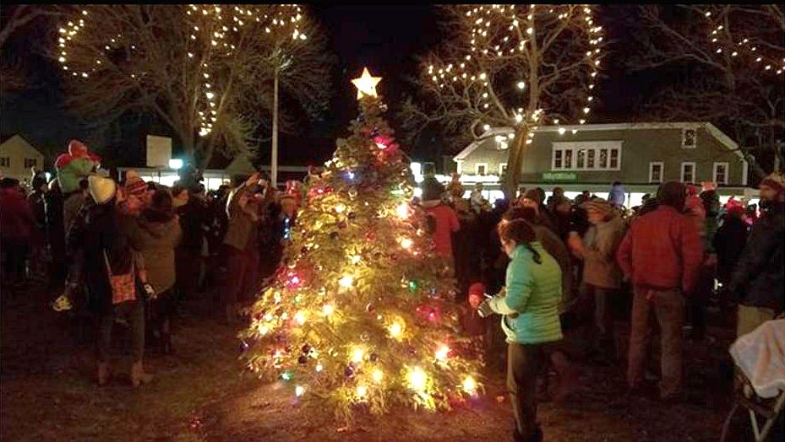Hundreds of people gathered on December 4 atLittleton Common to kick off the holiday season with the town's tree-lighting ceremony. The event was co-sponsored by the Rotary Club of Littleton and theLittleton Electric Light Department.

Photo: Alexander Silva, Wicked Local

READ MORE

To learn more about Littleton Rotary, click here.

Montachusett Area Installs Mattie Merchant as Newest Member

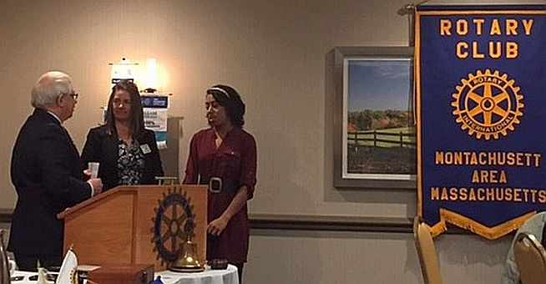Mattie Merchant (right), director of recreational programs for The Arc of Opportunity in Fitchburg, has been installed as the newest member of theRotary Club of Montachusett Area. The Arc is a corporate member of the club and Mattie will be the lead member for the Arc. She was installed by Immediate Past District Governor Jim Fusco (left), who is a past president and present member of the Montachusett Area club. Also shown, is Montachusett Area President Jennifer Peck (middle).

Wachusett Area Rotary, Chamber Hear State Secretary Jay Ash Offer Local Economic Outlook

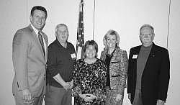Jay Ash, secretary of the state Executive Office of Housing and Economic Development, shared his outlook on economic development in Central Massachusetts onDecember 2 at a breakfast co-hosted in West Boylstonco-hosted by the Rotary Club of Wachusett Area and the Wachusett Area Chamber of Commerce.

Left to right: Secretary Jay Ash, Chamber President Iain McKinlay, State SenatorAnne Gobi, State Representative Kim Ferguson, and Rotary President Gary Hough.

READ MORE

To learn more about Wachusett Area Rotary, click here.

District Holiday Party A Great Success

VIEW ALL PHOTOS

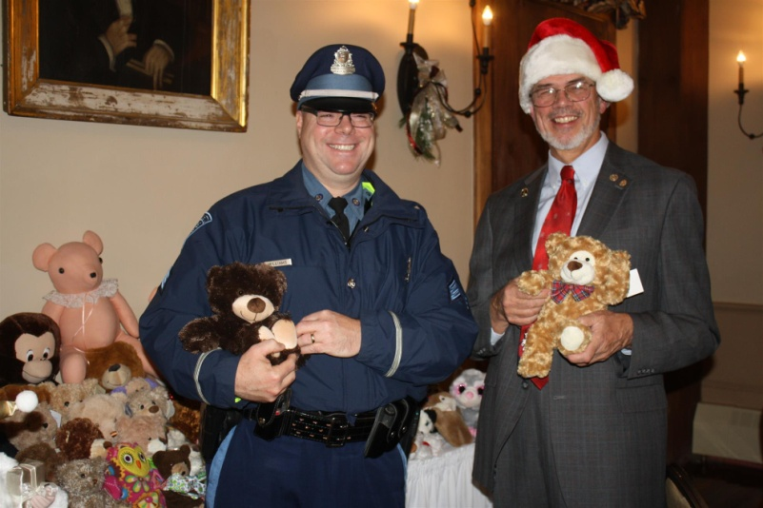
Past District Governor Klaus Hachfeld (right) of Sturbridge Rotary and Sergeant Kevin Williams (left) of the Brookfield State Police Barracks pose with some of the many donated Teddy bears.

District Governors Pat and Skip Doyle hosted the annual District Holiday Party on Sunday, December 4 at the Publick House in Sturbridge. Ninety-five attendees enjoyed the festivities. with entertainment provided by the Tantasqua Regional High School"Choraleers." Attendees brought Teddy bears. which were presented to Sergeant Kevin Williams of the Brookfield State Police Barracks. The grand finale was the "coronation" of Pam Anastasi of the Rotary Club of Billerica as district governor-nominee-designate. She will serve as district governor for Rotary year 2019-2020. Thank you to Past District Governor Klaus Hachfeld and his wife, Glenys Hachfeld, both of whom are members of the Rotary Club of Sturbridge for planning this event, and to MC Steve Jones-D'Agostino of the Rotary Club of Auburn, and our ace district photographers, Immediate Past District Governor Jim Fusco of the Rotary Club of Montachusett Area and Cheryl Rosen of the Rotary Club of Hudson.

Tantasqua Regional H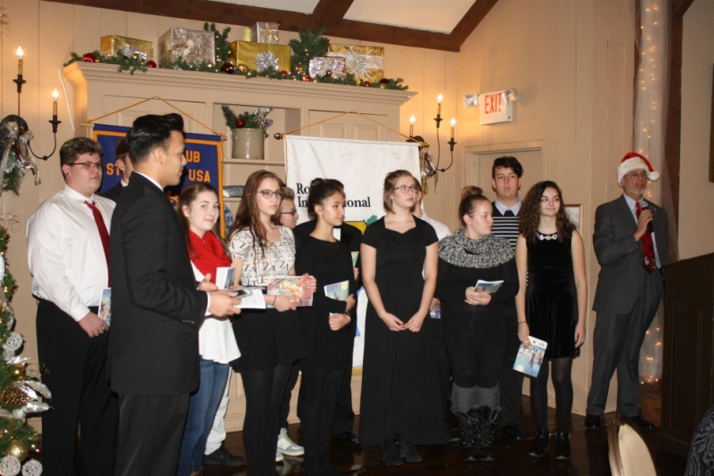igh School "Choraleers," led by Derek Ternullo (second from left), performed several holiday-season songs in acapella style during the Holiday Party. They were introduced by Past District Governor Klaus Hachfeld (far right) of Sturbridge Rotary

Bay Path High Wins District’s First Interact Video Contest

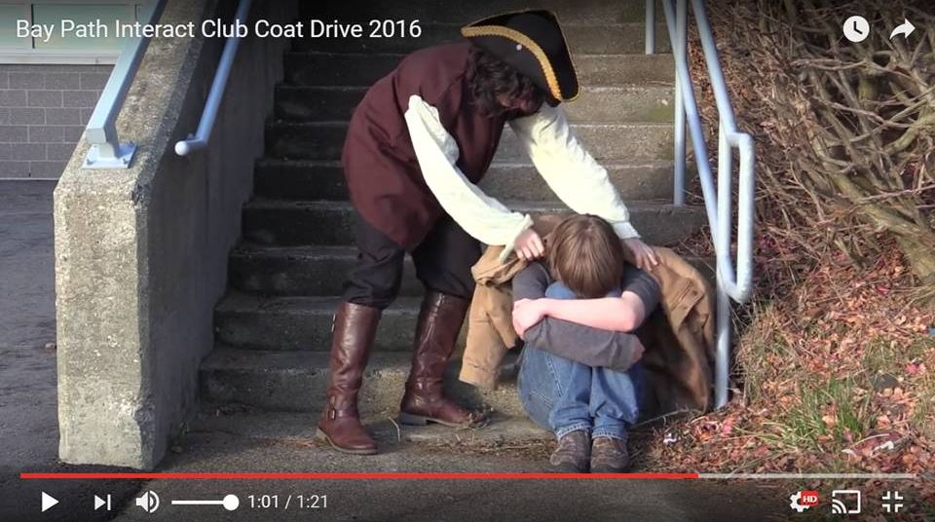
The newly formed Interact Club at Bay Path Regional Vocational Technical High School in Charlton has won the District Interact Committee’s first Interact Club Video Contest - and with it, the $250 prize. The winning video, for the November contest, was inspired by Bay Path High’s participation in the sixth annual Worcester County Coat Drive, conducted by the Worcester County Sheriff's Office. (see “Auburn Supports Bay Path High’s Participation in Worcester County Coat Drive,” below).

WATCH VIDEO

The Interact Committee is also pleased to announce that all Interact clubs are again invited to submit a video for a December competition.

READ MORE

To learn more about Bay Path High, click here. To learn more aboutInteract, click here.

Bay Path’s Interact Club is sponsored by the Rotary Clubs of Auburn and Southbridge. To learn more about Auburn Rotary, click here. Tolearn more about Southbridge Rotary, click here.

Franklin Rotaract Club Installed at Dean College

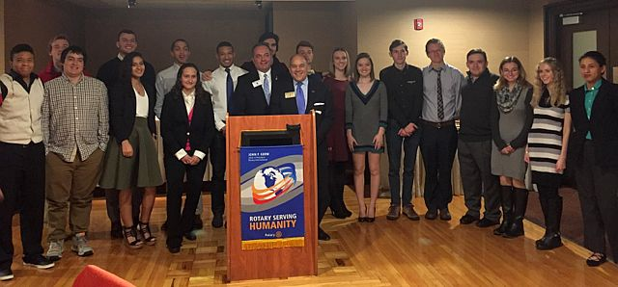
The new Rotaract Club of Dean College was installed on November 17. Shown, are the 18 of the 19 charter members of the Rotaract club posing with Rotary Club of Franklin President Terry Katsaros(left, behind podium) and District Governor-Nominee Steve Sager(right, behind podium).

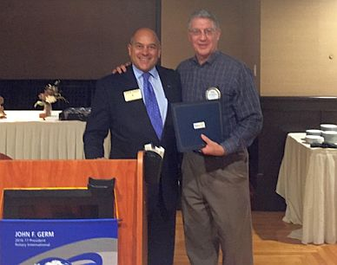Shown, is Frank Cusano (right), immediate past president of Franklin Rotary, accepting the Rotary International citation for membership retention on behalf of his club from District Governor-Nominee Steve Sager (left)

To learn more about Franklin Rotary, click here.

Tewksbury Recognizes High School Seniors

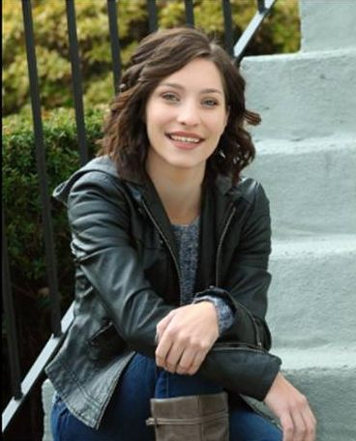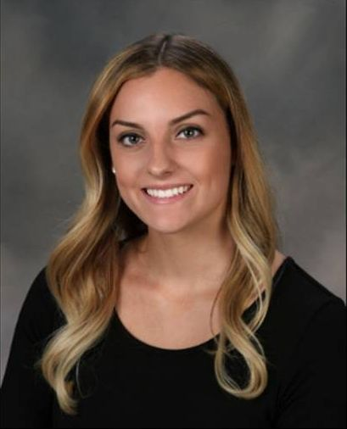
Tewksbury Memorial High School seniors Alexandra Bourassa(left) and Kathleen Garcia (right) were honored by the Rotary Club of Tewksbury at a luncheon on November 17 at the Tewksbury Country Club.

READ MORE

To learn more about Tewksbury Rotary, click here.

Westborough Funds, Celebrates Festival of Lights
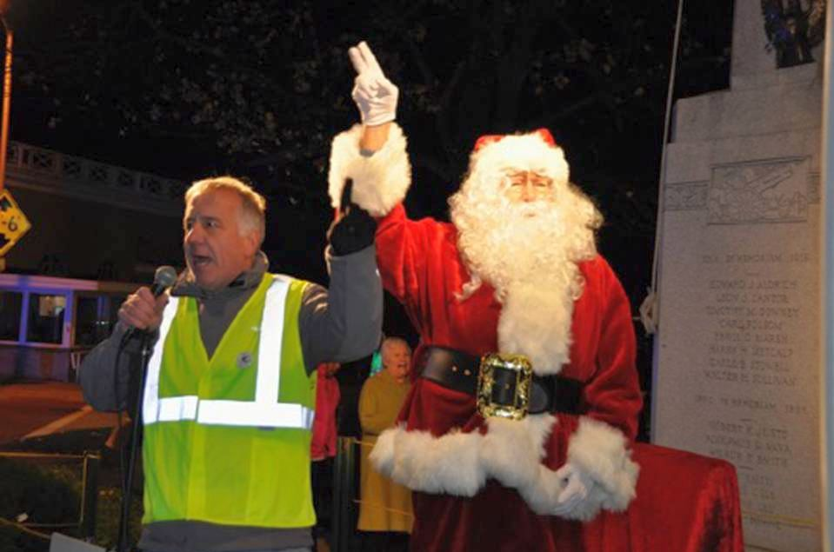
As part of the Rotary Club of Westborough’s ongoing service commitment to the community, the club has provided funding for the Festival of Lights each year during the holidays, decorating the trees located on Main, Milk and South streets in downtown Westborough. The Festival of Lights celebrates the beginning of the holiday season, as residents gather for a holiday parade, to watch as the lights are turned on for the first time, and children young and old meet Santa to request their holiday wishes. This year’s Festival included visits with Santa and Mrs. Claus, portrayed by the club’s own Jim Tepper and Maureen Ambrosino, respectively.

Left to right: President Gerry Gross, and Santa.

VIEW ALL PHOTOS

To learn more about Westborough Rotary, click here.

Milford Distributes '16 Tab to 13,000 Homes - Record sales, 94 photos, 334 smiling faces

A Great Fundraising Idea for All Clubs!

To read the Milford RotaryTab, click here.

To learn more about Milford Rotary, click here.

On to Atlanta in 2017: Early-Registration Discount Ends December 15

Planning to attend? Contact District Chair Steve Glines.

More than 43,000 attendees left the Rotary International Convention in South Korea inspired to end polio for good, to celebrate The Rotary Foundation's centennial, and to champion changes that will help Rotary appeal to a broader audience. On the last day, RI President K.R. “Ravi” Ravindran shared a personal story of his mother’s triumph over polio.

To read the story, click here.

To register for the 2017 RI Convention in Atlanta, click here.

Pat and Skip Doyle Installed as '16-'17 DGs

District 7910's 2016 Rotary Youth Leadership Awards were held on June 24 through 26 at Fitchburg State University, ending with the installation of longtime RYLA supporters Pat and Skip Doyle as District Governors for 2016-2017. The three-day RYLA event was attended by 188 sophomores. To learn more about RYLA, visit ryla7910.org.

To watch a video of the installation, click here.

District Banners Available
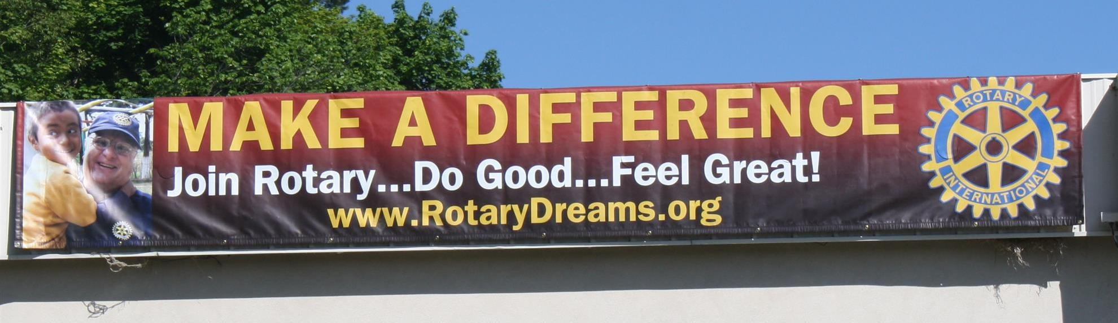

Our district banners are available for your use when you have an upcoming event or fundraiser.

If you want to reserve one of the banners, please contact PR Chair Laura Spear at laura@spear.net.

MAJOR DISTRICT & CLUB HAPPENINGS: WINTER 2017
Saturday, March 11: Uxbridge - 'Wine and Chocolate Tasting'

Click here to download event flyer

SUBMIT MAJOR CLUB HAPPENINGS

Send flyers of your club's major events and activities, in eitherJPEG or PDF format, to Immediate Past District
Governor/Newsletter Editor Jim Fusco at jim.fusco2@gmail.com.

