Meet Tatsuya Hayase, Our Rotary Scholar

To Have Tatsuya Speak to Your Club, Contact Indira Desai
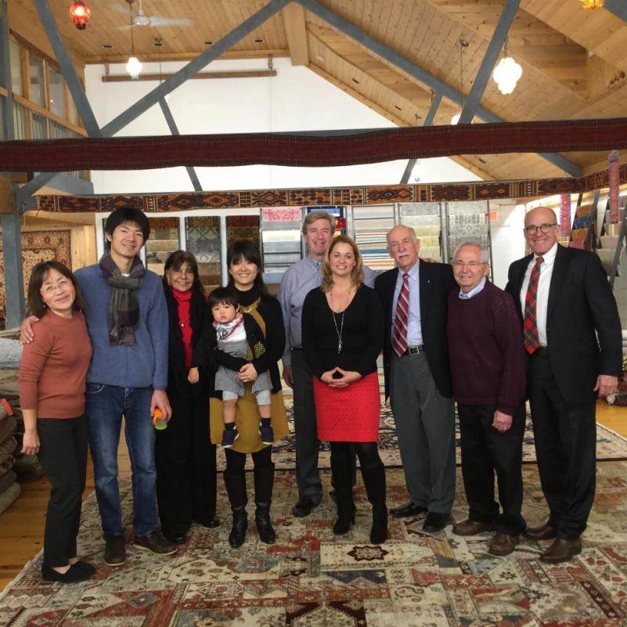Meet Tatsuya Hayase(second from left), a Rotary Scholar from District 2760(Aichi Prefecture in Japan) who is visiting our district. He is spending the year at the Heller School for Social Policy and Management at Brandeis University in Waltham studying Peace and Conflict Prevention and Resolution.

Left to right: Newton Rotarian Chris Chu; Rotary Scholar Tatsuya Hayase, his wife, Marie Hayase, and their son, Yuto Hayase; Host Counselor Indira Desai, immediate past president of Newton Rotary; Newton Rotary President Paul Sullivan and his wife, Monica Sullivan; District Scholarship Chair Tory DeFazio, a Wellesley Rotarian; and Newton Rotarians Tony Bibbo and Tom Keery.

This month, Tatsuya is receiving a Masters in Coexistence and Conflict. He is an extraordinary young man, having worked for more than nine years for the Japan International Cooperation Agency. He formulated and supervised several programs and projects for conflict-affected countries as an officer of the Peace-building Unit of JICA. Previously, he studied as an exchange student at the University of Washington in Seattle.

Tatsuya’s application for a Rotary Scholarship reflects his passion and goals: "By witnessing the lasting war between Israel and Palestine on the ground and also other lasting civil wars in the Middle East, I keenly felt the importance of political activity for conflict resolution such as preventive diplomacy and mediation work,” he states. “Moreover, it motivated me to work not only through development institutions but also as a mediator to get directly involved for conflict resolution."

As part of Brandeis University’s Conflict Resolution and Coexistence curriculum, Tatsuya is taking courses in theory and analysis, negotiation, coexistence intervention (monitoring and evaluation), mediation principles and skills, research methods, and planning and implementation. One of his long-term goals is to be an expert of mediation on the United Nations’ Standby Team of Mediation Experts. Certainly, his study will enhance his objectives. "I would like to contribute to the mission of the Rotary Foundation,” he states. “That is, ‘to advance world understanding, goodwill, and peace through the improvement of health, the support of education and the alleviation of poverty’.”

While Tatsuya has a very heavy study program, he has agreed to participate in as many Rotary activities as possible during his stay here. We are deeply indebted to Indira Desai, his host counselor and immediate past president of the Rotary Club of Newton - his host club in our district - plus the rest of Newton Rotary for sharing their time and opportunity to make him and his family feel welcome to the Rotary family during their stay. For more information, please contact Indira at indira.desai@gmail.com.

Return to December 19 & 26 Newsletter
Return to December 12 Newsletter

View pa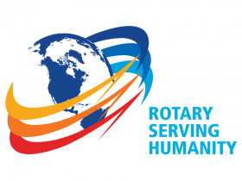st issues
Visit our website
'Like' our Facebook page
'Follow' our Twitter page

