Portion of 'Papa’s Boots' Proceeds to Benefit Polio Plus
By Carl Good III
Last Friday, Amanda Graves gave a moving presentation to the Rotary Club of Wachusett Area on her children's book Papa's Boots. The short, beautifully illustrated book chronicles a grandfather explaining his childhood polio to his grandson. Amanda is an excellent speaker and provides a portion of the proceeds to Polio Plus. For more information, contact Amanda at amandacooks@hotmail.com. To buy the book at Amazon.com, click here.

Members of the Wachusett Area club contributed $531 in cash and checks, which was further supplemented b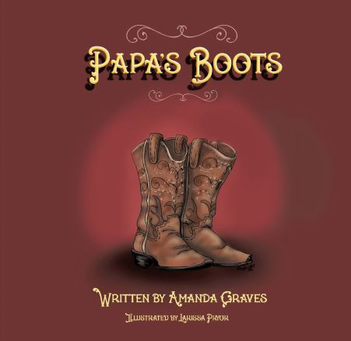y $20 that Amanda gave to Polio Plus from the sale of 20 copies of Papa's Boots. Another $20 came from the sale of special Fathers' Day cards that Past District Governor Carol Toomey brought to the meeting. Wachusett Area members will get Paul Harris Fellow credits for their $531 contribution. The other $40 was credited to the club. Rotary's polio-eradication effort will get a total of $1,713 as a result of a 2-to-1 match by the Bill and Melinda Gates Foundation.

Wachusett Area Rotarian Lisa Bean, who chairs the club’s Speakers Committee and is a member of the club's Board of Directors, had e-mailed club members to bring at least $26.50 each in cash or in a check to the meeting. It paid off nicely.

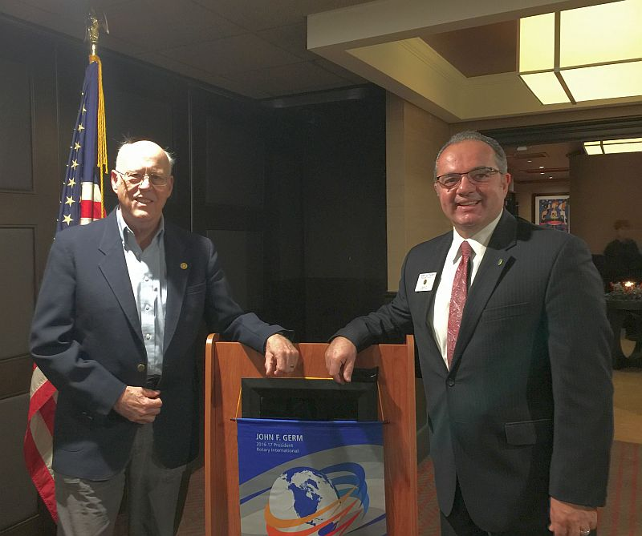Last week, I made presentations on Polio Plus at the Rotary Club of Franklin and the Rotary Club of Worcester. These visits are very rewarding because of the chance to meet other Rotarians and see their enthusiasm for the Polio Plus program.

Left to right: District Polio Plus Chair Carl Good III and Franklin President Terry Katasaros

As District Foundation Chair Sanjay Deshpande has noted, our districtwide goal is that each Rotary club contribute at least $26.50 per member to Polio Plus during the 2016-2017 Rotary year, which ends next June 30. We appeal to all 51 clubs to do their best to meet this modest goal.

Remember that contributions to Polio Plus during this Rotary year will count towards the “per-capita contribution to the Foundation” eligibility requirement for receiving District Grants and Global Grants during the next Rotary year, which begins next July 1. Since that per-capita requirement is based on club membership as of last July 1, all collections from new members this year will add to the total but the average will be based on the July 1, 2016 membership. So, we appeal to all members to contribute to Polio Plus and other Foundation funds.

If all clubs achieve this goal of at least $26.50 per member in Polio Plus contributions, the total collection from the 1,455 Rotarians in our district would exceed $38,550. Because of the Gates Foundation’s 2-to-1 match Rotary’s fight against polio would receive more than $115,600 through the contributions of our district’s Rotarians.

Virtual-reality films bring a new dimension to polio fight

At this year’s World Polio Day celebration in Atlanta, Rotary harnessed the power of virtual-reality technology to build empathy and inspire action in our fight to eradicate polio.

Learn more about the films, click here.

To watch the video of World Polio Day in Atlanta, click here.

If you are had an event for World Polio Day (or Week), please send me a brief description. We are keeping track of the events.

READ MORE

Carl Good III, chair of the District Polio Subcommittee, may be reached at carlgood@yahoo.com.

Return to December 12 Newsletter

View past issues
Visit our website
'Like' our Facebook page
'Follow' our Twitter page

Portion of Papa’s Boots Proceeds to Benefit Polio Plus

By Carl Good III

Last Friday, Amanda Graves gave a moving presentation to the Rotary Club of Wachusett Area on her children's book Papa's Boots. The short, beautifully illustrated book chronicles a grandfather explaining his childhood polio to his grandson. Amanda is an excellent speaker and provides a portion of the proceeds to Polio Plus. For more information, contact Amanda at amandacooks@hotmail.com. To buy the book at Amazon.com, click here.

Members of the Wachusett Area club contributed $531 in cash and checks, which was further supplemented by $20 that Amanda gave to Polio Plus from the sale of 20 copies of Papa's Boots. Another $20 came from the sale of special Fathers' Day cards that Past District Governor Carol Toomey brought to the meeting. Wachusett Area members will get Paul Harris Fellow credits for their $531 contribution. The other $40 was credited to the club. Rotary's polio-eradication effort will get a total of $1,713 as a result of a 2-to-1 match by the Bill and Melinda Gates Foundation.

Wachusett Area Rotarian Lisa Bean, who chairs the club’s Speakers Committee and is a member of the club's Board of Directors, had e-mailed club members to bring at least $26.50 each in cash or in a check to the meeting. It paid off nicely.

Last week, I made presentations on Polio Plus at the Rotary Club of Franklin and the Rotary Club of Worcester. These visits are very rewarding because of the chance to meet other Rotarians and see their enthusiasm for the Polio Plus program.

Left to right: District Polio Plus Chair Carl Good III and Franklin President Terry Katasaros
As District Foundation Chair Sanjay Deshpande has noted, our districtwide goal is that each Rotary club contribute at least $26.50 per member to Polio Plus during the 2016-2017 Rotary year, which ends next June 30. We appeal to all 51 clubs to do their best to meet this modest goal.

Remember that contributions to Polio Plus during this Rotary year will count towards the “per-capita contribution to the Foundation” eligibility requirement for receiving District Grants and Global Grants during the next Rotary year, which begins next July 1. Since that per-capita requirement is based on club membership as of last July 1, all collections from new members this year will add to the total but the average will be based on the July 1, 2016 membership. So, we appeal to all members to contribute to Polio Plus and other Foundation funds.

If all clubs achieve this goal of at least $26.50 per member in Polio Plus contributions, the total collection from the 1,455 Rotarians in our district would exceed $38,550. Because of the Gates Foundation’s 2-to-1 match Rotary’s fight against polio would receive more than $115,600 through the contributions of our district’s Rotarians.

