COMMITTEE REPORTS

Club Central: Short video on how to post your club goals

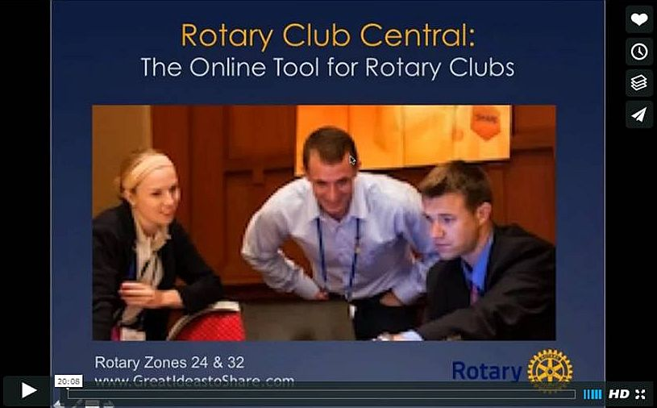
This 20-minute webinar recording is designed for club leaders to assist in posting goals on Rotary Club Central. Bob Wallace and Ian Lancaster, facilitators from Rotary Zone 24 East, provide practical start-up information.

CLICK HERE

Did You Know?: District 7640 has more Interactors than Rotarians

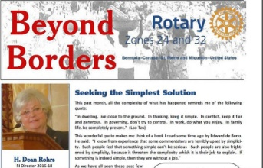

READ MORE

Interact Actions: Interact teens needed to help next June in Atlanta
By Bob Anthony
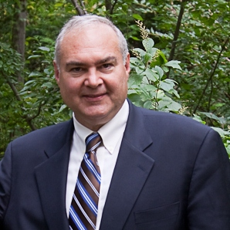All Interact teens are invited to help staff the House of Friendship booths next April 29 during the Multi-District Conferencein Providence and next June 10 to 14during Rotary International Conference in Atlanta. We strongly encourage clubs that win a District Interact Video Contest to attend both events, to communicate their achievements!
READ MORE

How to launch an Interact club

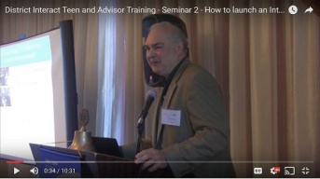
In Seminar 2 of the District Interact Teen and Advisor Training Seminar, held on September 17 in Needham, Bob Anthony, chair of the District Interact Committee, discusses “How to launch an Interact club,”including the certification letter, roles and responsibilities of the president, the Rotary advisor and, in the case of school-based clubs, the faculty advisor.

WATCH VIDEO

Rotary Means Business: Holds first event in our district

By Ron Bott

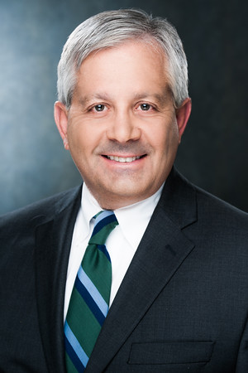On December 7, our district’s business-networking fellowship, Rotary Means Business, was launched. More than 30Rotarians and guests attended.

READ MORE (including event photos)

'17 RI Convention in Atlanta: Discount ends December 15

Beyond Borders Dinner on June 11: To register now, click here.

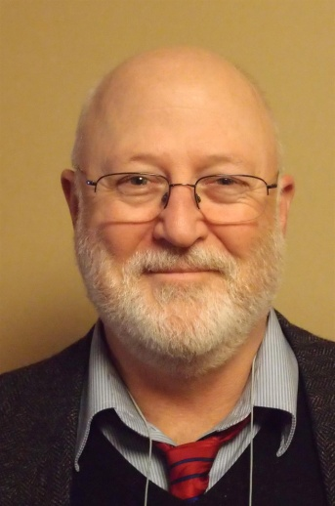
Here's a letter from Steve Glines, chair of the District International Convention Promotion Committee.

READ LETTER

To register and find hotel options, click here

For more information on the 2017 RI Convention in Atlanta, click here

Million Dollar Dinner: RI Past President Kalyan Banerjee to be keynote speaker

By Satya Mitra

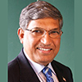
I am pleased to inform you that Kalyan Banerjee, a past Rotary International president and chair and trustee of The Rotary Foundation, has confirmed his attendance next May 25 for our district’s Million Dollar Dinner. He needs to attend another event in Zurich, Switzerland on May 27 May, so he will leave early on May 26.

The venue, Mechanics Hall in Worcester, has been reserved for this gala event. Let’s do a grand celebration of the centennial year of The Rotary Foundation.

READ MORE

Polio Plus Update: Portion ofPapa’s Boots Proceeds to Benefit Polio Plus

By Carl Good III

Last Friday, Amanda Graves gave a moving presentation to the Rotary Club of Wachusett Area on her children's book Papa's Boots. The short, beautifully illustrated book chronicles a grandfather explaining his childhood polio to his grandson. Amanda is an excellent speaker and provides a portion of the proceeds to Polio Plus. For more information, contact Amanda at amandacooks@hotmail.com. To buy the book at Amazon.com, click here.
READ MORE

Foundation Note: Foundation-Giving Scorecard for ‘16-‘17
By Sanjay Deshpande

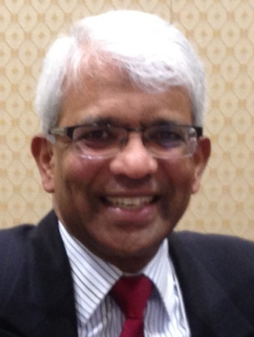
The Rotary Foundation is supported by contributions from Rotarians all around the world. Our district has set a goal of $325,000 in total Foundation giving in Rotary year 2016-2017, which ends next June 30. That’s about 10 percent above the $293,705 contributed during ’15-‘16. The ’16-’17 per-capita average goal is about $225.

READ MORE

Membership Corner: Corporate memberships in Rotary

By Tom Sturiale
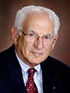
In our renewed zeal to broaden our membership, we are approaching large corporations and businesses to join our organization. In days past, corporations used to encourage their employees to join charitable and community organizations but times have changed and it is more difficult to continue those practices. In the past few years, we have been evolving a methodology to encourage businesses to join our effort.

READ MORE

To learn how the Rotary Club of Melbourne in Victoria, Australia does corporate membership, click here

To learn about District 7910 Membership Workshops inOctober, click here.
Membership Materials On Sale: Order now!
To order, click here

PR Tips: Pictures - Show something awesome!

By Laura Spear
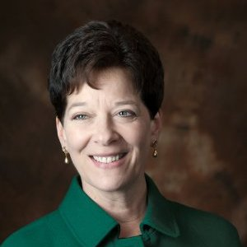
Don’t use a cookie-cutter picture of people shaking hands, standing in a
row, or presenting a large check.

READ MORE

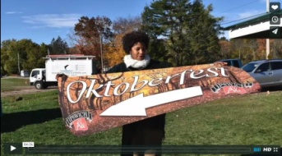Click here for an excellent example of a club-event promotional video by Concord President Steve Kirk.

RAAGNE Newsletter: Update on visioning process

By Klaus Hachfeld

Hello, members and friends of the Rotary Alumni Association of Greater New England! Here is to the latest edition of the RAAGNE newsletter! Over the past year, we went through a visioning process to work out the future direction of RAAGNE.

READ MORE

Speaker's Bureau: Looking for good speaker for your club?

By Steve Levitsky

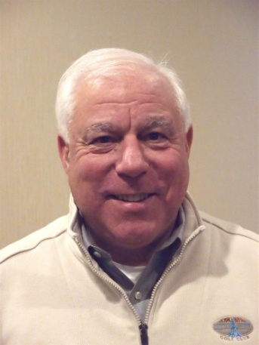
It's not always easy to come up with ideas week after week. We have many suggestions for you. Here are just a few:
- Rwandan genocide: Carine Boggis
- Elevator-pitch tips: Andy Winig
- Positive-results hypnosis: Bob Martel
- Differentiation and game-changing simplicity: Stephen Melanson
VIEW MORE

Treasurer's Report: Message about your dues

By Jack Hoell
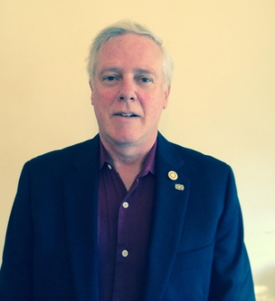
Rotary International dues bills will be invoiced in January based on membership numbers that are shown on your membership roster as of this December 31, so ensure that your membership numbers are accurate and up-to-date. District dues will be based on the same membership numbers that are used by Rotary International The RI and District dues bills will be sent to club presidents and secretaries in mid January.
READ MORE

District Charity Fund: How does DCF operate?

By Karin Gaffney
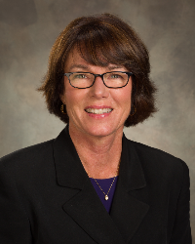
The District Charity Fund is a 501(c)3 charitable, non-profit that can be used by the Rotary clubs in District 7910.
READ MORE

Communications Link: Seeking club photo, video albums
By Steve Jones-D'Agostino
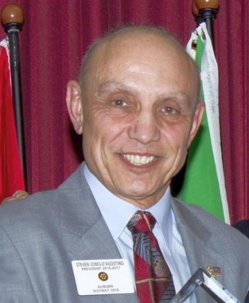
Does your District committee or Club have Rotary-related photo and/or video albums that you'd like to share with other Rotarians?
READ MORE

SUBMIT CONTENT

To submit content for consideration for the Monday, December 19 issue of Rotary District 7910 Newsletter, please e-mail it to Immediate Past District Governor and Newsletter Editor Jim Fusco at jim.fusco2@gmail.com.
The submission deadline for that issue is Friday, December 16. All text must be in Word format. All images must be in either JPEG or PDF format. Please identify the people, left to right, who are shown in your photos, including their first and last name as well as their club or other title.

PAST ISSUES
To view past issues of the weekly Rotary District 7910 Newsletter, click here

DISTRICT 7910 ONLINE
Visit our website
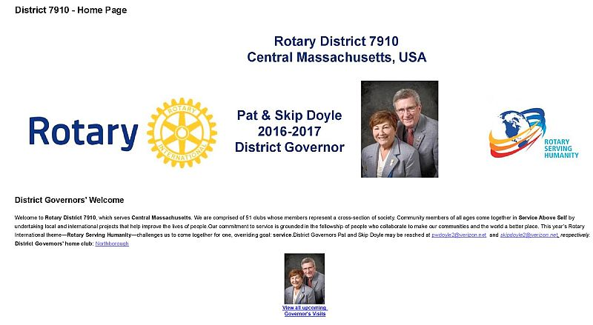
Click on each one

'Like' and share us on Facebook
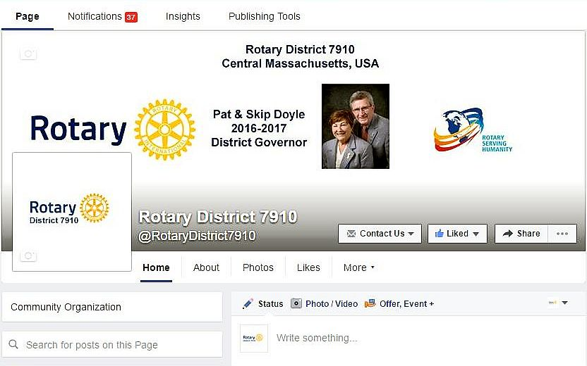

WATCH OUR VIDEOS

VIEW OUR PHOTOS
Archived on Google Photos, since May 2015; and on ClubRunner, before May 2015
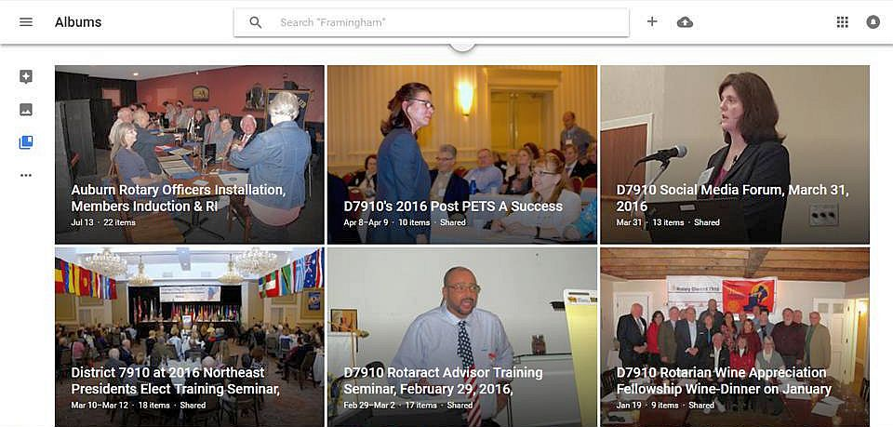

CONTACT US
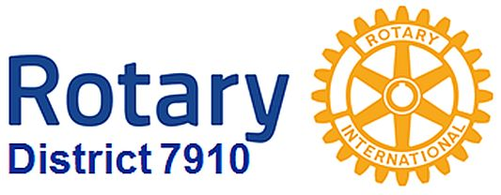Jim Fusco, Immediate Past District Governor and Newsletter Editor
​jim.fusco2@gmail.com
Steve Jones-D'Agostino,District Webmaster and Newsletter Copyeditor
​srdagostino@icloud.com

© Copyright 2016-2017 - Rotary District 7910, Central Massachusetts, USA

