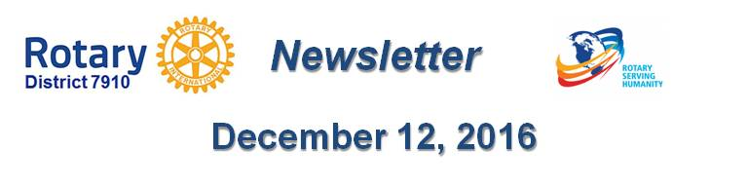

Rotary Means Business Holds First Event in Our District
By Ron Bott

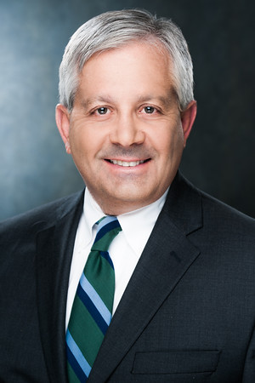
.On December 7, our district's new business-networking fellowship, Rotary Means Business, was launched. More than 30 Rotarians and guests met.

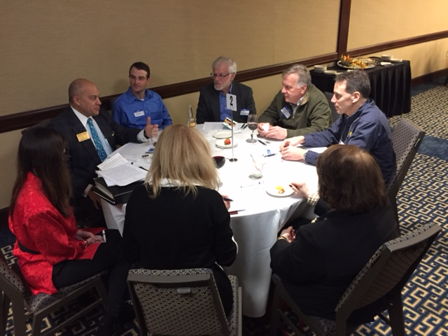
Clockwise, starting at top, are: an unidentified guest; Ron Facenda of Newton Rotary; Gerry Gross of Westborough Rotary; Tony Gallo of Milford Rotary; Peggy Thorsen of Marlborough Rotary; Nancy Gilroy of Bedford Rotary; Cheryl Rosen of Hudson Rotary; and District Governor-Nominee Steve Sager of Westborough Rotary.

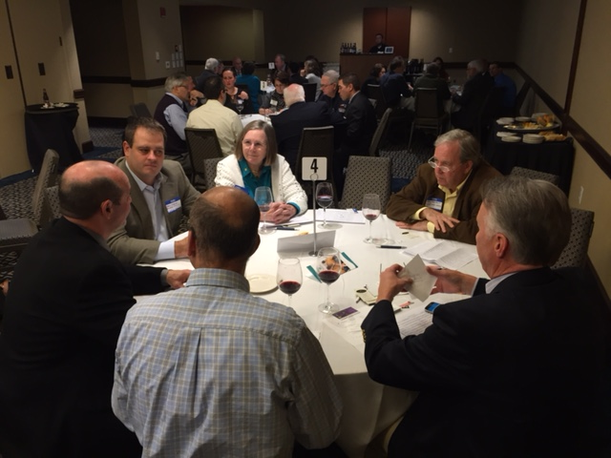Clockwise, starting at top: Carol Toomey of Nashoba Valley Rotary; Larry Perrault, a guest; Ron Fraser of Worcester Rotary; Vinny Tingley of Natick Rotary; Paul Gauvinof Fitchburg Rotary; and Eric Lazzari of Natick Rotary.

Rotary Means Business was founded in 2013 as an official Rotary International Fellowship. RMB provides Rotarians with business networking events to meet and socialize with other Rotarians in business. It encourages Rotarians to support the success of their fellow Rotarians by doing business with them, and by referring others to them.

For more information, contact me as chair of the District Rotary Means Business Committee at 978-423-0564 or ron@bottgroup.com.

Return to December 12 Newsletter

View pa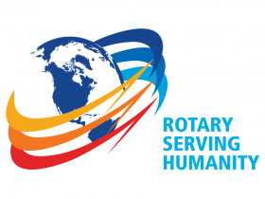st issues
Visit our website
'Like' our Facebook page
'Follow' our Twitter page

