Foundation-Giving Scorecard for ‘16-‘17
By Sanjay Deshpande

The Rotary Foundation is supported by contributions from Rotarians all around the world. Our district has set a goal of $325,000 in total Foundation giving in Rotary year 2016-2017, which ends next June 30. That’s about 10 percent above the $293,705 contributed during ’15-‘16. The ’16-’17 per-capita average goal is about $225.

As of November 24, the district’s total giving stood at $33,393, or 10 percent of the annual goal. Historically, December and the April-June quarter are the highest contribution periods. District Governor-Nominee-Designate Pam Anastasi (left) will be leading the district-wide charge toward the goal with the help of Steve Levitsky (middle), chair of the District Fundraising Subcommittee, and Satya Mitra (right), chair of the District Endowments and Major Gifts Subcommittee.

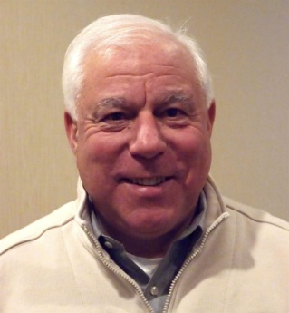

The Top 10 leaders in Foundation-giving, through December 17, are shown in this table, ranked by per-capita contribution:

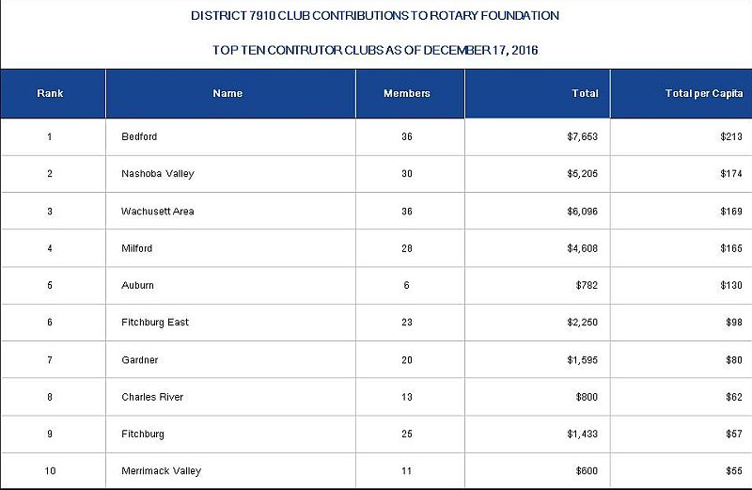

For the complete list, in PDF format, of District 7910 club contributions, in alphabetical order, click here.

For the complete list, in PDF format, of District 7910 club contributions, in order of total per-capita giving, click here

A time for charitable giving - and tax planning

December traditionally is the time that people do the most of their giving," Michael Thatcher, president and CEO of Charity Navigator, told CNBC's "On The Money." Founded in 2001, Charity Navigator is a non-profit organization that acts as a charity watchdog, evaluating non-profits and charities. (Charity Navigator rates The Rotary Foundation in its highest category of recommended charities.) According to Charity Navigator, “Thirty-one percent of all annual giving occurs in the month of December and 12 percent of that annual giving occurs on the last three days of the year!”

Over the past three years, District 7910 Rotarians have given generously during December, as seen below.

 | 2013-'14 | 2014-'15 | 2015-'16
December contribution | $19,893 | $26,488 | $34,510
Share of full-year total | 11.2% | 12.7% | 17.7%

We are hopeful that in the next 12 days Rotarians will take advantage of the tax deductibility of contributions to The Rotary Foundation and increase their giving, to get our district's total for December above $35,000. December is the time for tax planning, and it is a smart strategy to make all of the charitable contributions for 2016 now.

Also, those Rotarians who receive required minimum distributions from their IRAs may wish to follow the example of Bud Fortin of the Rotary Club of Fitchburg East. Last year, he urged district officers to share this message with all Rotarians: “My guess is that there are many Rotarians such as myself who are retired, over 70, have IRAs and no home mortgage. Most of us probably do not itemize deductions, so it may be helpful to point out to us that any funds donated from the required minimum distribution directly to a qualified charity do not have to be included as income on our taxes. In other words, without even itemizing, we can completely avoid the tax on that portion of the distribution.

“I believe it does cover any amount taken out of an IRA after age 70-1/2, and I'm not even sure one must be 70-1/2,” Bud continued. “It would pleasantly surprise me if any Rotarian would be donating more than his/her minimum distribution. I have my donations sent to: The Rotary Foundation, 14280 Collections Center Drive, Chicago, IL 60693. Be sure that the donor includes his/her Rotary number, so credit can be given.”
Pam Anastasi, Steve Levitsky and Satya Mitra will be approaching all Rotarians through their clubs in the next few days, weeks and months to appeal for your generous contributions to The Rotary Foundation.

Pam Anastasi may be reached at pamela.anastasi@ebtc.com, Steve Levitsky may be reached at stevey50@aol.com, and Satya Mitra may be reached at satya@thegurutax.com.

If you have any questions about the District Foundation Committee, contact either District Grants Subcommittee Chair Jorge Yarzebski at yj.rotary@gmail.com or me, District Foundation Committee Chair Sanjay Deshpande, sanjdesh51@aol.com.

For the Foundation Notes archive, click here

Learn more about District 7910 Foundation Grants:
- Timeline for District 7910 Foundation Grants (Web Page)
- District 7910 Monthly Club Contribution Report - Total Per Capita (PDF Format)
- District 7910 Monthly Club Contribution Report - Alphabetical (PDF Format)
- Rotary Areas of Focus Policy Statements (PDF Format)
- District 7910 Eligible and Ineligible Activities in a District Grant (Word Format)
- District 7910 Grant Qualification Table (PDF Format)
- District 7910 Grant Proposals and Qualifications Status (Web Page)
- District 7910 2015-2016 Foundation Contributions Report - (Excel Format)
- Foundation Grants in 2016-'17 and Beyond (PDF Format)
- District 7910 2016-2017 District Grant Proposal Template (PDF Format)
- District Grant Proposal Form (Word Format)
- Global Grant Proposal Form (Word Format)
- District 7910 District Grants Scoring Rubric (PDF format)
- District 7910 Club Memorandum of Understanding (PDF Format)
Return to December 19 & 26 Newsletter

View past issues
Visit our website
'Like' our Facebook page
'Follow' our Twitter page

