Happy Holidays!

No newsletter Next Week
By Pat and Skip Doyle

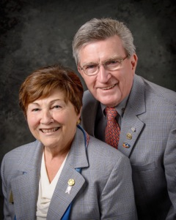As we write this message, we are looking out at a snowy landscape. Our backyard borders the woods. The pine trees are covered in snow. It is very still. So far, we have not seen any birds or small animals. It certainly is a very peaceful scene. This is the time of the year when contemplating peace comes naturally to many of us. It brings to mind one of the goals of our Rotary year - that, of encouraging our clubs to become aware of the Rotary Peace programs.

A Rotary Peace Fellowship builds skills in advancing peace and resolving conflicts. Skills that can be shared with school, governments and non-profit organizations. This is a program funded by The Rotary Foundation at no cost to Rotary clubs or to our district. Visit the Rotary Peace Centers Facebook Page for more information.

Replace the word "peaceful" with "joyful" and that would describe how we feel after a couple of weeks of joining many clubs at their holiday parties. We only wish that so many of them did not happen at the same time so we could have attended twice as many. Thank you all for your hospitality and wonderful expressions of fellowship. We much appreciated all the fun, music and laughter.

As this is the last newsletter of 2016, we have some important reminders for you.\:

- Please remember the Rotary Foundation in your year-end financial planning. See the Foundation Note column in this week’s newsletter for ways to donate.
- Next Sunday, January 1 is last date to register at a reduced rate for the Multi-District Conference next April in Providence. Go to www.RotaryConference2017.org. An updated program should be available on our website next week.
Enjoy the holidays with friends and family, and join us here again on January 2 for the first newsletter of 2017.

Please send us photos of your club's events during this season of giving. We hear so many wonderful stories of the good deeds you are all doing. We would love to fill the newsletter in the next couple of weeks with pictures of all you do. E-mail your club's event photos to newsletter Editor Jim Fusco at jim.fusco2@gmail.com.

Left to right: District Governor-Elect Karin Gaffney, Immediate Past District Governor Jim Fusco, District Governor-Nominee-Designate Pam Anastasi, District Governor Skip Doyle, District Governor-Nominee Steve Sager and District Governor Pat Doyle, during the District Holiday Party on December 4 in Sturbridge.

VIEW ALL PHOTOS

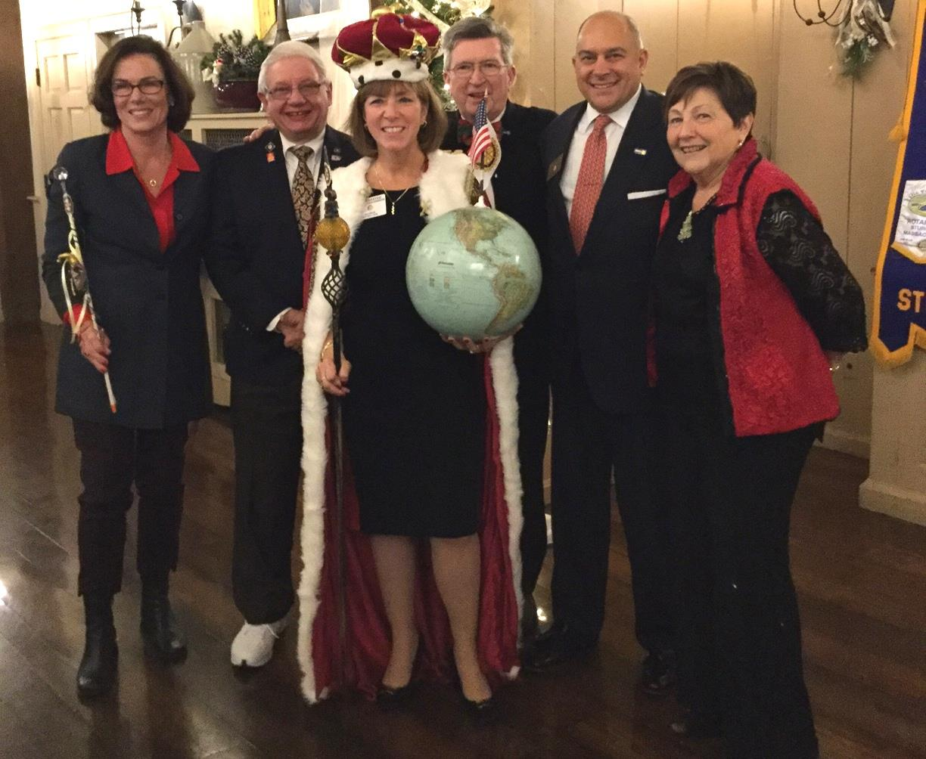

Hot Off the Press!: 2016-2017 District Directory
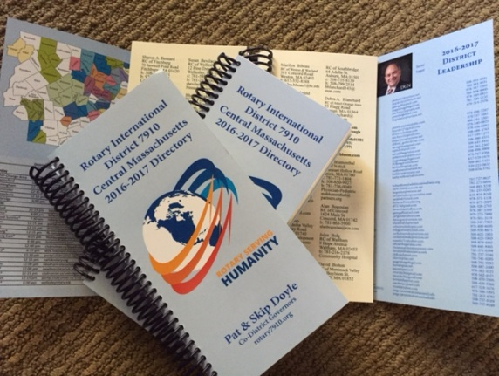
Print copies of our information-packed, 332-page Directory for this Rotary year will soon be delivered to your club.

The Directory includes: district and Rotary International general information; district club information; Yellow Pages of Rotarian-run businesses; District Resolutions; and a complete membership directory.

A digital copy is now available for automatic download, in PDF format.

Please note: Member login is required.

Click here, to download

Thank You! Thank You!! Thank You!!!

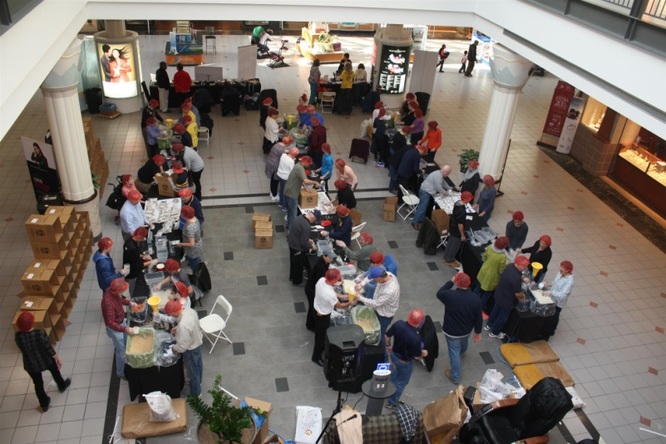Our District Food Packaging Event on November 12 at the Solomon Pond Mall in Marlborough was a solid success.

More than 100 volunteers from around the district packaged 20,000 meals, which will be sent to Haiti to help feed the children left homeless by the hurricane. These volunteers were Rotarians and their friends and families, young and old There were Interactors from local clubs, passersby who wanted to help and past and present participants of Rotary Youth Leadership Awards. We raised more than $4,000 toward our goal of $5,000 - so we are still actively seeking donations.

VIEW ALL PHOTOS

Always remember, you can call us with questions at 508-393-9031.

District Governors Pat and Skip Doyle may be reached at pwdoyle2@verizon.net and skipdoyle2@verizon.net,
respectively.

There will be no newsletter on Monday, December 26 because of the holiday weekend. Merry Christmas and Happy New Year!

Click here to submit content for the January 2 issue. The submission deadline for this issue is Friday, December 30.

Click here for past issues.

Return to December 19 & 26 Newsletter

Visit our website
'Like' our Facebook page
'Follow' us on Twitter

