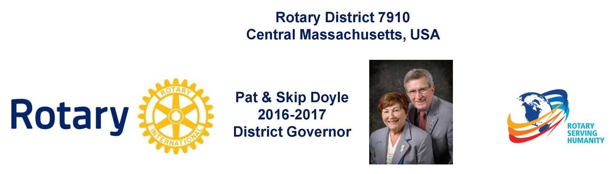

Governors' Welcome
Welcome to Rotary District 7910, which serves Central Massachusetts. We are comprised of 51 clubs whose members represent a cross-section of society. Community members of all ages come together in Service Above Self by undertaking local and international projects that help improve the lives of people.

Our commitment to service is grounded in the fellowship of people who collaborate to make our communities and the world a better place. This year’s Rotary International theme—Rotary Serving Humanity—challenges us to come together for one, overriding goal: service.

District Governors Pat and Skip Doyle may be reached at pwdoyle2@verizon.net and
skipdoyle2@verizon.net, respectively.

District Governors' home club: Northborough

register now: 2017 Multi-District Conference, April 28-30, Providence. Register by January 1 - and save! To Register, click here.
To download the Conference Highlights flyer (shown, below) in PDF format, click here

To download the Conference Sponsorship Donation form in PDF format, click here

To download the Rotary Waterfire Fundraiser brochure in PDF format, click here

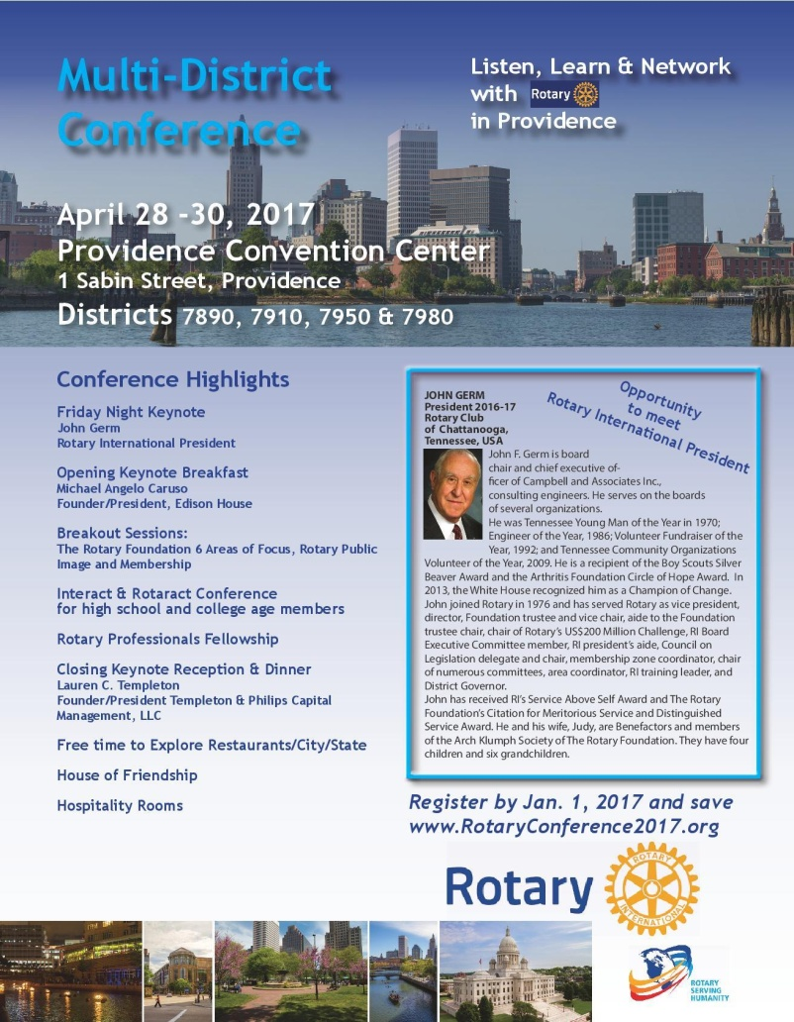

Hot Off the Press!
2016-2017 Rotary District 7910 Directory
Print copies of our 332-page, information-packed 2016-2017 Rotary District 7910 Directory will soon be delivered to your club.

The Directory includes:
- District 7910 and Rotary International general information
- District club information
- Yellow Pages of Rotarian-run businesses
- District Resolutions
- Complete membership directory

A digital version of the Directory is now available for automatic download, in PDF format. Please note: Member login is required.

Click here, to download

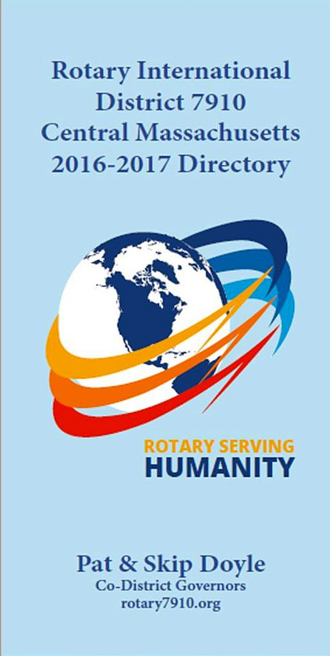

District at a glance

Click on each one

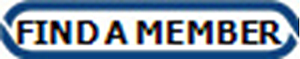

District SOCIAL MEDIA

Click on each one

View Live: Our Facebook Page!
Rotary District 7910

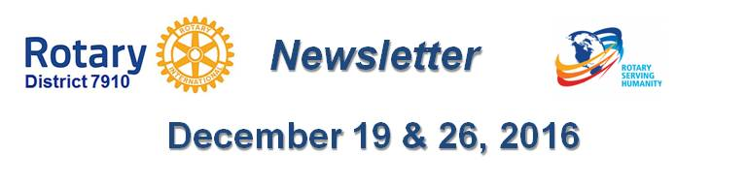

Click here for the complete issue

Or, click on each of these issue highlights:

Governor's Message: Happy holidays! No newsletter next week - By Pat and Skip Doyle

District Alert: It's winter accessibility and safety time - By Ron Goodenow

Treasurer's Report: Membership Numbers Must Be Updated By December 31- By Jack Hoell

Rotary Means Business: Holds first event in our district - Next one on January 25 - By Ron Bott

Foundation Note: Foundation-Giving Scorecard for ‘16-‘17 - By Sanjay Deshpande

Membership Corner: Improving effective membership efforts - By Tom Sturiale

PR Tips: More about pictures - By Laura Spear

Interact Actions: Interact teens invited to help in Providence and Atlanta - By Bob Anthony

Interact Video Contest: Bay Path High Rotaract is District’s First Winner

'17 RI Convention in Atlanta: Discount ends December 31 - By Steve Glines

Rotary International Website Updated: Get a sneak peak

Million Dollar Dinner: RI Past President Kalyan Banerjee to be keynote speaker - By Satya Mitra

Polio Plus Update: Portion of Papa’s Boots Proceeds to Benefit Polio Plus - By Carl Good III

Club Central: Short video on how to post your club goals - By Bob Wallace and Ian Lancaster

Did You Know?: District 7640 has more Interactors than Rotarians - By Zone 24 & 32

RAAGNE Newsletter: Update on visioning process - By Klaus Hachfeld

Speakers Bureau: Do you need a speaker for your club? By Steve Levitsky
District Charity Fund: How does DCF operate? - By Karin Gaffney

Communications Link: Seeking club photo, video albums - By Steve Jones-D'Agostino

Click here for our archive of past issues

