GOVERNOR'S MESSAGE
Happy Holidays!
No newsletter next week
By Pat and Skip Doyle
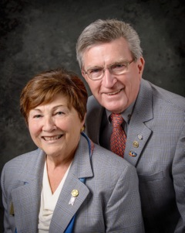As we write this message, we are looking out at a snowy landscape. Our backyard borders the woods. The pine trees are covered in snow. It is very still. So far, we have not seen any birds or small animals. It certainly is a very peaceful scene. This is the time of the year when contemplating peace comes naturally to many of us. It brings to mind one of the goals of our Rotary year - that, of encouraging our clubs to become aware of the Rotary Peace programs.
A Rotary Peace Fellowship builds skills in advancing peace and resolving conflicts. Skills that can be shared with school, governments and non-profit organizations. This is a program funded by The Rotary Foundation at no cost to Rotary clubs or to our district. Visit the Rotary Peace Centers Facebook Page for more information.
Replace the word "peaceful" with "joyful" and that would describe how we feel after a couple of weeks of joining many clubs at their holiday parties. We only wish that so many of them did not happen at the same time so we could have attended twice as many. Thank you all for your hospitality and wonderful expressions of fellowship. We much appreciated all the fun, music and laughter.
As this is the last newsletter of 2016, we have some important reminders for you.\:
- Please remember the Rotary Foundation in your year-end financial planning. See the Foundation Note column in this week’s newsletter for ways to donate.
- Next Sunday, January 1 is last date to register at a reduced rate for the Multi-District Conference next April in Providence. Go towww.RotaryConference2017.org. An updated program should be available on our website next week.
Enjoy the holidays with friends and family, and join us here again on January 2 for the first newsletter of 2017.
District Governors Pat and Skip Doyle may be reached at pwdoyle2@verizon.net and skipdoyle2@verizon.net,
respectively.

There will be no newsletter on Monday, December 26 because of the holiday weekend. Merry Christmas and Happy New Year! Click here to submit content for the January 2 issue. The submission deadline for this issue is Friday, December 30.

Click here for past issues.

DISTRICT ALERT
It's Winter Accessibility and Safety Time

By Ron Goodenow

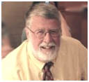According to the national Centers for Disease Control and Prevention, roughly 32,000 Americans die every year from falls. In 2012 and 2013, 55 percent of all unintentional-injury deaths among adults aged 65 and over were due to falls. Other studies reveal that falls are the leading cause of death due to injury among the elderly and that 87 percent of all fractures in the elderly are due to falls.

Though there are many reasons for falls, about one-third of those taken by seniors are environment-related, with data suggesting that more than one-third of adults in the U.S. suffer serious injuries due to falling on snow or ice. Almost 20,000 will die each year as the result of these injuries, and approximately 600,000 are hospitalized. Some of these are doubtless Rotarians.

READ MORE

WELCOME, NEW ROTARIANS

- Anna Hueston, Littleton
- Rob Hueston, Littleton
- Elda Kalivioti, Concord
- Scott Long, Gardner
- Edward Moore, Southbridge
Remember to ask ... ask ... ask!

REGISTER NOW: 2017 MULTI-DISTRICT CONFERENCE, APRIL 28-30, PROVIDENCE. REGISTER BY JANUARY 1 - AND SAVE! TO REGISTER, CLICK HERE
To download the Conference Highlights flyer (shown, below) in PDF format, click here
To download the Conference Sponsorship Donation form in PDF format, click here
To download the Rotary Waterfire Fundraiser brochure in PDF format, click here

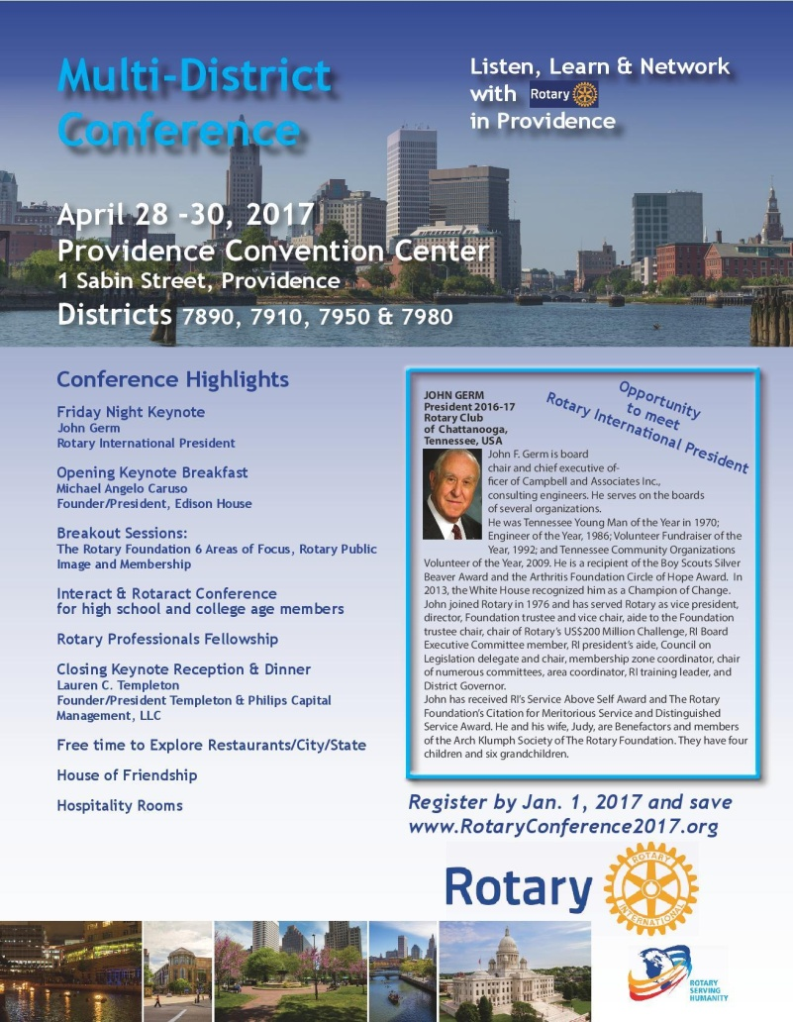

HOT OFF THE PRESS!

2016-2017 DISTRICT DIRECTORY
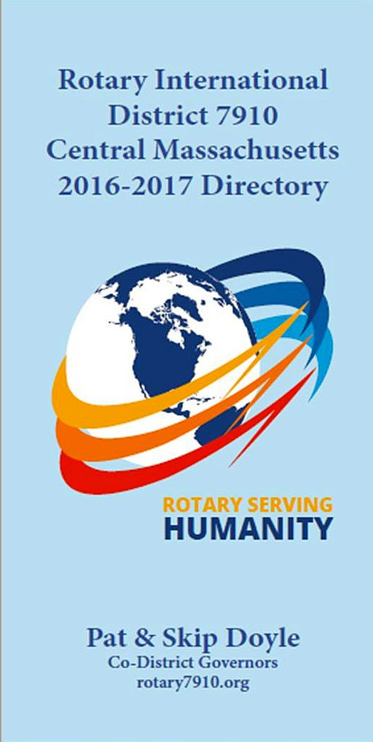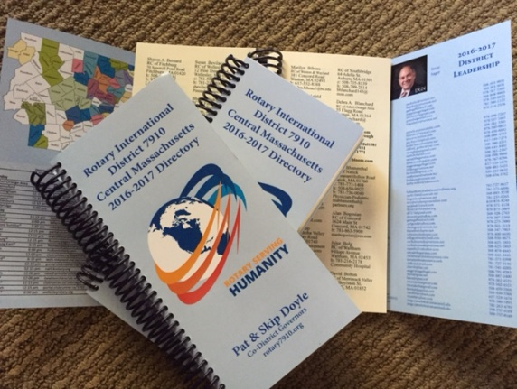
Print copies of our information-packed, 332-page Directory for this Rotary year will soon be delivered to your club.

The Directory includes: district and Rotary International general information; district club information; Yellow Pages of Rotarian-run businesses; District Resolutions; and a complete membership directory.

A digital copy is now available for automatic download, in PDF format.

Please note: Member login is required.

Click here, to download

CLUB MEMBERSHIP GROWTH, ’16-‘17
We share with you the results of club-membership growth in our district during Rotary year 2016-2017, which began July 1.

This is a unique opportunity for Rotarians and friends to discuss partnering on humanitarian projects affecting our local communities.

READ MORE

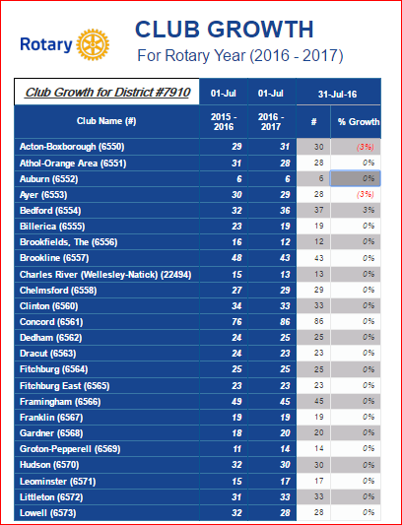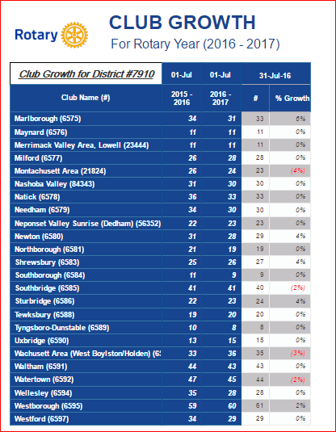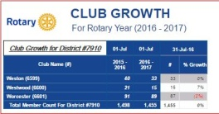

CLUB PLANNING WORKSHEET '16-'17
In both Excel and PDF formats, we share with you the Club Planning Worksheet for Rotary year 2016-2017, which began on July 1.
Please enter your club information in the indicated cells.

Excel Format

PDF Format

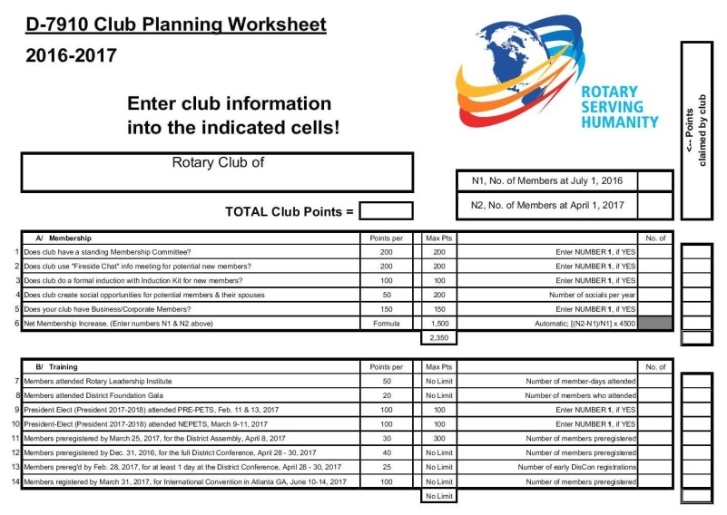

DISTRICT & CLUB ROUNDS

Video Available On District Fundraising Goals

We are all well aware thatThe Rotary Foundation is celebrating its 100th anniversary in 2017. Steve Kirk, president of the Rotary Club of Concord, has produced a five-minute video that outlines our owndistrict’s fundraising goals for the current Rotary year, which ends next June 30.

WATCH VIDEO

To learn more about The Rotary Foundation, click here.

Auburn Picks Heather Chivallatti as President-Elect, Installs Rick Stock as Member

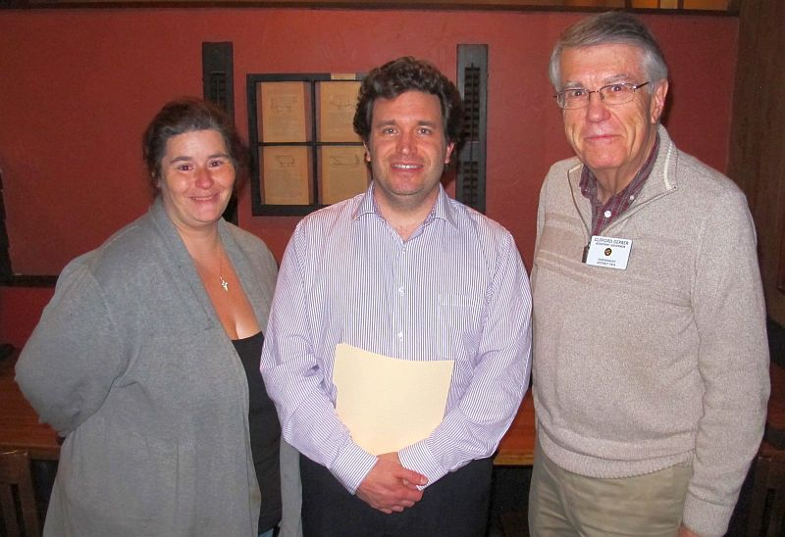Heather Chivallatti (left),president-elect and secretary of the Rotary Club of Auburn, and newly installed Auburn Rotarian Rick Stock (middle) pose with Assistant Governor Cliff Gerber (right) on December 7 at Chuck's Steak House in Auburn. The club voted unanimously to choose Heather as president-elect for the Rotary year that begins next July 1. Cliff installed Rick, who was sponsored by Heather.

To learn more about Auburn Rotary, click here.

Auburn Helps Auburn Middle, Bay Path High Raise $632 in Purple Pinkie Campaign

The Rotary Club of Auburn has helped students atAuburn Middle School and Bay Path Regional Vocational Technical High School to raise $632for the 2016 Purple Pinkie campaign, promoted by Rotary International’s global drive to End Polio Now. Because the Bill & Melinda Gates Foundationmatches 2-to-1 every dollar raised to eradicate polio, $1,896 will directly go to the worldwide vaccination effort. The two schools held their fundraisers onOctober 24, World Polio Day, with club President-Elect and Secretary Heather Chivallatti coordinating the Auburn Middle School push and club Interact Chair Jennifer Reil, a Bay Path teacher, and Rick Carrero, also a Bay Path teacher, overseeing that school’s effort. “Auburn Rotary is proud to have played a small but important part in the global movement to wipe out polio,” states club President Steve Jones-D’Agostino, “We are grateful to Auburn Middle and Bay Pay High for their generous support of this noble cause.”

READ MORE

To learn more about the Rotary Club of Auburn, click here.

Fitchburg Holds Breakfast With Santa

The Rotary Club of Fitchburg participated recently in Breakfast with Santa at Hollis Farm in Fitchburg. This was third straight year that Fitchburg has sponsored Santa Claus and provided photo services.

Left to right: Fitchburg Members Paul Gauvinand Karen Fusco, Fitchburg Immediate Past President Wayne Carney, and Santa Claus.Can you guess who is playing Santa?

Tewksbury Rotary, Lions Teaming Up for Sock Hop

The Rotary Club of Tewksbury and theTewksbury Lions Club are teaming up for an all-new event, complete with live entertainment, dancing and raffle prizes. The event, called Sock Hop, will be held on Friday, January 20 at 7:00 p.m. atTewksbury Country Club. Reminisce, a New England-based vocal group will perform songs of the 1950s and '60s.
READ MORE

To learn more about Tewksbury Rotary, click here.

Westborough’s Free Holiday Store Open Through December 24

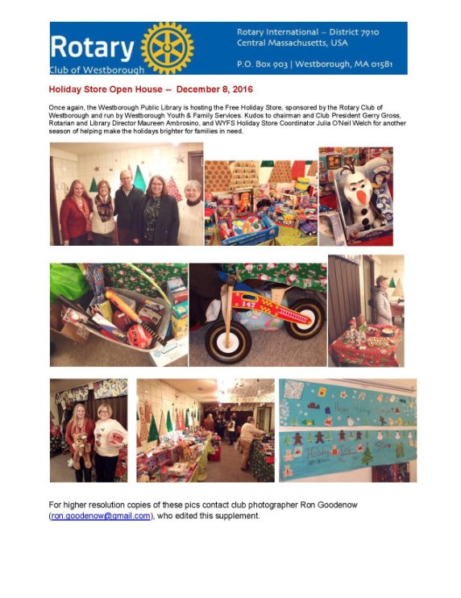The Rotary Club of Westborough had produced a photographic supplementfocusing on its free Holiday Store, which provides toys and gift cards to Westborough families in need during the holiday season. The store opened on December 8 and will operate through Saturday, December 24. Congratulations to the club’s photographer extraordinaire, Ron Goodenow, for creating this supplement.

VIEW PHOTO SUPPLEMENT

To learn more about Westborough Rotary,click here.

Worcester Awards $10,000 To Be Like Brit Foundation

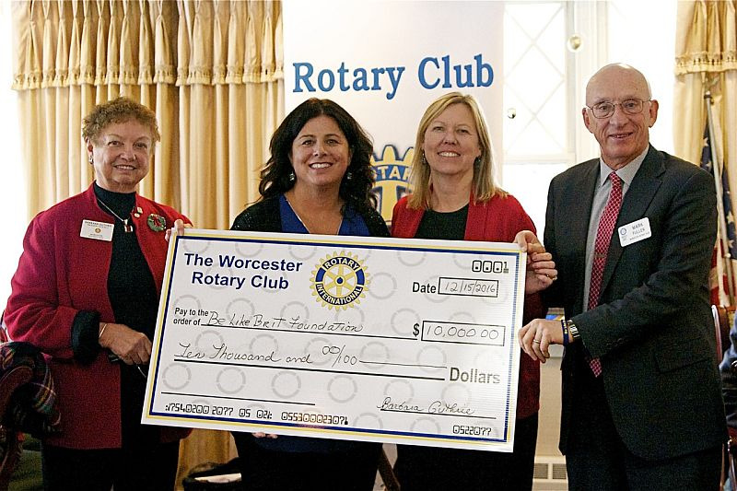On December 15, theRotary Club of Worcestercelebrated its annualHoliday Glogg Party.During the event the club presented a check for$10,000 to Cherylann Gengel and the Be Like Brit Foundation to be used to provide water to an orphanage the Gengels built in Haiti. Left to right: Worcester President Barbara Guthrie; Cherylann Gengel of the Be Like Brit Foundation; Patty Eppinger; and Worcester Member Mark Fuller.

To learn more about Worcester Rotary, click here.

Worcester Donates $41,000 Opioid Education, Addiction Prevention

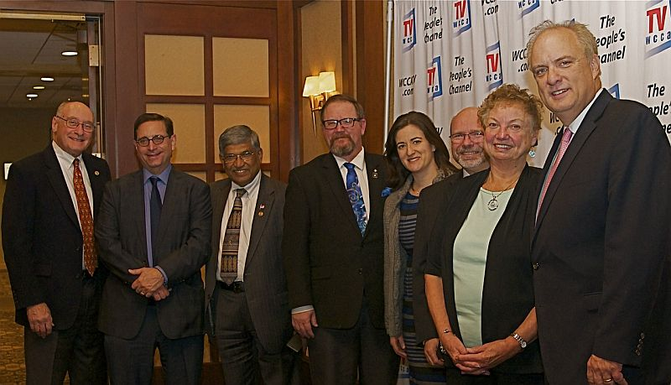On November 29, theRotary Club of Worcesterpresented a check for$41,000 to the City of Worcester. The city will use the donation for opioid education and addiction prevention. Left to right: Worcester MembersRichard Prager and Mauro DePasquale; Worcester Past President Satya Mitra,;Worcester Members Chris Gates and Amy Mosher Berry; Worcester Immediate Past President Bob Mangan; Worcester President Barbara Guthrie; and Worcester Mayor Joseph Petty.

To learn more about Worcester Rotary, click here.

Worcester Receives Humanitarian Award from WCCA-TV

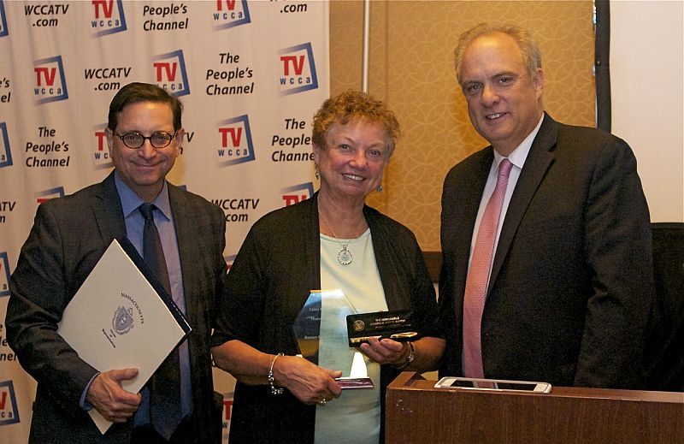On November 17, theRotary Club of Worcester received theFather Michael Bafaro Humanitarian Award fromWCCA-TV, the cable community-access channel for Worcester. The award celebrated Worcester Rotary's humanitarian contributions to Worcester. Left to right: Worcester Member and WCCATV General Manager Mauro DePasquale; Worcester President Barbara Guthrie; and Worcester Mayor Joseph Petty.

To learn more about Worcester Rotary, click here.

Rotary Means Business Holds First Event in Our District - Next Event on January 25

On December 7, our district's new business-networking fellowship, Rotary Means Business, was launched. More than 30 Rotarians and guests met.

READ MORE

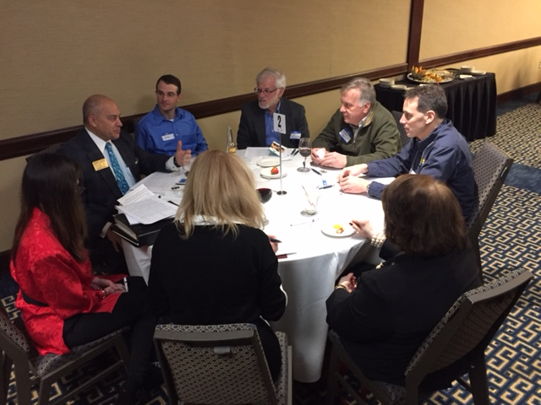
Clockwise, starting at top, are: an unidentified guest; Ron Facenda of Newton Rotary; Gerry Gross of Westborough Rotary; Tony Gallo of Milford Rotary; Peggy Thorsen of Marlborough Rotary; Nancy Gilroy of Bedford Rotary; Cheryl Rosen of Hudson Rotary; and District Governor-Nominee Steve Sager of Westborough Rotary.

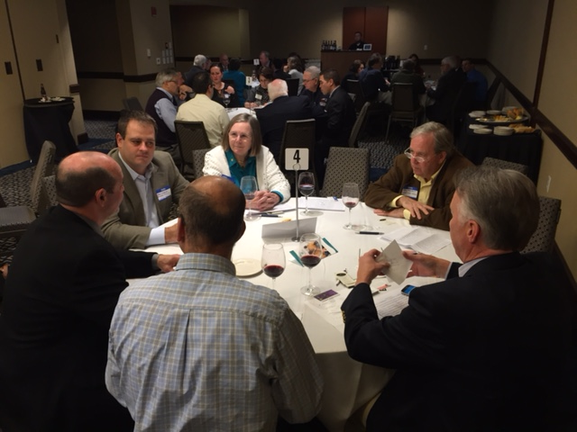Clockwise, starting at top: Carol Toomey of Nashoba Valley Rotary; Larry Perrault, a guest; Ron Fraser of Worcester Rotary; Vinny Tingley of Natick Rotary; Paul Gauvinof Fitchburg Rotary; and Eric Lazzari of Natick Rotary.

Video of Governor Baker's Address to District Rotarians Now Available

The Rotary Club 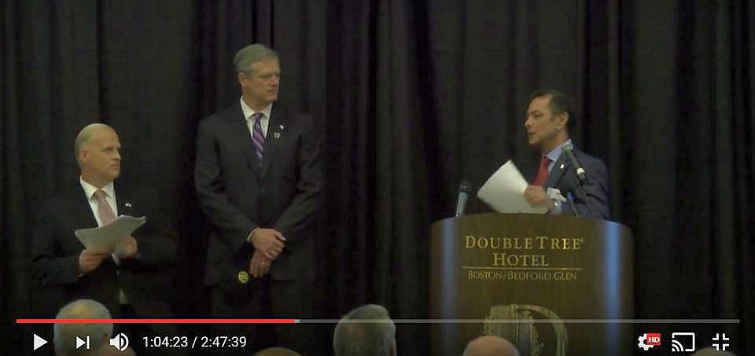of Billerica has provided a video of Governor Charlie Baker's address to District 7910 Rotarians on September 27 at the DoubleTree Hotel in Bedford. To watch the two-hour-47-minute video, click here.

The Rotary Clubs of Bedford, Billerica, Lowell, Newton and Shrewsbury sponsored the event, which was a unique opportunity for Rotarians and friends to discuss partnering on humanitarian projects affecting our local communities. To viewevent photos, click here.

Meet Tatsuya Hayase, Our Rotary Scholar

To Have Tatsuya Speak to Your Club, Contact Indira Desai

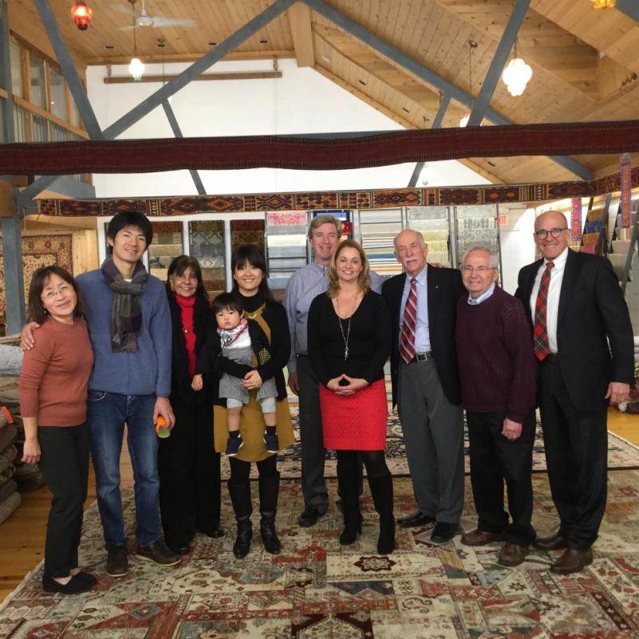
Meet Tatsuya Hayase(second from left), a Rotary Scholar from District 2760(Aichi Prefecture in Japan) who is visiting our district. He is spending the year at the Heller School for Social Policy and Management at Brandeis University in Waltham studying Peace and Conflict Prevention and Resolution.
READ MORE
Left to right: Newton Rotarian Chris Chu; Rotary Scholar Tatsuya Hayase, his wife, Marie Hayase, and their son, Yuto Hayase; Host Counselor Indira Desai, immediate past president of Newton Rotary; Newton Rotary President Paul Sullivan and his wife, Monica Sullivan; District Scholarship Chair Tory DeFazio, a Wellesley Rotarian; and Newton Rotarians Tony Bibbo and Tom Keery.

Athol-Orange's Al Bowers Makes Foundation Presentation

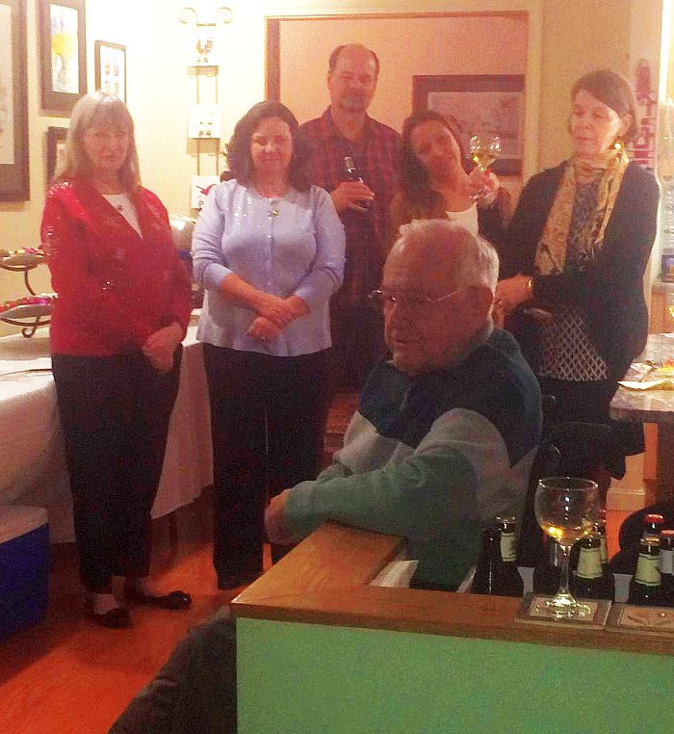The Rotary Club of Athol-Orange held its annual Christmas Party at the home of Member Bill Howland. Club Foundatioin Chair Al Bowers, immediate past District Charitable Fund chair, attended and made a wonderful presentation on The Rotary Foundation. A surprise Paul Harris recognition was bestowed on club Secretary Carol Courville by Assistant Governor Karen Fusco.

Posing during the Athol-Orange Christmas Party with club Foundation Chair Al Bowers, seated, are, left to right, Assistant Governor Karen Fusco, club Secretary Carol Courville, club Member Ted Ledgard, club President-Elect Tanya Quinn, and club Member Barbara Robichaud.

Bay Path Interactors Perform at Their School's Santa Claus Pancake Breakfast

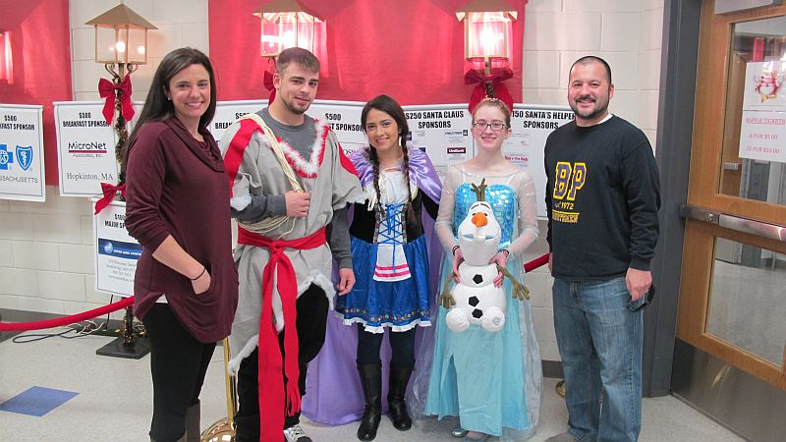
The Bay Path Educational Foundation, which supports Bay Path Regional Vocational Technical High School in Charlton, held its annual Santa Claus Pancake Breakfast on December 10 at the school. Members of the Interact Club of Bay Path (shown) participated, playing characters from Disney's 2013 hit movie "Frozen," inspired by Hans Christian Andersen's fairy tale "The Snow Queen." The Bay Path club is co-sponsored by the Rotary Club of Auburn and the Rotary Club of Southbridge.

Shown: Bay Path Interact President Veronica Martinez (middle),Treasurer Kayleigh Blanchard (second from right) and Member Matthew Pecore (second from left) are shown posing with Auburn Rotarian and Bay Path Teacher Jen Reil (far left) and Bay Path Teacher Rick Carrero (far right), both of whom advise the Bay Path club.

Photos: Steve Jones-D'Agostino, Auburn Rotary

VIEW ALL PHOTOS

Learn more about:
- Bay Path
- Auburn Rotary
- Southbridge Rotary

Chelmsford Donates $1,000 to The Wish Project

The Rotary Club of Chelmsford made a $1,000 donation to The Wish Project at a recent meeting. The project's mission is to "help end homelessness by providing otherwise-expensive home and baby items for free so that families moving out of shelters succeed the first time."

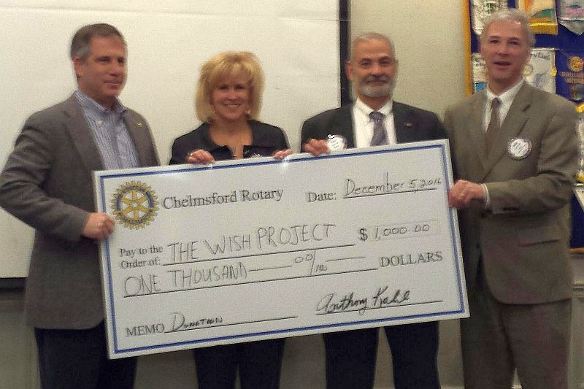Left to right: David Fitzgerald, executive director of The Wish Project, Chelmsford Past President Dawn Ferrari; Chelmsford Treasurer Tony Kalil; and Chelmsford President Paul Cohen.

Fitchburg Throws Holiday Party for Its Past Presidents

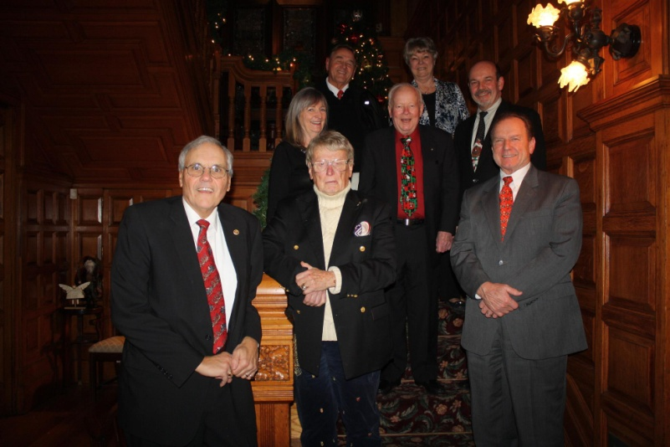
Left to right, bottom: David Moquin, Gerry Martel, and Bernie.

Left to right, middle: Karen Fusco, Bill Lakso, and Paul Gauvin.

Left to right, top: Gill, and Linda Largey

Maynard Marches in Christmas Parade

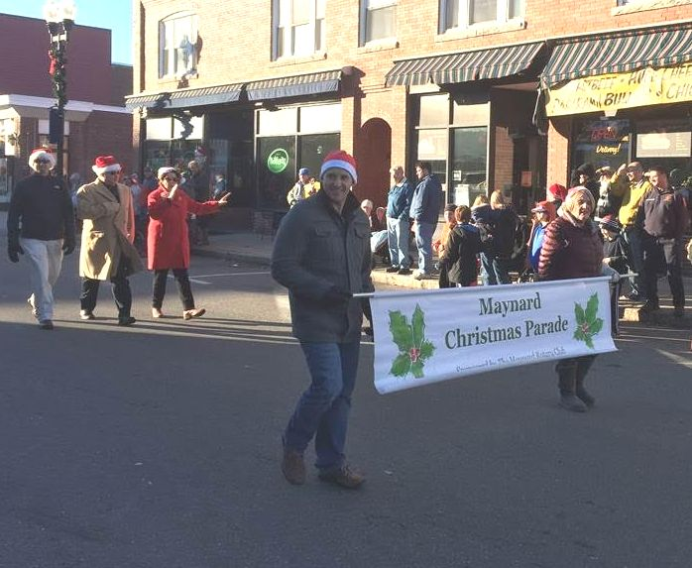
Left to right: Maynard President Matthew Farrow, and Maynard SecretaryAnn Heinonen.

Littleton Tree-Lighting Kicks Off Holiday Season

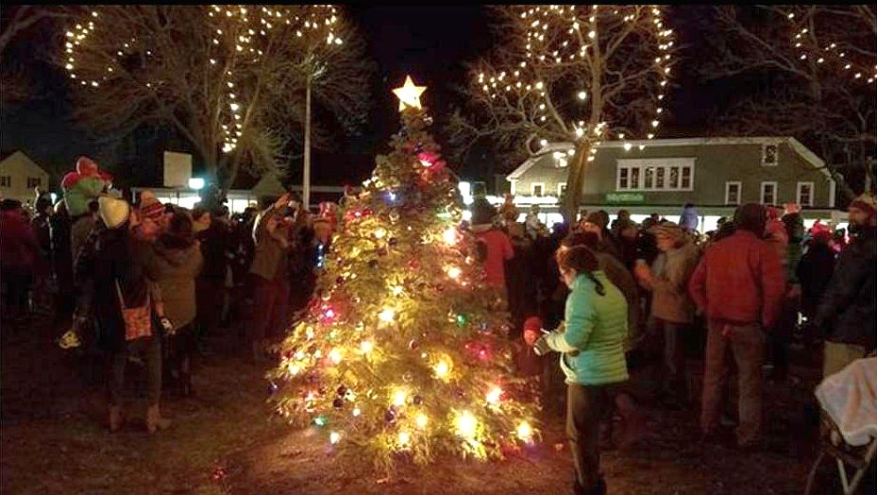Hundreds of people gathered on December 4 at Littleton Common to kick off the holiday season with the town's tree-lighting ceremony. The event was co-sponsored by the Rotary Club of Littleton and the Littleton Electric Light Department.

Photo: Alexander Silva, Wicked Local

READ MORE

To learn more about Littleton Rotary, click here.

Montachusett Area Installs Mattie Merchant as Newest Member

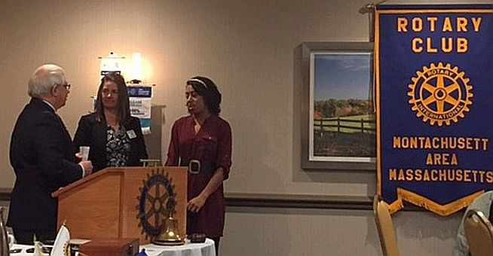Mattie Merchant (right), director of recreational programs for The Arc of Opportunity in Fitchburg, has been installed as the newest member of the Rotary Club of Montachusett Area. The Arc is a corporate member of the club and Mattie will be the lead member for the Arc. She was installed by Immediate Past District Governor Jim Fusco (left), who is a past president and present member of the Montachusett Area club. Also shown, is Montachusett Area President Jennifer Peck (middle).

Wachusett Area Rotary, Chamber Hear State Secretary Jay Ash Offer Local Economic Outlook

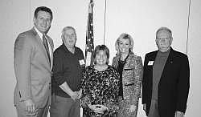Jay Ash, secretary of the state Executive Office of Housing and Economic Development, shared his outlook on economic development in Central Massachusetts on December 2 at a breakfast co-hosted in West Boylston co-hosted by the Rotary Club of Wachusett Area and the Wachusett Area Chamber of Commerce.

Left to right: Secretary Jay Ash, Chamber President Iain McKinlay, State Senator Anne Gobi, State Representative Kim Ferguson, and Rotary President Gary Hough.

READ MORE

To learn more about Wachusett Area Rotary, click here.

District Holiday Party A Great Success

VIEW ALL PHOTOS

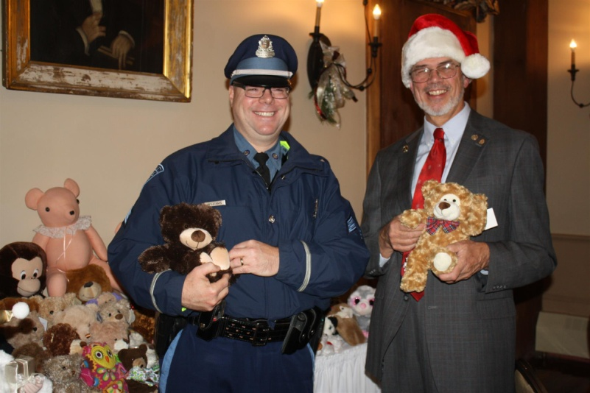
Past District Governor Klaus Hachfeld (right) of Sturbridge Rotary and Sergeant Kevin Williams (left) of the Brookfield State Police Barracks pose with some of the many donated Teddy bears.

District Governors Pat and Skip Doyle hosted the annual District Holiday Party on Sunday, December 4 at the Publick House in Sturbridge. Ninety-five attendees enjoyed the festivities. with entertainment provided by the Tantasqua Regional High School"Choraleers." Attendees brought Teddy bears. which were presented to Sergeant Kevin Williams of the Brookfield State Police Barracks. The grand finale was the "coronation" of Pam Anastasi of the Rotary Club of Billerica as district governor-nominee-designate. She will serve as district governor for Rotary year 2019-2020. Thank you to Past District Governor Klaus Hachfeld and his wife, Glenys Hachfeld, both of whom are members of the Rotary Club of Sturbridge for planning this event, and to MC Steve Jones-D'Agostino of the Rotary Club of Auburn, and our ace district photographers, Immediate Past District Governor Jim Fusco of the Rotary Club of Montachusett Area and Cheryl Rosen of the Rotary Club of Hudson.

Tantasqua Regional H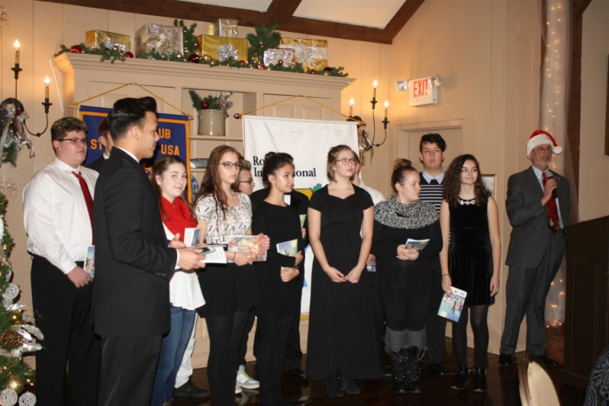igh School "Choraleers," led by Derek Ternullo (second from left), performed several holiday-season songs in acapella style during the Holiday Party. They were introduced by Past District Governor Klaus Hachfeld (far right) of Sturbridge Rotary

Bay Path High Wins District’s First Interact Video Contest

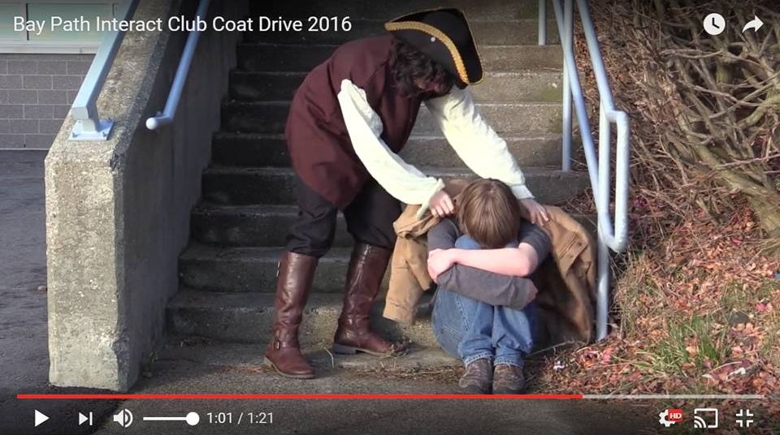
The newly formed Interact Club at Bay Path Regional Vocational Technical High School in Charlton has won the District Interact Committee’s first Interact Club Video Contest - and with it, the $250 prize. The winning video, for the November contest, was inspired by Bay Path High’s participation in the sixth annual Worcester County Coat Drive, conducted by the Worcester County Sheriff's Office. (see “Auburn Supports Bay Path High’s Participation in Worcester County Coat Drive,” below).

WATCH VIDEO

The Interact Committee is also pleased to announce that all Interact clubs are again invited to submit a video for a December competition.

READ MORE

To learn more about Bay Path High, click here. To learn more aboutInteract, click here.

Bay Path’s Interact Club is sponsored by the Rotary Clubs of Auburn and Southbridge. To learn more about Auburn Rotary, click here. Tolearn more about Southbridge Rotary, click here.

Franklin Rotaract Club Installed at Dean College

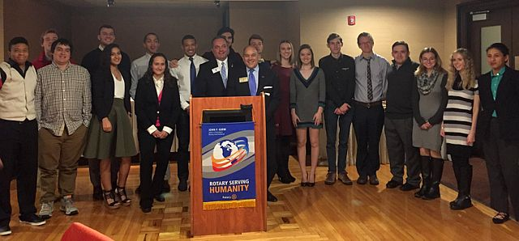
The new Rotaract Club of Dean College was installed on November 17. Shown, are the 18 of the 19 charter members of the Rotaract club posing with Rotary Club of Franklin President Terry Katsaros(left, behind podium) and District Governor-Nominee Steve Sager(right, behind podium).

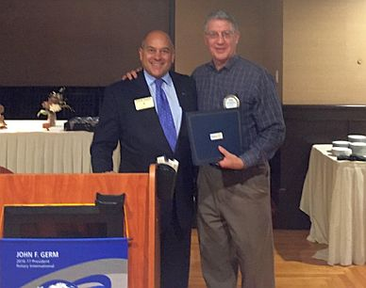Shown, is Frank Cusano (right), immediate past president of Franklin Rotary, accepting the Rotary International citation for membership retention on behalf of his club from District Governor-Nominee Steve Sager (left)

To learn more about Franklin Rotary, click here.

A Great Fundraising Idea for All Clubs

Milford Distributes '16 Tab to 13,000 Homes - Record sales, 94 photos, 334 smiling faces

To read the Milford RotaryTab, click here.

To learn more about Milford Rotary, click here.

On to Atlanta in 2017: Early-Registration Discount Ends December 31

Planning to attend? Contact District Chair Steve Glines.

More than 43,000 attendees left the Rotary International Convention in South Korea inspired to end polio for good, to celebrate The Rotary Foundation's centennial, and to champion changes that will help Rotary appeal to a broader audience. On the last day, RI President K.R. “Ravi” Ravindran shared a personal story of his mother’s triumph over polio.

To read the story, click here.

To register for the 2017 RI Convention in Atlanta, click here.

Pat and Skip Doyle Installed as '16-'17 DGs

District 7910's 2016 Rotary Youth Leadership Awards were held on June 24 through 26 at Fitchburg State University, ending with the installation of longtime RYLA supporters Pat and Skip Doyle as District Governors for 2016-2017. The three-day RYLA event was attended by 188 sophomores. To learn more about RYLA, visit ryla7910.org.

To watch a video of the installation, click here.

District Banners Available
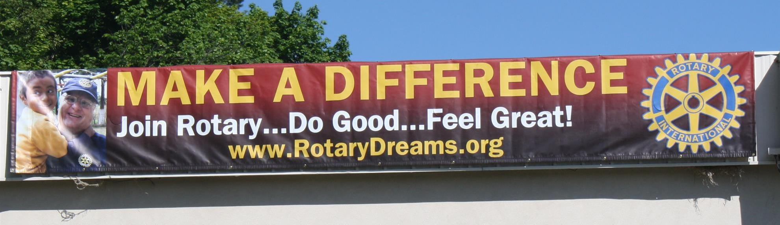

Our district banners are available for your use when you have an upcoming event or fundraiser.

If you want to reserve one of the banners, please contact PR Chair Laura Spear at laura@spear.net.

MAJOR DISTRICT & CLUB HAPPENINGS: WINTER 2017
Saturday, March 11: Uxbridge - 'Wine and Chocolate Tasting'

Click here to download event flyer

SUBMIT MAJOR CLUB HAPPENINGS

Send flyers of your club's major events and activities, in eitherJPEG or PDF format, to Immediate Past District
Governor/Newsletter Editor Jim Fusco at jim.fusco2@gmail.com.

