More about Pictures
By Laura Spear

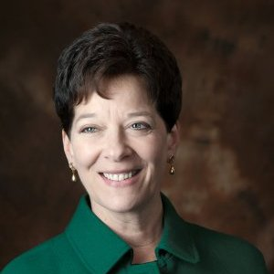Make sure your photos reflect connections and community and are not staged.
From Rotary Voice and Visual Identity Guidelines, "When choosing or
shooting new photography, aim for the following:
- Editorial or reportage style (fly on the wall)
- Candid poses or natural portraits
- Real, natural, sincere, endearing expressions
- Demonstrations of active leadership and impact
- Special moments of camaraderie, friendship, warmth, and
celebration
- Movement and momentum
- Rich, full color, or black-and-white
- Short depth of field with selective focus (people shot through crowds)
- Wide angles
- Natural backgrounds and real context (not solid portraiture backdrops or studio photography)”

To learn more, in Rotary Voice and Visual Identity Guidelines, click here.

To learn more about PR for your club, click on the "Public Relations" section of the navigation bar of the District 7910 website.

Laura Spear, chair of District 7910's Public Relations Committee, may be reached at laura@spear.net.

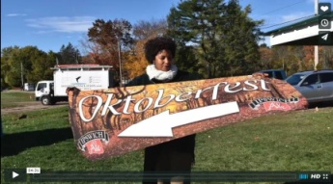Click here for an excellent example of a club-event promotional video by Concord President Steve Kirk.

Return to December 19 & 26 Newsletter

Visit our website
'Like' our Facebook page
'Follow us

