Dear $NICK_NAME$,

It is our pleasure to share with you the December 5 issue of Rotary District 7910 Newsletter.

For the complete issue, click here.

To explore past issues, click here.

Highlights of December 5 issue:

Governor's Message: It's official: Pam Anastasi is district governor-nominee-designate - By Pat and Skip Doyle

Our Presidents Speak: Q&A with Vinny Tingley of Natick Rotary

'17 RI Convention in Atlanta: Discount ends December 15 - By Steve Glines

Million Dollar Dinner: RI Past President Kalyan Banerjee to be keynote speaker - By Satya Mitra

PolioPlus Update: Let's meet this modest goal - By Carl Good III

Foundation Note: Update on club-qualification status for Foundation Grants - By Sanjay Deshpande

Rotary Means Business: First meeting on December 7 - By Ron Bott

Membership Corner: Does your club’s strategy have an impact on membership?- By Tom Sturiale

PR Tips: Get visual - By Laura Spear

RAAGNE Newsletter: Update on visioning process - By Klaus Hachfeld

Interact Video Contest: Bay Path High is District’s First Winner

Interact Actions: How to launch an Interact club - By Bob Anthony

Speakers Bureau: Do you need a speaker for your club? By Steve Levitsky
Treasurer's Report: Message about your dues - By Jack Hoell

District Charity Fund: How does DCF operate? - By Karin Gaffney

Communications Link: Seeking club photo, video albums - By Steve Jones-D'Agostino

Our next newsletter will come out on Monday, December 12. The submission deadline is this Friday, December 9. Text content must be submitted in Word format. Image content must be submitted in either JPEG or PDF format. Send your content submissions to Immediate Past District Governor/Newsletter Editor Jim Fusco at jim.fusco2@gmail.com.

Governors Pat & Skip

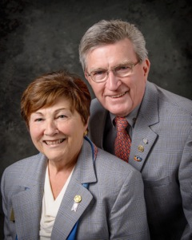Pat and Skip Doyle
2016-2017 Governors
Rotary District 7910
pwdoyle2@verizon.net
skipdoyle2@verizon.net

