It's Official: Pam Anastasi is District Governor-Nominee-Designate
By Pat and Skip Doyle
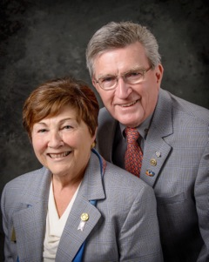
It's official. Pam Anastasi of the Rotary Club of Billerica has been named our district governor-nominee-designate for the 2019-2020 Rotary year. She has joined Immediate Past District Governor Jim Fusco, District Governor-Elect Karin Gaffney, District Governor-Nominee Steve Sager and us as members of the District Steering Committee. As a district, we are very proud of our Steering Committee. We feel this group will guarantee the bright future we all wish for District 7910.

The Steering Committee exists to help our clubs achieve their goals. Please call upon any one of us when you have problems that you think we can help you solve. Together, let's build membership, spread the reality of Rotary and successfully complete our Million Dollar journey.
Our wish for all of you in the coming dark days that end with the shortest day of the year is that you will do all you can to lighten the time with feasts and colorful lights and decorations. Take advantage of every opportunity to have a celebration to keep your clubs from falling into deep depression. Invite us, and we will try to join you as often as possible.

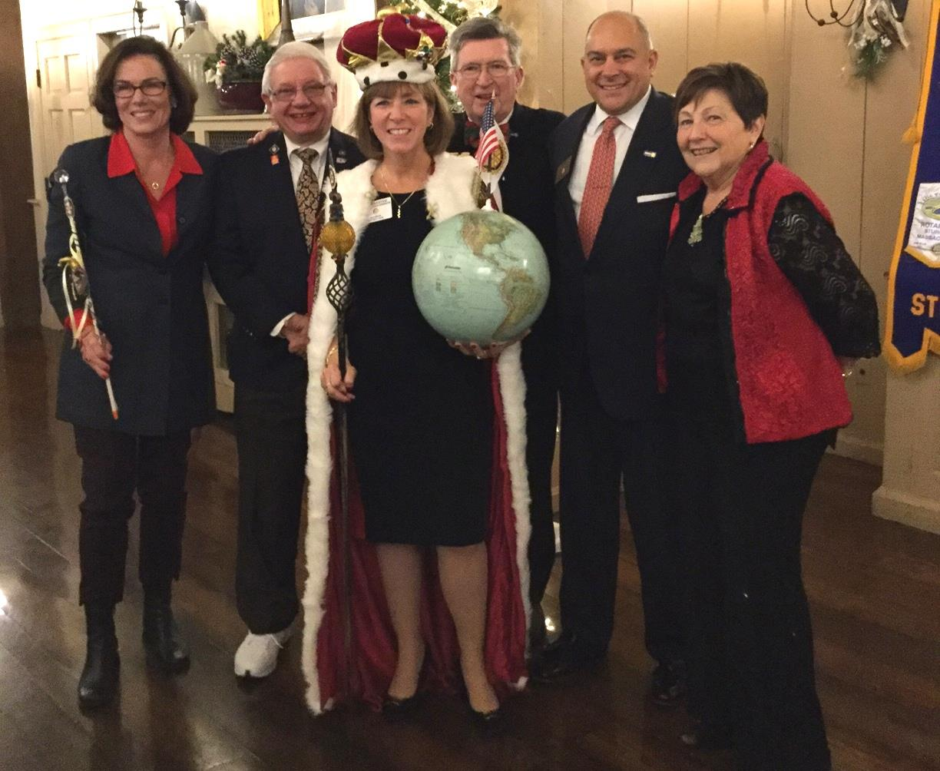Left to right: DGE Karin Gaffney, IPDG Jim Fusco, DGND Pam Anastasi, DG Skip Doyle, DGN Steve Sager and DG Pat Doyle, during the District Holiday Party on December 4 in Sturbridge.

VIEW ALL PHOTOS

Thank You! Thank You!! Thank You!!!

Our District Food Packaging Event on November 12 at the Solomon Pond Mall in Marlborough was a solid success.

More than 100 volunteers from around the district packaged 20,000 meals, which will be sent to Haiti to help feed the children left homeless by the hurricane. These volunteers were Rotarians and their friends and families, young and old There were Interactors from local clubs, passersby who wanted to help and past and present participants of Rotary Youth Leadership Awards. We raised more than $4,000 toward our goal of $5,000 - so we are still actively seeking donations.

VIEW ALL PHOTOS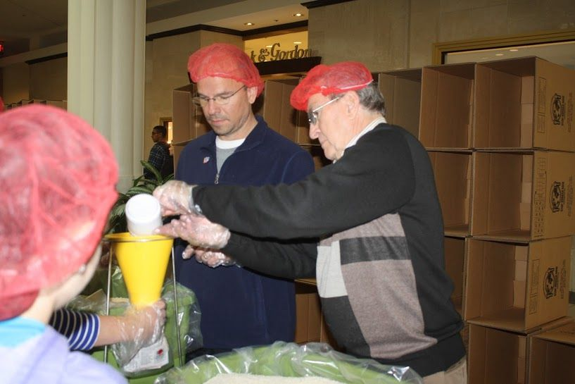

It is hard to pick out a highlight from the event, there were so many. One is perhaps the numbers of people with whom we were able to talk about what Rotary is - the reality of Rotary, not the perception. This event puts us a little further toward our goal of making Rotary more visible and more real in our district. Thank you also to the Solomon Pond Mall for allowing us to utilize their space for this event.
Always remember, you can call us with questions at 508-393-9031.

District Governors Pat and Skip Doyle may be reached at pwdoyle2@verizon.net and skipdoyle2@verizon.net,
respectively.

Click here to submit content for the December 12 issue.
The submission deadline for this issue is Friday, December 9.

Click here for past issues.

Return to December 5 Newsletter

Visit our website
'Like' our Facebook page
'Follow us on Twitter

