Interact teens needed to help NEXT JUNE IN Atlanta

By Bob Anthony

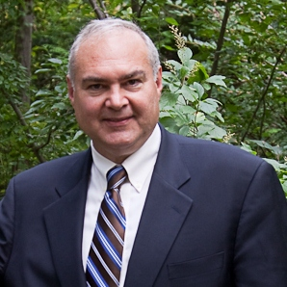I was amazed by the telephone discussion with Bob Pfahnl, the Interact chair for District 5170 in California. Their model includes a vibrant teen council for the district and a districtwide project called Circle of Love. The achievements include 100 Interact clubs delivering tens of thousands of volunteer hours and fund raising more than $200,000. The amazing thing was that they were asking help to learn from District 7910!

How might we be helpful? They hope some of our Interact teens will help next June 10 to 14 in Atlanta at the Rotary International Conference’s House of Friendship booth, with a 45-minute presentation session. Contact me at bobanthony@adolescentwellness.org, if you are interested.

District 7910 Interact teens have three areas of experience they hope will be discussed:
- They are an urban group while we are a suburban and rural group
- They are committed to a project, both locally and globally, to normalize the conversation on mental health and wellness. We have content for doing that, which we use in our Peer Leadership and Depression Prevention project, replicated to date in India and Puerto Rico.
- They have not had a middle school Interact club

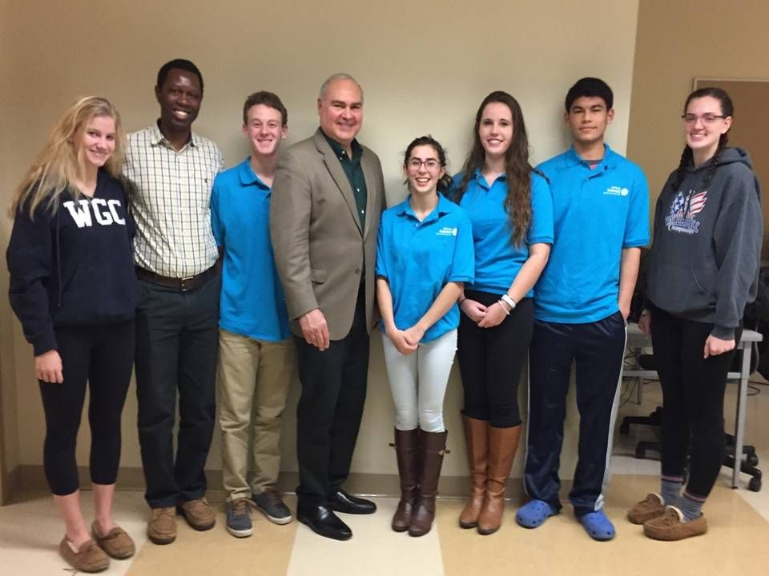Left to right: Interact teen Susanna Buckley, a visitor from the project in India; Interact teens Ramnath Subba Siddi and Cole Harris; District Interact Chair Bob Anthony; and Interact teens Ana Natalia Epstein, Hannah Lee, Alex Kung and Lindsay Canaday.

Photo: Phyllis Gimbel

To learn more about Interact, click here.

Bob Anthony, chair of the District Interact Committee, may be reached at bobanthony@adolescentwellness.org.

How to launch an Interact club
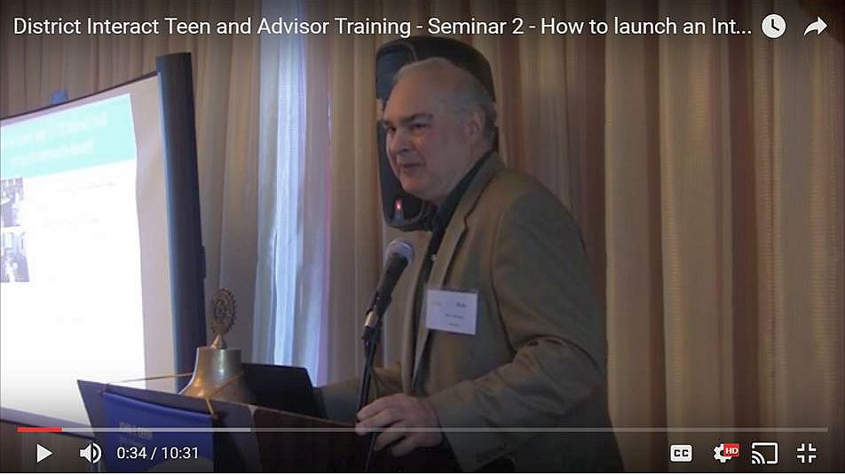In Seminar 2 of the District Interact Teen and Advisor Training Seminar, held on September 17 in Needham, Bob Anthony, chair of the District Interact Committee, discusses “How to launch an Interact club,” including the certification letter, roles and responsibilities of the president, the Rotary advisor and, in the case of school-based clubs, the faculty advisor.

WATCH VIDEO

Return to December 5 Newsletter

View past issues
Visit our website
'Like' our Facebook page
'Follow' our Twitter page

Interact Actions: Interact teens needed to help next June in Atlanta
By Bob Anthony
I was amazed by the telephone discussion with Bob Pfahnl, the Interact chair for District 5170 in California. Their model includes a vibrant teen council for the district and a districtwide project called Circle of Love. The achievements include 100 Interact clubs delivering tens of thousands of volunteer hours and fund raising more than $200,000. The amazing thing was that they were asking help to learn from District 7910!
How might we be helpful? They hope some of our Interact teens will help next June 10 to 14 in Atlanta at the Rotary International Conference’s House of Friendship booth, with a 45-minute presentation session. Contact me at bobanthony@adolescentwellness.org, if you are interested.
District 7910 Interact teens have three areas of experience they hope will be discussed:
- They are an urban group while we are a suburban and rural group
- They are committed to a project, both locally and globally, to normalize the conversation on mental health and wellness. We have content for doing that, which we use in our Peer Leadership and Depression Prevention project, replicated to date in India and Puerto Rico.
- They have not had a middle school Interact club
Left to right: Interact teen Susanna Buckley, a visitor from the project in India; Interact teens Ramnath Subba Siddi and Cole Harris; District Interact Chair Bob Anthony; and Interact teens Ana Natalia Epstein, Hannah Lee, Alex Kung and Lindsay Canaday.
Photo: Phyllis Gimbel
READ MORE
To learn more about Interact, click here.
Bob Anthony, chair of the District Interact Committee, may be reached at bobanthony@adolescentwellness.org.

How to launch an Interact club

In Seminar 2 of the District Interact Teen and Advisor Training Seminar, held on September 17 in Needham, Bob Anthony, chair of the District Interact Committee, discusses “How to launch an Interact club,” including the certification letter, roles and responsibilities of the president, the Rotary advisor and, in the case of school-based clubs, the faculty advisor.

WATCH VIDEO

