SUBMIT EVENTS
You may submit event information per the District 7910 Promotional Guidelines. If your club does not use ClubRunner, please send your event information to Immediate Past Governor/Newsletter Editor Jim Fusco, jim.fusco2@gmail.com. And, please make sure to add Jim to your club's distribution list.

DISTRICT EVENTS

DECEMBER 5, 2016-JANUARY 30, 2017
Rotary Means Business - Networking Event (guests are welcome)

Wednesday, December 7

5:30-7:30 p.m.

Sheraton Framingham Hotel & Conference Center, Framingham

Presidents-Elect Training Webinar

Monday, January 9

6:00-7:00 p.m.

Resolution Committee Meeting

Tuesday, January 10

7:00-9:00 p.m.

Holiday Inn, Boxborough

International Assembly

Sunday, January 15 - Friday, January 21

Rotary Means Business

Wednesday, January 25

5:30-7:30 p.m.

Trustee Meeting

Thursday, January 26

6:30-8:30 p.m.

Newton/Waltham area (to be announced)

Assistant Governors Meeting

Monday, January 30

VIEW THESE PLUS MORE UPCOMING DISTRICT EVENTS - INCLUDING ALL GOVERNOR'S VISITS

RI SPOTLIGHT

This Holiday Season: Spend Less. Give More.
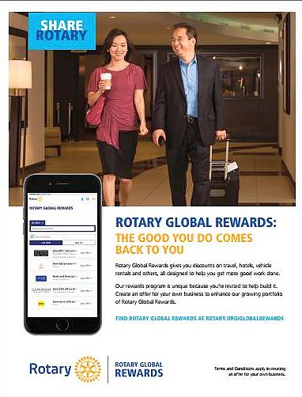
Use Rotary Global Rewards this holiday season and throughout the year for discountsand special offers on everything from airline travel to shopping to events. Look for offers that send a percentage of your purchase back to Rotary
- Airline Discount Center: Discounts on more than 600 airlines and 4 percent back to Rotary
- Hotel Discount Center: Discounts at thousands of hotels and 10 percent back to Rotary
- Amazon: Up to 8 percent back to Rotary
- Hertz: Discounts on rental cars and 2 percent back to Rotary
Click here for more information

Click here to send an e-mailto Judy Merriman, chair of the District Rotary Global Rewards Committee

TRF Named World’s Outstanding Foundation

The Association of Fundraising Professionals has selected The Rotary Foundation for its annual Award for Outstanding Foundation for 2016, a recognition that honors organizations that show philanthropic commitment and leadership through financial support, innovation, encouragement of others, and involvement in public affairs.

READ MORE

Young Leaders in Action

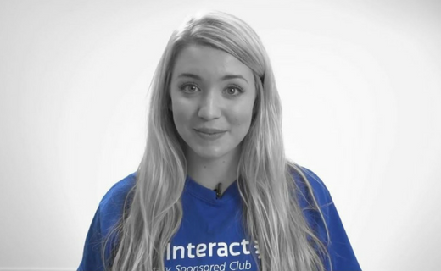
To submit a video for the Interact Video Awards, click here

Deadline: December 2

Haiti Devastated by Hurricane Matthew

Even as parts of Haiti were still recovering from a catastrophic 2010 earthquake, Hurricane Matthew tore through the impoverished island country on October 4, leaving hundreds dead and many more homeless.

READ MORE

'Rotary Leader' Newsletter: November 2016

Click on each one to go to that article:

Giving: Cultivating young donors

Our Foundation: The growing popularity of online giving

Tech Tools: A sneak peek at the Rotary.org refresh

District Corner: What makes a successful medical-training team?

Building Peace and Helping Refugees in Nigeria

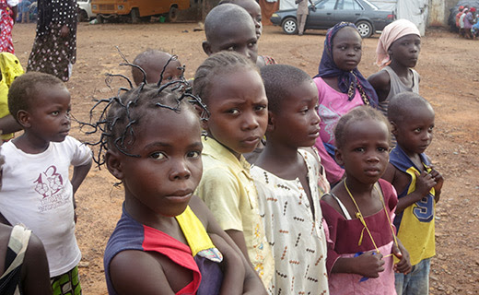
The Rotary Club of Yola-AUN is located on the campus of the American University of Nigeria, smack-dab in the region where Boko Haram is most active.
READ MORE

Membership Minute: Impact Begins with You

A positive member experience begins long before someone joins a Rotary club. Start by introducing prospective members to Rotary with the Impact Begins With You brochure.

READ MORE

Dean Rohrs: '16-'17 RI Director for Zones 24 & 32
To read Dean's November newsletter, click here.
To read Dean's highlights of the latest RI Board of Directors meeting, click here.
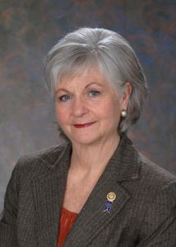

Meet Jeff Cadorette: Our New RI Director

READ MORE

Meet Sam Owori: Our '18-'19 RI President

Sam Owon is a Ugandan businessman and a member of the Rotary Club of Kampala.

READ MORE

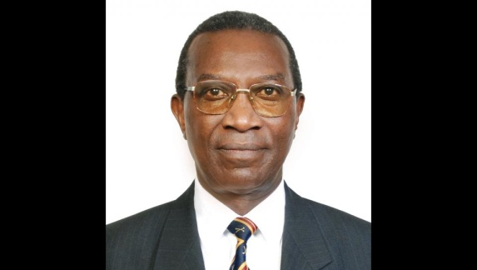

A Letter from '16-'17 RI President John Germ and Foundation Chair Kalyan Banerjee
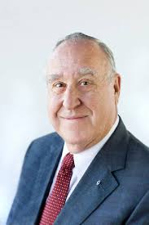

Dear fellow Rotarians,
At the 1917 Rotary Convention in Atlanta, Past President Arch C. Klumph proposed a revolutionary idea: an endowment fund for the purpose of doing good in the world. Since then, The Rotary Foundation has grown tremendously and in many ways, serves as the foundation for Rotary as we know it today.
READ MORE
Download the World Polio Day toolkit

For information on the April 2017 Rotary International Convention, click here.
Read John Germ's Membership Message

Read a profile of John Germ

Visit the President’s page

Great Video: Meet Your President

Campaign to End Polio: What you don't know
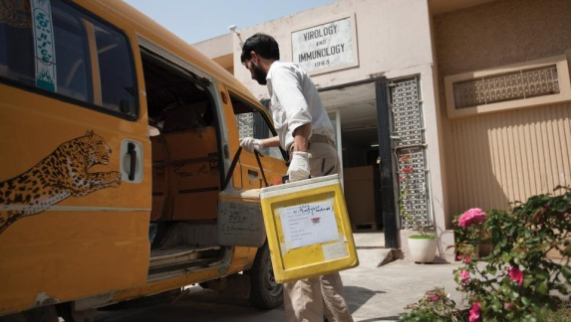
When was the last time there was polio in Europe?

READ MORE

What Millennials Love about Rotary

Millennials, an ethnically diverse, fiercely independent generation of digital natives, are doing more than just snapping selfies—they’re looking for a way to make a difference in their communities.

READ MORE

Get Ready for Your District Rotary Foundation Seminar
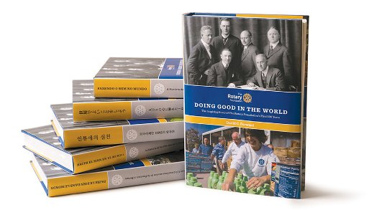
The Rotary Foundation is celebrating its 100th year of Doing Good in the World. Take the opportunity to strengthen your district and clubs during your district's Rotary Foundation Seminar by using resources from centennial.rotary.org.
Go to the Promotional resources tab to download the following Centennial Promotional Kit materials:
- Ideas and activities for clubs
- Doing Good in the World promotional flier
- Doing Good in the World bookmark
- Sample press release
- Centennial letterhead
- Centennial PowerPoint template
- History of the Rotary Foundation PowerPoint
- Centennial postcard
Let others know about these materials they can use to promote the Foundation in their clubs and communities.

Membership Materials on Sale: Order Now!

To order, click here
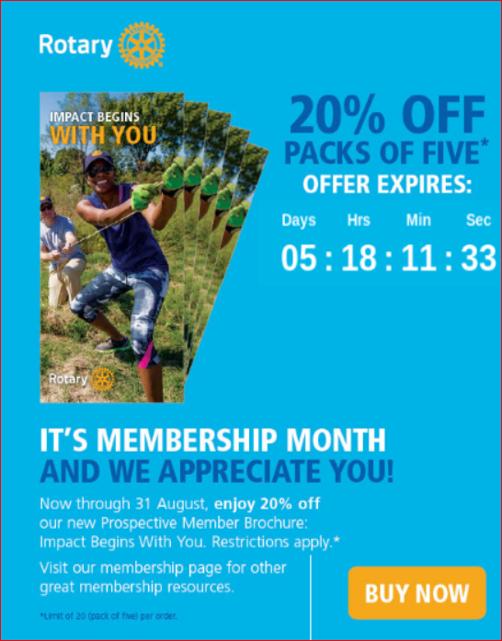

New Tools for Membership Tool Belt

Looking to enhance your club membership experience?

READ MORE

A How-To Membership Leads Video
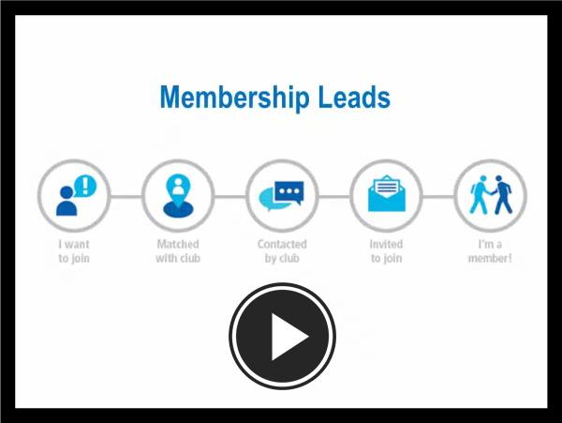

Click here for a new video that helps district and club leaders make the most of the recently enhanced Membership Leads resource. It shows how to track a prospective member from the initial membership-leads submission all the way to connection with a local club. It also outlines the role of club and district leaders in the redesigned process, highlighting how their participation will help strengthen membership, and features the new Rotary resources available to support them. Join the conversation in the Membership Best Practices discussion group to tell us how you’re using the new Membership Leads resource to grow and diversify membership.

RI Membership Resource Guide
To download the Guide in PDF format, click here
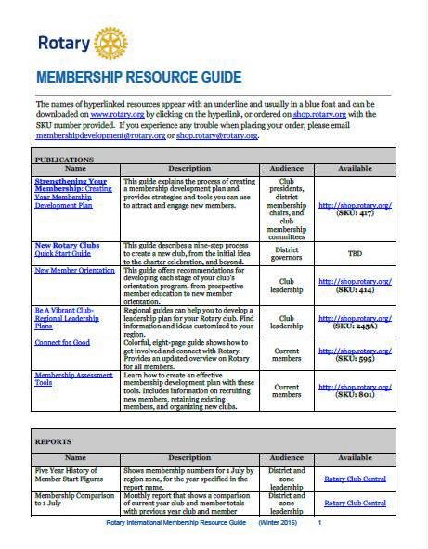

RI Makes Changes in 'Brand Center' Online Tool

We hope that you've found Rotary International’s Brand Center a useful tool to create customized logos and brochures - and to tell Rotary's story in a consistent and engaging way. To gain access, you will need to login with your Rotary Membership ID.

'16-'17 Rotary Theme: 'Rotary Serving Humanity'
To download the image in JPEG format, click here.

Check Out 'Rotary Voices' Blog

Check out Rotary Voices, the official blog of Rotary International. This blog features stories by and about Rotary members, Rotary program alumni, and the people we partner and work with.

