Does Your Club’s Strategy Have An Impact On Membership
By Tom Sturiale

What is this all about? What does it mean? Why should we have a strategy? We are Rotary!

It is clear we are a large, worldwide, benevolent, service organization that has been in existence for more than 100 years. We fund projects all over the world. Why should our club have a strategy to retain our current members and to attract new members? People should be proud to remain as Rotarians and eager to join Rotary. Really? How is that working out for your club?

Why, indeed!

Do you think you can bounce along week after week from meeting to meeting, from event to event, from project to project, continuing to do the same things year after year and retain all your members and attract new members? Times change. Cultures change. Generations change. Rotary clubs must change with the times. How do we effect the necessary changes? How do we organize? What strategies should we implement? Where do we start?

Let’s start at the beginning. What are your current objectives? That is, what is your club trying to achieve in community service, international service, club administration, youth service and membership? How are you setting those objectives? Do you have a steering committee made up of past, current and future presidents who meet periodically to set objectives, to review with the membership and to gain consensus? Have you recognized any issues or problems with your club which are addressed in your strategy sessions? Have you aligned your club objectives with the desires, interests and capabilities of your current membership and your local community?

There are several Rotary International publications that can be very helpful in these efforts. Another good start is to engage in a visioning exercise to get your club kick-started along the path of long-term planning.

It is so easy to continue along the old tried and true path of weekly meetings, legacy agendas, an occasional fundraiser, writing a few checks and thinking everything is going to be okay. If you think all your members understand your club’s strategy and objectives, maybe you should check. If that path has resulted in a loss of current members, a failure to attract new members, and a continuation of recycling senior members through leadership positions, then it may be time to reexamine your total club strategy with a mind towards major revision. What is that saying that most of us are familiar with about the definition of “lunacy?”

By the way, this is not an easy process. Strategy and objective development require a concerted effort, with a few dedicated people and many hard meetings. Objectives, strategies and action plans must be written and reviewed periodically to determine whether or not you are on course. These ideas must be threshed out, refined and taken to the membership for review and consent. If you want to improve your club’s performance and develop your membership, then it is advised that you get started now!

Tom Sturiale, chair of District 7910's Visioning Committee and vice chair of its Membership Committee, may be reached at tsturiale36@gmail.com.

Documents for October 2016 Membership Workshops, in PDF format:
- Participant Comments
- Introductory Notes for Moderators
- Sessions Discussion Points
- Rotary Membership-Development Ideas Sites
To learn about the October 2016 Membership Workshops, click here.

For more information on Rotary memberships:
- Rotary Individual Membership Application - Word Format
- Rotary Corporate Membership Application - Word Format
- Rotary Corporate Membership Opportunity - Word Format
- Rotary Corporate Membership Information - Word Format
November 2016 'Membership Corner' articles:

- November 7: The Rotary 'why' factor
- November 14: Rotary clubs honor veterans
- November 21: RYLA is a great membership opportunity
- November 28: How to improve membership in Rotary
- To read previous articles for Rotary 2016-2017, click here.

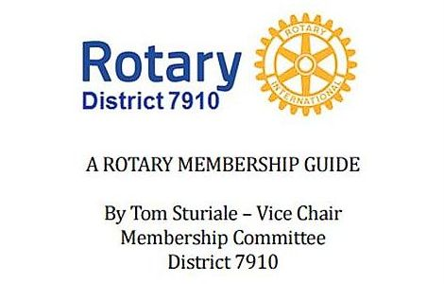"A Rotary Membership Guide" is a collection of "Membership Corner" articles written for this weekly newsletter during the 2015-2016 Rotary year, which began last July 1. It is intended to offer an idea or thought each week aimed at stimulating discussions, questions and actions to effectively increase membership at all our clubs. Click here, to download this 52-page "Guide," in Word format.

Return to December 5 Newsletter

Visit our website
'Like' our Facebook page
'Follow

