GOVERNOR'S MESSAGE

It's Official: Pam Anastasi is District Governor-Nominee-Designate

By Pat and Skip Doyle
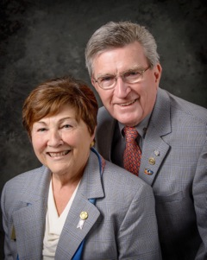
It's official. Pam Anastasi of the Rotary Club of Billerica has been named our district governor-nominee-designate for the 2019-2020 Rotary year. She has joined Immediate Past District Governor Jim Fusco, District Governor-Elect Karin Gaffney, District Governor-Nominee Steve Sager and us as members of the District Steering Committee. As a district, we are very proud of our Steering Committee. We feel this group will guarantee the bright future we all wish for District 7910.

The Steering Committee exists to help our clubs achieve their goals. Please call upon any one of us when you have problems that you think we can help you solve. Together, let's build membership, spread the reality of Rotary and successfully complete our Million Dollar journey.
Our wish for all of you in the coming dark days that end with the shortest day of the year is that you will do all you can to lighten the time with feasts and colorful lights and decorations. Take advantage of every opportunity to have a celebration to keep your clubs from falling into deep depression. Invite us, and we will try to join you as often as possible.

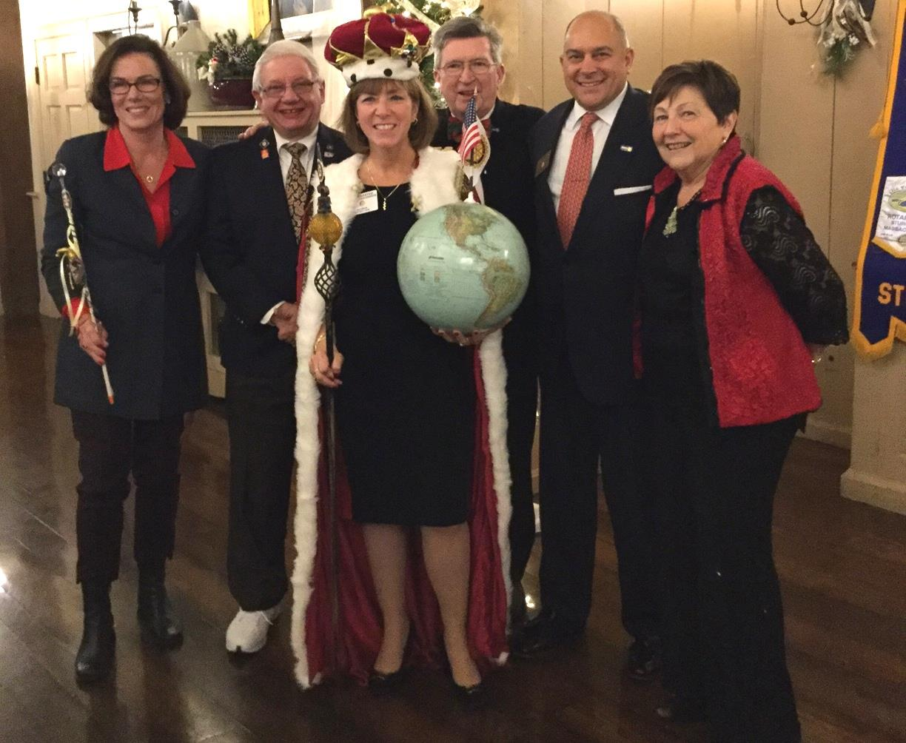Left to right:DGE Karin Gaffney, IPDG Jim Fusco, DGND Pam Anastasi, DG Skip Doyle, DGN Steve Sager and DG Pat Doyle,during the District Holiday Party on December 4 in Sturbridge.

VIEW ALL PHOTOS
Thank You! Thank You!! Thank You!!!

Our District Food Packaging Event on November 12 at the Solomon Pond Mall in Marlborough was a solid success.

More than 100 volunteers from around the district packaged 20,000 meals, which will be sent to Haiti to help feed the children left homeless by the hurricane (see article in left hand column). These volunteers were Rotarians and their friends and families, young and old There were Interactors from local clubs, passersby who wanted to help and past and present participants of Rotary Youth Leadership Awards. We raised more than $4,000 toward our goal of $5,000 - so we are still actively seeking donations.

VIEW ALL PHOTOS

It is hard to pick out a highlight from the event, there were so many. One is perhaps the numbers of people with whom we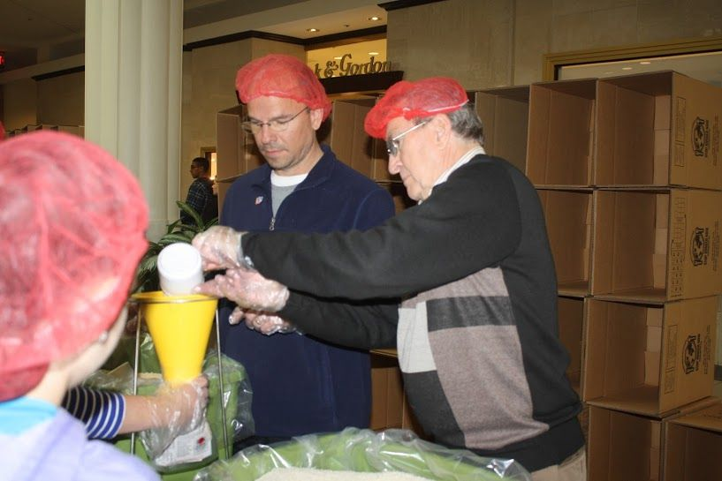 were able to talk about what Rotary is - the reality of Rotary, not the perception. This event puts us a little further toward our goal of making Rotary more visible and more real in our district. Thank you also to the Solomon Pond Mall for allowing us to utilize their space for this event.

Always remember, you can call us with questions at 508-393-9031.

District Governors Pat and Skip Doyle may be reached at pwdoyle2@verizon.net and skipdoyle2@verizon.net,
respectively.

Click here to submit content for the December 12 issue. The submission deadline for this issue is December 9.

Click here for past issues.

WELCOME, NEW ROTARIANS

Alphabetical order, by last name:

- Romeo Adams, Wellesley
- Phill Goff, Ayer

HOT OFF THE PRESS!

2016-2017 DISTRICT DIRECTORY
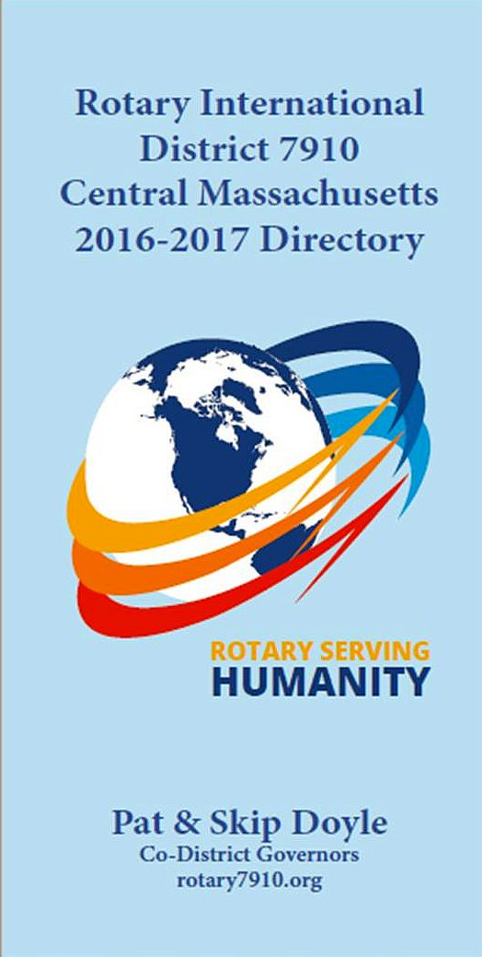

Print copies of our information-packed, 332-page Directory for this Rotary year will soon be delivered to your club.

A digital copy is now available for automatic download, in PDF format.

Please note: Member login is required.

Click here, to download

OUR PRESIDENTS SPEAK
Vinny Tingley of Natick Rotary

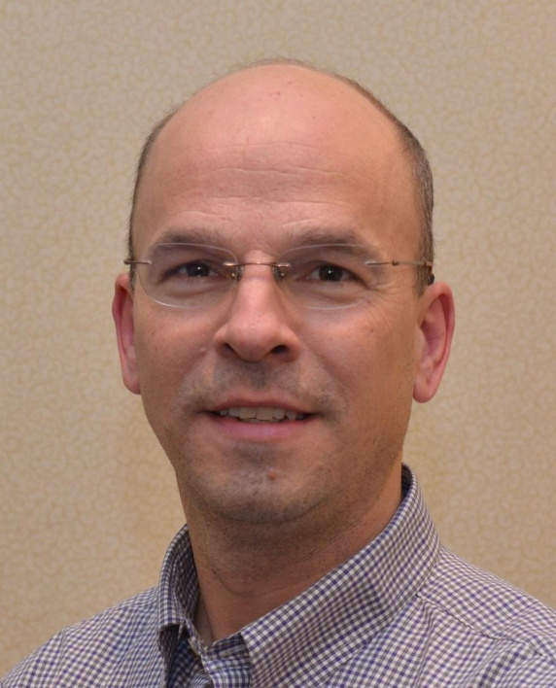

Please tell us what factors helped you decide to join Rotary.

Raising awareness with postings on social media, such as Facebook. Signs and banners all over town.

READ MORE

CLUB MEMBERSHIP GROWTH, ’16-‘17
We share with you the results of club-membership growth in our district during Rotary year 2016-2017, which began July 1.

This is a unique opportunity for Rotarians and friends to discuss partnering on humanitarian projects affecting our local communities.

READ MORE

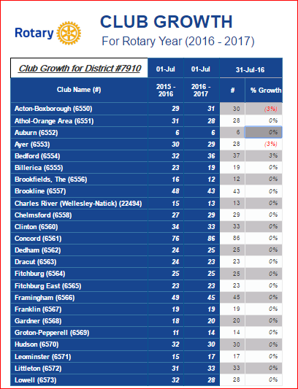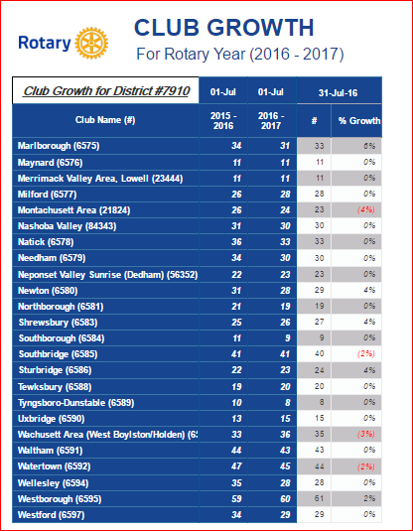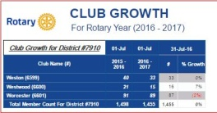

CLUB PLANNING WORKSHEET '16-'17
In both Excel and PDF formats, we share with you the Club Planning Worksheet for Rotary year 2016-2017, which began on July 1.
Please enter your club information in the indicated cells.

Excel Format

PDF Format

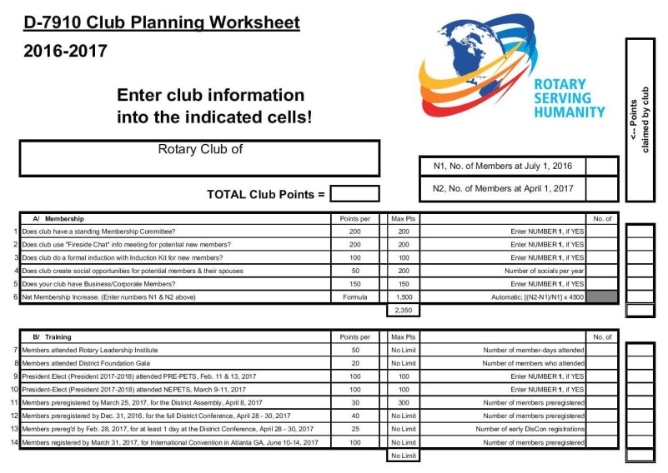

DISTRICT & CLUB ROUNDS
District Holiday Party: A great success
VIEW ALL PHOTOS
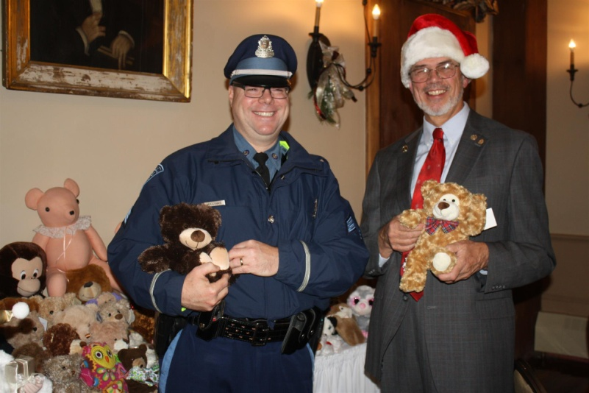
Past District Governor Klaus Hachfeld (right) of Sturbridge Rotary and Sergeant Kevin Williams (left) of the Brookfield State Police Barracks pose with some of the many donated Teddy bears.
District Governors Pat and Skip Doyle hosted the annual District Holiday Party on Sunday, December 4 at the Publick House in Sturbridge. Ninety-five attendees enjoyed the festivities. with entertainment provided by the Tantasqua Regional High School"Choraleers." Attendees brought Teddy bears. which were presented to Sergeant Kevin Williams of the Brookfield State Police Barracks. The grand finale was the "coronation" of Pam Anastasi of the Rotary Club of Billerica as district governor-nominee-designate.She will serve as district governor for Rotary year 2019-2020. Thank you to Past District Governor Klaus Hachfeldand his wife, Glenys Hachfeld, both of whom are members of the Rotary Club of Sturbridge for planning this event, and to MC Steve Jones-D'Agostino of the Rotary Club of Auburn, and our ace district photographers, Immediate Past District Governor Jim Fusco of the Rotary Club of Montachusett Area and Cheryl Rosen of the Rotary Club of Hudson.
Tantasqua Regional High School "Choraleers," led by Derek Ternullo (second from left), performed several holiday-season songs in acapella style during the Holiday Party. They were introduced by Past District Governor Klaus Hachfeld (far right) of Sturbridge Rotary.
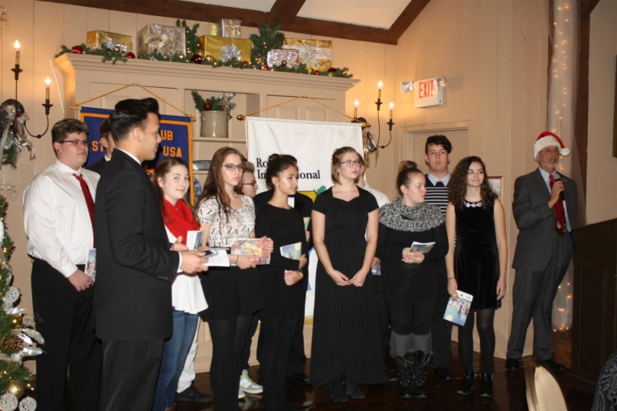

Bay Path High Wins District’s First Interact Video Contest

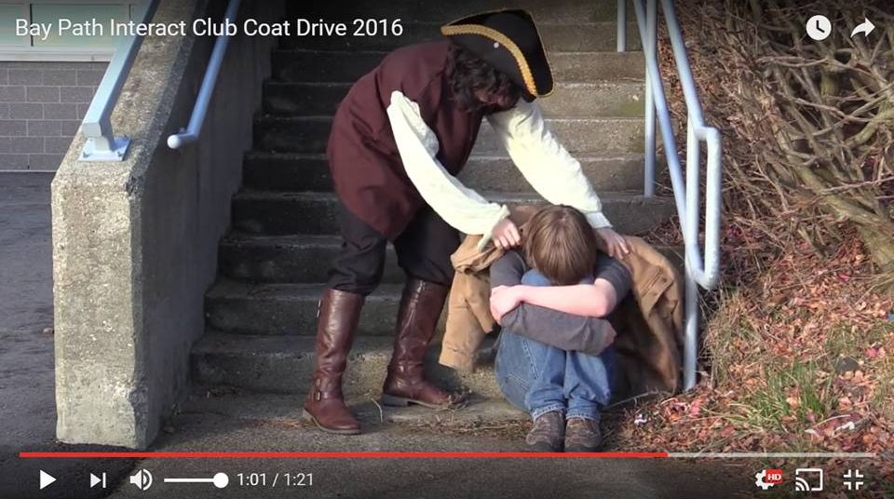

The newly formed Interact Club at Bay Path Regional Vocational Technical High School in Charlton has won the District Interact Committee’s first Interact Club Video Contest - and with it, the $250 prize. The winning video, for the November contest, was inspired by Bay Path High’s participation in the sixth annual Worcester County Coat Drive, conducted by the Worcester County Sheriff's Office. (see “Auburn Supports Bay Path High’s Participation in Worcester County Coat Drive,” below).

WATCH VIDEO

The Interact Committee is also pleased to announce that all Interact clubs are again invited to submit a video for a December competition.

READ MORE

To learn more about Bay Path High, click here. To learn more aboutInteract, click here.

Bay Path’s Interact Club is sponsored by the Rotary Clubs of Auburn and Southbridge. To learn more about Auburn Rotary, click here. Tolearn more about Southbridge Rotary, click here.

Framingham’s Annual Online Auction Underway Through December 7

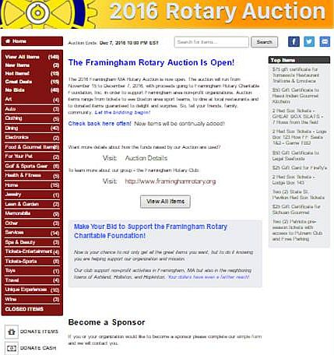

The Rotary Club of Framingham’s 45th Annual Online Auction is in full swing! Click here for just a few of the cool auction itemsavailable to bid on. But it all ends this Wednesday, December 7 at 10:00 p.m. (EST), when the Auction closes. So don't miss out! Be sure to check out the Auction site to see all the items and get in your bids.
READ MORE

To learn more about Framingham Rotary, click here.

Franklin Rotaract Club Installed at Dean College

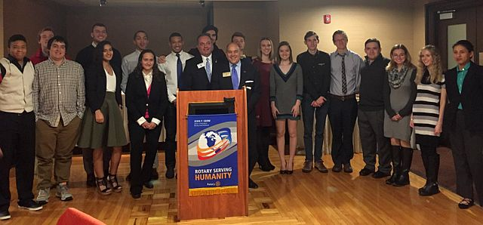

The new Rotaract Club of Dean College was installed on November 17. Shown, are the 18 of the 19 charter members of the Rotaract club posing with Rotary Club of Franklin President Terry Katsaros(left, behind podium) and District Governor-Nominee Steve Sager(right, behind podium).

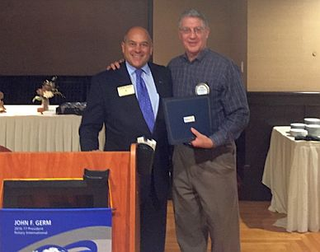

Shown, is Frank Cusano (right), immediate past president of Franklin Rotary, accepting the Rotary International citation for membership retention on behalf of his club from District Governor-Nominee Steve Sager (left)

To learn more about Franklin Rotary, click here.

Tewksbury Recognizes High School Seniors

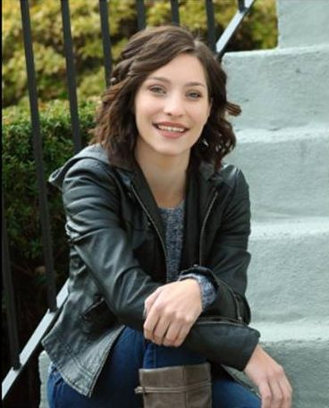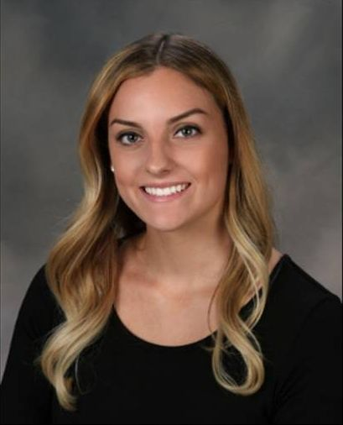

Tewksbury Memorial High School seniors Alexandra Bourassa(left) and Kathleen Garcia (right) were honored by the Rotary Club of Tewksbury at a luncheon on November 17 at the Tewksbury Country Club.

READ MORE

To learn more about Tewksbury Rotary, click here.

Westborough Funds, Celebrates Festival of Lights
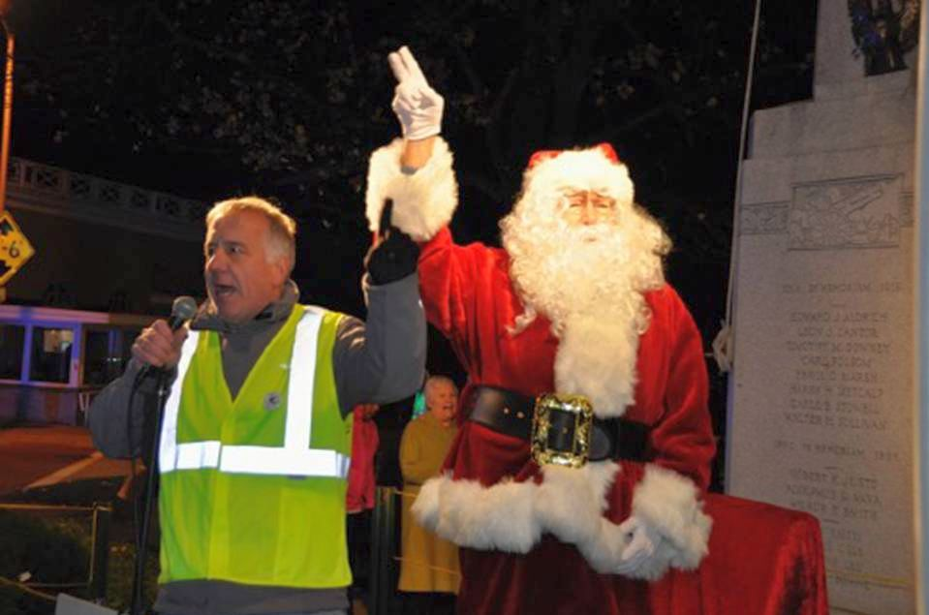

As part of the Rotary Club of Westborough’s ongoing service commitment to the community, the club has provided funding for the Festival of Lights each year during the holidays, decorating the trees located on Main, Milk and South streets in downtown Westborough. The Festival of Lights celebrates the beginning of the holiday season, as residents gather for a holiday parade, to watch as the lights are turned on for the first time, and children young and old meet Santa to request their holiday wishes. This year’s Festival included visits with Santa and Mrs. Claus, portrayed by the club’s own Jim Tepper and Maureen Ambrosino, respectively.

Left to right: President Gerry Gross, and Santa.

VIEW ALL PHOTOS

To learn more about Westborough Rotary, click here.

Auburn Supports Bay Path High’s Participation in Worcester County Coat Drive

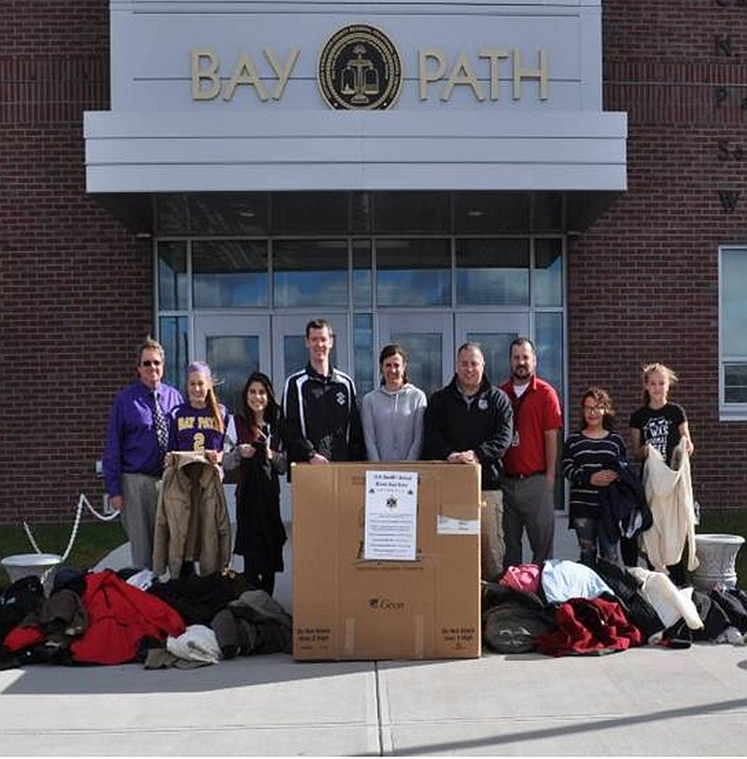

The Rotary Club of Auburn supported the participation by Bay Path Regional Vocational Technical High School in the sixth annual Worcester County Coat Drive, which was conducted by the Worcester County Sheriff’s Office. Between mid October and the end of November, Bay Path’s staff members gathered more than 400 gently used coats plus numerous other warm garments. That is nearly six times Bay Path's overall goal - and more than 11 times its total for last year’s campaign.

Bay Path teachers Rick Carrero and Jennifer Reil, who advise the school's Interact club, organized this year's drive. Southbridge Credit Union, which has a branch at Bay Path and whose president, Jeffrey Davenport, is the Rotary Club of Southbridge's advisor to Bay Path's Interact Club, was highly supportive of the school's Coat Drive.

Shown, are: Bay Path Principal Clifford Cloutier (far left); Bay Path teachers Jennifer Reil (center), who is also an Auburn Rotarian, and Rick Carrero (third from right), both of whom advise Bay Path’s Interact Club; Officer Steven Salovardos (fourth from left) and Community Outreach Director Shawn McKenna (fourth from right) of the Sheriff’s Office; and four of the Bay Path students participating in this year’s Coat Drive.

READ MORE

To learn more about Bay Path High, click here. To learn more about Interact, click here.

Bay Path’s Interact Club is sponsored by the Rotary Clubs of Auburn and Southbridge. To learn more about Auburn Rotary, click here. To learn more about Southbridge Rotary, click here.

Concord, Town Dedicate USS Concord Bell’s Installation

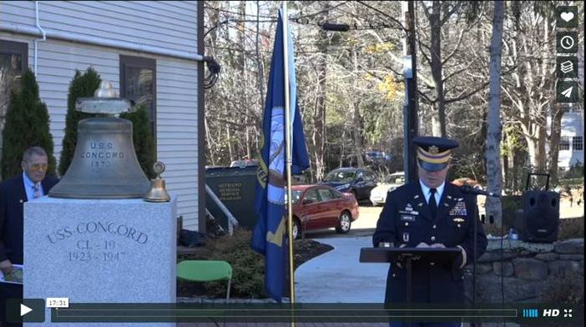

The USS Concord Bell Veterans Memorial project was conceived by the Rotary Club of Concord more 15 years ago, revived in 2012, and now, with the generous support of the Town of Concord’s Community Preservation Fund and help from many experts, donors and volunteers, has finally become a reality.

READ MORE

VIEW 17-MINUTE VIDEO (produced by Steve Kirk, president of Concord Rotary)

READ WICKED LOCAL CONCORD ARTICLE

To learn more about Concord Rotary, click here.

Framingham Rips Apart Cooked Turkeys for Curtis Family Thanksgiving Dinner

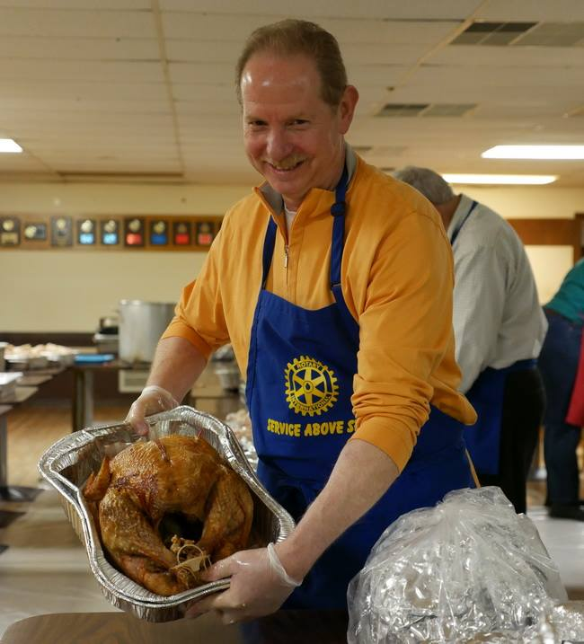

The Rotary Club of Framingham joined other community volunteers on November 23 to help rip apart cooked turkeys for the annual Curtis Family Thanksgiving day dinner. This year’s event provided free meals to more than 2,000 people.

After the Curtis family closed their restaurant, Eagles All-American Grille in Framingham, in 2014, they carried on the tradition of hosting the Curtis Family Thanksgiving. The dinner is held at the Fraternal Order of Eagles hall, located at 55 Park St. in Framingham.

Shown, is Framingham club President Lindsey Morris displaying cooked turkey in a tray.

VIEW ALL PHOTOS

To learn more about Framingham Rotary, click here.

Needham, Wellesley Team Up for Annual Football Banquet

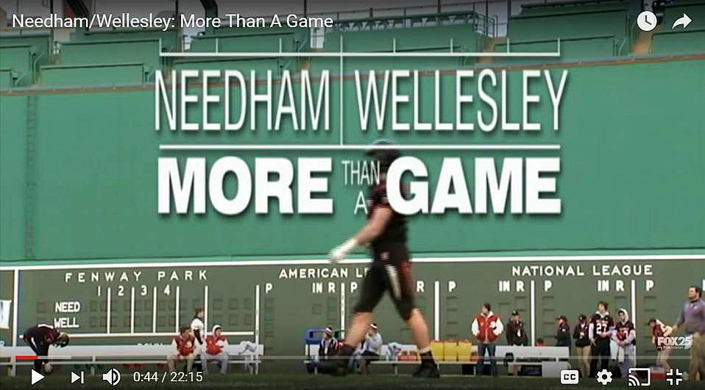

In true Rotary spirit and camaraderie, The Rotary Clubs of Needhamand Wellesley gathered recently at the Sheraton Hotel in Needham for their annual Football Banquet, hosted this year by Needham Rotary. After a welcome, the Pledge of Allegiance, song and prayer, Needham President Ted Shaughnessey and Wellesley President Scott Secrest gave the audience the background about Rotary and their respective clubs.

Guests were introduced, including the superintendents, principals and athletic directors of the Needham and Wellesley High Schools. Amid much applause, the head coached introduced their staff and senior players, including the captains.

READ MORE

WATCH VIDEO

To learn more about Needham Rotary, click here.

To learn more about Wellesley Rotary, click here.

Sturbridge Donates Funds for Holiday Meals

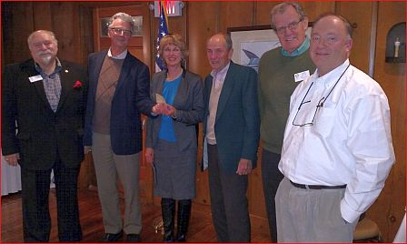

For the ninth consecutive year, the Rotary Club of Sturbridge has donated funds to organizations providing meals for families in need in the Tri-Community area. This year, funds were designated for the Tri-Community Church Collaborative, the Saint John Paul II Food Pantry and for needy families whose children attend Burgess Elementary School in Sturbridge. The latter program is coordinated by Lisa Meunier, school nurse at Burgess. All Rotary funds were donated directly to the Food Pantry, which coordinates the food supplies. Sturbridge Rotary also conducts an annual fundraiser each June to support the Saint John Paul II Food Pantry. One of the club’s goals is to help alleviate hunger in its local communities. So far in 2016, the club has contributed $4,100 toward this goal.

Left to right: President-Elect Dave Zonia; President Otto Prohaska; Lisa Meunier, Burgess Elementary School nurse; Bill Pioppirepresenting the Food Pantry; Community Service Chair Bob White; and Fundraising Chair Peter Zeh.

To learn more about Sturbridge Rotary, click here.

Watertown Holds $10,000 Raffle to Benefit Local Charities

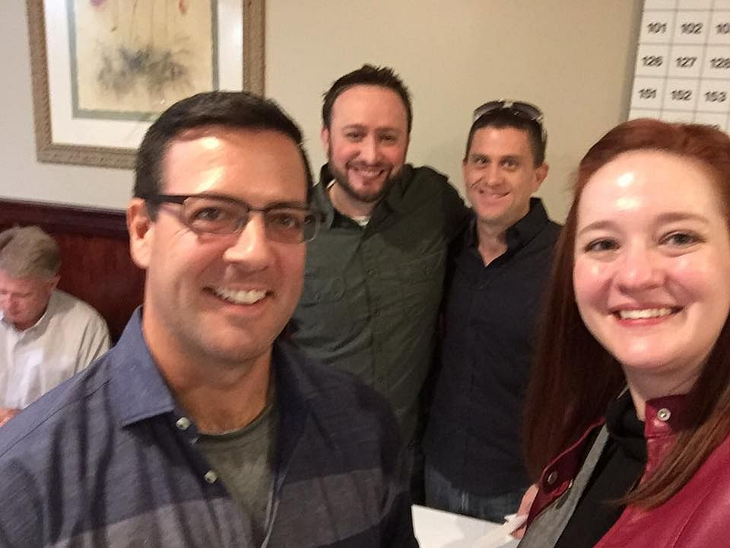

The Rotary Club of Watertown Rotary held its annual $10,000 Raffle on November 4. Tickets were $100 each for a chance to win the First Prize of $10,000 The Second Prize was $500 and the Third through Seventh prizes were $200 each. All proceeds will go to benefit various local charities.

Left to right: John Airasian, membership chair; Anthony Donato, two-time past president; Jesse Wallace, 10K Raffle chair; and Lilia Weisfeldt, president.

To learn more about Watertown Rotary, click here.

Westborough Holds Annual Turkey Trot To Support Town's Public Schools

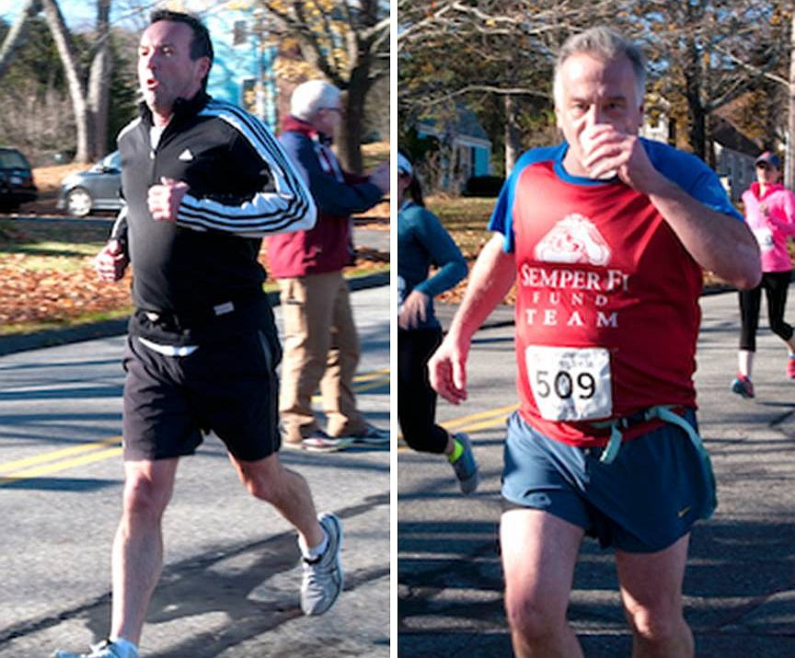

Member Patrick McGrath (left) and President Gerry Gross (right) of the Rotary Club of Westborough hit the pavement on a recent, beautiful Saturday, to run a 5K race in support of Westborough Public Schools.

To learn more about Westborough Rotary, click here.

Westborough Installs New Member

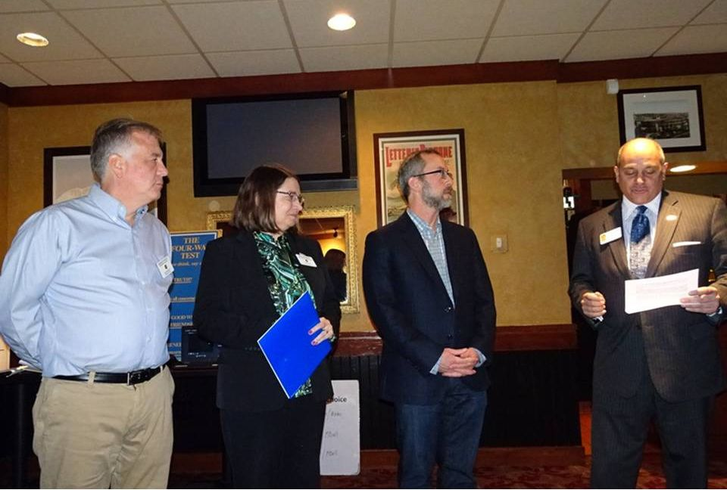
Milford Distributes '16 Tab to 13,000 Homes - Record sales, 94 photos, 334 smiling faces

To read the Milford RotaryTab, click here.
Here’s an example of the content in the 2016 issue of Milford Rotary Tab:
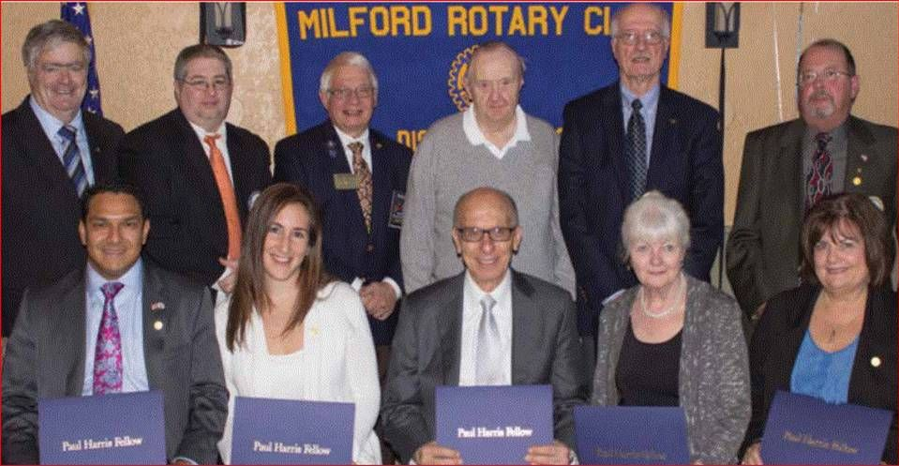
2015 Paul Harris Award Recipients
Front row, left to right: Allan and Lauren Villatoro; Frank Saba, since-retired CEO of Milford Regional Medical Center; Mary Ann Mastroianni; and Susan McWade Surapine.
Back row, left to right: Thomas C. Sawyer, Foundation chair; Michael DiCicco; Jim Fusco, then-district governor; Russ Dennett; Ralph Mastroianni; and Paul Surapine.
To learn more about Milford Rotary, click here.

Wellesley Helps Sixth-Graders Students Learn of Rotary Four-Way Test, Interact Global Grant Project
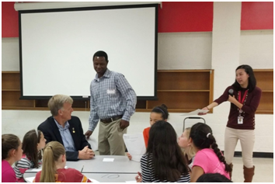
About 80 students from the Wellesley Middle School used a lesson plan developed by English teacher Claire Lee (standing, right) to exercise the iconic Rotary tool for decision-making. The Grade 6 students were invited to list good and bad decisions they remembered and weigh them using the Rotary Four-Way Test. They were also invited to participate in a writing contest expanding on the same topic. John Adams(seated, left), Cynthia Sibold and Bob Anthony represented the Rotary Club of Wellesley in offering the writers judged to be the top three prizes valued at $400.
To view the Rotary Four-Way Test Worksheet, click here.
To read the history of the Four-Way Test, click here.
READ MORE
To learn more about Wellesley Rotary, click here
The Rotary Club of Westborough has welcomed and installed its newest member, Tony Vaver (second from right). Sponsored by club Secretary Maureen Ambrosino (second from left), Tony has been a Westborough resident for 10 years, and is the local history librarian at Westborough Public Library.
Tony was installed by District Governor-Nominee Steve Sager (far right), a Westborough Rotarian. Steve reminded his fellow club members that when people become Rotarians, they not only join a particular club, but they also in excess of 35,000 clubs in more than 200 countries around the world that promote Rotary’s mission of ”service above self.”
Also shown is Westborough President Gerry Gross (far left).
To learn more about Westborough Rotary, click here.

On to Atlanta in 2017: Early-Registration Discount Ends December 15

Planning to attend? Contact District Chair Steve Glines.

More than 43,000 attendees left the Rotary International Convention in South Korea inspired to end polio for good, to celebrate The Rotary Foundation's centennial, and to champion changes that will help Rotary appeal to a broader audience. On the last day, RI President K.R. “Ravi” Ravindran shared a personal story of his mother’s triumph over polio.

To read the story, click here.

To register for the 2017 RI Convention in Atlanta, click here.

Pat and Skip Doyle Installed as '16-'17 DGs

District 7910's 2016 Rotary Youth Leadership Awards were held on June 24 through 26 at Fitchburg State University, ending with the installation of longtime RYLA supporters Pat and Skip Doyle as District Governors for 2016-2017. The three-day RYLA event was attended by 188 sophomores. To learn more about RYLA, visit ryla7910.org.

To watch a video of the installation, click here.

District Banners Available

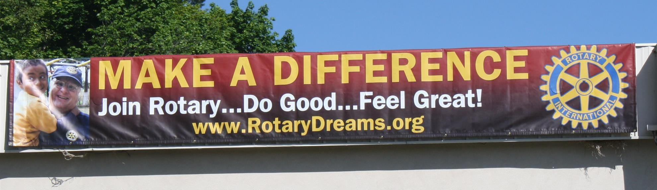

Our district banners are available for your use when you have an upcoming event or fundraiser.

If you want to reserve one of the banners, please contact PR Chair Laura Spear at laura@spear.net.

MAJOR DISTRICT & CLUB HAPPENINGS: FALL 2016

Today - Monday, December 5: Sturbridge Rotary - 'Lottery Ticket Raffle'

To download the event flyer, click here.

Tuesday, December 6: Hudson - 'Overcoming Distractions - Thriving with Adult ADHD'

To download the event flyer, click here

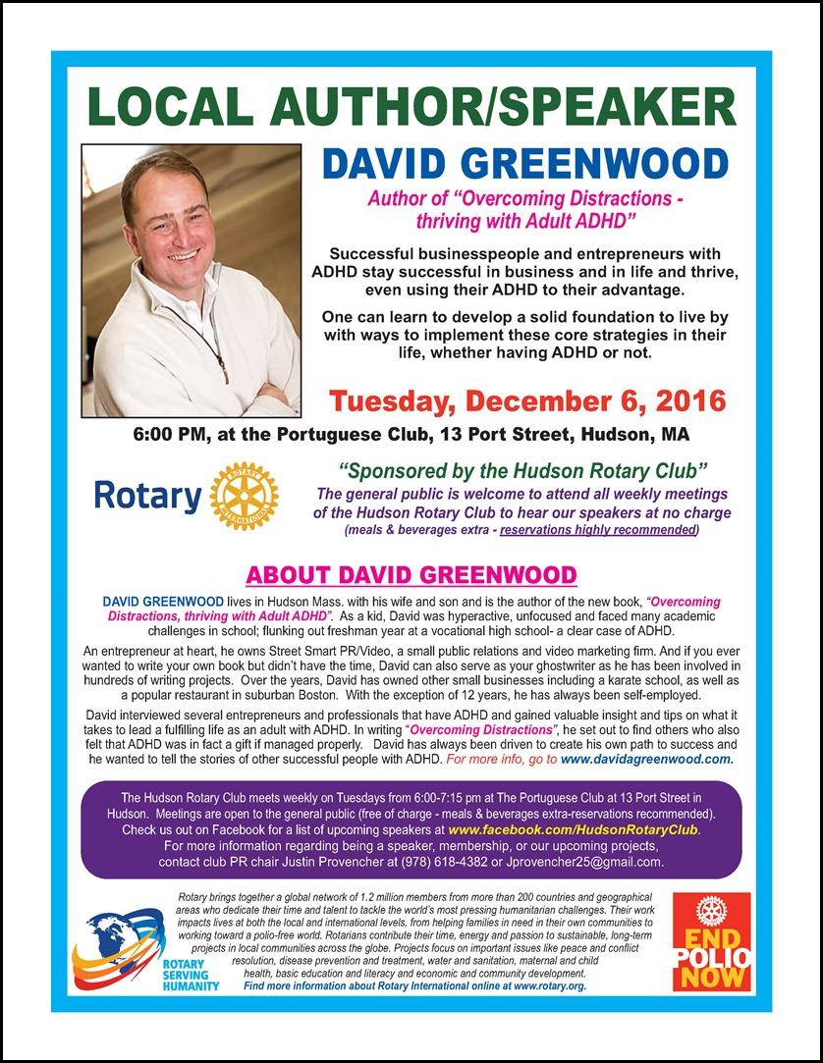

Through Wednesday, December 7: Framingham - 'Click & Bid 2016 Online Auction'

All proceeds benefit Framingham Rotary's community-service efforts.

To learn more and to bid, click here.

Wednesday, December 7: Rotary Means Business - 'Networking Fellowship for Rotarians and Friends'

To download the event flyer, click here.

Through December 11: Leominster - 'Festival of Trees'

The Rotary Club of Leominster is participating in the annualFestival of Trees, which is being held through next Sunday in Tata Auditorium at Leominster City Hall. Leominster RotarianLynn Gaudet did an outstanding job decorating this year's tree(shown, below) with Rotary ornaments. Money raised from the event will go to support the Mayor’s Fuel Fund and city events! Tata Auditorium is open today, tomorrow, Wednesday and Fridayfrom 9:00 a.m. to 4:00 p.m., Thursday from 9:00 a.m. to 5:30 p.m.and Saturday and Sunday from 11:00 a.m. to 3:00 p.m. On Sunday, the Colonial Band will perform starting at 2:00 p.m. The Silent Auction will close on Sunday at 5:00 p.m. For more information, contact Melissa Tasca of City Hall at 978-534-7525 ext. 260 or mtasca@leominster-ma.gov. Or, visit the Festival of Trees' Facebook Events page, click here.

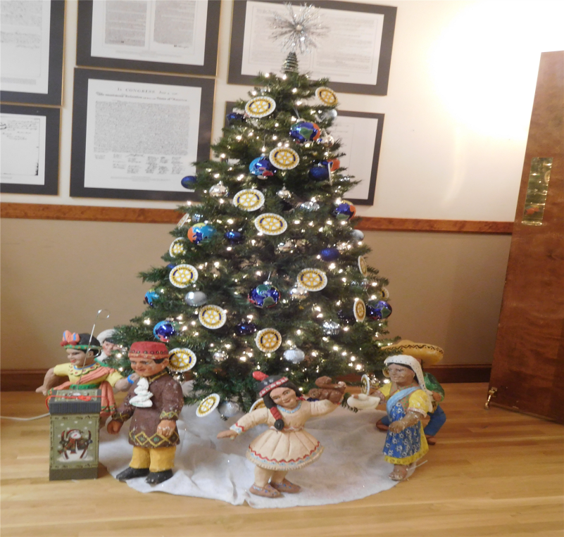

SUBMIT MAJOR CLUB HAPPENINGS

Send flyers of your club's major events and activities, in eitherJPEG or PDF format, to Immediate Past District
Governor/Newsletter Editor Jim Fusco at jim.fusco2@gmail.com.

