Kalyan Banerjee to be keynote speaker
By Satya Mitra

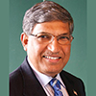I am pleased to inform you that Kalyan Banerjee (shown, right), a past Rotary International president and chair and trustee of The Rotary Foundation, has confirmed his attendance next May 25 for our district’s Million Dollar Dinner. He needs to attend another event in Zurich, Switzerland on May 27 May, so he will leave early on May 26.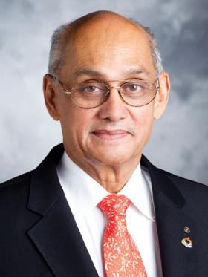

The venue, Mechanics Hall in Worcester, has been reserved for this gala event. Let’s do a grand celebration of the centennial year of The Rotary Foundation.
Banerjee, who served as RI president during the 2011-2012 Rotary year, joined Rotary in 1972. He has also has served as an RI director, Foundation trustee, RI Board Executive Committee member, International Assembly group-discussion leader, task-force chair, and district governor. And, he has chaired The Rotary Foundation in India. He has received The Foundation’s Distinguished Service Award, and he and his wife, Binota Banerjee, are Major Donors and members of the Bequest Society of the Foundation.
Now that we have the date, venue and the chief guest determined, let’s promote the event and the concept of Million Dollar Dinner to each member in every club in our district - and raise more than $1 million to strengthen the endowment funds of the Rotary Foundation. Let’s all get excited and move forward.

Our goal is to reach the Million Dollar mark by the end of this month and then continue to increase the endowments through next May - and beyond. I am certain we can do it and make a history for our district.

Satya Mitra, chair of the District Endowments, Major Gifts and Million Dollar Dinner Celebration Committee, may be reached at satya@thegurutax.com .

Return to December 5 Newsletter

View past issues
Visit our website
'Like' our Facebook page
'Follow' our Twitter page

Million Dollar Dinner: Kalyan Banerjee to be keynote speaker

By Satya Mitra

I am pleased to inform you that Kalyan Banerjee (shown, below), a past Rotary International president and chair and trustee of The Rotary Foundation, has confirmed his attendance next May 25 for our district’s Million Dollar Dinner. He needs to attend another event in Zurich, Switzerland on May 27 May, so he will leave early on May 26.

The venue, Mechanics Hall in Worcester, has been reserved for this gala event. Let’s do a grand celebration of the centennial year of The Rotary Foundation.

Now that we have the date, venue and the chief guest determined, let’s promote the event and the concept of Million Dollar Dinner to each member in every club in our district - and raise more than $1 million to strengthen the endowment funds of the Rotary Foundation. Let’s all get excited and move forward.

Our goal is to reach the Million Dollar mark by the end of this month and then continue to increase the endowments through next May - and beyond. I am certain we can do it and make a history for our district.

Satya Mitra, chair of the District Endowments, Major Gifts
and Million Dollar Dinner Celebration Committee, may be reached at satya@thegurutax.com .

