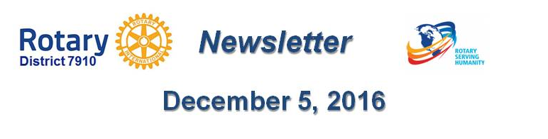

Vinney Tingley OF Natick ROTARY
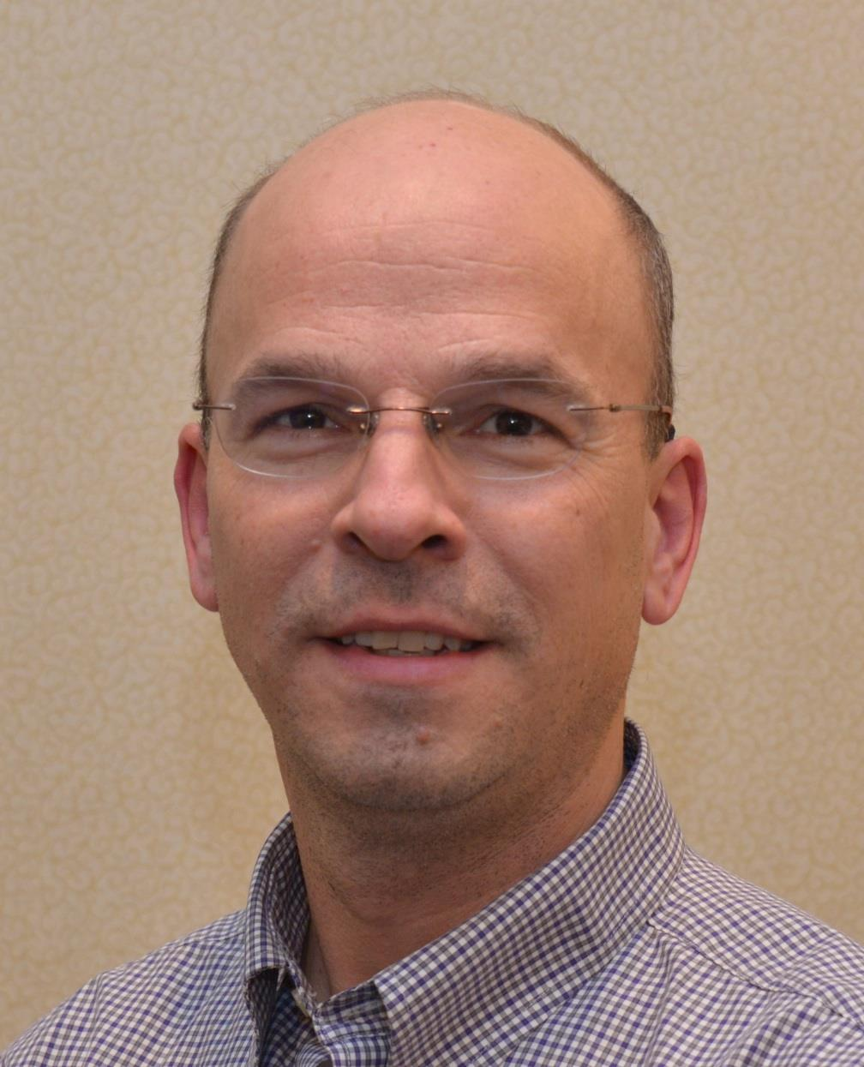
Please tell us what factors helped you decide to join Rotary.
Raising awareness with postings on social media, such as Facebook. Signs and banners all over town.
Do you have any advice to offer others in our district about how best to achieve a successful fundraiser?

Ask Rotarians personally for their participation. Consider partnering with another organization - the type that helps charities raise money

Do you have any innovative plans for Rotary-related publicity during your presidency?

We post a large sign outside of every meeting and event to raise awareness, We made a huge banner for the town center to celebrate our 90th year.

As president, what’s your biggest concern for the coming year?

Creating flexibility in meeting times, places and what a “meeting” is considered. For example, our visiting a nursing home each month counts as a meeting.

What’s the best book you’ve read in the past three years?

Any of the John Grisham books.

What’s your favorite quotation?

“You can not control people, only yourself”

Vinney Tingley, president of the Rotary Club of Natick, may be reached at vincent@tingleyelectric.com.

To learn more about Natick Rotary, click here.

Return to December 5 Newsletter

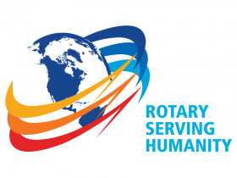Visit our website
'Like' our Facebook page
'Follow us on Twitte

