COMMITTEE REPORTS

Club Central: Short video on how to post your club goals

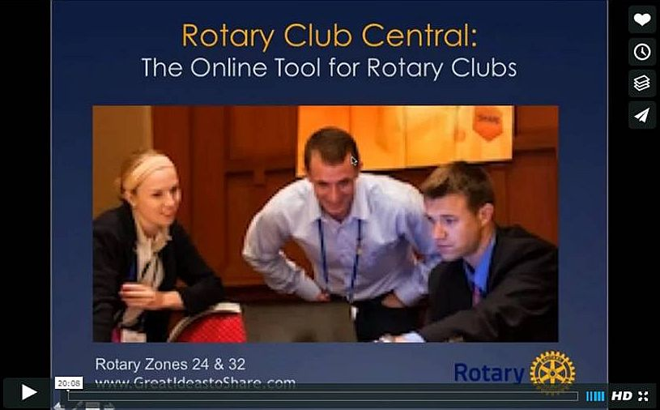
This 20-minute webinar recording is designed for club leaders to assist in posting goals on Rotary Club Central. Bob Wallace and Ian Lancaster, facilitators from Rotary Zone 24 East, provide practical start-up information.

CLICK HERE

'17 RI Convention in Atlanta: Discount ends December 15

Beyond Borders Dinner on June 11: To register now, click here.

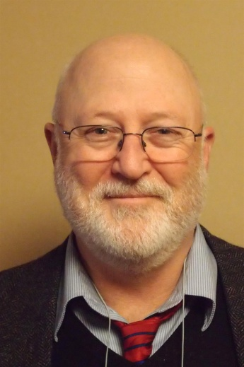

Here's a letter from Steve Glines, chair of the District International Convention Promotion Committee.

READ LETTER

To register and find hotel options, click here

For more information on the 2017 RI Convention in Atlanta, click here

Million Dollar Dinner: RI Past President Kalyan Banerjee to be keynote speaker
By Satya Mitra

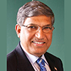

I am pleased to inform you that Kalyan Banerjee, a past Rotary International president and chair and trustee of The Rotary Foundation, has confirmed his attendance next May 25 for our district’s Million Dollar Dinner. He needs to attend another event in Zurich, Switzerland on May 27 May, so he will leave early on May 26.

The venue, Mechanics Hall in Worcester, has been reserved for this gala event. Let’s do a grand celebration of the centennial year of The Rotary Foundation.

READ MORE

Polio Plus Update: Let's meet this modest goal

By Carl Good III

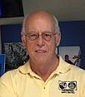

Our districtwide goal is that each club can generate contribution to the Polio Plus Fund of at least $26.50 per member during the 2016-2017 Rotary year. which ends next June 30. We appeal to all 51 clubs to do their best to meet this modest goal.

READ MORE

Foundation Note: Update on club-qualification status for Foundation grants
By Sanjay Deshpande

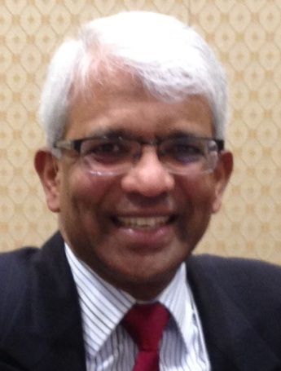

District 7910 conducted a third Grant Management Training session last month to help clubs, which had not participated in the earlier two training sessions, to qualify for Foundation grants during the rest of Rotary year 2016-2017, which ends next June 30.
As a result of last week’s session, our district now has 25 clubs that are fully qualified for participation in District and Global grants ‘16-‘17.

READ MORE

Rotary Means Business: First meeting in 2 days on December 7

By Ron Bott

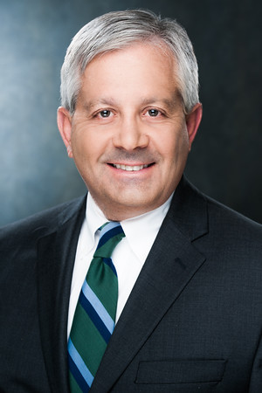

The first Rotary Means Business event in District 7910 will be held on Wednesday, December 7 from 5:30 to 7:30 p.m. at the Sheraton Hotel in Framingham. The cost is $15 for Rotarians and $20 for non-Rotarians. Light appetizers will be served and a cash bar will be available.

READ MORE

Interact Actions: Interact teens needed to help next June in Atlanta
By Bob Anthony
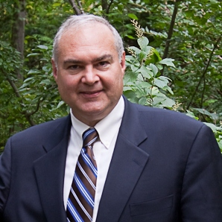

I was amazed by the telephone discussion with Bob Pfahnl, the Interact chair for District 5170 in California. Their model includes a vibrant teen council for the district and a districtwide project called Circle of Love. The achievements include 100 Interact clubs delivering tens of thousands of volunteer hours and fund raising more than $200,000. The amazing thing was that they were asking help to learn from District 7910!

READ MORE

How to launch an Interact club

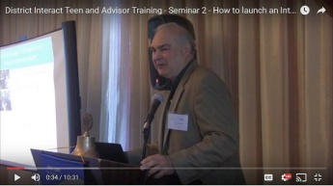

In Seminar 2 of the District Interact Teen and Advisor Training Seminar, held on September 17 in Needham, Bob Anthony, chair of the District Interact Committee, discusses “How to launch an Interact club,” including the certification letter, roles and responsibilities of the president, the Rotary advisor and, in the case of school-based clubs, the faculty advisor.

WATCH VIDEO

Membership Corner: Does your club’s strategy have an impact on membership?

By Tom Sturiale
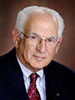

What is this all about? What does it mean? Why should we have a strategy? We are Rotary!

READ MORE

To learn about the October 2016 Membership Workshops, click here.
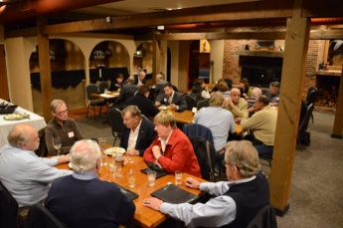

Membership Materials On Sale: Order now!
To order, click here

PR Tips: Get visual

By Laura Spear
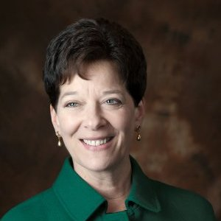

Visual content engages the public and media outlets.

READ MORE

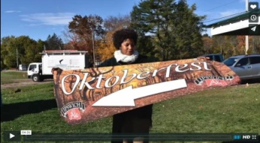

Click here for an excellent example of a club-event promotional video by Concord President Steve Kirk.

RAAGNE Newsletter: Update on visioning process

By Klaus Hachfeld

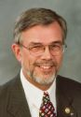

Hello, members and friends of the Rotary Alumni Association of Greater New England! Here is to the latest edition of the RAAGNE newsletter! Over the past year, we went through a visioning process to work out the future direction of RAAGNE.

READ MORE

Speaker's Bureau: Looking for good speaker for your club?

By Steve Levitsky

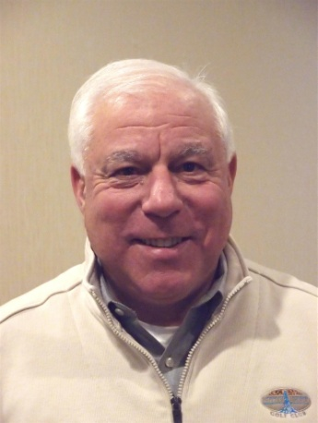

It's not always easy to come up with ideas week after week. We have many suggestions for you. Here are just a few:
- Rwandan genocide: Carine Boggis
- Elevator-pitch tips: Andy Winig
- Positive-results hypnosis: Bob Martel
- Differentiation and game-changing simplicity: Stephen Melanson
VIEW MORE

Treasurer's Report: Message about your dues

By Jack Hoell
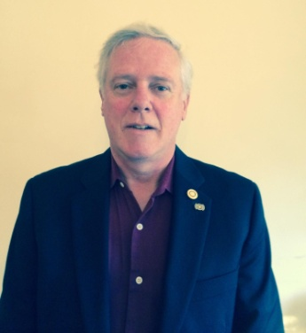

Rotary International dues bills will be invoiced in January based on membership numbers that are shown on your membership roster as of this December 31, so ensure that your membership numbers are accurate and up-to-date. District dues will be based on the same membership numbers that are used by Rotary International The RI and District dues bills will be sent to club presidents and secretaries in mid January.
READ MORE

District Charity Fund: How does DCF operate?

By Karin Gaffney
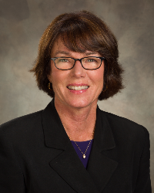

The District Charity Fund is a 501(c)3 charitable, non-profit that can be used by the Rotary clubs in District 7910.
READ MORE

Communications Link: Seeking club photo, video albums
By Steve Jones-D'Agostino
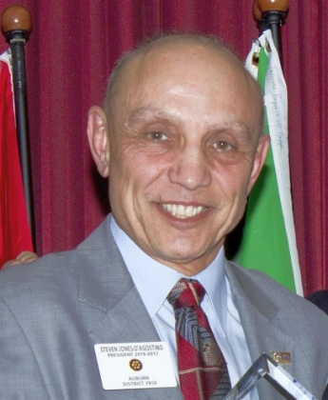

Does your District committee or Club have Rotary-related photo and/or video albums that you'd like to share with other Rotarians?
READ MORE

SUBMIT CONTENT
To submit content for consideration for the Monday, December 12 issue of Rotary District 7910 Newsletter, please e-mail it to Immediate Past District Governor and Newsletter Editor Jim Fusco at jim.fusco2@gmail.com.
The submission deadline for that issue is Friday, December 9. All text must be in Word format. All images must be in either JPEG or PDF format. Please identify the people, left to right, who are shown in your photos, including their first and last name as well as their club or other title.

PAST ISSUES
To view past issues of the weekly Rotary District 7910 Newsletter, click here

DISTRICT 7910 ONLINE
Visit our website
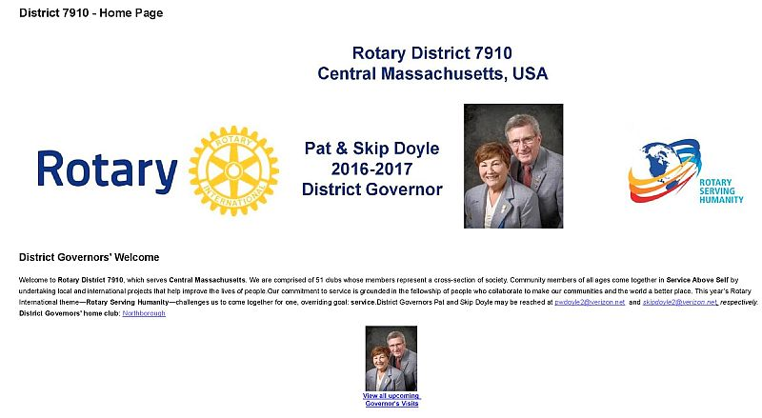
Click on each one

'Like' and share us on Facebook
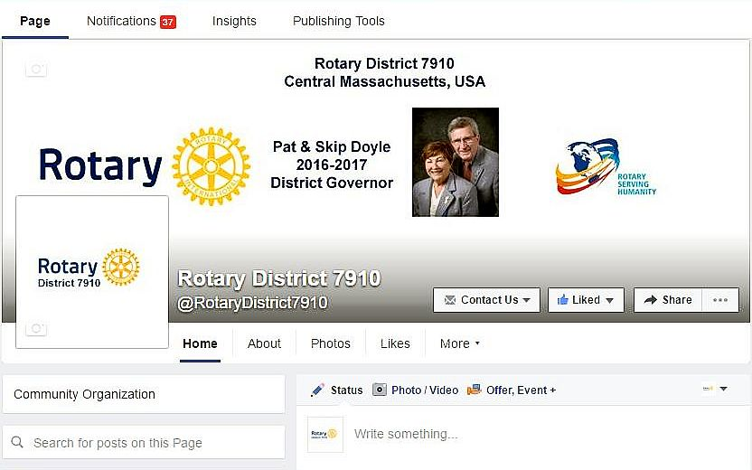

WATCH OUR VIDEOS

VIEW OUR PHOTOS
Archived on Google Photos, since May 2015; and on ClubRunner, before May 2015
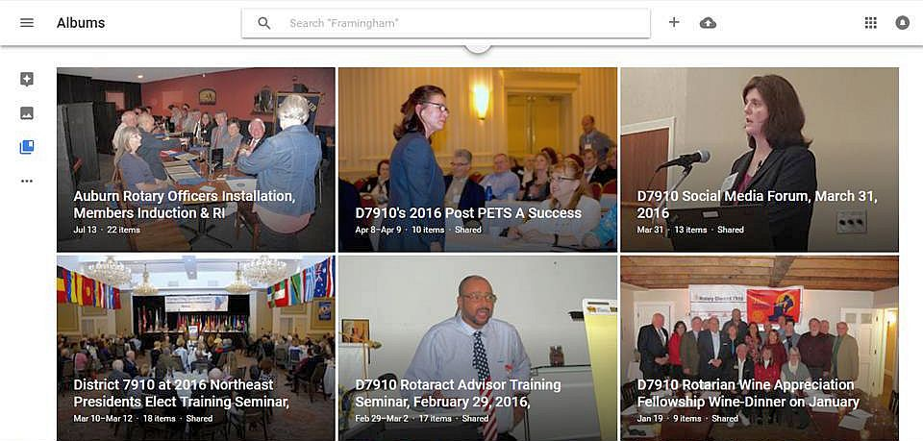

CONTACT US
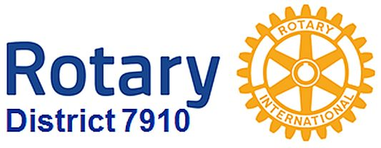Jim Fusco, Immediate Past District Governor and Newsletter Editor
​jim.fusco2@gmail.com
Steve Jones-D'Agostino, District Webmaster and Newsletter Copyeditor
​srdagostino@icloud.com

© Copyright 2016-2017 - Rotary District 7910, Central Massachusetts, USA

