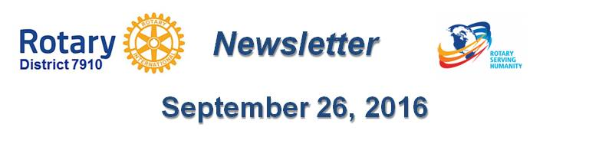

Why Should I Go to the Rotary International Convention?
By Karin Gaffney
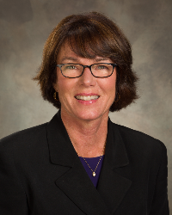
Here is why you should attend - in the words of your fellow District 7910 Rotarian Steve Glines (shown, right) an assistant governor from Littleton Rotary, who attended his first RI Convention this past May in Seoul, Korea:
"Imagine a District Conference on steroids. Instead of a single club proudly displaying a poster setup of their contributions to ShelterBox, Shelter Box is there with a booth occupying several hundred square feet (or meters, if you prefer). They have examples of all the different tents and kits they provide, tailored to the emergency at hand, and knowledgeable people there to explain the differences. For example after the devastation of Fiji by a Category 5 typhoon, tarps, shovels, hammers and nails were the requirements while in Tibet, winterized tents were needed.
Every organization, company and governmental and non-governmental group that has partnered with Rotary is there, as well as hundreds of merchants hawking every kind of Rotary memorabilia imaginable. That’s just in the “House of Friendship.”

But that’s just part of it. There were the Plenary Sessions, where the business of Rotary was discussed and in some cases voted on. I sat through an interesting presentation of the inner details of the PolioPlus initiatives. It was fascinating hearing about bargaining (and bartering) a cease-fire in Nigeria so that health workers could inoculate as many children as possible against polio. I sat through a few minutes of the discussion of the Rotary Bylaws changes. I’m sure any lawyer or politician in Rotary would be fascinated and would have a great deal of input.

Every day, there were dozens of talks prepared by various groups partnering with Rotary as well as district, or multiple-district partnerships that were very interesting. For example, the district that covers the Bahamas partnered with the district that covers Los Angeles to build an emergency reverse-osmosis water-generation plant for the times when hurricanes pollute the public water supplies. There was a group that wants to mobilize the PolioPlus community to eliminate malaria. There were groups of Rotarians with ham radios ready for an emergency as well as Rotarians with trucks outfitted for service in communities that get waterlogged. It seems that almost every district bounded by large bodies of water has a project designed to aid those in a flood.

Having a large, district-wide project seems to help the districts feel united.

Finally, the food. Wherever you went, there was regional food. In the case of the Seoul convention, Korean food was different enough to both peek my interest and, in some cases, frighten me off. I discovered that in South Korea, the redder the food, the hotter it gets.

As an experience, a Rotary International Convention is something not to be missed. We are blessed with next year’s convention being held in Atlanta. Lordy, I can’t wait for that southern BBQ, and peach cobbler for dessert. The best places in Atlanta are on Peachtree Street."

You may reach Littleton Rotarian Steve Glines at steveglines@gmail.com.

Return to October 10 Newsletter

Return to October 3 Newsletter

Return to September 26 Newsletter

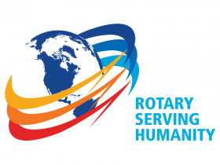
View past issues
Visit our website
'Like' our Facebook page
'Follow us on Twitter

