[](http://rotary7910.org/page/rotary-district-7910-newsletter-october-31-2016-2/)

**WHY SHOULD I GO TO THE ROTARY INTERNATIONAL CONVENTION?**

By  Karin Gaffney

I a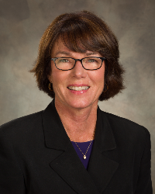m providing testimonials from our Rotarians who have attended a Rotary International Convention. Here's a testimonial from Assistant Governor **Karen Fusco** of **Fitchburg Rotary:**

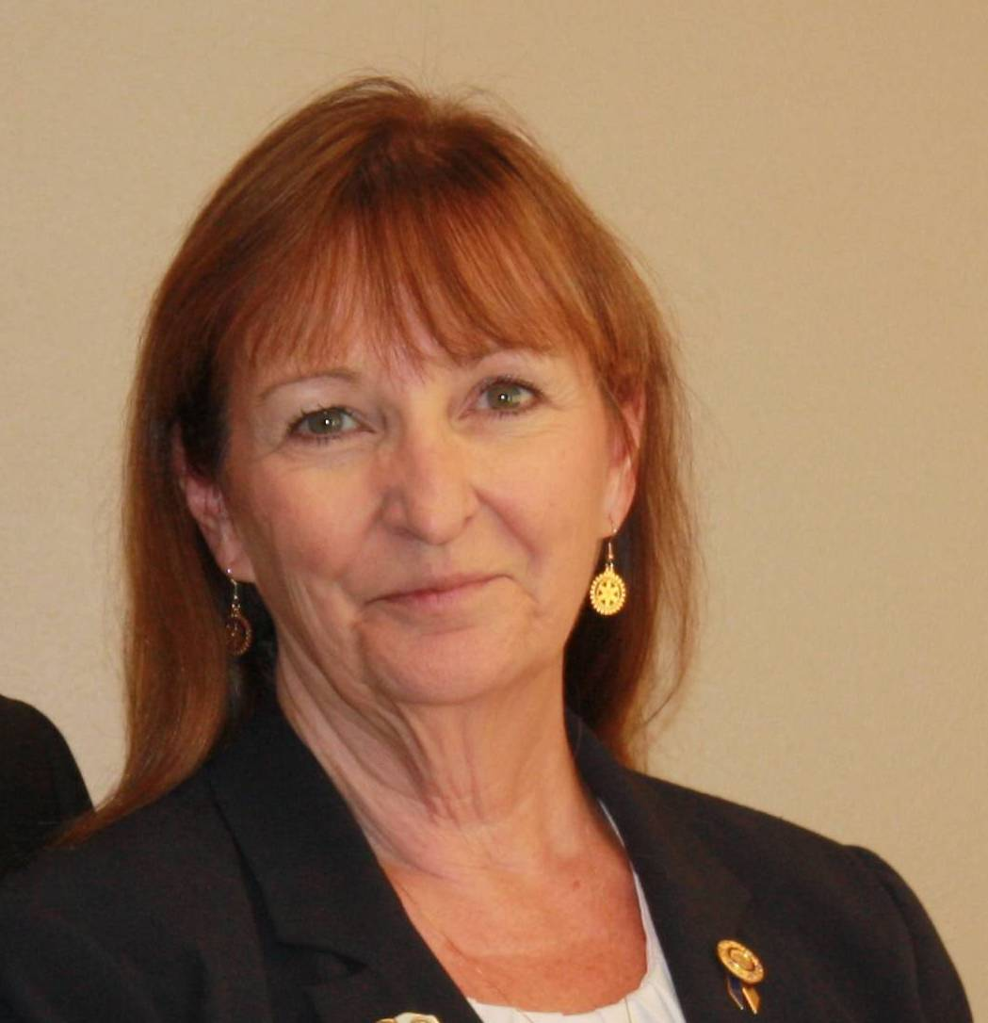

My husband, **Jim Fusco**, and I have been to five Rotary International Conventions and each year it gets better and better. We have been to Indianapolis, Los Angeles, Montreal, New Orleans, and Sao Paulo, Brazil. We have met great people and we have seen amazing sights and in June 2017 we are going to Atlanta!

**Go by train, plane or automobile - and we will see you there:**

* **Go** to Atlanta for the Rotary International Convention. Not just for Rotary, but all the wonderful and exciting museums, parks, and attractions.
* **Go** for the Atlanta Cyclorama & Civil War Museum - since 1893, the longest-running show in the country. Take your place in history, which is home of the world's largest painting, "The Battle of Atlanta," and home of the historic Civil War locomotive, "Texas," hero of the "Great Train Race." Through spectacular music, art and sound effects, history comes alive as you step back to July 22, 1864 and become part of the battle.
* **Go** for the Carter Presidential Library
* **Go** for the Margaret Mitchell House
* **Go** for the CNN Center
* **Go** for the world headquarters of Coca-Cola
* **Go for** Stone Mountain

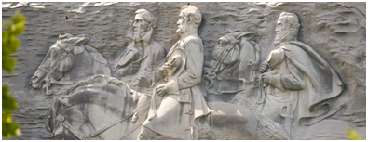

Stone Mountain's top attraction is The Summit Skyride. This high-speed Swiss cable car provides a stunning view of the Confederate Memorial Carving as it transports guests more than 825 feet above ground to the top of the mountain. From the top, experience amazing views of the Atlanta skyline, the Appalachian Mountains and more up to 60 miles away.

**But most of all, go and meet** more than 40,000 Rotarians from around the world. We all speak the same language: “Rotary.”

For**more information**on the **2017 RI Convention**in Atlanta,[click here](http://echo4.bluehornet.com/p/vTRgyO4Y-N).

Assistant Governor Karen Fusco may be reached at [karen.fusco@verizon.net.](mailto:karen.fusco@verizon.net)

**Next week,** I'll have a **testimonial** from Linda Cargiuloloof**Bedford Rotary**.

District Governor-Elect Karin Gaffney may be reached at [karin.gaffney@rocklandtrust.com](mailto:karin.gaffney@rocklandtrust.com).

[Return to October 31 Newsletter](http://rotary7910.org/page/rotary-district-7910-newsletter-october-31-2016-2/)

[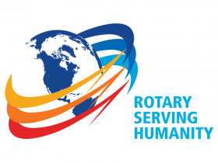](http://rotary7910.org/page/rotary-district-7910-newsletter-july-4-2016/)

[View past issues](http://rotary7910.org/Page/newsletter-ebulletin-archive)

[Visit our website](http://www.rotary7910.org/)

['Like' our Facebook page](https://www.facebook.com/RotaryDistrict7910?fref=ts)

['Follow' our Twitter page](https://twitter.com/rotary7910)