Dear $NICK_NAME$,

It is our pleasure to share with you the February 7 issue of Rotary District 7910 Newsletter, which now comes out on Tuesday at 10:00 a.m. The weekly submission deadline remains the same: Friday.

For the complete issue, click here.

To explore past issues, click here.

Highlights of the February 7 issue:
Governor’s Message: - By Pat and Skip Doyle
RYLA Rounds: Training and registration deadlines - By Christine Pinney
Polio Plus Update: Donation a great birthday present to Rotary - By Carl Good III
Membership Corner: Mark your calendar for March Membership Workshops - By Tom Sturiale
Morley Scholarship Deadline: Applications due by March 15 - By Tory DeFazio
Million Dollar Dinner: $850,000 raised so far - By Satya Mitra
PR Tips: Know what role your club plays in your community - By Laura Spear
Rotary Essay: It's time to treasure Rotary - and for Rotary to give loud voice to its values - By Ron Goodenow
Plus: Lots more district and club news, information and events

Our next newsletter will come out on Tuesday, February 14. The submission deadline is Friday, February 10.

Text content must be submitted in Word format. Image content must be submitted in either JPEG or PDF format.

Send your content submissions to Immediate Past District Governor/Newsletter Editor Jim Fusco at jim.fusco2@gmail.com.

Governors Pat & Skip

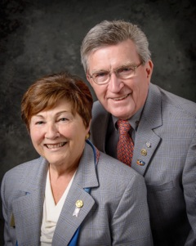Pat and Skip Doyle
2016-2017 Governors
Rotary District 7910

pwdoyle2@verizon.net
skipdoyle2@verizon.net

