Multi-district conference: ALL PRICES GO UP APRIL 1 - SO REGISTER NOW
By Pat and Skip Doyle
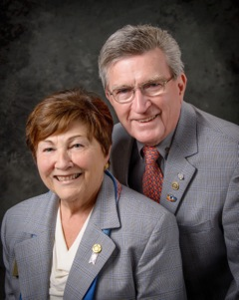
We want to make sure as many members as possible read all about our Multi-District Conference on April 28 through 30 in Providence, and so we are changing last week's "Governor's Message" only a little. If you have not as yet put this date on your calendar, please do it now so you will not forget. All prices will go up on April 1 - so don't wait to register. To register now, click here.

One thing we want to call your attention to is our Youth Program planned for Saturday and Sunday, April 29 and 30. Saturday's program is an all-day conference within a conference for our Interactors and Rotaractors. There are interesting speakers, panel discussions and interactive sessions planned all day for our youth. We will include a complete schedule next week. The registration fee for our interactors is $25, which includes lunch. Pricing for Rotaractors will be available next week - and will include an overnight stay. We hope that Rotary clubs sponsoring Interact clubs may want to defray the costs for the Interactors who participate.

On the subject of costs, if District 7910 were to plan an event such as the Multi-District Conference on its own, given the current prices for venues, it would be prohibitively expensive. We are able to provide this priceless experience at this low cost because three other districts - 7890, 7950 and 7980 - are holding this conference with ours. The venue is being paid through the collective buying power of all Rotarians from all four districts who will be attending this conference. Since we are already holding sessions in the Providence Convention Center and there are spaces available for our young people as well, you might consider your attendance at the full conference as a way to help our Interactors.

More information about schedules and pricing will be available next week.

Seeking trustees

We are now seeking two Rotarians to become trustees of theDistrict Board of Trustees plus one Rotarian to become a trustee of the District Special Fund Board. Those who who applied before ar eligible to apply again. For more information, contact us at pwdoyle2@verizon.net and skipdoyle2@verizon.net.

Six important things to know:

1. The weekly submission deadline for the Newsletter will remain the same: Friday. As usual, text content must be submitted in Word format, and image content, in either JPEG or PDF format. Continue to submit your content to Immediate Past District Governor/Newsletter Editor Jim Fusco at jim.fusco2@gmail.com.
2. Resolutions: The District Resolutions Committee met on January 10 and addressed three changes to the District Resolutions that will be proposed and voted on at the annual District Business Meeting, to be held during the Multi-District Conference in Providence, on Saturday morning, April 29. For more information on the District Resolutions, contact Resolutions Chair Doug Detweiller (shown, right) at rotary@detweiler.org.

3. District Nominations: The District Nominating Committee is seeking qualified applicants to serve as District Trustee for 2017 to 2019 and District Charitable Fund Trustee for 2017 to 2020. Clubs and club leadership are asked and encouraged to actively recruit and promote service in Rotary through their members' service as district leaders. The deadline for submitting applications is this February 18. All completed applications should be either e-mailed to Nominating Committee Chair Michael Ellis (shown,right) at mellis0144@comcast.net, or mailed to him at: Michael Ellis, District 7910 Nominating Committee, 88 Coburn Ave., Gardner, MA 01440. Postmarked mail after February 18 will not be accepted. To download the Trustee Nomination Form, click here. To download the Nomination Form Supplement, click here.
4. Rotary Youth Leadership Awards: The RYLA Club Pack has been updated and posted on RYLA7910.org. When you download it, you will notice changes from last year. Please read the material carefully and direct your questions to Christine Pinney, chair of the RYLA Committee,who may be reached at christine@christinepinney.com. The RYLA season has begun and the RYLA Committee is working to make RYLA 2017 the "best RYLA ever." (See RTLA article in right hand column)

5. Club Planning Worksheet: To download the Club Planning Worksheet, click here.This worksheet is made available to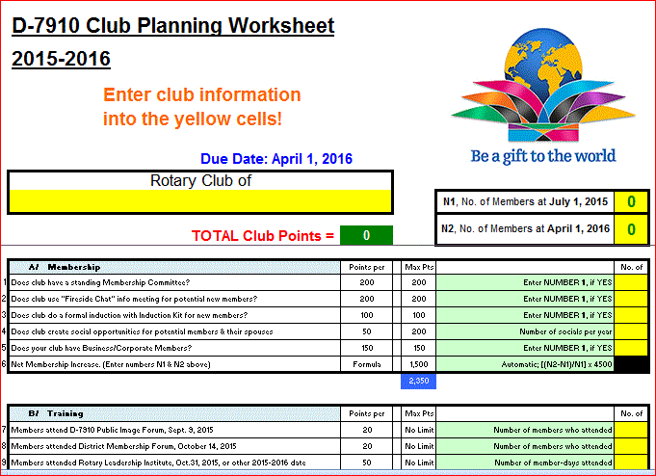 clubs so they can gauge their progress in achieving the goals they set last July. This month is a good time to review the worksheet and see how far you have come and how much farther you need to go as a club. You may surprise yourselves and realize that you are well on the way to earning district recognition. We recommend the club president appoint the president-elect to be the "champion" of the Worksheet, and to use it as a guide for the club, and to report monthly to the club's membership and board on the club's progress.

6. As your district governors, we have resolved to:
- Revisit as many clubs as possible in the next few months.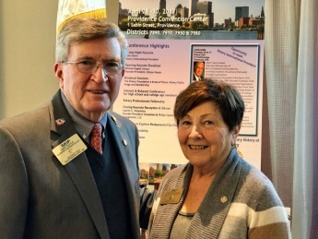
- Help our clubs achieve the goals they set in July
- Do all we can to build membership in the district
- Plan a grand event to celebrate our Million Dollar Foundation Journey
- "Move the ball forward," in harmony, with District Governor-ElectKarin Gaffney, District Governor-Nominee Steve Sager and District Governor-Nominee-Designate Pamela Anastasi
- Celebrate all of this at our Multi-District Conference this April in in Providence
District Governors Pat and Skip Doyle (shown, right) may be reached at pwdoyle2@verizon.net and skipdoyle2@verizon.net, respectively.

Click here to submit content for the Tuesday, February 14 issue. The submission deadline for this issue is Friday, February 10.

Click here for past issues.

Return to February 7 Newsletter

Visit our website
'Like' our Facebook page
'Follow' us on Twitter
Watch our videos
View our photo albums

